Open Loop CMMR Versus Frequency From Datasheet-LM8261
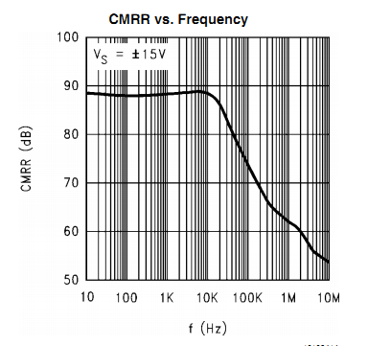
Simulation Setup used for Finding the CMRR of single Op-amp Differential Amplifier using LM8261 –
1) For 10K
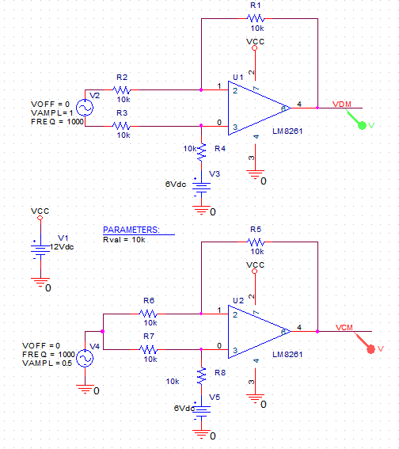 | VDM Vs F
 | VCM Vs F
CMRR Plot
2) Parametric Analysis
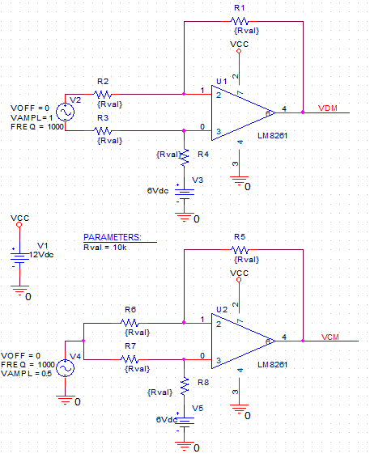 | VDM Vs F
 | VCM Vs F
CMRR Plot

