TUSB3410 Implementation Tips

- Introduction
The TUSB3410 provides bridging between a USB port and an enhanced UART serial port. The TUSB3410 contains all the necessary logic to communicate with the host computer using the USB bus. It contains an 8052 microcontroller unit (MCU) with 16K bytes of RAM that can be loaded from the host or from the external on-board memory via an I2C bus. It also contains 10K bytes of ROM that allow the MCU to configure the USB port at boot time. The ROM code also contains an I2C boot loader. All device functions, such as the USB command decoding, UART setup, and error reporting, are managed by the internal MCU firmware under the auspices of the PC host.

The TUSB3410 can be used to build an interface between a legacy serial peripheral device and a PC with USB ports, such as a legacy-free PC. Once configured, data flows from the host to the TUSB3410 via USB OUT commands and then out from the TUSB3410 on the SOUT line. Conversely, data flows into the TUSB3410 on the SIN line and then into the host via USB IN commands.

The TUSB3410 controls its USB interface in response to USB commands, and this action is independent of the serial port mode selected. On the other hand, the serial port can be configured in three different modes: the RS-232 data mode, the RS-485 data mode, and the IrDA data mode. Similar to the USB mode, once configured for a specific application, it is unlikely that the mode would be changed. The different modes affect the timing of the serial input and output or the use of the control signals. However, the basic serial-to-parallel conversion of the receiver and parallel-to-serial conversion of the transmitter remain the same in all modes. Some features are available in all modes, but are only applicable in certain modes.

As with any interface device, data movement is the main function of the TUSB3410, but typically the initial configuration and error handling consume most of the support code. For more detailed information, you can take a look into the current TUSB3410 datasheet at: http://focus.ti.com/lit/ds/slls519h/slls519h.pdf

This guide will show you the basic steps and the proper reference documents needed to take a TUSB3410 device implementation to production.

This is achieved by using the controller and our Virtual COM port driver SW solution (Windows, Mac or Linux) before to moving forward to a VCP solution.
- FW load options
The first step is determining which FW load option whether an attached I2C EEPROM or download it over USB from the host computer will be best for your implementation.

The TUSB3410 controller, which integrates an 8051/8052 microcontroller and uses on-board RAM to store code during execution, provide a choice of where to store the microcontroller firmware prior to loading to this RAM: in on-board EEPROM, or on the PC.

Note that no matter where the application firmware is stored, the controller always begins running its ROM-based bootcode upon power-up. After performing some initialization tasks, it looks for a valid header on the EEPROM device. The header refers to a properly-structured set of descriptor blocks, as defined by each controller’s data sheet. Each descriptor block contains information that defines the USB device. A descriptor block usually contains either USB descriptor information or executable firmware.

If a valid header is found, it begins parsing and processing the descriptor blocks in the header. If it finds that one of these blocks contains FW, it loads that FW and transfers execution to it. (In some cases, the bootcode may handle enumeration by the host before loading the firmware from the EEPROM.) If it does not find firmware in the header, the bootcode handles enumeration by the host and then waits for application FW to be downloaded from the PC.

Generally speaking, there are no strong advantages or disadvantages to placing the firmware in EEPROM or on the PC. However, depending on the application, engineers may have a preference, and for this reason both methods are provided.

- Storage in an EEPROM

The FW can be stored in an external EEPROM located on the USB controller’s I²C port. As described in the introduction to this section, this is the first place the bootcode checks when looking for application firmware.

Each USB controller’s bootcode handles application firmware in the EEPROM somewhat differently. Generally speaking, there are two methods. The first is to load the code immediately after it is found and begin executing it, prior to enumeration by the USB host. In the second method, the bootcode only sets a flag when application firmware is found, handles enumeration directly, and then loads the firmware from the EEPROM.

TI provides a utility that generates a properly-formatted header file, called the Header Generator utility. The Header Generator is available on the TI website () and uses a simple scripting scheme to instruct the utility in how to form the header.

For details of how a given USB controller handles firmware in the EEPROM, refer to the data manual for that controller and the readme documentation included with the Header Generator utility.

Theoretically, code download is somewhat faster via the EEPROM. However, this is not detectable by the end user.

- Storage on the PC

If stored on the PC, the FW binary file is downloaded to the USB device after the enumeration process. As described previously, the bootcode handles enumeration. If the host driver’s INF file is configured properly, the host will associate this device with a driver. The driver can then download the application firmware to the USB controller, to which execution is subsequently transferred.

An advantage to storing FW on the PC rather than in an EEPROM device is that the device can be significantly smaller if it is only required to store a few USB descriptors. This can result in cost savings. However, it should be noted that an EEPROM should be used in all production ready applications. This is because the manufacturer’s vendor ID and product ID must be resident within the USB device hardware, so that it can report this information to the host at enumeration.

If FW is to be downloaded from the PC, it is necessary that the driver has this special functionality.
- VID/PID and Serial Number
Every USB device has two codes that help distinguish it from other USB devices that a host may encounter: the Vendor ID (VID) and Product ID (PID). A VID/PID unique to a particular USB device must be contained within the device hardware to comply with the USB specification.

The VID and PID are each two bytes long. Every equipment vendor must petition the USB Implementers Forum for a unique VID. The PID can be anything the vendor wishes, but it is a good idea to make the PID unique to a particular design.

Furthermore, USB devices of a given VID/PID combination can be serialized. This allows the operating system to track not only a particular model, but also a specific board of that model. If it is important that configuration settings be associated with a particular board, it is strongly recommended that the boards be serialized.

If it is important that configuration settings on the host be associated with a specific board, and not just a certain product model, TI highly recommends serializing the EEPROM device. For example, when using TUSB3410 or TUSB5052 with the UART driver/firmware solution, the designer may wish to ensure a particular device is always associated with the same virtual COM port. If the user has two of these devices, and neither is serialized, the operating system will not be able to dependably identify the boards. In Windows, a phenomenon called “COM port hopping” may occur, in which a new virtual COM port is assigned every time the device is attached at a different USB port.

The solution is to include a string descriptor in the EEPROM designated as the serial number. The device descriptor must include a valid index to this descriptor, and the serial number string descriptor in each EEPROM device should contain a unique value. Most EEPROM programmers are able to assign incremental values to particular locations within their mask files, and this mechanism can be used to serialize the EEPROMs.

If serialization is not used, the operating system recognizes this by the lack of a valid index to a string descriptor within the device descriptor. At this point, it attempts its own method of providing unique identification. Windows OS assigns values based on incidental data, such as the USB port into which the device is plugged. This means that a board moved from one port to another port can be identified as a different device. The only way to consistently provide unique identification is EEPROM serialization.

String descriptors can be implemented in the EEPROM header of TUSB3410, or can be implemented programmatically in the firmware of the other devices. In the latter case, this of course requires that firmware be kept in EEPROM. Example configuration files for TUSB3410 are included with the Header Generator utility that demonstrate creating a serial number string descriptor.
- USB Descriptors
There are many USB descriptors that can be included in the EEPROM, as defined by the USB specification, Sections 9.5 and 9.6. A few of them can be stored separately in the header, depending on the USB controller being used; the rest can be handled programmatically in firmware. (The Header Generator readme indicates which types are available for a given controller device). At a minimum, there are two descriptor types that should be included in the EEPROM for any production USB device.

The first is the device descriptor. This provides basic information about the USB device to the host. Most importantly, it includes the VID and PID. This is essential because it differentiates the device from any other USB device the host may encounter.

The second is the string descriptor. Strings encapsulated by the string descriptors are displayed to the end user the first time the device is enumerated by Windows. Without these descriptors, the default strings will be reported to the host when the device enumerates. As a result, Windows presents the USB device to the end user as something TI-specific; for example, “TI TUSB3410 Boot Device”. Unless this is deemed acceptable, it is necessary to include a unique string descriptor in the EEPROM. (Note that after the first enumeration, Windows pulls the display strings from the driver associated with this device.) A string descriptor is also used in EEPROM serialization, as discussed in section 3.
- Generating a valid EEPROM binary file with the Header Generator utiity.
Once you have decided the FW load option, valid VID/PID and serial number have been assigned for the TUSB3410 implementation, the next step in the process is generating the file that you will use to program the EEPROM with that “customized” information.

- You will need to download and install the TUSB3410 USB I2C Header Generator Utility for VCP Applications (http://www.ti.com/litv/zip/sllc297a).

- After downloading, you will need to run the SETUP.EXE and follow the onscreen directions. If you just accept the defaults, the files will be installed by default on you local drive under “\\Program Files\Texas Instruments\I2C Header Generator Utility for VCP apps”.

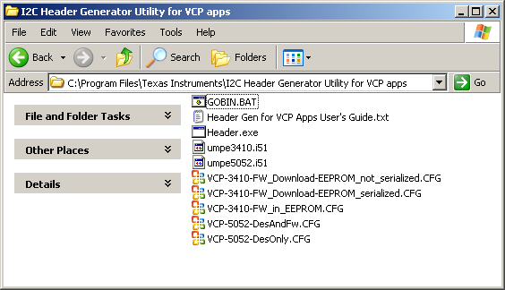

- After you have installed the utility, you will choose a Configuration file to modify based on the firmware location decision you made in Step 1 above:

  - VCP-3410-FW_Download-EEPROM_serialized.cfg: Lets you generate your EEPROM binary with VID/PID, descriptors, and enables the use of a serial number, but no firmware – recommended usage model.

  - VCP-3410-FW_Download-EEPROM_not_serialized.cfg: Lets you generate your EEPROM binary with FW, VID/PID and descriptors, but without firmware or a serial number – not a recommended usage model.

  - VCP-3410-FW_in_EEPROM.cfg: Lets you generate your EEPROM binary with FW, VID/PID, descriptors, and enables the use of a serial number – recommended usage model. Please make sure that the proper “umpe3410.i51” FW build is present in the same directory where the Header generator utility is located. Otherwise FW will not be merged into the binary file to be burned in the EEPROM.

- The balance of this document is based on “VCP-3410-FW_Download-EEPROM_serialized.cfg” above. You can use any standard text editing tool with this file. The areas that need to be modified are pointed out via the comments at the end of each line.

  - VID=1234, PID=5678.

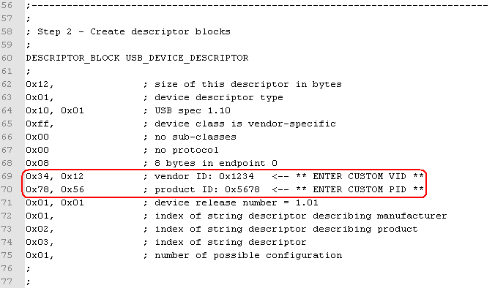

  - Manufacturer and Product Name strings.

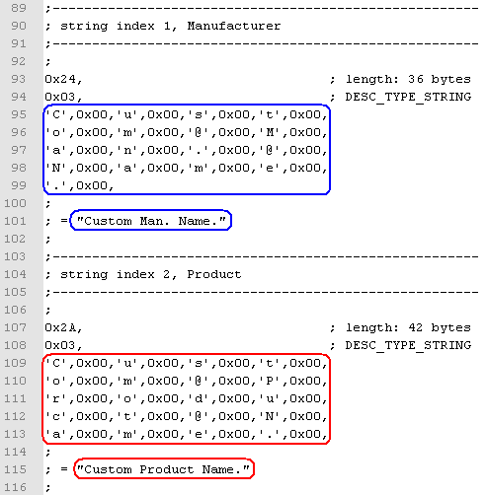

  - Serialization (assuming you are enabling serialization, which is TI recommendation).

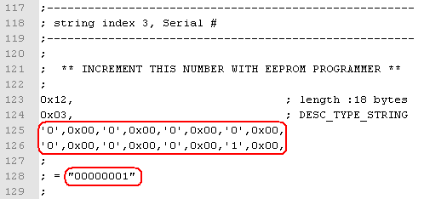

- Once the CFG file has been customized with your desired information, create your EEPROM file using the header generator utility per the “Header Gen for VCP Apps User's Guide.txt” document.

  - To generate the BIN file use the "gobin VCP-3410-FW_Download-EEPROM_serialized" command. (Here you should first open a command prompt window, and go to the proper directory where the Header Gen utility is located).

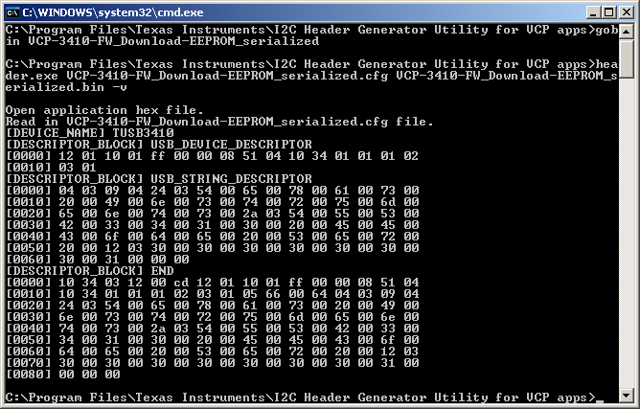

- Install “TI USB EEPROM Burner Utility for the TUSB3410 (Rev. A)” following the steps shown within it’s install documentation (SLLA179A - Using the TI TUSBxxxx EEPROM Programmer). To do so, please download this utility from: http://www.ti.com/litv/zip/sllc259a.

- Once you have installed the EEPROM burner utility for the TUSB3410 Evaluation board, please make sure that before connecting the TUSB3410 SCL_ISOLATE jumper is removed (JP2 for TUSB3410UART EVM or JP4 for TUSB3410GPIO EVM).

- After the TUSB3410 Evaluation board has been properly recognized, open the EEPROM burner utility. Select the proper settings:

  - Select the USB Device → TI T USB3410 EEPROMBurner.
  - Select EEPROM size → 256kbits (this is for a 24LC256).
  - Select EEPROM Image → Browse to “\\Program Files\Texas Instruments\I2C Header Generator Utility for VCP apps\” and choose “VCP-3410-FW_Download-EEPROM_serialized”.

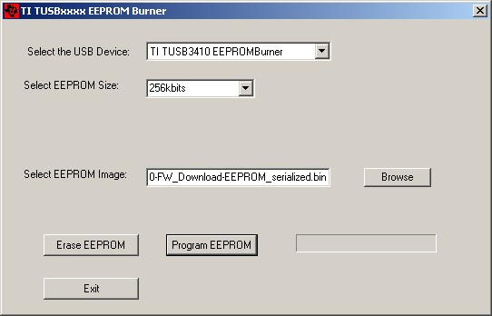

- Now is time to place the jumper (JP2 or JP4 depending on the EVM being used) to enable the EEPROM connected to the TUSB3410 device. Click on “Program EEPROM” button afterwards and wait until the “EEPROM Programmed Successfully!” message box pops up. Click OK to continue.

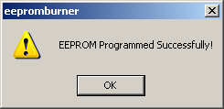

- At this point, your TUSB3410 implementation has a customized VID/PID, manufacturer/product strings and serial number.

- You can now proceed to install your TUSB3410 implementation using any Windows, Linux or Mac OS-X Virtual COM port driver example.

