Hi Patrick,

Thanks for your reply and I am sorry my original description was a bit sketchy.

I and one of my colleagues have been through the application notes and tried everything we can think of with no luck.

The test is Conducted Emissions to CISPR22, I have copied the results in below. You can see that we are only a couple of dB over in the 10 to 30MHz region. We are using about 1m of standard CAT5.

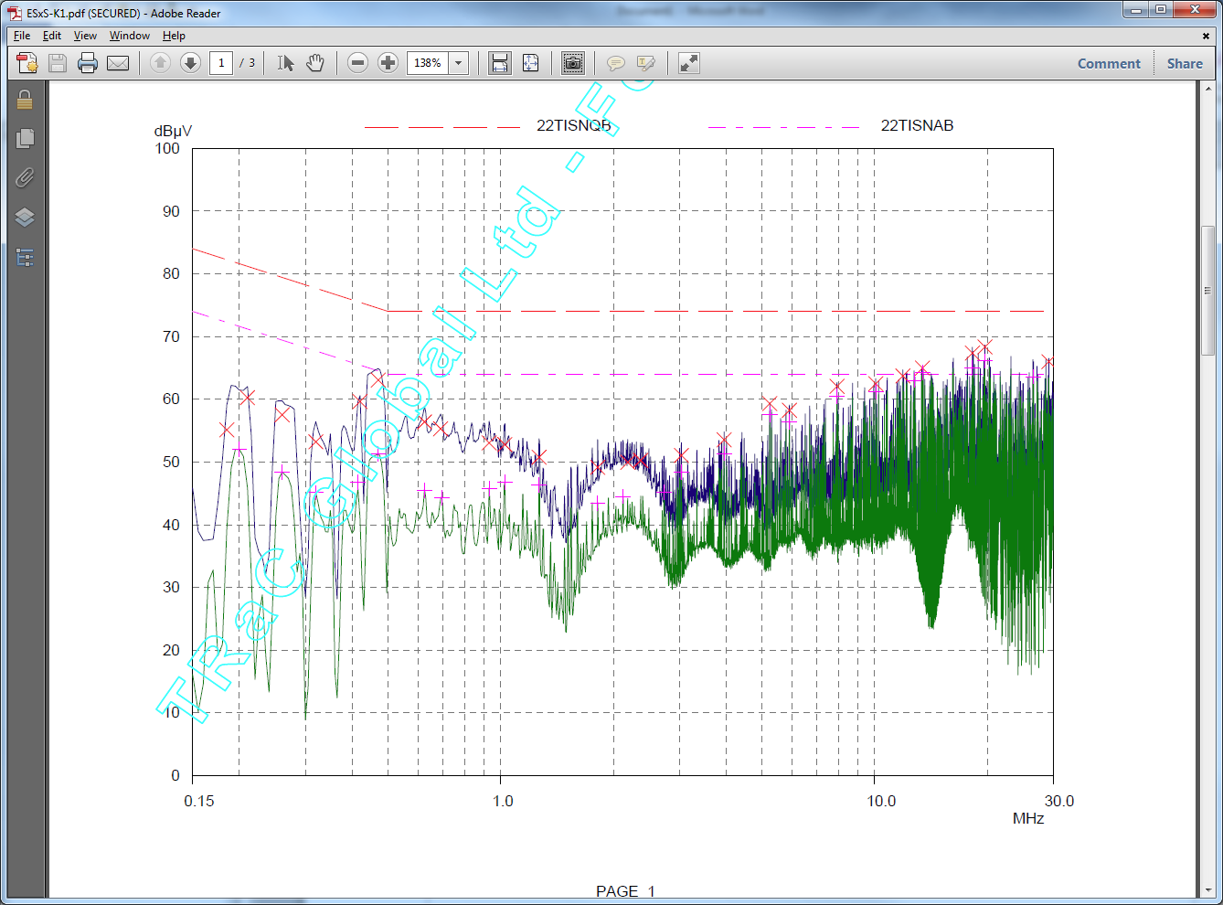

The system operates in RMII mode with a FXO-HC736R-50 crystal. The circuit is shown below.

Any help you can offer will be greatly appreciated. One thing we thought it might be is the lack of connection between the secondary of the transformer and ground. The board is placed to provide no connection at all.

