Green trace – debug trace (pulses alternate in length for debug purpose)

* First pulse – enters ISR
* Second pulse – right before switch
* Third pulse – after turning one module off, and setting second to pwm
* Forth pulse – end of switch
* Fifth pulse – end of ISR

Note that whenever switch statement is reached while “pwm to off” pwm module is low I get a delay in new pwm settings.

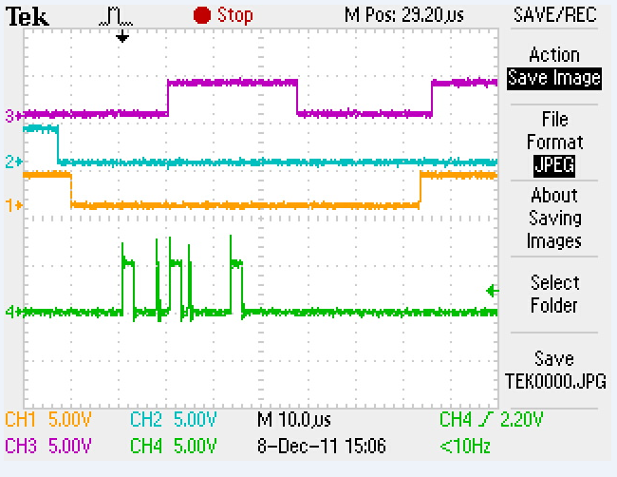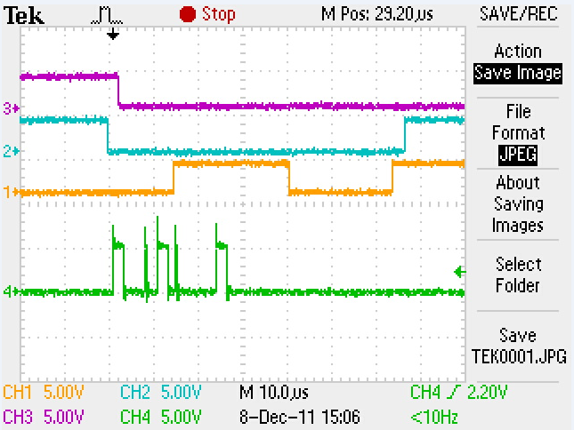

Note that whenever switch statement is reached while “pwm to off” pwm modules is high, new pwm settings go into effect OK.

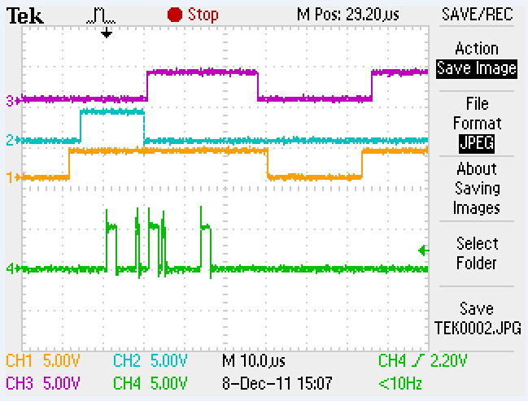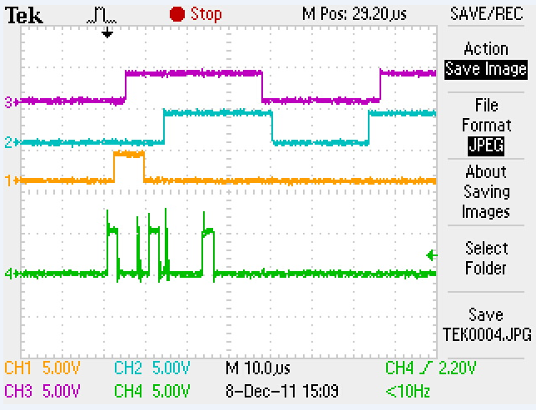

So I played around to see if there is a magic count when it is OK to introduce new pwm settings. When I reset the counter to one of the compare values things seem to work much better. I would say 99.9% of my commutations are clean, but once in a while and for some reason same commutation state still has this problem. Using debug gpio it looks like this problem pops up whenever counter is in one specific state.

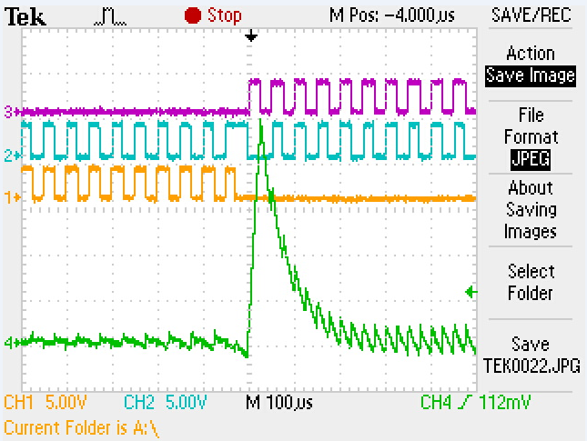

Following is abbreviated code I use with debug pulses and counter reset fix…………

// Init Timer-Base Control Register for EPWM1-EPWM3

EPwm1Regs.TBCTL.bit.FREE_SOFT = SOFT_STOP_FLAG;

EPwm1Regs.TBCTL.bit.PHSDIR = PHSDIR_CNT_UP;

EPwm1Regs.TBCTL.bit.CLKDIV = CLKDIV_PRESCALE_X_1;

EPwm1Regs.TBCTL.bit.HSPCLKDIV = HSPCLKDIV_PRESCALE_X_1;

EPwm1Regs.TBCTL.bit.SYNCOSEL = 0; //send synch down stream

EPwm1Regs.TBCTL.bit.PRDLD = 1; //0-shadow mode, 1-immidiate mode

EPwm1Regs.TBCTL.bit.PHSEN = 1; //no sync, make this pwm master

EPwm1Regs.TBCTL.bit.CTRMODE = TIMER_CNT_UP;

EPwm2Regs.TBCTL.bit.FREE_SOFT = SOFT_STOP_FLAG;

EPwm2Regs.TBCTL.bit.PHSDIR = PHSDIR_CNT_UP;

EPwm2Regs.TBCTL.bit.CLKDIV = CLKDIV_PRESCALE_X_1;

EPwm2Regs.TBCTL.bit.HSPCLKDIV = HSPCLKDIV_PRESCALE_X_1;

EPwm2Regs.TBCTL.bit.SYNCOSEL = 0; //sync to master

EPwm2Regs.TBCTL.bit.PRDLD = 1; //0-shadow mode, 1-immidiate mode

EPwm2Regs.TBCTL.bit.PHSEN = 1; //sync enable

EPwm2Regs.TBCTL.bit.CTRMODE = TIMER_CNT_UP;

EPwm3Regs.TBCTL.bit.FREE_SOFT = SOFT_STOP_FLAG;

EPwm3Regs.TBCTL.bit.PHSDIR = PHSDIR_CNT_UP;

EPwm3Regs.TBCTL.bit.CLKDIV = CLKDIV_PRESCALE_X_1;

EPwm3Regs.TBCTL.bit.HSPCLKDIV = HSPCLKDIV_PRESCALE_X_1;

EPwm3Regs.TBCTL.bit.SYNCOSEL = 0; //sync to master

EPwm3Regs.TBCTL.bit.PRDLD = 1; //0-shadow mode, 1-immidiate mode

EPwm3Regs.TBCTL.bit.PHSEN = 1; //sync enable

EPwm3Regs.TBCTL.bit.CTRMODE = TIMER_CNT_UP;

//EPwm2Regs.TBCTL.all = EPwm1Regs.TBCTL.all;

//EPwm3Regs.TBCTL.all = EPwm1Regs.TBCTL.all;

// Init Compare Control Register for EPWM1-EPWM3

EPwm1Regs.CMPCTL.bit.SHDWBMODE = 1; //0-shadow mode, 1-immidiate mode

EPwm1Regs.CMPCTL.bit.SHDWAMODE = 1; //0-shadow mode, 1-immidiate mode

EPwm1Regs.CMPCTL.bit.LOADBMODE = 0; //0-load on zero, 1-load on PRD

EPwm1Regs.CMPCTL.bit.LOADAMODE = 0; //0-load on zero, 1-load on PRD

EPwm2Regs.CMPCTL.all = EPwm1Regs.CMPCTL.all;

EPwm3Regs.CMPCTL.all = EPwm1Regs.CMPCTL.all;

//===========================================================================

//

// Global: gMotorControlECapIsr

//

Void gMotorControlECapIsr(UArg capture_number)

{

**static** **int** i = 0;

**static** int16 pwm_period_temp = 0;

**asm**(" EALLOW");

GpioCtrlRegs.GPBMUX2.bit.GPIO58 = 0; // 0=GPIO, 1=MCLKR-A, 2=XD21, 3=Resv

GpioCtrlRegs.GPBDIR.bit.GPIO58 = 1; // 1=OUTput, 0=INput

**asm**(" EDIS");

GpioDataRegs.GPBCLEAR.bit.GPIO58 = 1; // uncomment if --> Set Low initially

GpioDataRegs.GPBSET.bit.GPIO58 = 1; // uncomment if --> Set High initially

//GpioDataRegs.GPBTOGGLE.bit.GPIO58 = 1;

**for**(i = 0; i < 5; i++)

{

**asm**(" NOP");

}

GpioDataRegs.GPBTOGGLE.bit.GPIO58 = 1;

//-----------

Init Code….

//------------

GpioDataRegs.GPBTOGGLE.bit.GPIO58 = 1;

**for**(i = 0; i < 1; i++)

{

**asm**(" NOP");

}

GpioDataRegs.GPBTOGGLE.bit.GPIO58 = 1;

pwm_period_temp = pwm_shifted_cmp_a;

**switch**(CommutationState)

{

**case** COMMU_STATE_0:

{

// Unused

EPwm3Regs.AQCSFRC.bit.CSFA = 1; // Low

EPwm3Regs.AQCSFRC.bit.CSFB = 1; // Low

EPwm3Regs.DBCTL.bit.OUT_MODE = BP_DISABLE;

**asm**(" EALLOW");

SysCtrlRegs.PCLKCR0.bit.TBCLKSYNC = 0;

**asm**(" EDIS");

EPwm1Regs.TBCTR = pwm_period_temp;

EPwm2Regs.TBCTR = pwm_period_temp;

EPwm3Regs.TBCTR = pwm_period_temp;

**asm**(" EALLOW");

SysCtrlRegs.PCLKCR0.bit.TBCLKSYNC = 1;

**asm**(" EDIS");

// Power In

EPwm1Regs.AQCSFRC.bit.CSFA = 0; // PWM 1a (Ah)

EPwm1Regs.AQCTLA.bit.CAU = 2; // high when CTR = CMPA on UP

EPwm1Regs.AQCTLA.bit.PRD = 1; // low when CTR = PRD

EPwm1Regs.CMPA.half.CMPA = pwm_duty_ticks; // PWM duty cycle

EPwm1Regs.AQCSFRC.bit.CSFB = 0; // Comp PWM with Deadband on 1B

EPwm1Regs.DBCTL.bit.OUT_MODE =BP_ENABLE;//deadband(overides CSFB)

GpioDataRegs.GPBTOGGLE.bit.GPIO58 = 1;

**for**(i = 0; i < 5; i++)

{

**asm**(" NOP");

}

GpioDataRegs.GPBTOGGLE.bit.GPIO58 = 1;

// Power Out

EPwm2Regs.AQCSFRC.bit.CSFA = 0; // Shifted Complement PWM

EPwm2Regs.AQCTLA.bit.CAU = 1; // Set Low CMPA on UP-count

EPwm2Regs.AQCTLA.bit.CBU = 2; // Set high CPMB on UP-count

EPwm2Regs.CMPA.half.CMPA = pwm_shifted_cmp_a; // PWM duty cycle

EPwm2Regs.CMPB = pwm_shifted_zero; // PWM duty cycle

EPwm2Regs.AQCSFRC.bit.CSFB = 0;//1; // OverRidden by DeadBand

EPwm2Regs.DBCTL.bit.OUT_MODE =BP_ENABLE;//deadband(overides CSFB)

GpioDataRegs.GPBTOGGLE.bit.GPIO58 = 1;

**for**(i = 0; i < 1; i++)

{

**asm**(" NOP");

}

GpioDataRegs.GPBTOGGLE.bit.GPIO58 = 1;

**break**;

}

} // switch

// force pwm sync

EPwm1Regs.TBCTL.bit.SWFSYNC = 1;

// More code…

GpioDataRegs.GPBTOGGLE.bit.GPIO58 = 1;

**for**(i = 0; i < 5; i++)

{

**asm**(" NOP");

}

GpioDataRegs.GPBTOGGLE.bit.GPIO58 = 1;

}