(1)OK
Battery is connected at BAT pin
10-Ohm is connected at OUT pin
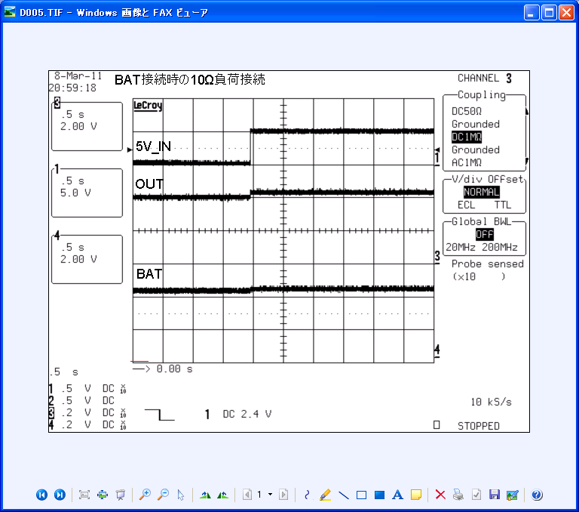

5V
GND

GND
2V

GND
2V

(2) NG
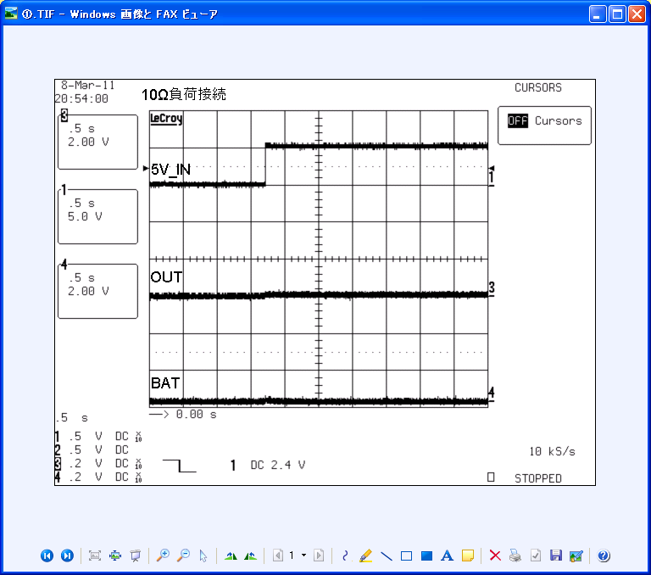
10-Ohm is connected at OUT pin

出力なし

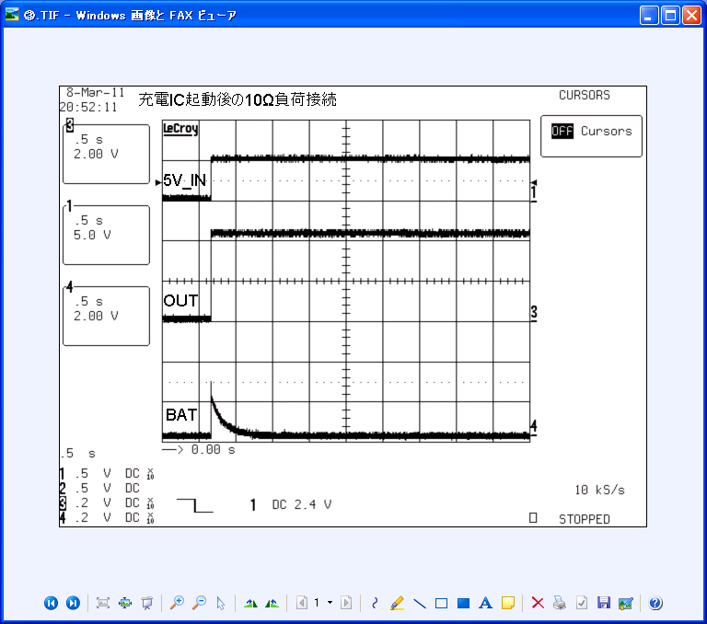

(3) OK
After bq24070 is powered up,
10-Ohm is connected at OUT pin

