 | Checklist | Note
 | General Visual Inspection
 | Check for any damaged components
 | Verify actual component value vs. schematic design value
 | Check for any bad solder joints
 | Check for missing or desoldered components
 | Wrong Cell Voltage Measurement
 | Check actual cell voltage at battery cell side vs. VCx pins | May have bad components (the RC filters) if voltage value doesn't match.  If initial reported voltage is correct, but then it slowly drifted off. This could be caused by a bad filter cap. Inspect or replace the component.
 | If VCELL+/- pins are accessible. Measure the VCELL+/- waveform. | See Fig.1
 | If external cell balancing is used, check for any damaged FETs | If one cell is reporting a small voltage, while the cell next to it is report a very high voltage. It is very likely one of the cell balancing FETs is damaged
 | If calibration data looks abnormal, than save a copy of .gg or .senc file and re-calibrate voltage.
 | Wrong Current Measurement
 | Measure voltage across sense resistor. I = Vsense/Rsense.  Compared the measured current vs. device reported current | Could be a bad IC if measured vs. reported current doesn't match
 | If calibration data looks abnormal, than save a copy of .gg or .senc file and re-calibrate CC offset and CC gain.
 | Wrong Temperature Measurement
 | Check thermistor contact/soldering | Open: reporting a very high temperature >120degC (at room)  Short: reporting a very small temperature <-30degC (at room)
 | Check thermistor waveform on TOUT pin | See Fig.1
 | Verify data flash Temp coef vs. device default (if 103AT-2 NTC is used)
 | If non-103AT NTC is used, verify data flash temp coef vs. thermistor coef Calculator | Thermistor Coefficient Calculator for TI Advanced Fuel Gauges: slua398
 | If calibration data looks abnormal, than save a copy of .gg or .senc file and re-calibrate temperature
 | No Communication
 | Measure regulator voltages | REG33 = 3.3V  REG25 = 2.5V
 | If regulators are not on, measure VBAT pin and make sure VBAT is >6V  Perform a jump start at PACK+ | If device is still not powering up, apply voltage on PACK+ (at least 6V).  Send failure PCB to FA if device still fails to power up (could be a bad IC)
If regulator voltages are correct, but there is no communication.
Provide SMBus scope capture to TI for analysis
 | Cannot Write to Flash
 | Check if device is sealed. Can only write to flash is device is unseal
 | Check the data flash "Flash Update Ok Voltage" value.  Make sure battery voltage is higher than this parameter setting for flash update | For 2-cell application, the default "Flash Update Ok Voltage" is too high.  Apply a charger (i.e. voltage at PACK+), and reduce this parameter value to 6V
 | IT related Issue
 | For all IT related issues, please provide:  - gg file/senc file  - Log data  - Test procedure | Refer to SLUA474 for detail

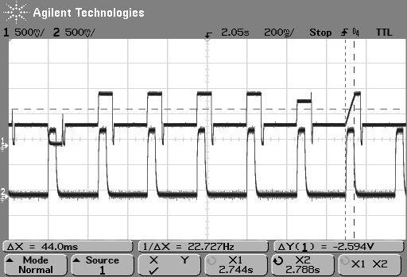
AFE cell channels offset :
cell0
cell1
cell2
cell3
Vcell0~3
AFE ref
2. Tout
1. Cell+
AFE gain
Pack+ measurement
ADC Offset
a
Fig.1: bq20zxx VCELL+ and Tout waveforms. The pulse period is ~250msec.
The VCELL+ signal is inverted – the smaller the Cell Voltage, the higher the VCELL+ amplitude. The delta between Vcell and AFE channel offset (i.e. value a) = the scaled cell voltage = Actual cell voltage * 0.15

