DATA TRANSACTION OMAP (1.8V) SIDE (f POINT)
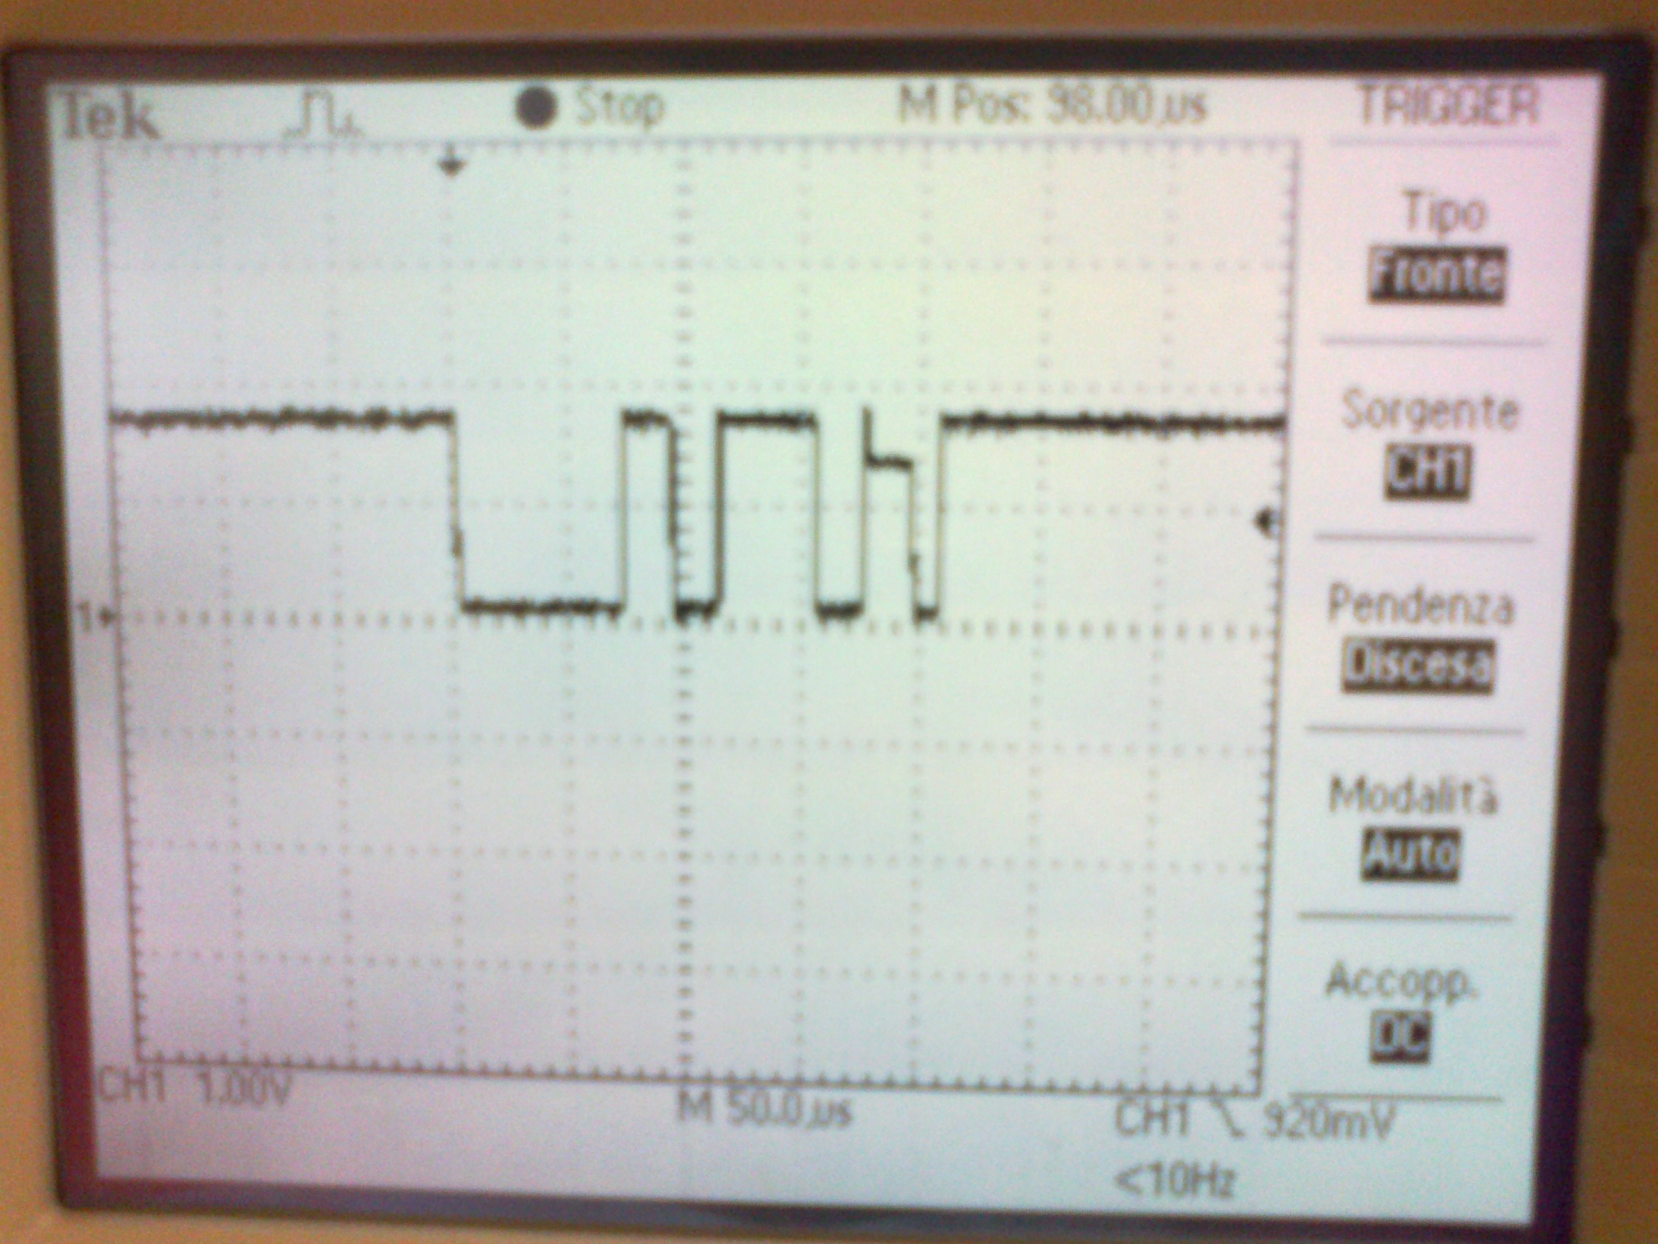

DATA TRANSACTION BQ (2.5V) SIDE (d POINT)

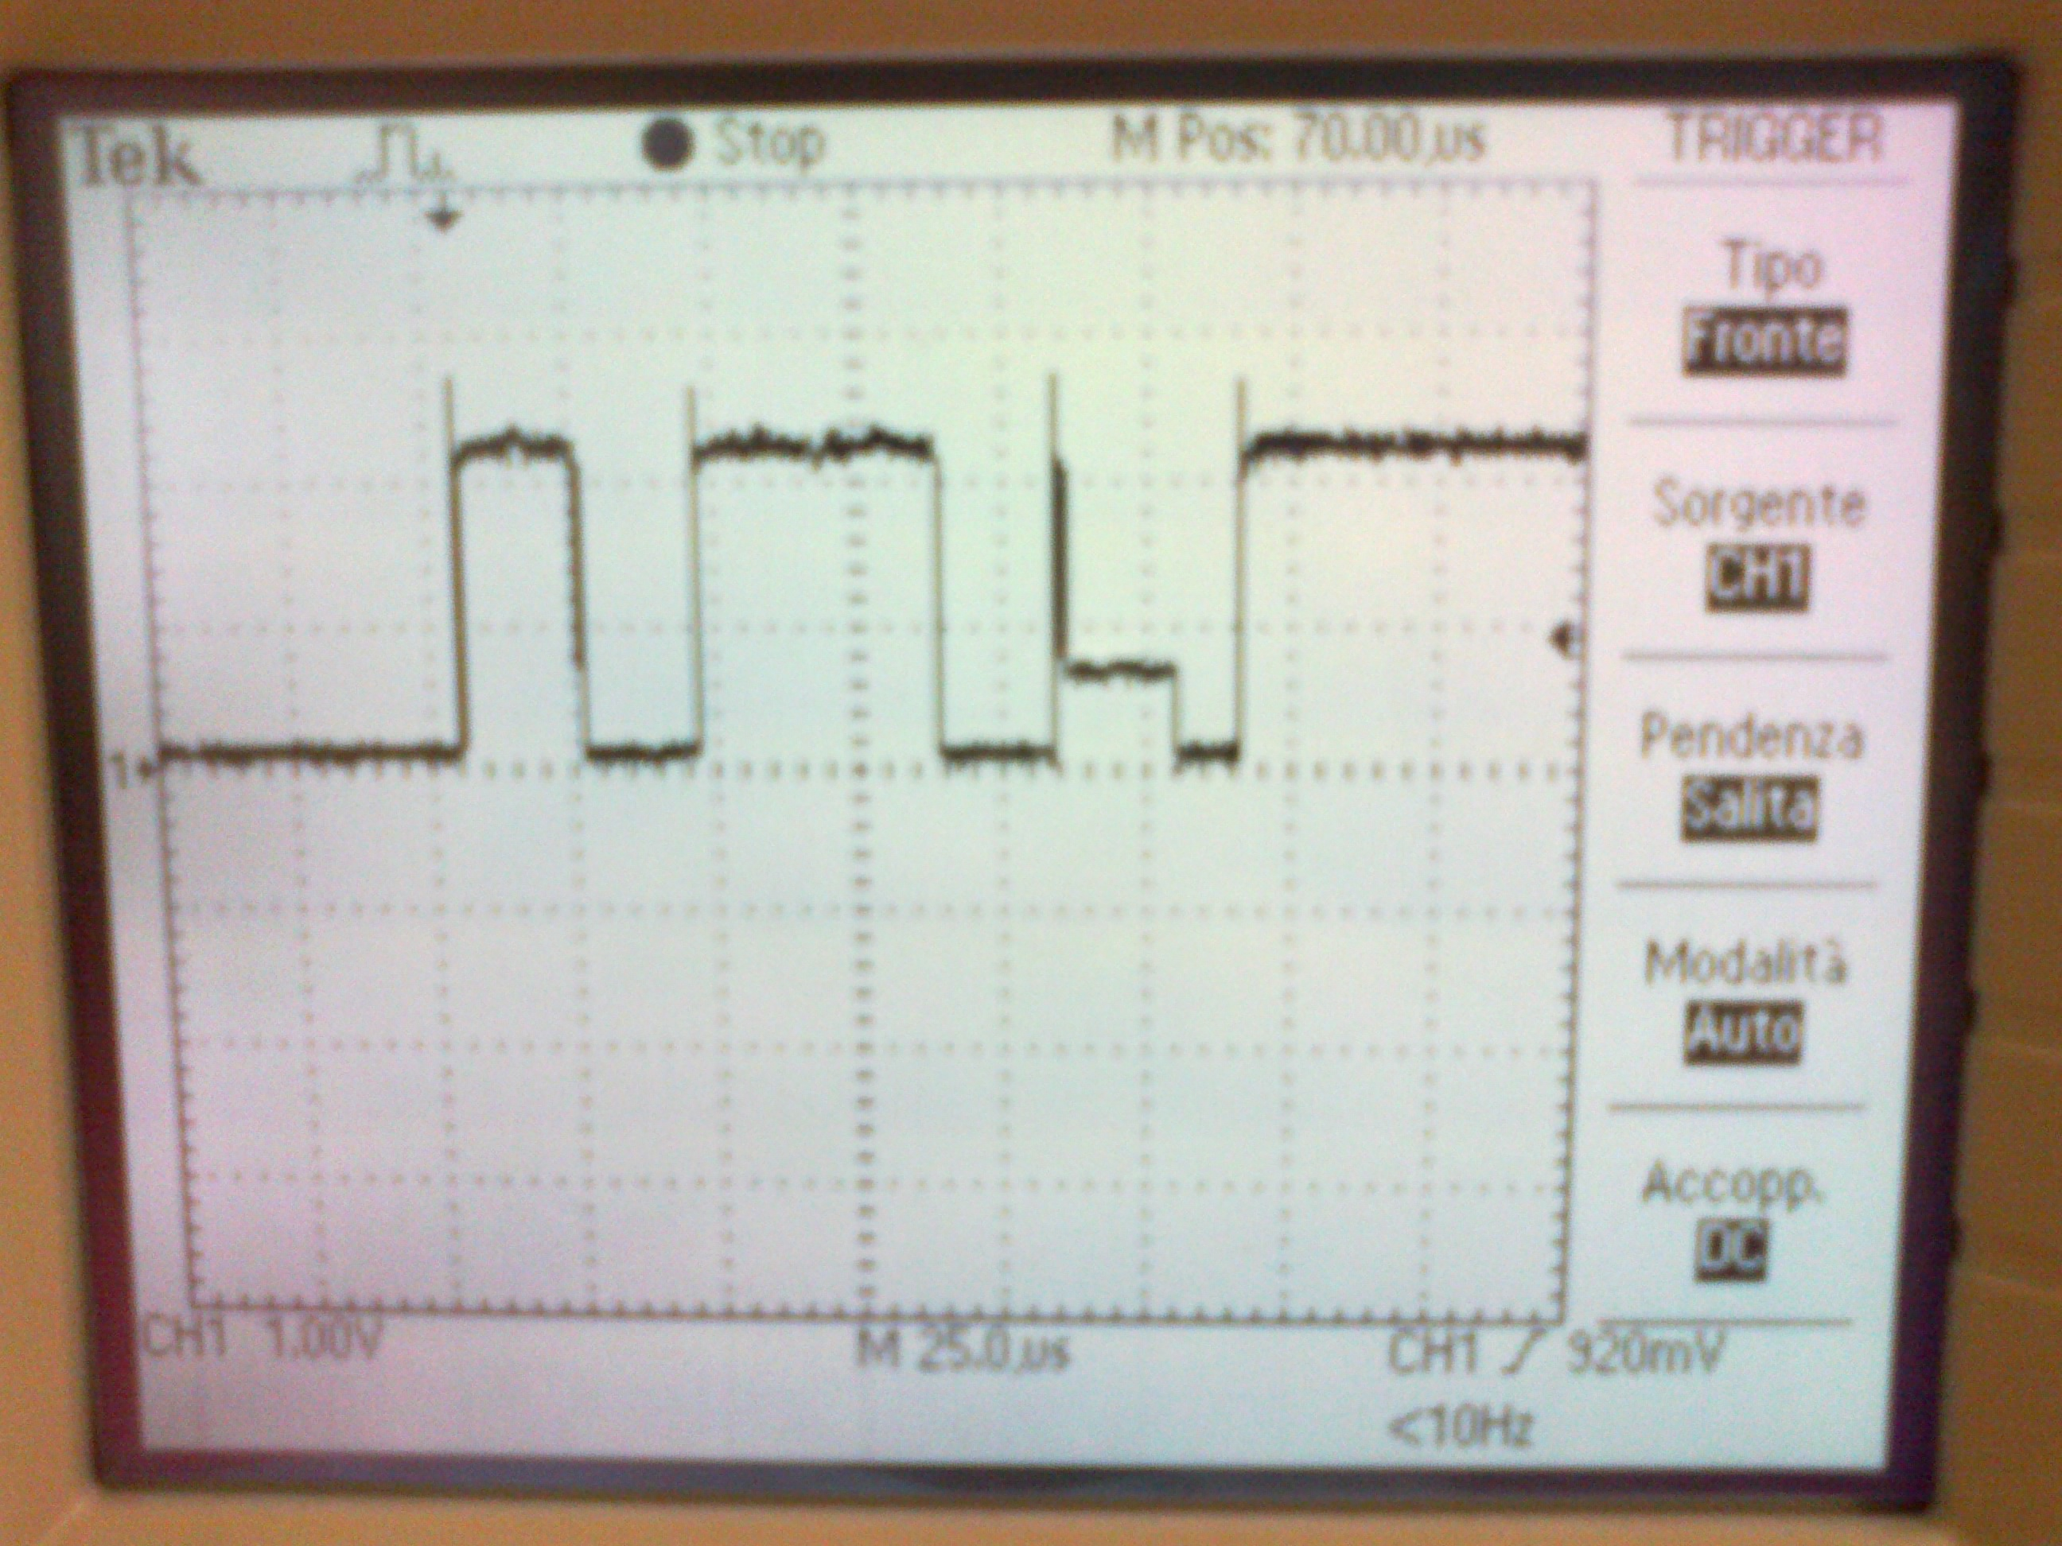

LOGIC SCHEMATIC OF THE CONNECTIONS:

VIO_OMAP = 1.8V

OMAP2430
22
22
4.7K
4.7K

MAX3378

1.8V

3.3V
PIN7:
GND
BATTERY WITH 3.3/2.5V SMBUS
SYSTEM
INTERFACE
BATTERY
12V
c
d
a
f

