Brian Fritz
I get the following error using the bqEasy tab on the bq20z65 Gas Gauge Evaluation System Software.
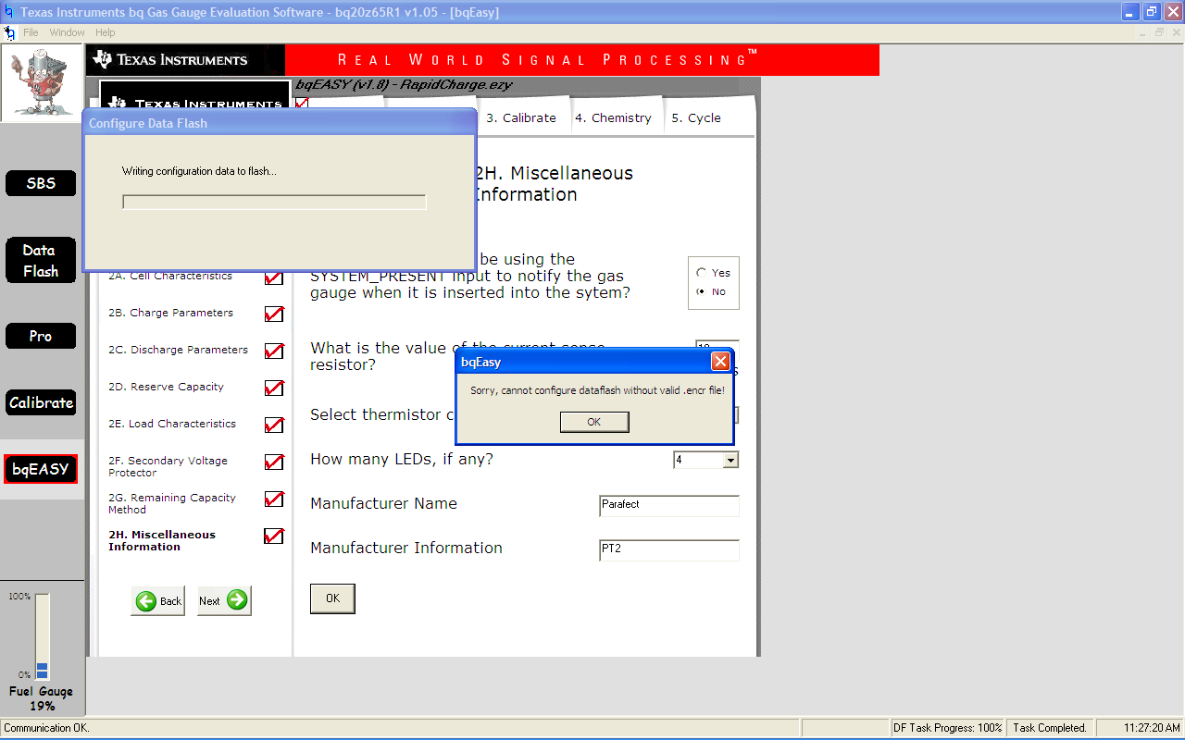
Scanning is turned off on the SBS screen,
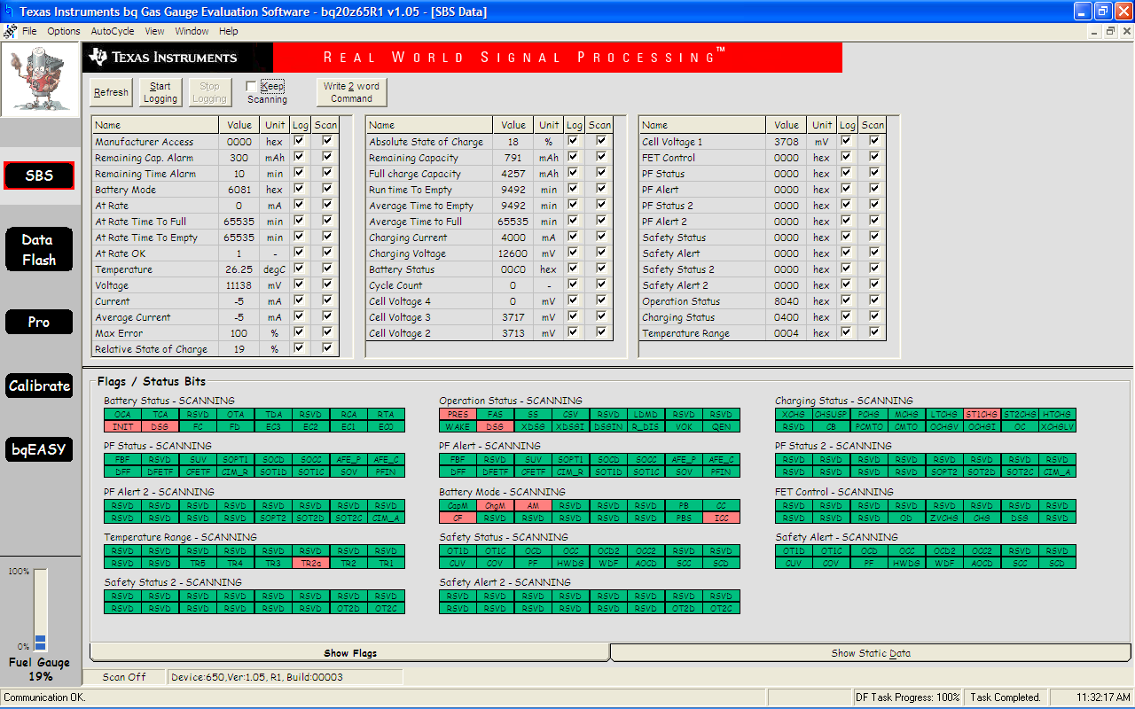

I believe the .encr file it refers to is in the correct place.
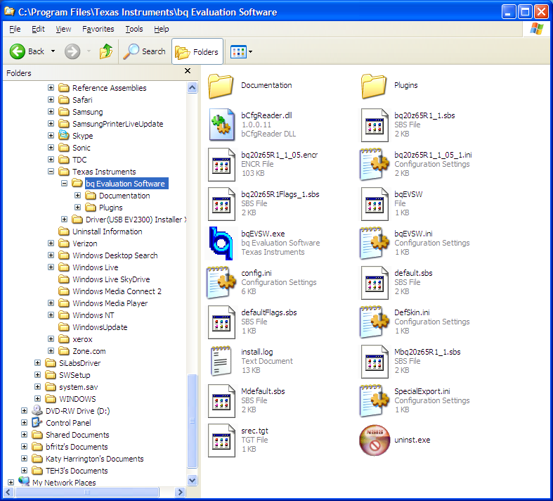
and I see no evidence of any PF flags being set.
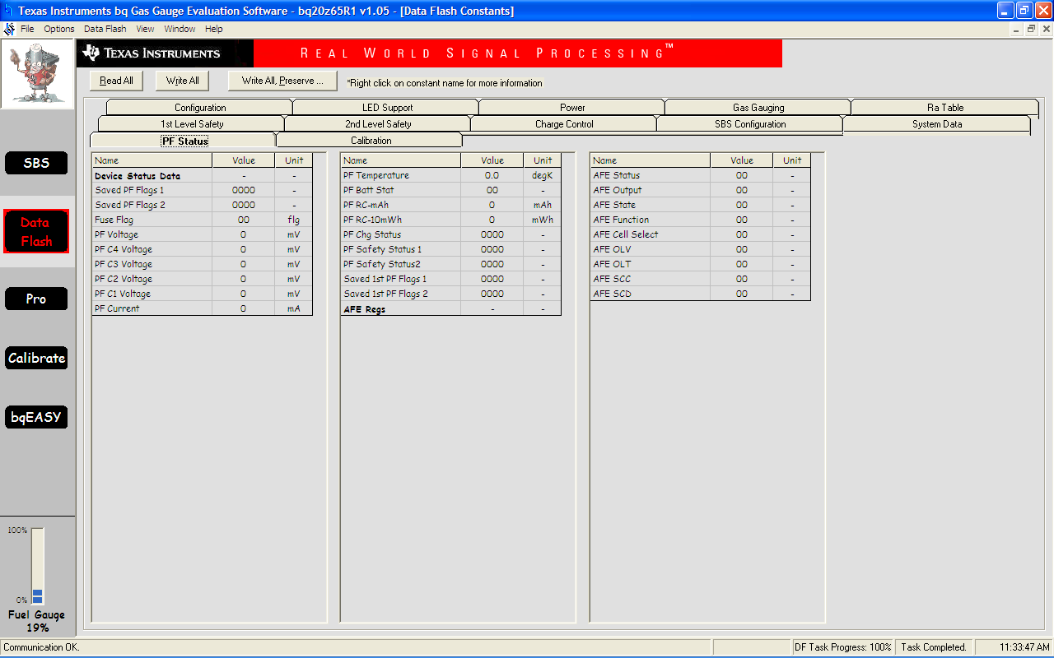
Also, when I try to use the <Help> <Contents> menu choice, nothing seems to happen, as if the help file is missing.
If I choose the <Help> <User Guide> menu item, I get the following error:
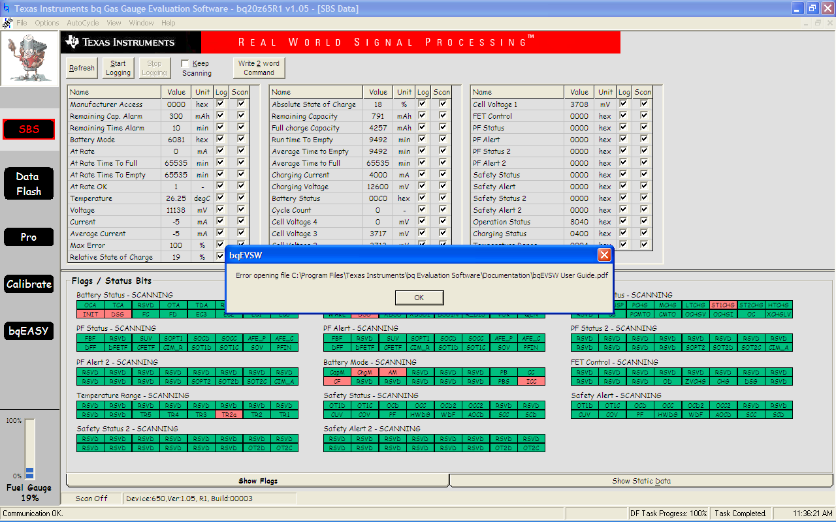
It looks like the install file isn’t installing all the files needed for the software.
Thanks, Brian

