Communication screen
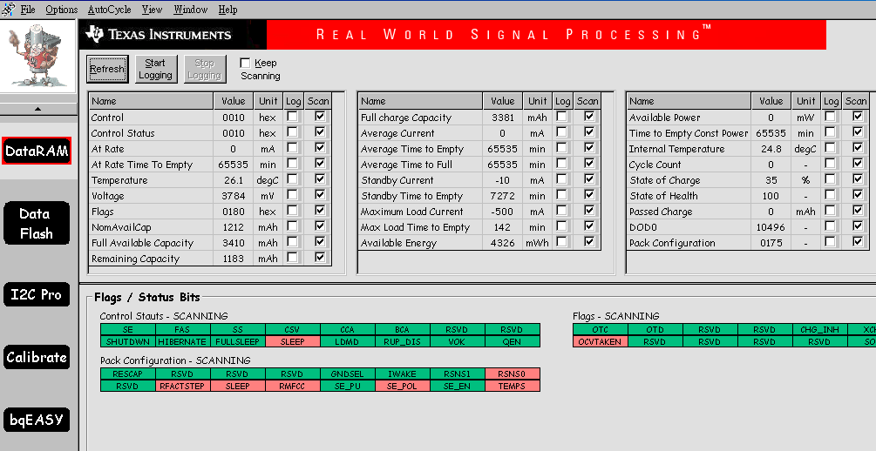
FlashData Map
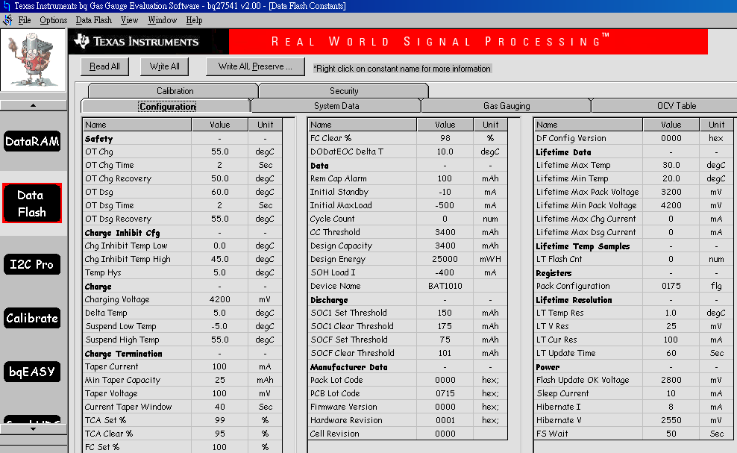

Attempt to changed data, But fail.
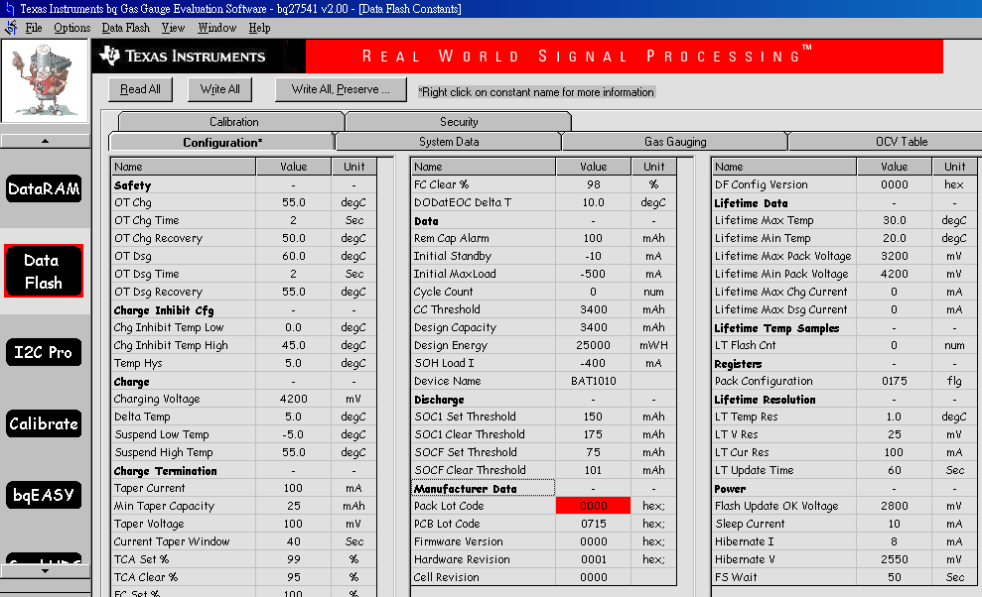
Input 1234 then click enter, but data no chaged

