Steady State Inductor Current with 4.7uH Inductor
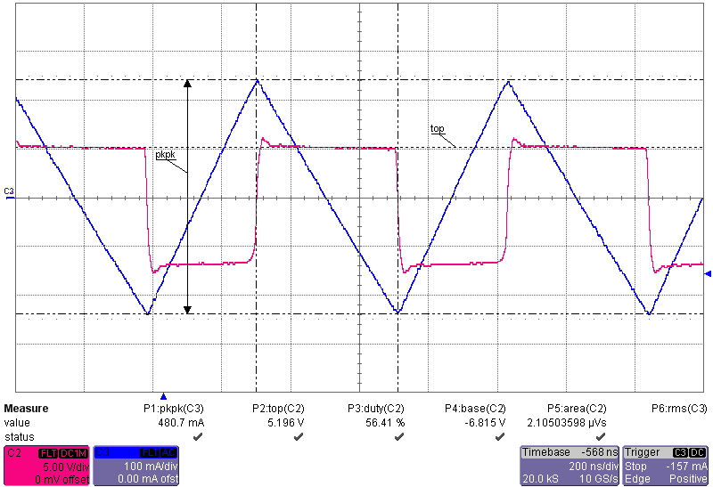

Steady State Inductor Current with 2.2uH Inductor

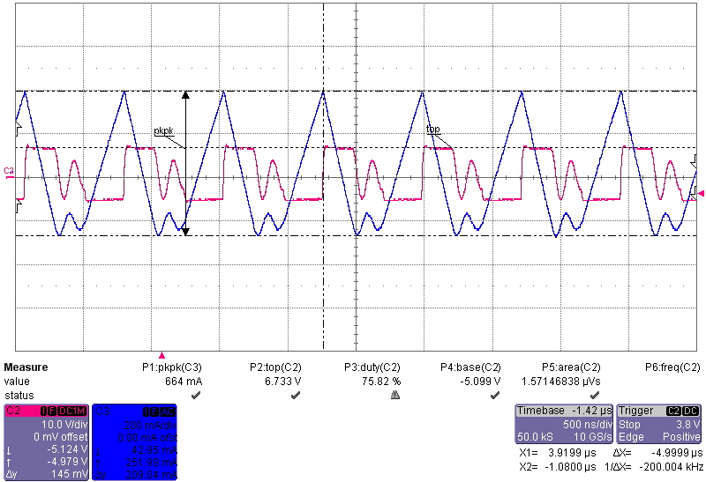

Start-up waveforms with 4.7uH inductor (page 1 of 2)

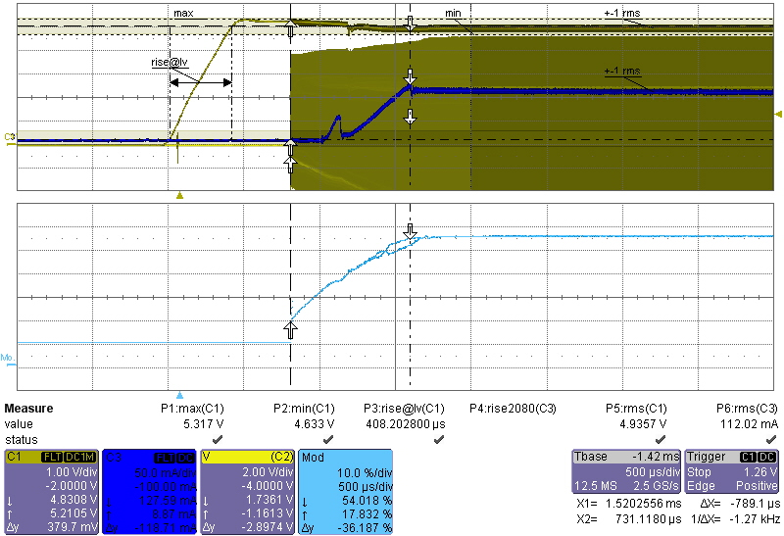

Start-up waveforms with 4.7uH inductor (page 2 of 2)
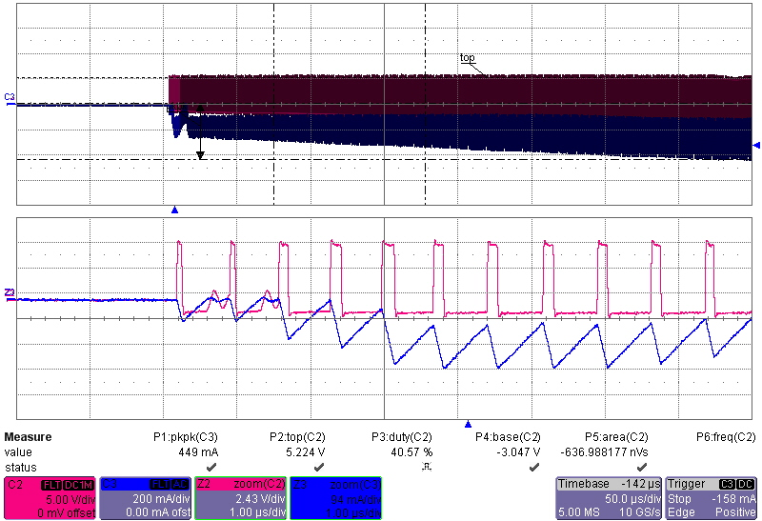

Start-up Waveforms with 2.2uH inductor (unstable)
