How to Power the TPS6507x On and Off

Thomas Schäffner/Clancy Soehren Battery Power Applications

Abstract

The TPS6507x is a single-chip power management solution for portable applications. The chip contains a battery charger, three step-down converters, two LDOs, a wLED boost converter, I2C interface, 10 bit A/D converter, and touch screen interface. Power path management allows for the USB, AC adaptor, or battery input to power the device. The TPS6507x features a flexible start-up and shut-down sequence depending on user settings and on the dominant power source. This application report explains the TPS6507x state machine, describes four different examples of turning the TPS6507x outputs on and off, and corrects some common misconceptions.

Contents

Introduction 2

Signal Definitions: 2

State Machine 3

Examples: 5

Case A: 5

Case B: 7

Case C: 9

Case D: 11

POWER_ON Pin Timing: 13

Summary: 14

Figures

Figure 1. Block Diagram of TPS6507x and Application Processor System 2

Figure 2. State Machine 4

Figure 3. Case A - Battery Powered (No AC or USB Input Voltage) 6

Figure 4. Case B - Battery Powered (No AC or USB Input Voltage) 8

Figure 5. Case C - AC or USB Powered 10

Figure 6. Case D – AC or USB Powered 12

Figure 7. POWER_ON Fails to Trigger “Powering OFF” State 13

Figure 8. POWER_ON Triggers “Powering OFF” State, PGOOD and SYS Signals Start to Ramp Down 14

Tables

Table 1. Case A Timing Diagram Description 5

Table 2. Case B Timing Diagram Description 7

Table 3. Case C Timing Diagram Description 9

Table 4. Case D Timing Diagram Description 11

Introduction

The TPS6507x is a single chip power solution that includes a single cell Li-Ion or Li-Polymer battery charger as well as a power path management system. The charger can be supplied by an AC adapter or USB power source. The device can also be powered by the battery if no power is available at the AC adapter or USB inputs. The method used to turn the device outputs on and off varies depending on which way the device is powered. Some methods require specific timing. In these cases, the TPS6507x is used in conjunction with an application processor. If a simpler system is desired, Case C in the examples shows an option of how to turn the device outputs on and off without using an application processor. The flexible nature of the turn-on scheme allows the designer to adapt the TPS6507x to various applications.

Figure 1 shows a block diagram of how the TPS6507x can be connected to the application processor. Itshows the important input and output signals used in the turn-on and turn-off processes.

on-off

1. Block Diagram of TPS6507x and Application Processor System

Signal Definitions:

The important TPS6507x signals for this application used throughout this document are as follows:

**/PB_IN**: This is a user input that can be implemented by using a push-button. This signal in conjunction with POWER_ON going high turns the device off and on.

**PB_OUT**: This is an output signal from the TPS6507x that should be sent to the application processor. This signal is a level shifted and debounced version of /PB_IN. It lags 50ms behind /PB_IN on the falling edge, and does not lag at all on the rising edge of /PB_IN.

**SYS**: This is the system voltage, the output of the power path manager.

**POWER_ON**: This is an input to the TPS6507x from the application processor. It also serves as an enable signal. Please note that this is different from the “Power ON 1” and “Power ON 2” states introduced later.

**Converter x**: The step-down converters start-up sequence is programmable via the CON_CTRL1 register. For most configurations, the three converters are separated into two groups. All converters within each group will start at the same time. The converter x signal shows how one of these groups starts-up.

**Converter y**: This signal shows how the second group starts-up.

**EN_DCDC1, EN_DCDC2, EN_DCDC3**: These are the enable signals for the 3 DC/DC converters. The enables are assumed to happen at the same time as the signals “converter x” and “converter y” in the figures below.

**PGOOD**: This signal becomes active when all of the enabled converters are within minimum regulation.

**AC**: This signal is the voltage level at the AC adapter input. The AC pin would be connected to a DC power supply. For the purposes of turning on the TPS6507x, the USB voltage input will cause exactly the same effect as the AC input.

*NOTE: The two LDOs are also included in the TPS6507x start-up sequence. Depending on how the register LDO_CTRL1 is set, they can ramp up at the same time as the step-down converters, after the step-down converters, or before the step-down converters. These LDO signals are not shown in the waveforms in this paper, but will behave the same as the converter x and y signals.*

State Machine

(Footnote: The state machine shown in Figure 2 is a slight modification of the state machine found on pg. 34 of the TPS6507x datasheet.)

The state machine shown in Figure 2 is helpful when attempting to visualize the start-up and shut-down procedures.

1. State Machine

The purpose of the “Stand-By” state is to allow for an option where the power consumption can be dropped as far as possible without completely turning the device off. To achieve this low power consumption, all of the step-down converters and SYS outputs are turned off. When in the “Stand-By” state, the TPS6507x can draw as little as 7 µA from the battery. When power is applied through the AC or USB inputs, it is not possible to stay in the “Stand-By” state.

The “Decision” state is a transition state. Once the TPS6507x enters this state it will immediately transition to either the “Wait for Power ON” or “Power ON 1” state, depending on if AC/USB or battery power is used.

The two “Power ON” states reflect the two options for keeping the TPS6507x on. “Power ON 1” is the state used if /PB_IN is being held low to keep the device on. Once POWER_ON is asserted high, the device transitions to the “Power ON 2” state, where the POWER_ON signal dictates when the TPS6507x transitions to the “Powering OFF” state.

Notice that the TPS6507x behaves differently depending on whether it is powered from the BAT, AC, or USB input. The state machine behaves the same if either the AC or USB input is used. If the BAT input is used, slightly different behavior occurs. The four examples, Cases A through D, will help to explain this state machine. Cases A and B show possible timing diagrams if the TPS6507x is powered only from the battery. Cases C and D show possible timing diagrams if the TPS6507x is powered from the AC or USB input.

Examples:

Case A:

Figure 3 shows Case A, where the device is powered only from the battery and the /PB_IN signal is used to turn the device on and off. A detailed description of Case A’s behavior is included after Figure 3.

A summary of the steps that occur in Case A are shown in Table 1.

1. Case A Timing Diagram Description

|  |  |
| --- | --- |
| Sequence of Events | State |
| 1. Systems starts with /PB_IN = HIGH and all outputs off | Stand-By |
| 1. /PB_IN = LOW | Decision |
| Power ON 1 |
| 1. SYS ramps up |
| 1. PB_OUT signal indicates to processor that PB_IN key has been pressed |
| 1. Converters ramp up |
| 1. PGOOD is turned on |
| 1. Processor sets POWER_ON = HIGH (keeps TPS6507x enabled) | Power ON 2 |
| 1. PB_IN is released HIGH |
| 1. PB_IN is set LOW again |
| 1. PB_OUT signal indicates to processor that PB_IN key has been pressed |
| 1. Processor sets POWER_ON = LOW | Powering OFF |
| 1. Converters ramp down with the inverse sequencing and PGOOD is turned off |
| 1. SYS voltage ramps down | Stand-By |
| 1. TPS6507x enters “Stand-By” state while /PB_IN is still held LOW |
| 1. /PB_IN is released HIGH |

t1

**Stand-By**

**Decision to Power ON 1**

**Power ON 2**

**Powering OFF**

**Stand-By**

1. Case A - Battery Powered (No AC or USB Input Voltage)

When in this configuration, the /PB_IN pin dictates when the start-up sequence begins. The /PB_IN signal can easily be controlled by the user by installing a push-button. The PB_OUT signal is an output of the TPS6507x and is a level shifted and debounced version of the /PB_IN signal. The debouncing causes a 50ms delay between /PB_IN and PB_OUT on the falling edge. As soon as /PB_IN is pulled low, the TPS6507x leaves the “Stand-By” state and enters the “Power ON 1” state, where the SYS voltage starts to ramp up. Once the SYS voltage is stabilized, the converters start to turn-on, depending on the configured start-up sequence. Once all of the converters are turned on, the PGOOD signal output will go high.

The PB_OUT signal is sent to the application processor, which will in turn send a POWER_ON signal back to the TPS6507x. The POWER_ON signal must be set to logic high before the /PB_IN button is released for the TPS6507x to stay on. The device transitions to the “Power ON 2” state once the POWER_ON signal is set to logic high. To turn the TPS6507x off, the user just has to push the /PB_IN push-button again. 50 ms later the PB_OUT signal will drop low, which will signal the application processor to set the POWER_ON signal to logic low. As soon as the POWER_ON signal drops, the device transitions to the “Powering OFF” state and the converters start ramping down. The sequence in which they turn off will be reversed from the sequence in which they turned on. The PGOOD signal will be pulled low as soon as the converters start to turn off. The SYS signal will be the last to turn off. As soon as all of the voltages have turned off, the TPS6507x will transition to the “Stand-By” state.

Case B:

Figure 4 shows Case B, where the device is powered only from the battery, but the scheme used to turn off the device is slightly different from Case A. A detailed description of Case B’s behavior is included after Figure 4.

A summary of the steps that occur in Figure 4 are shown in Table 2.

1. Case B Timing Diagram Description

|  |  |
| --- | --- |
| Sequence of Events | State |
| 1. System starts with /PB_IN = HIGH and all outputs off | Stand-By |
| 1. /PB_IN = LOW | Decision |
| Power ON 1 |
| 1. SYS ramps up |
| 1. PB_OUT signal indicates to processor that PB_IN key has been pressed |
| 1. Converters ramp up |
| 1. PGOOD is turned on |
| 1. Processor sets POWER_ON = HIGH | Power ON 2 |
| 1. Processor sets POWER_ON = LOW | Powering OFF |
| 1. Converters ramp down with the inverse sequencing and PGOOD is turned off |
| 1. SYS voltage ramps down | Stand-By |
| 1. POWER_ON is set HIGH again |
| 1. No change in state; TPS6507x stays disabled until PB_IN is released and pulled LOW again |
| 🡪The TPS6507x converters can only be enabled with the falling edge of /PB_IN when powered from the battery input. |

t2

**Stand-By**

**Decision to Power ON 1**

**Power ON 2**

**Powering OFF**

**Stand-By**

1. Case B - Battery Powered (No AC or USB Input Voltage)

This example shows that the device can only be enabled once each time the /PB_IN push-button is pressed. The turn-on sequence is exactly the same as in Case A except that the /PB_IN push-button is held down for the entire power cycle. Instead of using a second button press to turn off the device, the application processor turns off the POWER_ON signal. The falling edge of this signal transitions the device to the “Powering OFF” state, despite the fact that the /PB_IN push-button is still pressed.

Once the device has been powered off and is in the “Stand-By” state, only the falling edge of /PB_IN will cause the device to transition to the “Decision” state. While in the “Stand-By” state, turning the POWER_ON signal back on does nothing.

Case C:

Figure 5 shows Case C, where the AC or USB input is used to power the device and /PB_IN is not toggled at all and is allowed to remain high with its internal pull-up resistor. This start-up sequence does not make use of /PB_IN, so the converters are controlled only with POWER_ON. This means that the TPS6507x could be operated without a separate application processor. In the following set of waveforms, PB_OUT has a pull-up resistor connected to converter x; this is presented as an optional output to the application processor. A detailed description of Case C’s behavior is included after Figure 5.

A summary of the steps that occur in Figure 5 are shown in Table 3.

1. Case C Timing Diagram Description

|  |  |
| --- | --- |
| Sequence of Events | State |
| 1. System starts with everything off | Stand-By |
| 1. V(AC) = 5V | Decision |
| Wait For Power ON |
| 1. SYS ramps up; main state machine active |
| 1. POWER_ON = HIGH | Power ON 1 |
| Power ON 2 |
| 1. Converters ramp up |
| 1. PGOOD is turned on |
| 1. POWER_ON = LOW | Powering OFF |
| 1. Converters ramp down in inverse sequence and PGOOD is turned off |
| 1. System waits to transition to Power ON 1 | Decision |
| Wait for Power ON |
| 10. Steps 4 through 9 repeat |  |
| 🡪TPS6507x can be enabled / disabled by POWER_ON while /PB_IN is inactive HIGH |  |



**Stand-By**

**Decision to**

**Wait for Power ON**

**Power ON 1**

**to Power ON 2**

**Powering**

**OFF**

**Decision to**

**Wait for Power ON**

**Power ON 1**

**to Power ON 2**

**Powering**

**OFF**

**Decision to**

**Wait for Power ON**

1. Case C - AC or USB Powered

In this configuration, PB_OUT is connected to converter x through a pull-up resistor. Because of this, PB_OUT will follow the converter x voltage.

The first difference from Cases A and B that should be noted is that the /PB_IN input is not toggled at all, it is simply left high. Once 5 V is applied to the AC pin, the TPS6507x enters the “Decision” state and the SYS signal starts to ramp up. Next, the device transitions to the “Wait for Power ON” state.

POWER_ON is raised high at some point after SYS has turned on. Once POWER_ON has been raised to logic high, the device transitions to the “Power ON 1” state, where the converters start to turn on in a particular sequence. Once the converters have completely turned on, the PGOOD signal will turn on. Since the POWER_ON signal is logic high, the TPS6507x will immediately transition to the “Power ON 2” state. From there, the system will remain on until something changes. Pulling the POWER_ON pin low will cause the device to transition to the “Powering OFF” state, where the converters and PGOOD signals turn off. After everything is off, the device transitions to the “Decision” state, and then to the “Wait for Power ON” state. From here, the entire cycle repeats.

When the AC or USB input powers the TPS6507x and the /PB_IN input is left high, the step-down converters are controlled with the POWER_ON signal. Notice that the SYS output remains high the entire time, which is true whenever there is power applied at the AC or USB input.

Case D:

Figure 6 shows Case D, where the AC or USB input is used to power the device and the /PB_IN signal is used to turn the device on. A detailed description of Case D’s behavior is included after Figure 6.

A summary of the steps that occur in Figure 6 are shown in Table 4.

1. Case D Timing Diagram Description

|  |  |
| --- | --- |
| Sequence of Events | State |
| 1. System starts with everything off | Stand-By |
| 1. V(AC) = 5V | Decision |
| Wait for Power ON |
| 1. SYS ramps up |
| 1. /PB_IN = LOW | Power ON 1 |
| 1. Converters ramp up |
| 1. PGOOD is turned on |
| 1. POWER_ON = HIGH | Power ON 2 |
| 1. POWER_ON = LOW disables converters | Powering OFF |
| 1. Converters ramp down and PGOOD is turned off |
| Decision |
| Wait for Power ON |
| 1. POWER_ON is set HIGH again |
| 1. No change in state; TPS6507x stays disabled until PB_IN is released |

t4

**Power ON 1**

**To Power ON 2**

**Powering OFF**

**Power ON 1**

**Stand-By**

**Decision to**

**Wait for Power ON**

**Power ON 2**

**Decision to**

**Wait for Power ON**

1. Case D – AC or USB Powered

As in Case C, the TPS6507x is powered by the AC or USB pins. Likewise, the SYS signal starts to ramp-up as soon as the input power is applied. Now, instead of using the POWER_ON pin to turn on the converters, the /PB_IN button is used.

When the push-button is pressed, the /PB_IN signal goes low, signaling the device to enter the “Power ON 1” state. This signals the converters to start their turn-on sequence. Once all of the converters have turned on, the PGOOD signal turns on. At some point during this process, the POWER_ON signal is turned on by the application processor. As soon as the POWER_ON signal is activated, the TPS6507x transitions to the “Power ON 2” state. When the application processor switches the POWER_ON signal to logic low, the device enters the “Powering OFF” state, and the converters and the PGOOD signal start to ramp down. Once the output signals have turned off (except for the SYS output), the device enters the “Decision” state and then almost immediately enters the “Waiting for Power ON” state.

While in the “Waiting for Power ON” state, further toggling of the POWER_ON signal does nothing because /PB_In is continuously held low. When /PB_In is raised to logic high, the TPS6507x transitions to the “Power ON 1” state because the condition of having both /PB_IN and POWER_ON logic high is true. The device then transitions to the “Power ON 2” state since POWER_ON is already logic high.

POWER_ON Pin Timing:

Figures 7 and 8 illustrate that the POWER_ON pin must be held low for a minimum amount of time before the TPS6507x transitions to the “Powering OFF” state. Both of the following figures occur when the device is battery powered.

In Figure 7, the POWER_ON signal is toggled low, but not for long enough to trigger the transition from the “Power ON 2” state to the “Powering OFF” state.

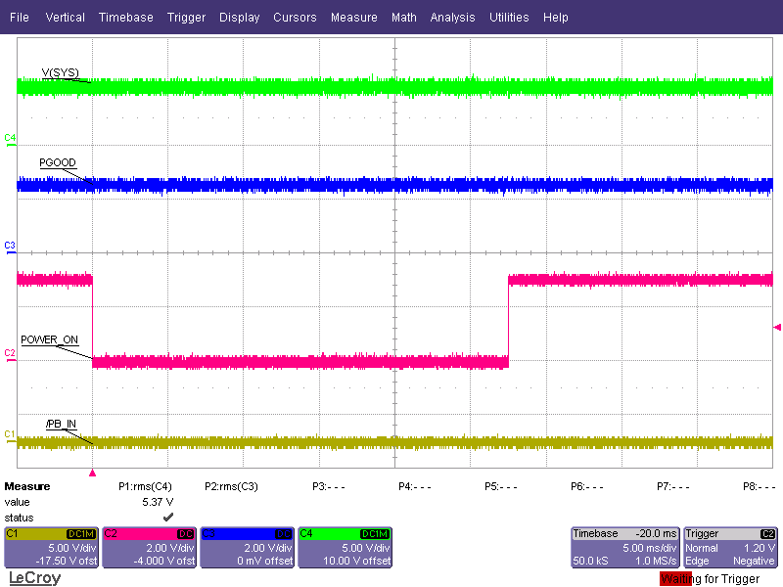

1. POWER_ON Fails to Trigger “Powering OFF” State

In Figure 8, the POWER_ON signal is held low for slightly longer; just long enough for the “Power ON 2” state to transition to the “Powering OFF” state. The PGOOD signal is pulled low as soon as the “Powering OFF” state is reached; however, it is only actively pulled low for a short period of time, after which the PGOOD signal is pulled up to the declining pull-up voltage.

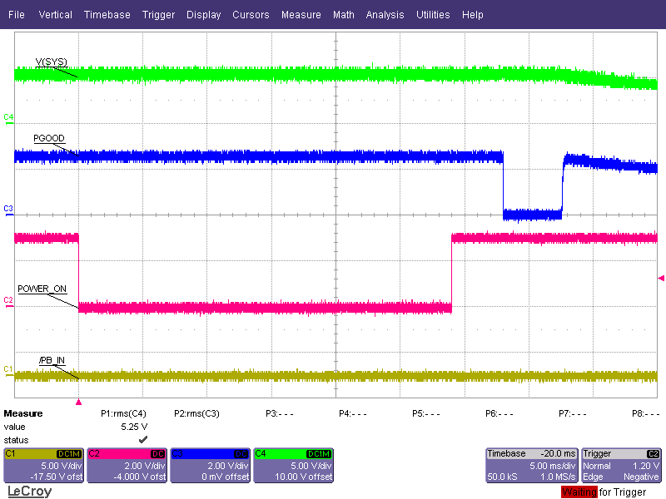

1. POWER_ON Triggers “Powering OFF” State, PGOOD and SYS Signals Start to Ramp Down

The behavior outlined here can be used to correctly turn on and off the TPS6507x. Page 69 of the TPS6507x datasheet outlines the different types of TPS6507x devices and the possible application processors that can be used with each. It also shows the default output voltages for each device as well as suggested timing settings.

Summary:

Most of the behavior described here can be inferred by examining the state machine and taking into account the delays associated with each signal. Slightly different behavior occurs depending on how the TPS6507x is powered. When powered from the battery, the device is capable of implementing a power saving state, the “Stand-By” state, where all of the outputs are turned off. When powered from the AC or USB input, this power saving state is unreachable, and the SYS output will always be on. If necessary, the TPS6507x can be configured to operate without an application processor, but only if the battery input is not used as a source of power. The TPS6507x is a versatile power solution that allows the engineer to configure the start-up and shut-down sequences to fit different applications.