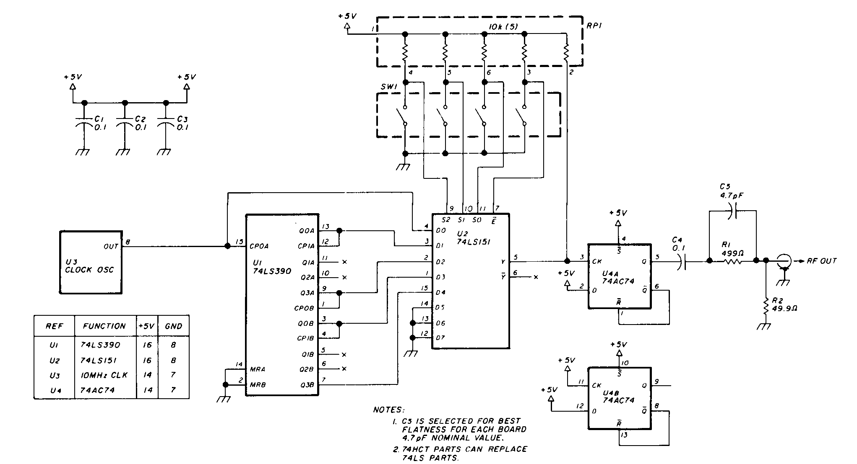
D flip flop having 16ns propagation delay which i have to replace with having 3 to 1ns. And the output of this replaced one have to drive a switching transistor. That transistor has to produce the same output as D flip flop produce.

