In the Agilent N4010A WLAN Virtual Front Panel program, I select the DSSS1-M88-1000.SEQ.

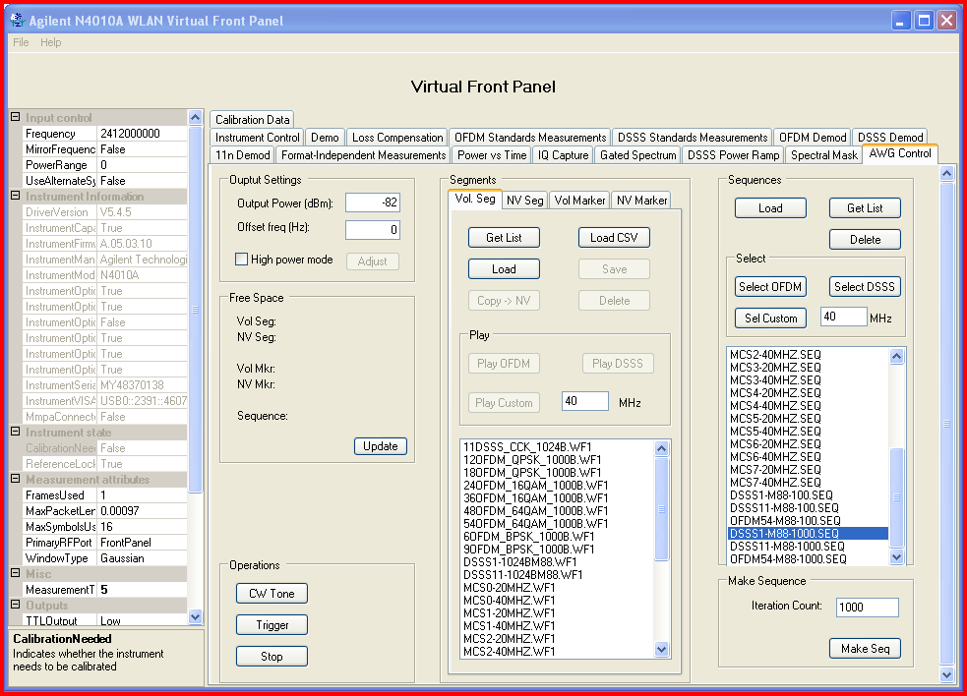

The wireless sniffer shows this:

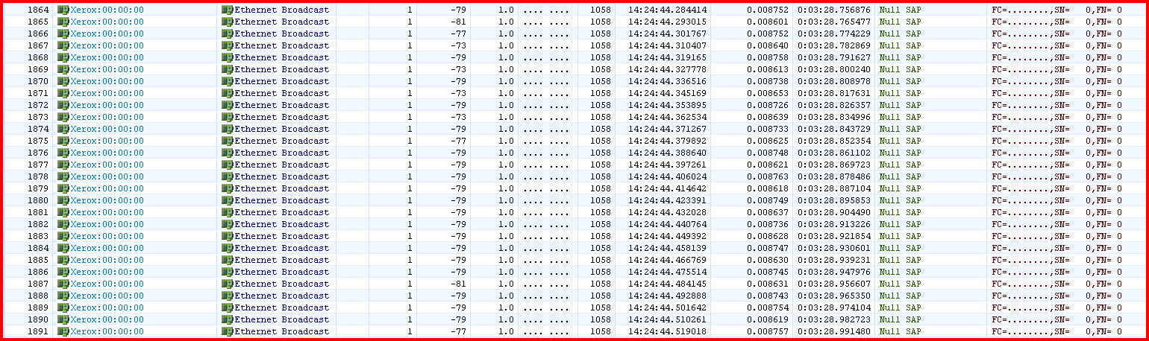

The radio shows this:

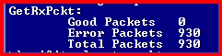

In the Agilent N4010A WLAN Virtual Front Panel program, I select the DSSS11-M88-1000.SEQ.

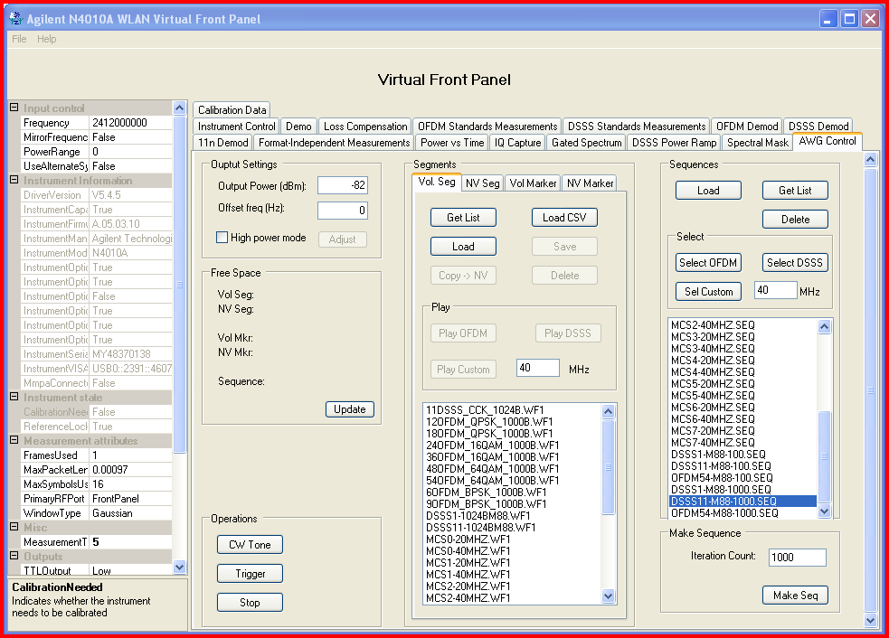

The wireless sniffer shows this:

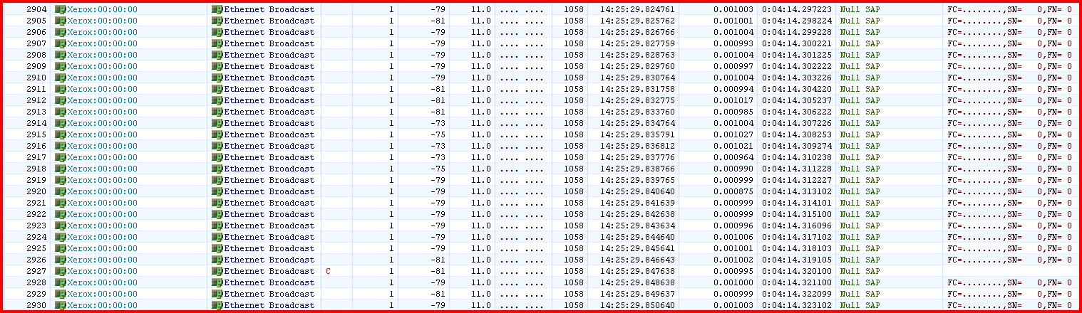

The radio shows this

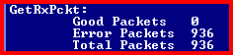

No difference between 1Mbps and 11Mbps?
In the Agilent N4010A WLAN Virtual Front Panel program, I select the 11DSSS_CCK_1014B.SEQ.

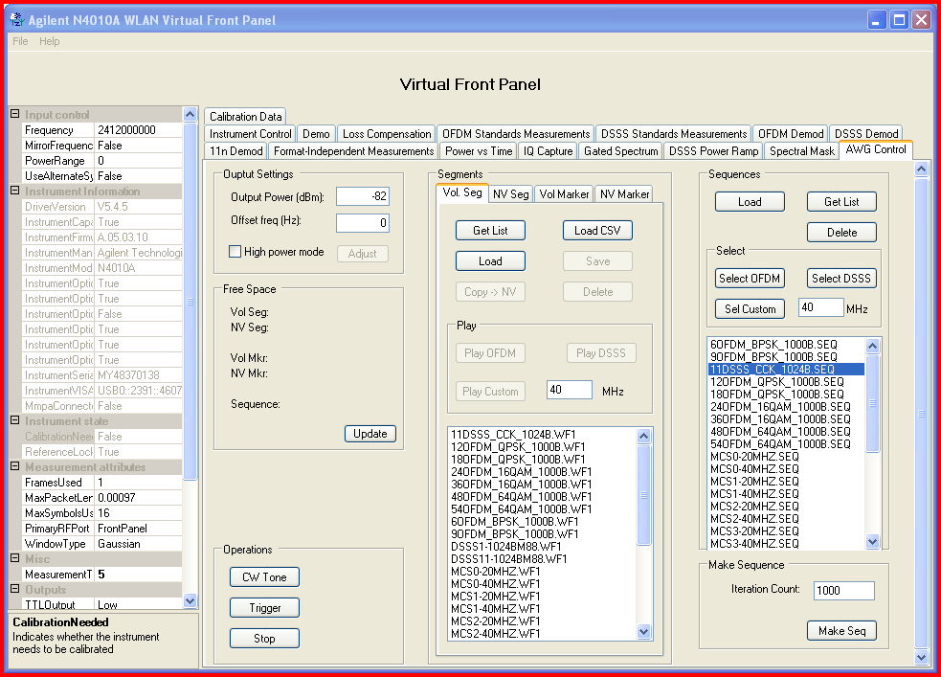

The wireless sniffer shows this:

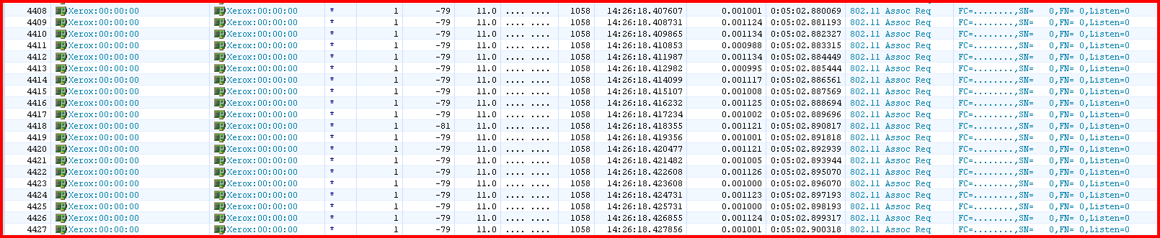

The radio shows this:

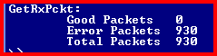

No difference in the result between preloaded 11Mbps N4010A sequence file and the Marvell sequence file

