You can see the device is listed at System Properties -> Device Manager.

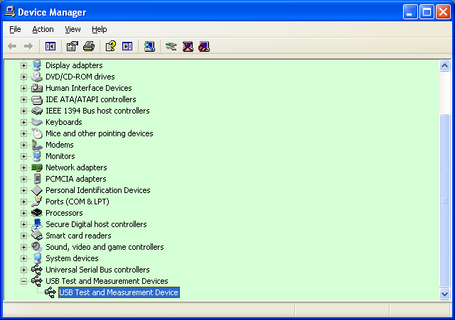

You can click on the device and look at the properties. In Full-Speed mode, we can see the product ID and serial number is on the properties list. In this case, product ID is U2021A and serial number is 1234567890.

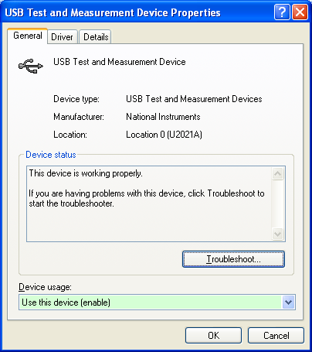 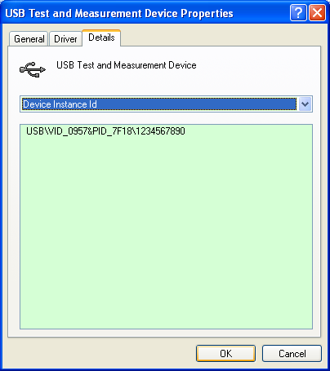

But, in High-Speed mode, we will not be able to see the product ID and serial number. It shows only USB Device for the product ID and a bogus serial number.

