# Programming EVM

Programming EVM (PROGEVM) SW tool failing to recognize the device placed on the board might be caused by the following: erroneous jumpers’ placement, not using the right PROGEVM SW tool or blank programming EVM.

## Check jumpers placement

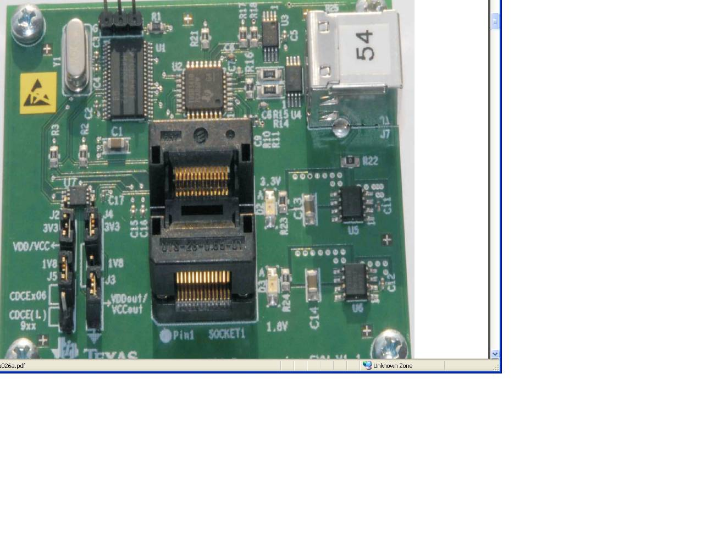

Figure 1. Programming EVM.

The following jumpers’ configuration should be on the board while trying to preprogram the CDCE913:

J1 leave open

J2 selects the voltage supply core, set to 1.8V (as CDCE913 is a 1.8V core supply device)

J3 can be set to 3.3V

J4 can be set to GND as there is no need for Vddout to be set to 3.3V in order for the device to be programmed correctly

J5 selects the device to be programmed, Just set the jumpers positioned as in the picture from

This information can be obtained on the users’ guide of the programming EVM:

<http://focus.ti.com/lit/ug/scau026a/scau026a.pdf>

## Downloads

PROG-EVM drivers from: <http://www.ti.com/litv/zip/scac131>

CDCE706 and CDCE906

PERF-EVM

CDCE706-906 TI clockProSW installer link <http://www.ti.com/lit/sw/scac073g/scac073g.zip>. GUI as per Figure 2 <http://www.ti.com/litv/zip/scac097a>

CDCE706-906 TI clockProSW executable link (if LabVIEW run time engine already available): GUI as per Figure 2 <http://www.ti.com/litv/zip/scac097a>

CDCE(L)913. CDCE(L)925, CDCE(L)937, CDCE(L)949

CDCE(L)9xx TI clockProSW link: <http://www.ti.com/litv/zip/scac119b> GUI as per Figure 3. This includes a tool for the programming EVM accessible from the mainMenu

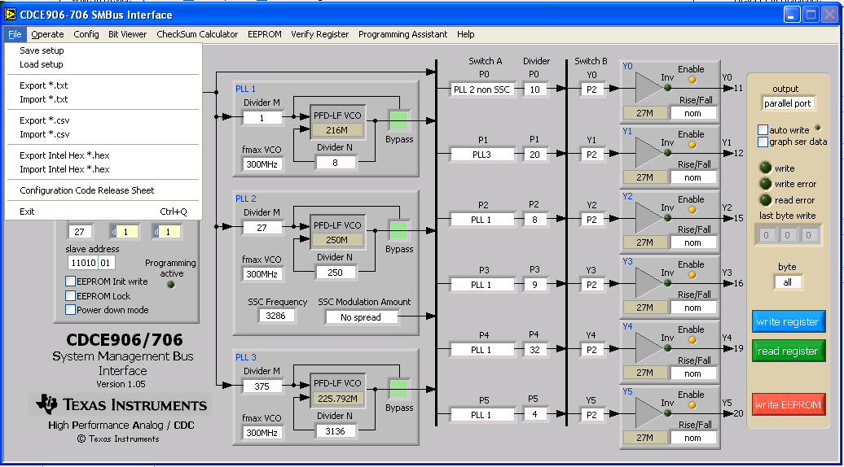

Figure . Generate the setup on the main window of the TI Clock Pro 2.5 for the CDCE906 and CDCE706 products. Many file types are supported (.ini, .csv, .txt, .hex, code release sheet). Link to this software:

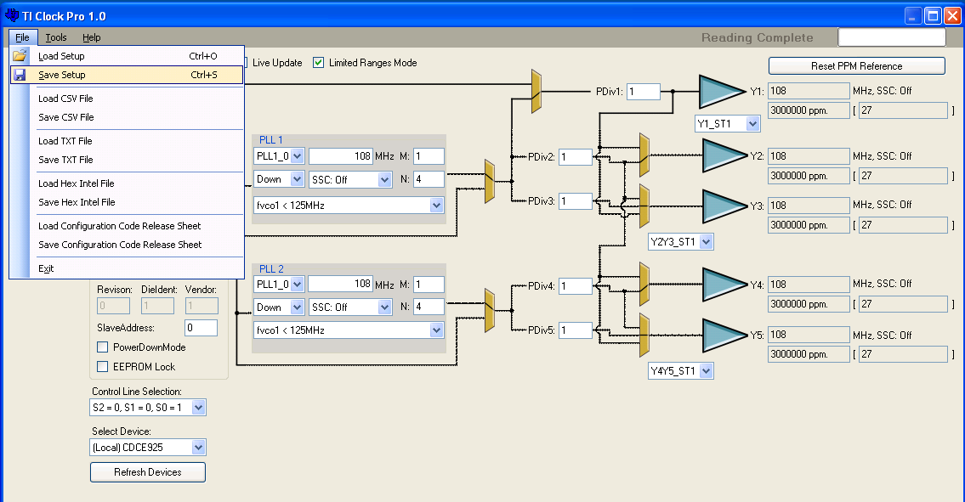

Figure . Generate the setup on the main window of the TI Clock Pro 1.0 for the CDCE(L)9xx products. Many file types are supported (.ini, .csv, .txt, .hex, code release sheet)

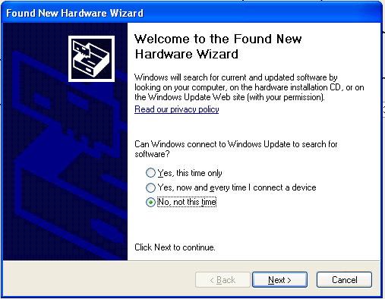

Figure . Dialog box after plugging the Programming EVM to the USB port. Select option: ”No, not this time” and click Next button

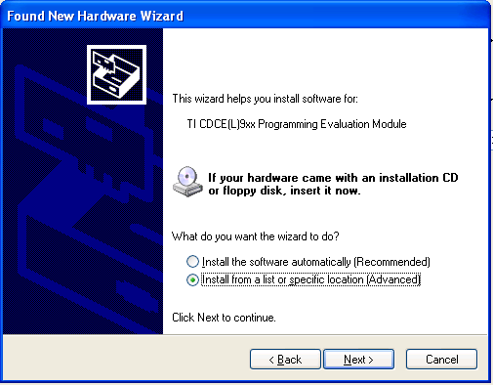

Figure . Pop up after dialog box from Figure 4. Select option: ”Install from a list or specific location (Advanced)”, then click Next button

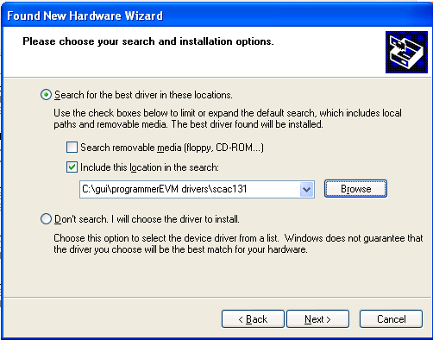

Figure . Pop up after the dialog box of Figure 5. Browse the directory where the PROG-EVM drivers were saved, then click Next button

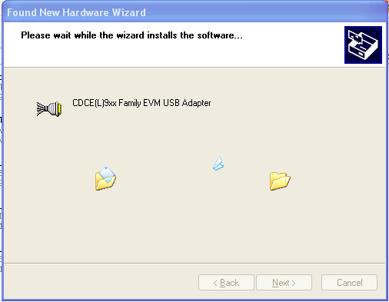

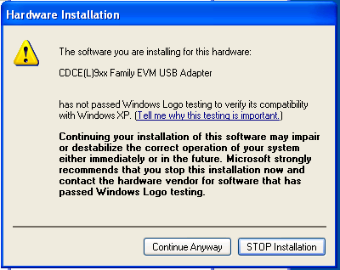

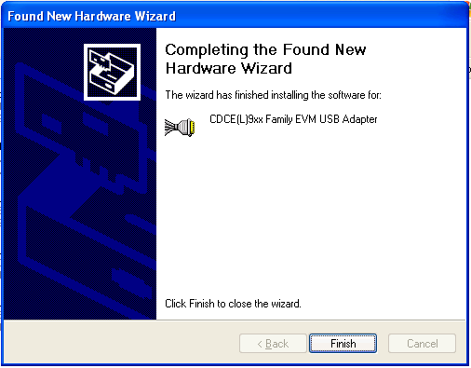

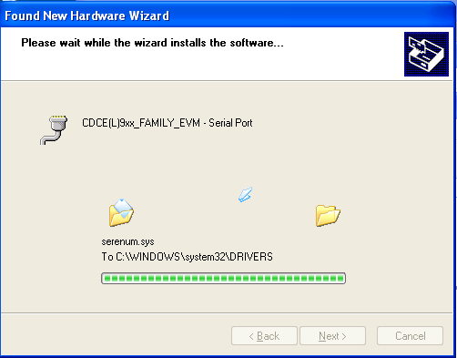

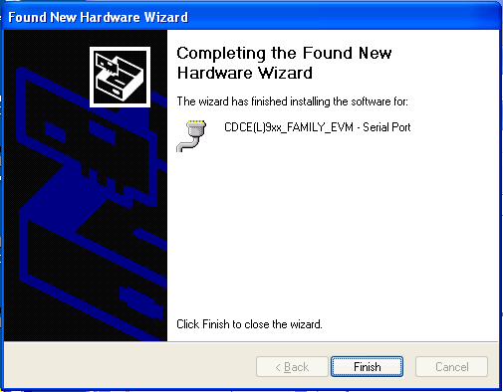

In order to start using the Programmer EVM software tool. Go to the main menu Tools option and select Programming EVM as per Figure 7

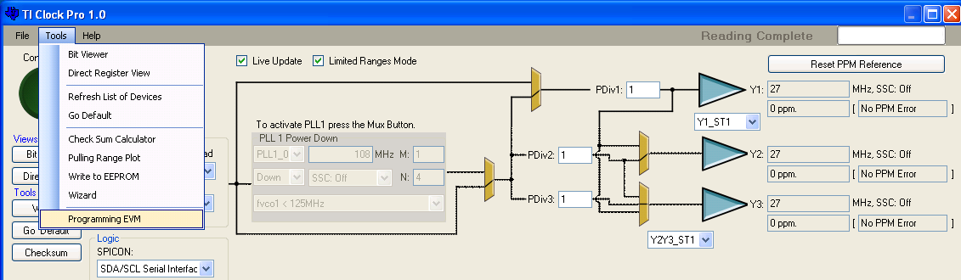

Figure . TIClock Pro includes the Programming EVM tool for the CDCE(L)9XX

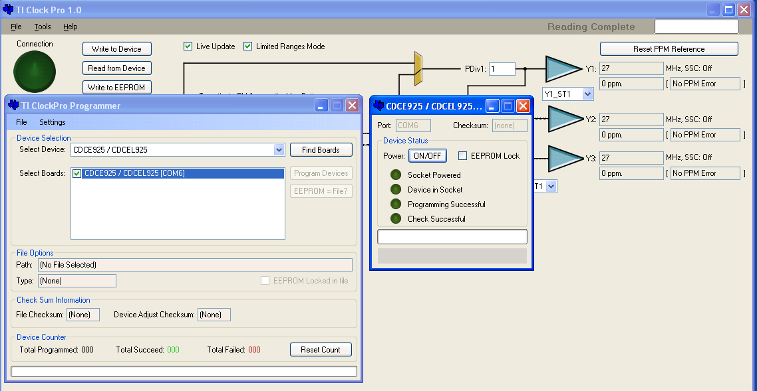

Figure . Select the device to pre-program, then after the board has been detected press FindBoards button. Under select Boards, when detected it will appear the PROG-EVM plugged. And a dialog box as the one of the right of the TI ClockPro Programmer main window will appear, showing the progress on of the programming, allowing individual control of the board.

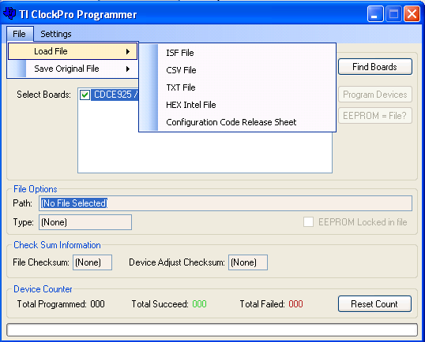

Figure . Once the programming EVM board is detected, on the main menu File, The sub menu Load File, allows you to select the file in all the clockPro available formats.

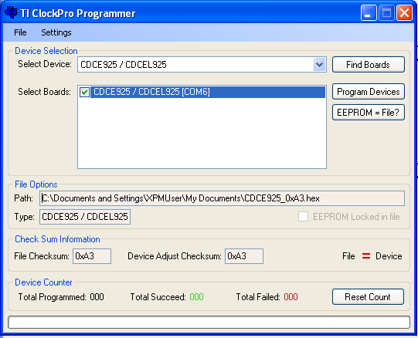

Figure . After selecting the file, in the File Options cluster it will show the path of the file to be programmed in the socket’s device.

