Problem with loading my code into TMDXEVM6670L 7/15/2011
I tried to load the receiver C code into the TMDXEVM6670L dsp board. The code compiled in Code Composer Studio without errors. The CCS version is:
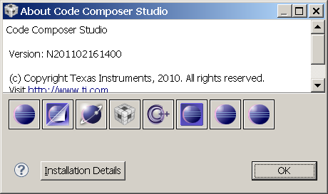
Then I tried to load the program into the dsp, but got errors. I thought perhaps the program was too large for the memory allocation, since I used only the default system settings that came with CCSv5. Therefore, I took a step back and tried to do a simple single line “hello world” project, which again compiled ok, but when I tried loading, got the same error message (see end of file) as the receiver code. Below, I made some screen captures of the steps I did to load the simple “hello world” project. The error message at the end of this file is the same for the “hello world” project and the receiver project. In the messages at the end of this file, just before the red text, the black text says the program falls onto a not writable part of memory. Where do I set where the program is loaded into? I don’t have a document or tutorial that explains this. I am using the defaults that were in some demo projects. I’ve been following the “BIOS MCSDK 2.0 Getting Started Guide” and the “BIOS MCSDK 2.0 User Guide”. Is there a better document or tutorial?
Create empty project:
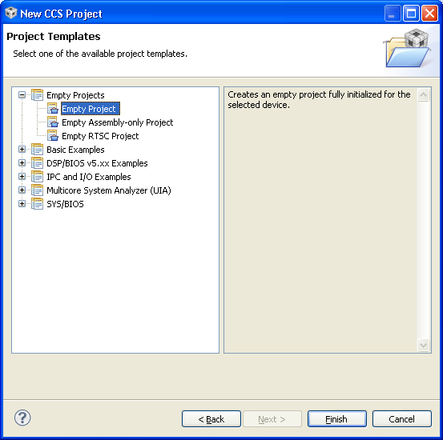
Single file, one printf
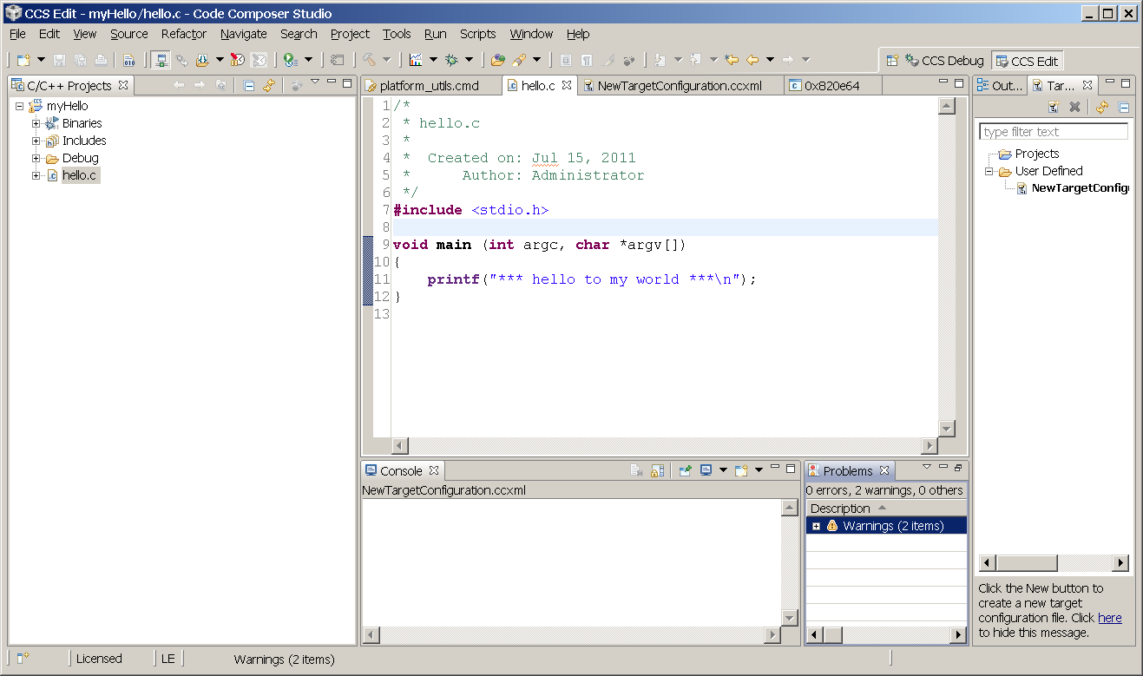

Target configuration:
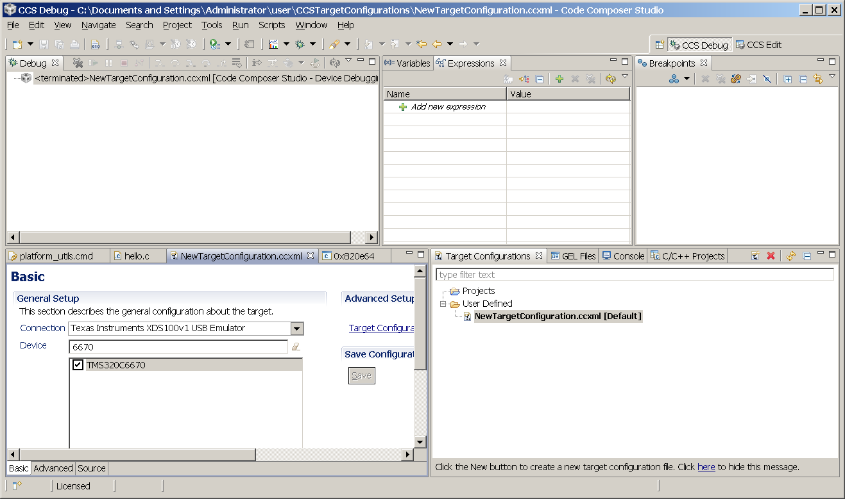
Launch target and connect core 0:
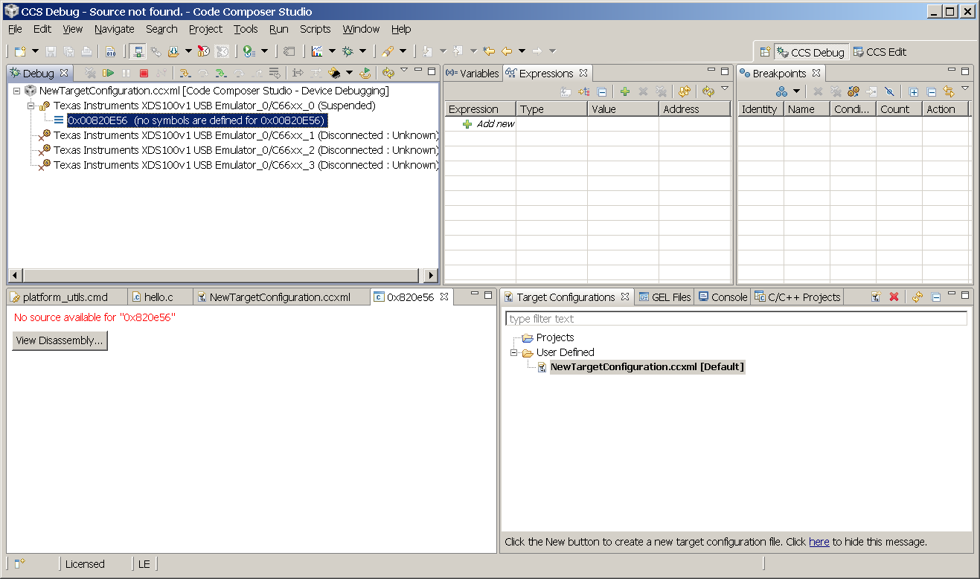
Load gel file from C:\Program Files\Texas Instruments\ccsv5\ccs_base_5.0.2.00006\emulation\boards\evmc6670l\gel\evmc6670l.gel
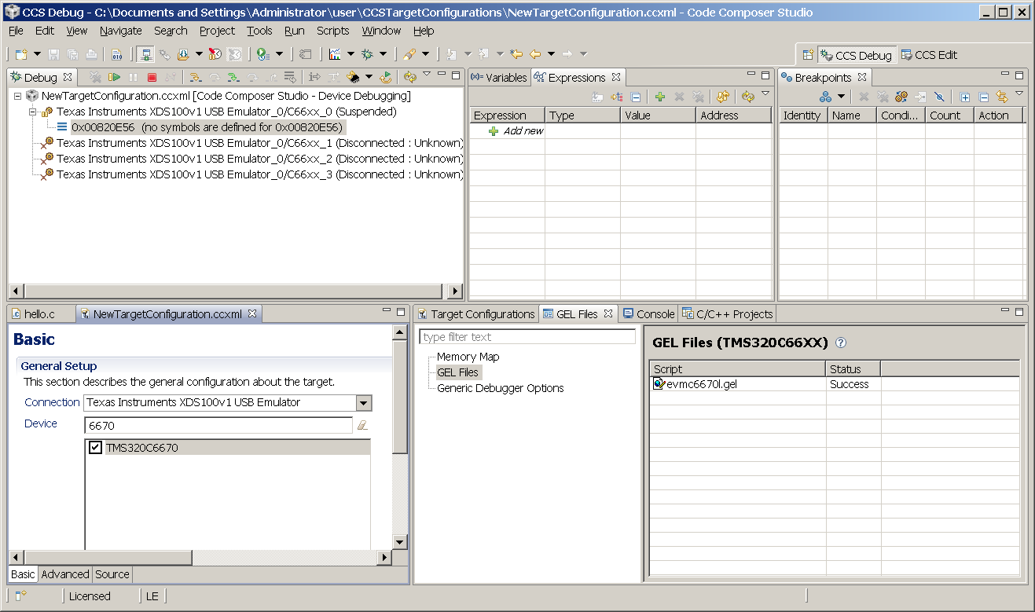
Scripts->default->Global_Default_Setup:
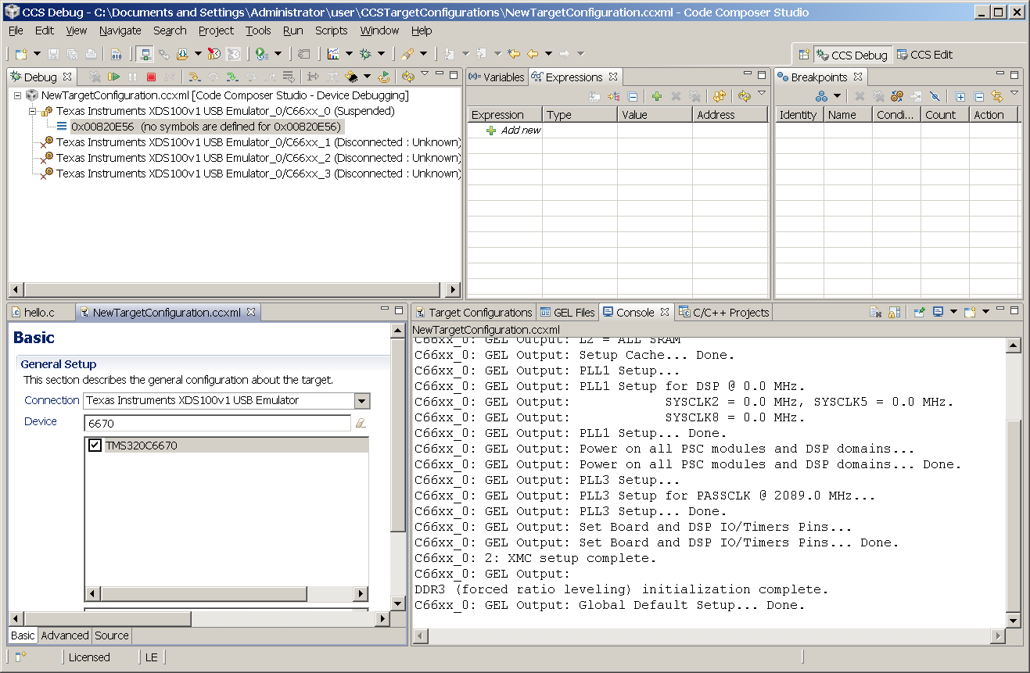
Run->Load->Load program (myHello.out):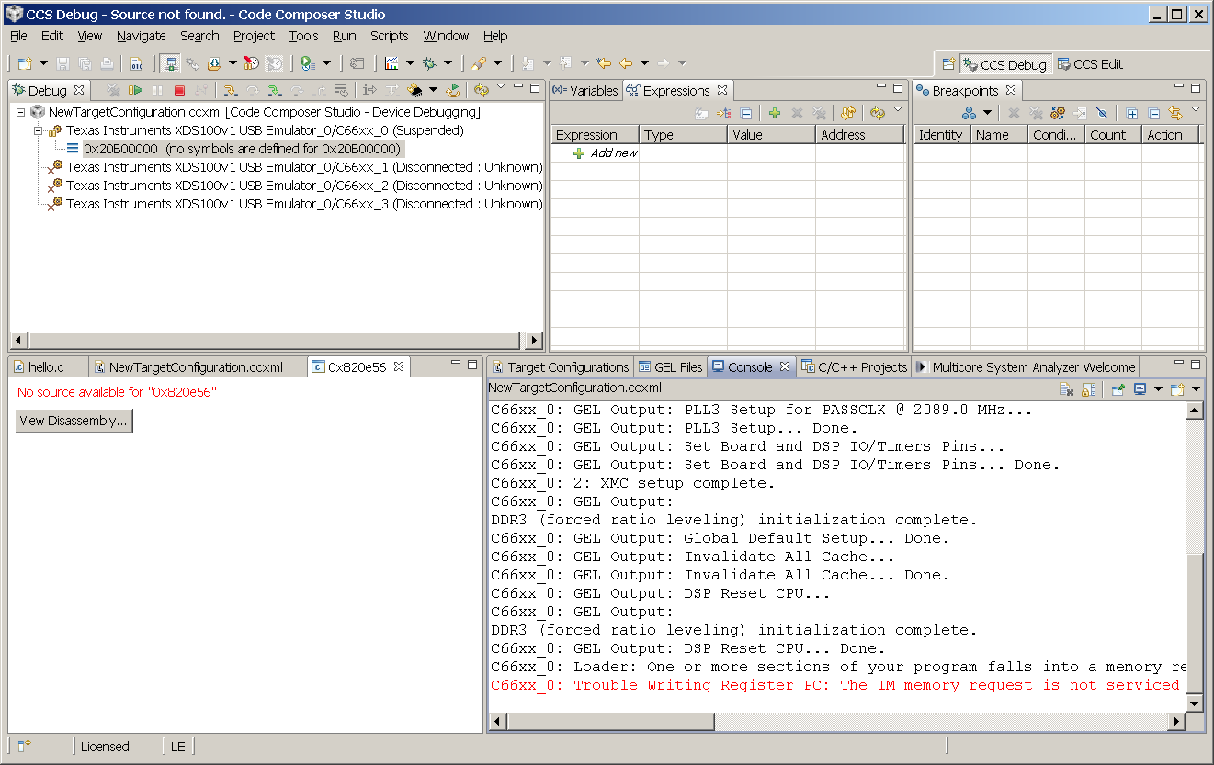
Console messages:
C66xx_0: GEL Output: Setup_Memory_Map...
C66xx_0: GEL Output: Setup_Memory_Map... Done.
C66xx_0: GEL Output: Global Default Setup...
C66xx_0: GEL Output: Setup Cache...
C66xx_0: GEL Output: L1P = 0K
C66xx_0: GEL Output: L1D = 0K
C66xx_0: GEL Output: L2 = ALL SRAM
C66xx_0: GEL Output: Setup Cache... Done.
C66xx_0: GEL Output: PLL1 Setup...
C66xx_0: GEL Output: PLL1 Setup for DSP @ 0.0 MHz.
C66xx_0: GEL Output: SYSCLK2 = 0.0 MHz, SYSCLK5 = 0.0 MHz.
C66xx_0: GEL Output: SYSCLK8 = 0.0 MHz.
C66xx_0: GEL Output: PLL1 Setup... Done.
C66xx_0: GEL Output: Power on all PSC modules and DSP domains...
C66xx_0: GEL Output: Power on all PSC modules and DSP domains... Done.
C66xx_0: GEL Output: PLL3 Setup...
C66xx_0: GEL Output: PLL3 Setup for PASSCLK @ 2089.0 MHz...
C66xx_0: GEL Output: PLL3 Setup... Done.
C66xx_0: GEL Output: Set Board and DSP IO/Timers Pins...
C66xx_0: GEL Output: Set Board and DSP IO/Timers Pins... Done.
C66xx_0: 2: XMC setup complete.
C66xx_0: GEL Output:
DDR3 (forced ratio leveling) initialization complete.
C66xx_0: GEL Output: Global Default Setup... Done.
C66xx_0: GEL Output: Invalidate All Cache...
C66xx_0: GEL Output: Invalidate All Cache... Done.
C66xx_0: GEL Output: DSP Reset CPU...
C66xx_0: GEL Output:
DDR3 (forced ratio leveling) initialization complete.
C66xx_0: GEL Output: DSP Reset CPU... Done.
C66xx_0: Loader: One or more sections of your program falls into a memory region that is not writable. These regions will not actually be written to the target. Check your linker configuration and/or memory map.
C66xx_0: Trouble Writing Register PC: The IM memory request is not serviced by the HW memory system. This could be caused by the memory address specified does not exist in the specified memory/cache level. (Error -1176) @ 55424 (0xD880)

