TI816x VIDEO CONFERENCING DEMO USER GUIDE
Document Revision: 2.0
Issue Date: December 7 2011

:,;;:;:;;;;;;;;r;;:,;;:;:;;;;;;;;:,;;:;:;;;;;;;;:,;;:;:;;;;;;;;:;;;;;;;;:,;;:;:
;,;:::;;;;r;;;rssiSiS552X5252525259GX2X9hX9X9XX2325S55252i5:,;;:;:;;;;;;;;:,;;:
;:;;;;;;;rrssSsS52S22h52299GGAAMHMM#BBH#B#HMM#HMBA&&XX2255S2S5Si:,;;:;:;;;;;;;;
;:;;r;;rsrrriiXS5S329&A&MH#BMB#A&9XXA252GXiSXX39AAMMMBB&G22S5i2SSiiiisi:,;;:;:;
;;;;;r;rr2iisiih393HB#B#AA99i22irrrX3X52AGsisss2Xii2299HBMA&X2S5S5iSiisSsi:,;;:
r:r;rrsrsihXSi2&##MHB&Ahh3AGHGA9G9h&#H##@@@##MAMMXXX9SSS29&&HGGX2i5iisiiisisi:,
;;rrrrsSiiiA&ABH&A9GAGhAhBAMHA9HM@@@@@@@@@@@@@@@@@@@HHhAh2S2SX9&Gh22SSiisiiisii
r:rrssisiS2XM##&h3AGAX&3GG3Ssr5H@M#HM2; ;2X&&&MHMB###GBB#B&XXSSs529XX55iSsisisi
r;rsrisSi2XHAhX99A3XXG&&XS;:,rH#HGhAS @@@@3rs2XBM@@A552&&AHA2XiisSS252SSsisSs
r;issi5S22&&3iSSX292&hXsr;;:;h@&G339&S9@@@@2@MA&9&HB##Xris29ABMAAX2ir;rsSi5iss5
rrsSi2XhG&9GXh399&X99i;;;;;;r#H&293H9X#@@@@@@@B&9GhAH@XrrsrsiXABHB&HG2rr;rrSiSi
;:rsisS599&AA9XG&3A35r;:::;,;BMh&&2iX5A@@@@@@@&392X5GB2;;;r;iSX393A##A&Xi:::rsi
;:rss552222X553&XHMhir;;::,:,h#HhGSXhG3#@@@@#AXXS2XAHA;::;;;;ss55XShBA3239r:,;;
r;ii2S5SSi2i53hirsh2srr::,,,,;MMXX359&Ah3h&Si59SX99A#i:,::::;;sri2,.2r;:SGAr;,:
;:;rrrrssiriXGSi::shs;;;,,,:,,rBBA9h5s5h5iS5isi2SAHB5:,,,:::;rrs5&SrisSX5Srrr:,
;,r;;;;rsriSSrrrr;;5Xrr;;,:,,.,;9AA2SsisS5323XXXG9&i:.,,::;;r;;;srrrrrr;;:;::::
:,;r;r;rrissrrr;:;::;s;;;;,:,,..,r293h222hXXAAGGGX;:,,,:,:,::;:;::,:,,,,...,,,,
;,;;;;rrrrrrrrirr;,.,,:::::::,,,,.,;SX&ABAB2hhXir:,,.,,.,,:,,,,..,,,..,..,,,..:
:.:;:;;;:;;;;r;rrs;:.. ,,:::::,:,:,,.::rrsrr;;,,.......,..,....,,,,,,,...,.,,:,
:.:::,::::::;;r;rrr;:.......,.,.,,:::,,...............,,::.,,,,:,::,,:,:,,,:,;:
,.::,:,,,,,;;;;;;;;r;;::,..............................;;;:;::::,:::::::,:,:,,,
: ,,:,,,,,,,,,,,,,:;rrr;;:;,,,,,,,::,.,.:.,.,;s,:;;;;:;:;;;;;::::,:::,:::,:,:,:
,.,,,,,,,...,,.,,....................................:,............:,,,:,:,,,,,

“Texas Instruments™” and “TI™” are trademarks of Texas Instruments
The TI logo is a trademark of Texas Instruments
OMAP™ is a trademark of Texas Instruments
Code Composer Studio™ is a Trademark of Texas Instruments
DSP/BIOS™ is a Trademark of Texas Instruments
eXpressDSP™ is a Trademark of Texas Instruments
TMS320™ is a Trademark of Texas Instruments
TMS320C6000™ is a Trademark of Texas Instruments

All other trademarks are the property of the respective owner.

Copyright © 2010 Texas Instruments Incorporated. All rights reserved.
Information in this document is subject to change without notice. Texas Instruments may have pending patent applications, trademarks, copyrights, or other intellectual property rights covering matter in this document. The furnishing of this document is given for usage with Texas Instruments products only and does not give you any license to the intellectual property that might be contained within this document. Texas Instruments makes no implied or expressed warranties in this document and is not responsible for the products based from this document.

Table of Contents
Table of Contents 1
1 Purpose 2
2 Demo requirements 2
2.1 Hardware Requirements 2
2.2 Software Requirements 2
2.3 Setting up the demo environment 3
2.3.1 Verify all settings 3
2.3.2 Prepare TFTP server 3
2.3.3 Flashing the U-Boot 3
2.3.4 Setting up the NFS file system on the Linux machine 5
2.3.5 Setting the Environment variables for demo boot on the EVM 6
3 Running the VC demo 6
3.1 Demo Setup 6
3.2 Executing the demo 7
3.3 Demo Details 8
4 Caring for your boards 8
5 FAQ 9
6 Figures 11
7 Revision History 12
Appendix-1-Typical Log while running VC 13
Appendix-2 – DDR-3 EVM Info 15
Flashing u-boot on a DDR3 EVM 15
Running demo on a DDR3 EVM 15

- Purpose
The purpose of this document is to describe how to demonstrate TI’s video Conferencing application on the TI816x EVM with DDR3 and video conferencing daughter card. The pre-built demo illustrates 1080p60 H.264/MPEG4/H263 simultaneous Encoding and Decoding on a single Netra.
- Demo requirements
  - Hardware Requirements
- One Spectrum Digital “TI816x EVM with DDR3”.
- One “Spectrum Digital TI816x Video Conferencing”. The daughter card has two Sil9135 HDMI capture port (HDMI IN1 & HDMI IN2), one TI TVP9002 based capture ports (RGB/YPrPb capture ports J1, J2, J3) and one Sil9022 on-board HDMI display port (HDMI OUT).
- One 12V-5A power supply for the EVM. The recommended model is ITE’s PW174KB1203F03 that supports input voltage of 100-240V AC.
- A Spectrum Digital XDS560v2 STM with a 20 pin adapter cable - see figure 4. You may also use TI XDS560 or Blackhawk XDS560.
- RS232 Serial port cable
- Ethernet cable
- Local Area network with DHCP capability
- A Linux TFTP server on your LAN.
- One 12V fan to cool the sample – SUNON VD8025 MS DC 12V 0.15A is recommended. You must affix 4 legs on the fan such that it can be placed on top of the sample (see figures 1 and 2). Double check that when the fan is placed above the chip as shown in figure 2, it will blow air towards the chip. The bottom of the legs must be insulated such that when placed on top of the EVM it does not electrically short anything on the board (see figure 1). DO NOT affix the fan to the EVM with glue. It must be placed loosely on the board. The electrical connections to the fan must be “lugs” as shown in figure 1. The fan will be electrically powered from the EVM itself. Please note, in the newer version of EVMs, fan is mounted directly on the TI816x chip.
- One 1080P60 source, it could be 1080P60 HD Digital Camcorder or 1080P60 HD players capable of displaying 1080P60 Video. This demo has been validated with a very limited number of 1080P60 source devices. Note that it may not work all the different types 1080P60 source as some devices have may be forcing output resolution to pre-set value in which case HDMI capture might not be able to handle in the current version of the software.
- Two HDMI Video cables, one to connect between the Video Conferencing Daughter card HDMI IN1 capture port and another connected to the base EVM On-Chip HDMI out port P6 to HDMI capable Television.
- One HDMI 1080p60 capable Television – recommend using size 32 inch or larger. This demo has been validated with a very limited number of HDMI 1080p60 TVs.
- One Audio Headset with microphone.
  - Software Requirements
- Install CCS_5.0.3.00028. Do not accept updates of this CCS version.
- Download and store “Teraterm” on the machine used for Demo.
- Download EZSDK package that contains:
  - nand-flash-writer.out – Utility to Flash NAND.
  - DM816x_evm_ddr2.gel – Used during Flashing U-Boot thru’CCS (DDR2 EVM).
  - DM816x_evm_ddr3.gel – Used during Flashing U-Boot thru CCS (DDR3 EVM).
  - u-boot_DDR2.noxip.bin – NAND u-boot for DDR2
  - u-boot_DDR3.noxip.bin – NAND u-boot for DDR3
  - uImage
  - arago-base-tisdk-image-dm816x-evm.tar.gz – Tar ball of NFS filesystem
  - prcm_config_app - PRCM configuration executable. Used for enabling IVAHDs, Spinbox, Mail box, Timer, I2C, HDVPSS clock enable, HDMI clk enable, HDVPSS VENC enable, PinMux for DVO2, TILER PAT view config.
  - vc3_a8host_debug.xv5T - Host (Cortex A8) executable (available in add-on package)
  - vc3_m3video.xem3 - Video -M3 binary (available in add-on package)
  - vc3_m3vpss.xem3 – VPSS-M3 binary (available in add-on package)
  - ti81xxhdmi.ko – On Chip HDMI kernel module
  - vpss.ko – vpss kernel module
  - ti81xxfb.ko – fbdev kernel module
  - Syslink.ko – Syslink kernel Module
  - firmware_loader – application on A8 to load and initialize M3 cores
  - mm_dm81xxbm_vc3.bin: Memory map binary file for vc3 used by firmware_loader (available in add-on package)
  - Setting up the demo environment
- Connect the Base EVM to the video conferencing daughter card. Ensure proper mating of the cards by bolting the cards using spacers exactly 9mm long. Use legs to place the mated boards on the table. The mother board should be on top, the daughter card below it. See figures 5 for guidance.
- Connect the fan to the power supply P11 and place it above the main chip as mentioned earlier. See figure 3 for useful guidance on connecting it.
    - Verify all settings
Verify all the Switch settings:
  - Base EVM – SW3 should be 0100100000 (1 = ON). The letter “ON” is marked on the DIP Switch. The bits marked 2 and 5 should be set to 1.
  - Base EVM – SW4 should be set to NAND = 1, SPI = Don’t care (1=ON).
  - VC daughter board – SW1 should be 0000 (all OFF)
    - Prepare TFTP server
You will need to store the uImage binary file accompanying this package in the /tftpboot of a TFTP server. (/tftpboot is the general location, it can be different for your machine). Find the file in the package and store it on your TFTP server. The i/p address of the server needs to be used as “ serverip “ in the section 2.3.5.
    - Flashing the U-Boot
- Connect the XDS560V2 STM JTAG emulator to the EVM via the 20-pin connector (connector J15 on the EVM)
- Power on the EVM using power-on switch mentioned as SW1 on the Base EVM. Green light should go on.
- Power On the XDS560V2 STM JTAG emulator
- Start Code Composer Studio v5.0.1 (Click on Start à All Programs →Texas Instruments à Code Composer Studio v5.0.3 à Code Composer Studio v5
- On the “Select a Workspace” prompt, pick a convenient workspace directory to store the code composer project files and context. Click OK.
- Creating New target configuration : Click on View->Target Configurations
  - On the Target Configurations (Tabbed Window), Right Click to get a menu. Select New Target Configuration. Enter the Target Configuration name (ex: NetraPF.ccxml). In the New Target Configuration window, under Connection tab, choose ‘Spectrum Digital XDS560V2 STM USB Emulator’. Under device, choose ‘TI816x’. Please do not choose ‘TI816x (no STM, ETB only)’ or ‘TI816x_HWA’, Save the Configuration. NetraPF.ccxml appears in the Target Configurations (Tabbed Window). On the Target Configurations (Tabbed Window), right click on the NetraPF.ccxml and select ‘Launch Selected Configuration’. Wait for Launch operation to complete (Bottom Right corner of the CCS App Window shows the status) and “Debug” window appears
NOTE: Assuming XDS560 is connected to EVM. Make sure XDS560 USB/Ethernet driver is installed.
  - In the debug window one should be able to see ‘NetraPF.ccxm[CodeComposerStudio – Device Debugging]’. On expanding, all cores open up. Please make sure that CortxA8 is amongst the list and it is in ‘Disconnected: Unknown’ as status.
- Connecting to Host: You will need to connect to the Cortex A8 processor which is the main host on Netra.
  - Right click on the CortexA8 (Host) core and select ‘Connect Target’.
Console message “ARM9_TPPSS: Failed to retrieve the Wait in Reset Mode: Failed to get PRSC status” can be safely ignored.

- Loading and Executing GEL File :
  - Release package contains the gel file DM816x_evm_ddr2.gel and DM816x_evm_ddr3.gel. Ensure no spaces in the path of the gel file. This is loaded and executed in below steps.
  - After status of A8 is shown as suspended, right click on the core and click on ‘Open GEL Files View’
  - A GEL files tab should open in CCS. Right click on the GEL Files window and click on ‘Load GEL…’. Select the DM816x_evm_ddr2.gel file provided with this package. (For DDR3, use DM816x_evm_ddr3.gel).
  - Run the command doall (Scripts -> DM816x External Memories -> doall). A number of status messages appear on the console. Wait for the message “PRCM for OCMCRAM0/1 Initialization in Done”.
- Loading And Running A8 Binary:
  - In CCS, (after highlighting the A8 processor in the debug window) click on Run → Load → Load program and select the “nand-flash-writer.out” program that is included in this package.
  - Run the program nand-flash-writer.out: To do this, select Run à Resume (F8), or click the Resume(F8) Icon on the Debug Tab.
  - Enter the option “2” for “Erase the whole NAND”
On successful completion you will get the message “NAND Flashing successful”.
- Re-run the program nand-flash-writer.out: To do this, Reset CPU by clicking Reset(SW) button on the Debug Window (or by CTRL+Shift+R), Reload the program Selecting Run → Load → Reload Program(CTRL+ALT+R). And executing by selecting Run à Resume (F8).

  - Enter the option “1” for Uboot image flashing
  - Enter the path for “u-boot_DDR2.noxip.bin” received with the package, Ex: use c:\Netra\ u-boot_DDR2.noxip.bin and for DDR3 EVM use c:\Netra\ u-boot_DDR3.noxip.bin
  - For Offset : Type 0x0
  - Enter the ECC scheme type, “1”, (BCH 8 bit)
On successful completion you will get the message “NAND flashing successful!”

- Disconnect CCS from A8 (Right-click on A8 → disconnect target) and switch off the EVM.

    - Setting up the NFS file system on the Linux machine
Following steps need to be done on a linux (NFS server) machine which will host the NFS file system with superuser (root) previleges.

  - Create a folder filesys and copy arago-base-tisdk-image-dm816x-evm.tar.gz into it.
mkdir ~/filesys
cp <demobinaries folder having arago-base-tisdk-image-dm816x-evm.tar.gz >/arago-base-tisdk-image-dm816x-evm.tar.gz ~/filesys
cd ~/filesys

  - Untar arago-base-tisdk-image-dm816x-evm.tar.gz provided in the release package by following command.
tar –zxvf arago-base-tisdk-image-dm816x-evm.tar.gz
rm arago-base-tisdk-image-dm816x-evm.tar.gz

  - Update the /etc/exports file with path of the NFS file system. Append at the end of /etc/exports file

~/filesys *(rw,insecure,sync,no_wdelay,no_root_squash)

  - Restart the NFS services by the following commands with superuser previliges.
sudo /etc/init.d/nfs-kernel-server stop
sleep 1
sudo /etc/init.d/nfs-kernel-server start

  - Create directory ~/filesys/home/vc
mkdir ~/filesys/home
mkdir ~/filesys/home/vc

  - On this linux machine hosting NFS server, copy following binaries from the release package into ~/filesys/home/vc
    - prcm_config_app
    - syslink.ko
    - ti81xxhdmi.ko
    - ti81xxfb.ko
    - vc3_a8host_debug.xv5T
    - vc3_m3video.xem3
    - vc3_m3vpss.xem3
    - firmware_loader
    - mm_dm81xxbm_vc3.bin
Provide the execute permissions for prcm_config_app and vc3_a8host_debug.xv5T.

    - Setting the Environment variables for demo boot on the EVM

Type the following commands in the U-Boot prompt:
- Switch on the EVM
- Setting the environment variables in uboot prompt

In the below commands, nfs server is having the ip address 172.24.191.45. NFS file system is supposed to be in /home/omx/filesys. Based on your system replace this appropriately. Each board should have a unique ethaddr. If specified by the u-boot, use the same MACID, or else give a unique MACID for each board. Following is the log @ UBoot prompt.

Net: <ethaddr> not set. Reading from E-fuse
Detected MACID: 22:33:44:55:66:bc
Ethernet PHY: GENERIC @ 0x01
DaVinci EMAC

setenv ethaddr 22:33:44:55:66:bc
setenv bootfile uImage;
setenv bootcmd 'dhcp; run addip; tftp 81000000 uImage;bootm'
setenv addip 'setenv bootargs ${bootargs} ip=${ipaddr}:${nfsserver}:${gatewayip}:${netmask}:${hostname}:eth0:off'
setenv machid af0;
setenv bootargs 'console=ttyO2,115200n8 root=/dev/nfs nfsroot=<SERVER_IP>:<NFS_PATH>, nolock rw mem=100M earlyprintk ip=dhcp notifyk.vpssm3_sva=<NOTIFY_MEM>'
eg., setenv bootargs 'console=ttyO2,115200n8 root=/dev/nfs nfsroot=172.24.137.17:/home/user/netra/filesys, nolock rw mem=100M earlyprintk ip=dhcp notifyk.vpssm3_sva=0xbf900000'
setenv serverip <TFTP SERVERIP e.g., 172.24.137.108>;
eg., setenv serverip 172.24.137.108
setenv nfsserver <NFS SERVERIP e.g., 172.24.137.253>;
eg., setenv nfsserver 172.24.137.17
setenv gatewayip <GATEWAY IP e.g., 172.24.179.1>;
saveenv
boot

You are now ready to run the VC demo. You will need to power cycle the EVM before the demo is run. Follow instructions in the section “Running the VC demo”.

- Running the VC demo
  - Demo Setup
- Connect the 1080p60 source output to the HDMI VIP1 Port (IN1) and the HDMI out port P6 to an HDMI input on the TV.
- Keep the fan above the TI816x as shown in figure 2 and connect the power inputs of the fan to the P11 connector on the EVM (shown in the figure 3). Connect the HDMI cable to the Base EVM card. The other end of the HDMI cable should be connected to the HDMI input of the television.
- Ensure that the TV video source is connected to the appropriate HDMI. Ensure that the TV supports 1080P (60 frames per second) on the HDMI. This demo will work only on TVs that support 1080P. You can check the display resolution using the TV remote and pressing Information or similar option.
- Switch on the 1080p60 source. If the source is a camera, ensure that the camera is powered up and generating video output. After the video source is powered up, power up the EVM. The daughter card doesn’t need a separate power supply and is directly powered from the EVM. Since this is an early demo, it is stable only when the video source is powered up before the EVM powers up. Please ensure this is the case.
- Connect Headset’s speaker and microphone to ‘HP out’ and ‘MIC in’ audio jacks respectively on the base EVM.

  - Executing the demo
- Switch off the Power supply by using Switch SW1 on Base EVM and Switch on after Few seconds. (Caution: Very quick switching-on was found to have issues)
- Wait for Login prompt:
Log in as root
- Go to the folder /home/vc
cd /home/vc
- Set the amixer settings for audio
amixer sset 'Left PGA Mixer Mic3L' on
amixer sset 'Left PGA Mixer Mic3R' on
amixer sset 'Right PGA Mixer Mic3L' on
amixer sset 'Right PGA Mixer Mic3R' on
amixer cset name='PCM Playback Volume' 75%,75%
amixer cset name='PGA Capture Volume' 75%,75%
- Run the application that does PRCM configuration of IVA_HDs
./prcm_config_app s
- Insert the syslink module
insmod syslink.ko
- Load the M3 firmware
./firmware_loader 1 vc3_m3video.xem3 start mm_dm81xxbm_vc3.bin
./firmware_loader 2 vc3_m3vpss.xem3 start mm_dm81xxbm_vc3.bin
- Insert the vpss kernel module
insmod vpss.ko sbufaddr=0xbfb00000 i2c_mode=1
- Insert the on-chip HDMI kernel module
insmod ti81xxhdmi.ko
- Insert fbdev kernel module
insmod ti81xxfb.ko
- Run the following command. The first parameter passed is the IP address. By default it is set to loopback (127.0.0.1). In case of a board-to-board call, it should be changed to the IP-address of the other board with which a call is to be established. The second parameter refers to the bit-rate of the call in kbps and the third one is frame-rate. The fourth parameter refers to the codec used - it can be either h264 or mpeg4 or h263 as shown below:
For H264:
./vc3_a8host_debug.xv5T 127.0.0.1 10000 60 h264
For MPEG4:
./vc3_a8host_debug.xv5T 127.0.0.1 10000 60 mpeg4
For H263:
./vc3_a8host_debug.xv5T 127.0.0.1 10000 60 h263
- On getting prompts for Entering any keys, please type any key.
- Congratulations! You have successfully run the pre-compiled demo binaries. Now you should be able to see the Video on the TV as well as hear the audio looped back on the headset.
  - Demo Details
The key features of this demo are as follows:
- 1 Channel of 1080p60 video (1920 x 1080 @ 60 frames/ second) is received at the SII9135 HDMI receiver. SII9135 takes the HD RGB input and generates one 16b YCbCr digital signal for TI816x at HDVPSS VIP1 port.
- Inside TI816x, the YUV422 input is converted to YUV420 semi-planar format. This 1080P60 is fed to the Auxiliary De-Interlacer Dual Output module. One of the DEI output is scaled to 640 x 360 size and fed to the BP0 display.
- The other DEI_MQ output is forwarded to Video M3 for Enc/Decode at 1080p60 (De-Interlacer is in bypass mode). All scaling is done in hardware in the Video Processing Sub-system (VPSS). VPSS scaling used is “Normal quality”. Edge based scaling is switched off.
- The 1920x1080 @60fps stream is encoded at 10 Mbps using the selected Encoder (H264/MPEG4/H263). Encoding is done on 1 HDVICP.
- The output of the encoded channel is looped-back to the RX chain for decoding and display purpose
- The decoders are running on the 2nd HD-VICP.
- The decoded output is connected to Main DeInterlacer Dual Output module which scales one output to 1280 x 720 and feeds to the BP0 display. The other output of the DEI module is discarded.
- In total, 2 scaled videos are composed in a mosaic (hardware compositing used) for the display. These include one channel of input (preview of the recording inputs) and one channel from the decoded output.
- Approximate processor loading is:
  - Video M3 – manages the codecs – 30%
  - VPSS M3 – manages the VPSS – 30%
  - DSP – not used – 0%
  - Cortex A8 – 20%

- Caring for your boards
- Always transport or store the boards in ESD protected packets.
- Always handle the boards while using ESD protection (such as an ESD-grounding wrist strap).
- Do not transport the board with the DIMM slot inserted. Always separate the DIMM and keep it in a separate ESD protected package.
- Use appropriate sized spacers while mating the daughter boards with the main boards.
- Use legs to place the board on ESD mats. Always place the board only on ESD mats.
- When flipping the board over to probe signals, be careful not to apply pressure on the DIMMs.
- Use Iso-propyl alcohol and a high pressure air pump to clean the board and
- FAQ
Q) What is the various processor / peripheral speed settings in this demo?
- Cortex A8: 987 MHz (not loaded)
- HD-VICP: 530 MHz
- Cortex M3: 246.5 MHz (approximate loading: 30% for Video M3 and 30% for VPSS-M3).
- C674x DSP: 800 MHz (not loaded)
- L3 Interconnect – 493 MHz.
- Dual DDR2 – 400 MHz clock speed, 800 MHz data rate. This demo uses DDR interleaving to maximize throughput. The video codecs are using tiled mode for video buffers (encoder input and reference, decoder output and reference). VPSS uses a mix of tiled and non-tiled buffers.
Q) When running the demo my TV doesn’t show anything. What should I do?
Ensure your TV supports 1080p (most good HDTVs above 32” do). We have tested with Samsung LA32B550K1R. Try changing TVs.

Q) Can I use a generic DIMM (like the one used for PCs) with the Netra EVM?
No, these are custom DIMM cards. Standard PC DIMM is not supported

Q) CCS updates are available. What should I do?
Do not accept any updates if you have already installed the specified version of CCS. The SW is validated only with this version.

Q) Does the demo support H.264 HP? Can I control other codec parameters like bit-rate, MV settings etc.?
The H.264 codec supports these features and these can be controlled from the A8 side OpenMax IL-Client

Q) How to Format the SATA HD
Unmount SATA
umount <mount location>
#for example. umount /media/sda
mkfs.ext2 /dev/sda

Q) How to find out the IP address of a board to make a board-to-board call?
The IP address of a board can be got while the kernel boots.
IP-Config: Complete:
device=eth0, addr=172.24.190.6, mask=255.255.252.0, gw=172.24.188.1,
host=172.24.190.6, domain=, nis-domain=(none),
bootserver=172.24.137.253, rootserver=172.24.137.253, rootpath=
In this example, ‘172.24.190.6’ refers to the IP address of the board.

Q) How to set up NFS server for Ubuntu?
Please refer the following site for detailed information to setup a NFS server with Ubuntu: https://help.ubuntu.com/community/SettingUpNFSHowTo

Q) I’m seeing following error message; What to do?
Could not Get Detailed Chip Id
Could not Get HPD
HDMI: HDMI Config ... ERROR !!!
[t=0x169bebf6] xdc.runtime.Main: ERROR: "src/dctrl/omx_ctrl_dc_if.c", line 282: assertion failure: assertion failure%s%s
xdc.runtime.Main: "src/dctrl/omx_ctrl_dc_if.c", line 282: assertion failure: assertion failure%s%s
xdc.runtime.Error.raise: terminating execution
This issue indicates that I2C reads are failing, so VPSS-M3 driver could not read HDMI chip Id. This will typically happen if the connection between EVM and VC/VS card is not good. Please disconnect them and reconnect them firmly, with spacers and screws if possible. To verify connection, run I2C test/Display test from HDVPSS package from the SDK source Release. Path for binaries is: HDVPSS_01_00_01_xx\build\bin\ti816x-evm\m3vpss\debug
HDVPSS user guide has details on how to run these tests.

R) Kernel is crashing; what to do?
Try with following bootargs:
setenv bootargs 'console=ttyO2,115200n8 root=/dev/nfs nfsroot==<SERVER_IP>:<NFS_PATH>, nolock noinitrd rw mem=100M earlyprintk ip=dhcp'

- Figures

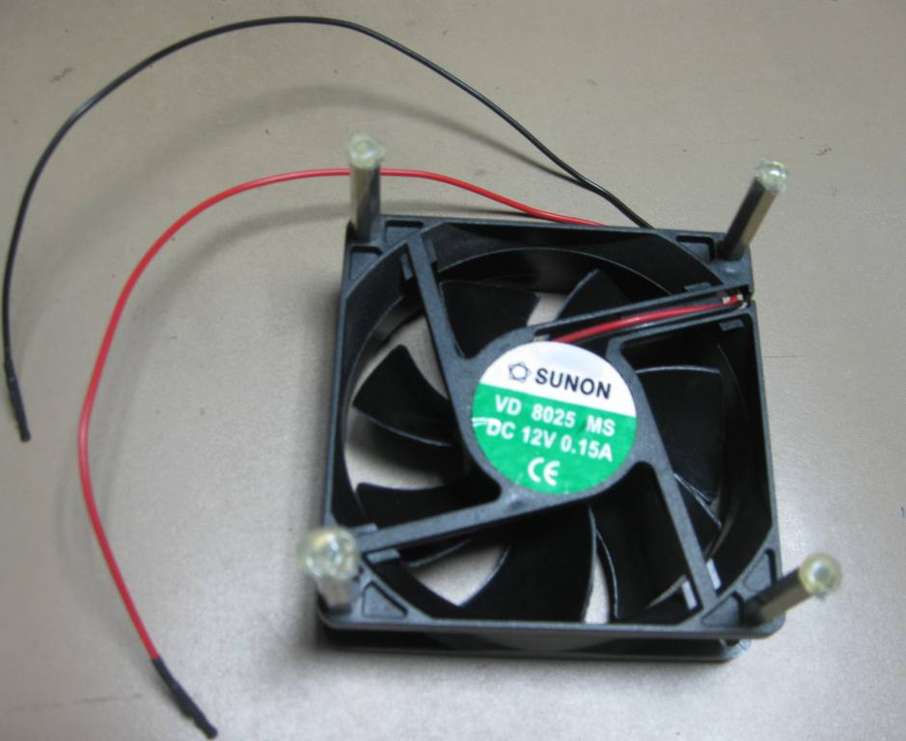

Figure 1: Attaching legs and insulating the fan. The “lugs” at the end of the electrical connectors are also visible.

Figure 2: Placing the fan with insulated legs on top of the TI816x. Double check that the fan is blowing air towards the chip.

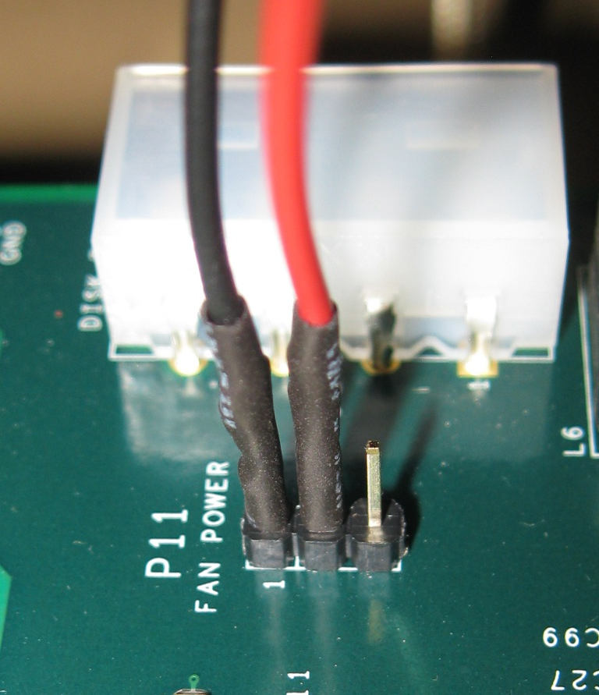
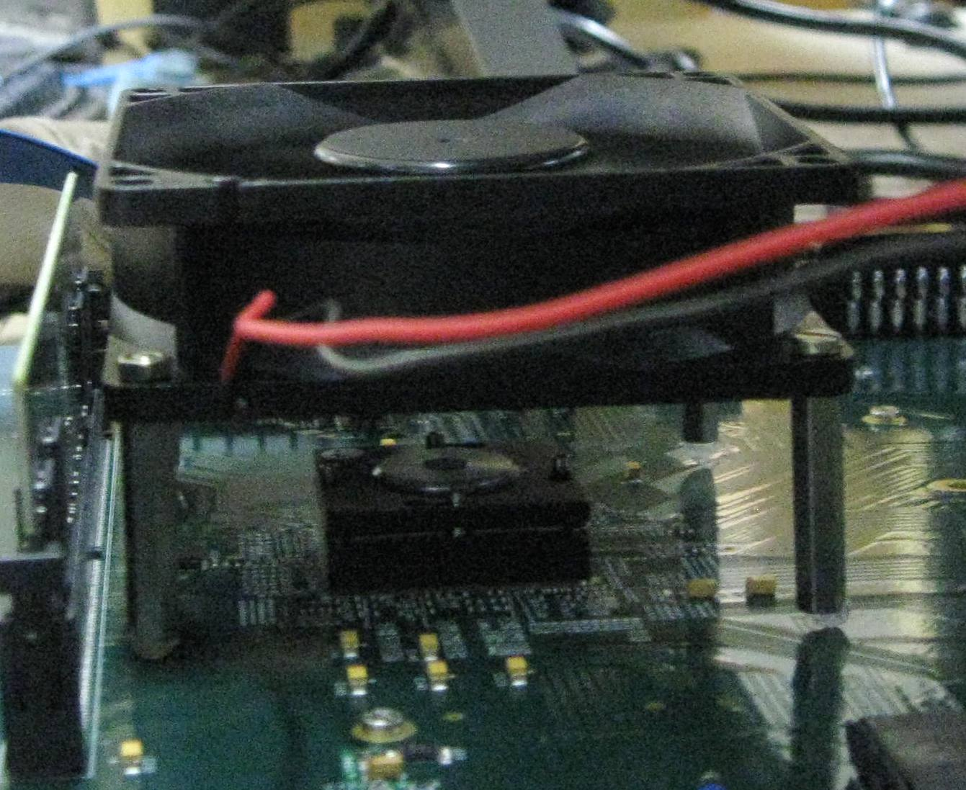

Figure 3: Connecting the fan to the EVM (use P11)

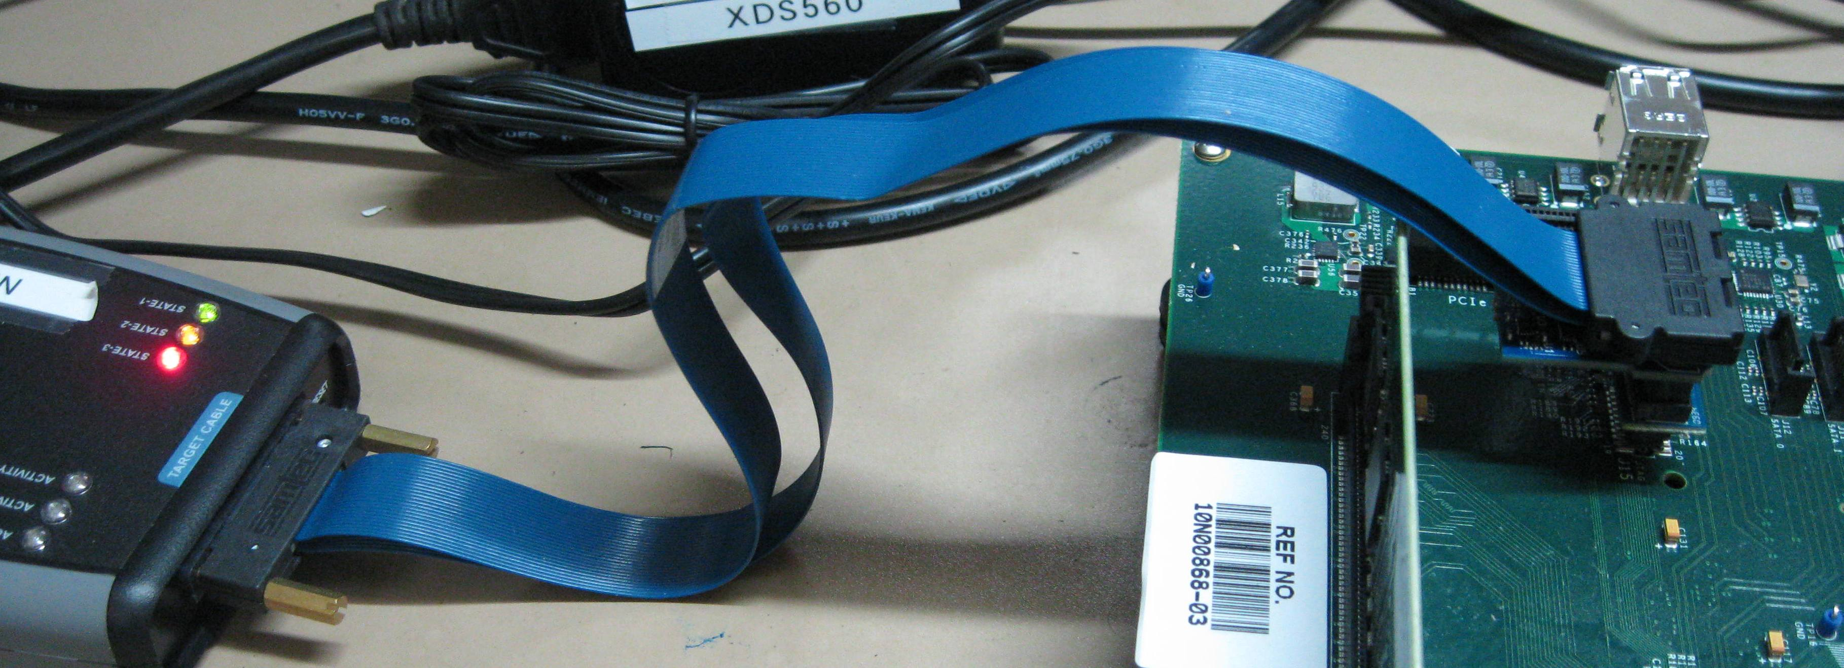

Figure 4: Connecting the XDS560V2 STM to the TI816x EVM via the 20-to-14 pin connector.

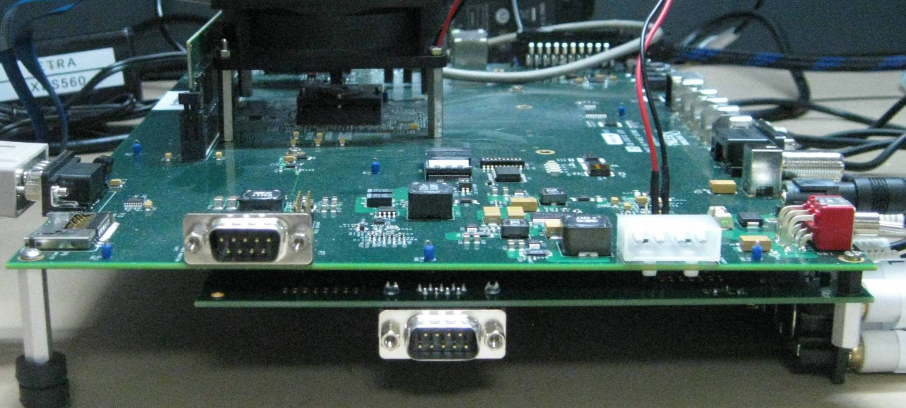

Figure 5: Connecting the VC daughter card to the TI816x EVM.

- Revision History
Revision | Date | Comments
1.8 | 18 November 2011 | Added support for MPEG4 Encoder and Decoder. VC3 application can now select codecs. Supported codecs are h264 and mpeg4  Added this section
1.9 | 23 November 2011 | Added H263 support for MPEG4/H263 Encoder  Fixed 60fps encoding issue for MPEG4/H263 Encoder  Updated document to add MPEG4/H263 support in addition to H264
2.0 | 7 December 2011 | Removed references to RTP  Updated Appendix 1

Appendix-1-Typical Log while running VC
Typical log while running VC demo from linux.

root@dm816x-evm:/home/vc3# ./vc3_a8host_debug.xv5T 127.0.0.1 10000 60 h264
SDK - VC Demo
=============
Bitrate: 10000 kbps, framerate 60 fps, codec h264
UIAClient is ready to send a UIA configuration command
UIAClient received UIA_CONFIGURE_ACK
UIAClient is done sending requests
UIAClient is ready to send a UIA configuration command
UIAClient received UIA_CONFIGURE_ACK
UIAClient is done sending requests
Entering : OMX_HDVPSS_MicroChain_Test
In Codec_SetBitRate: Bit rate is 10000000
In Codec_SetFrameRate: Frame rate is 60
In Codec_SetCompressionFormat: CodecId is 0
VFCC:0
VFDC:0
VFDC:0
VFPC_DEI:0
VENC_0 Port 0 Disabled
VFPC_VENC_H264:0
VENC_0 Port 1 Disabled
VDEC_0 Port 0 Disabled
VDEC_0 Port 1 Disabled
VFPC_VDEC_H264:0
VFCC Port 0 Enabled
VFPCDEI_1 Port 0 Enabled
VFPCDEI_1 Port 16 Enabled
VFDC_0 Port 1 Enabled
VFPCDEI_1 Port 17 Enabled
VENC_0 Port 0 Enabled
VENC_0 Port 1 Enabled
VLPB Port 0 Enabled
VLPB Port 16 Enabled
VDEC_0 Port 0 Enabled
VDEC_0 Port 1 Enabled
VFPCDEI_0 Port 0 Enabled
VFPCDEI_0 Port 16 Enabled
VFDC_0 Port 0 Enabled
VFPCDEI_0 Port 17 Enabled
VFDC_1 Port 0 Enabled
Changing the state of the components to Idle..
VFCC Component Transitioned to Idle state
CTRLTVP Component Transitioned to Idle state
VFPCDEI_1 Component Transitioned to Idle state
VENC_0 Component Transitioned to Idle state
VLPB Component Transitioned to Idle state
VDEC_0 Component Transitioned to Idle state
VFPCDEI_0 Component Transitioned to Idle state
CTRLDC_0 Component Transitioned to Idle state
CTRLDC_1 Component Transitioned to Idle state
VFDC_0 Component Transitioned to Idle state
VFDC_1 Component Transitioned to Idle state
Changing the state of the components to Executing..
CTRLDC_0 Component Transitioned to Executing state
CTRLDC_1 Component Transitioned to Executing state
VFDC_0 Component Transitioned to Executing state
VFDC_1 Component Transitioned to Executing state
VFPCDEI_0 Component Transitioned to Executing state
VDEC_0 Component Transitioned to Executing state
VLPB Component Transitioned to Executing state
VENC_0 Component Transitioned to Executing state
VFPCDEI_1 Component Transitioned to Executing state
CTRLTVP Component Transitioned to Executing state
VFCC Component Transitioned to Executing state
frameNumber[0]: 1800
frameNumber[0]: 3600
frameNumber[0]: 5400
frameNumber[0]: 7200

Appendix-2 – DDR-3 EVM Info
This section provides information to flash u-boot and run the demo on a DDR3 EVM.

Flashing u-boot on a DDR3 EVM
To flash u-boot on DDR-3 EVM, the general procedure is mostly same as mentioned in ‘Section 2.3.3 Flashing the U-Boot’. However there are a few changes that are to be followed as given below:

- In step 8 (c), use the gel file DM816x_evm_ddr3.gel provided in the package.
- In step 10 (b), use ‘u-boot_DDR3.noxip.bin’ for a DDR3 EVM. 10 (b) will become:
Enter the path for “u-boot_DDR3.noxip.bin” received with the package,
Ex: use c:\Netra\ DM816x_SDK_05_00_00_10_VC_demo\u-boot_DDR3.noxip.bin
- Other steps for flashing u-boot are same as DDR2.

Running demo on a DDR3 EVM
The other procedure for setting up NFS and running the demo are exactly the same for both DDR2 and DDR3 boards.

