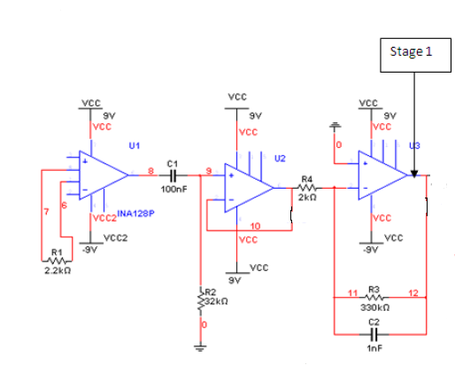

Ground Electrode (Elbow)

Electrodes from forearm muscle

Figure 1: EMG Circuit Schematic

Hello everyone.

For a university class project on biomedical instrumentation, I constructed the following circuit to measure electromyogram signals from the forearm muscles, namely the flexor digitorum superficialis muscle. I want to do an experiment to relate hand grip strength to electromyogram signals measured from the forearm muscles. However this circuit gives inconsistent results; it sometimes measures EMG signals very well, at other times there is allot of noise as shown in the figures below.

In this circuit schematic U1 is a Burr Brown INA 128 instrumentation amplifier with gain = 20. U2 is an active unity gain first order high pass filter with 50Hz cut off frequency constructed using Texas Instruments OPA2604 op amp. U3 is a low pass filter with cut off frequency of 500Hz. This low pass filter also amplifies the EMG signal, the gain of the amplification is set by R3/R4 = 165. Therefore the total gain of this circuit is 20x165 = 3300

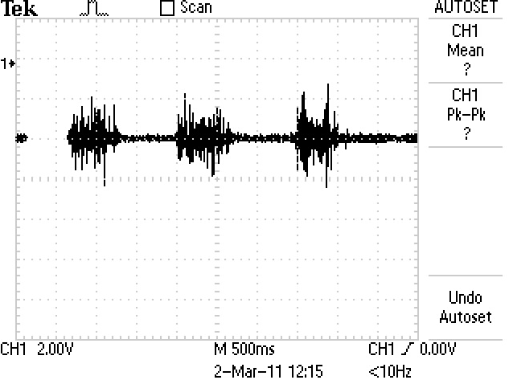

Figure 2: Good results of EMG recording – steady baseline

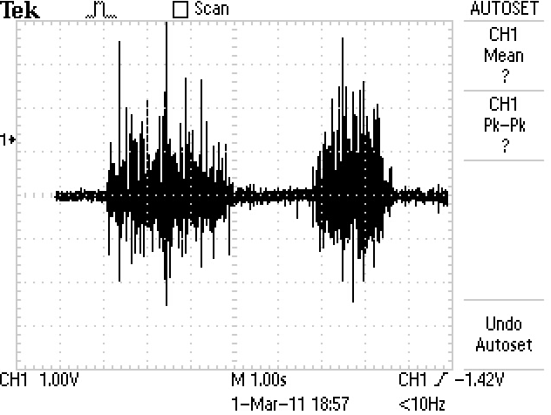

Figure 3: Good results for EMG recording (steady baseline)

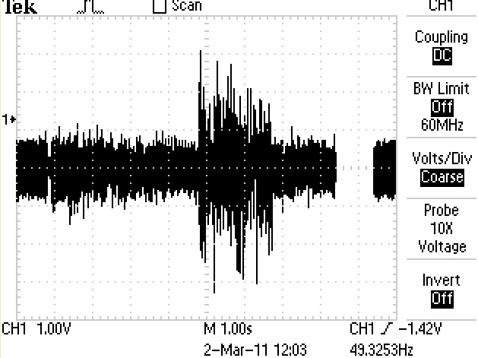

Figure 4: Poor results of EMG recording. Baseline with Noise.

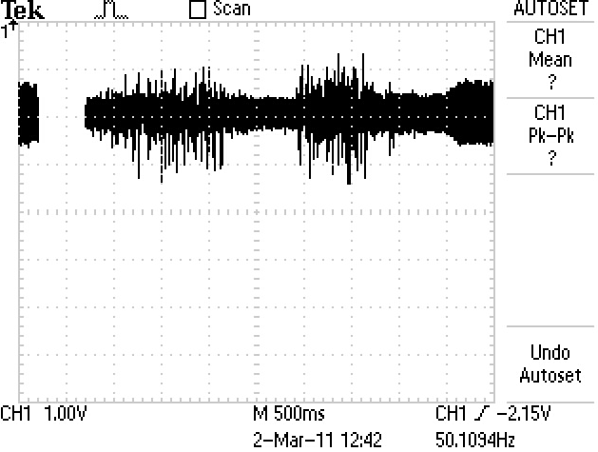

Figure 5: Poor results of EMG recording. Baseline with Noise.

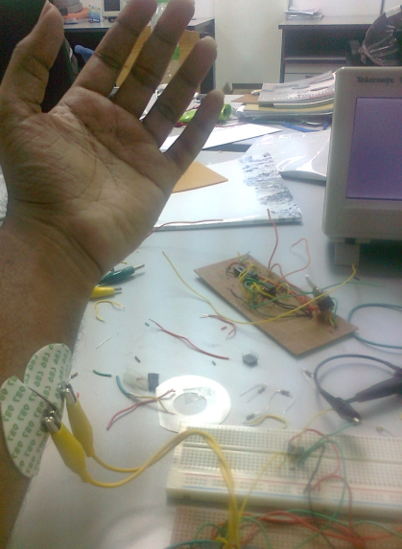

Figure 6: Noise is reduced when my left hand is lifted from the table, when my hand is rested on the table, there is lots of noise.

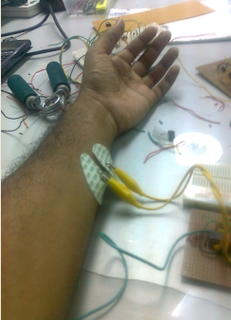

Figure 7: When my left hand is rested on the table, there is lots of noise

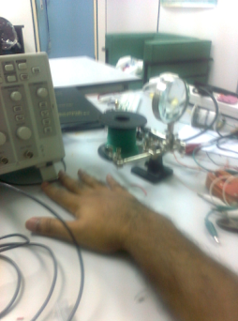

Figure 8: Position of right hand also affects noise. When right hand is rested on table, less noise appears.

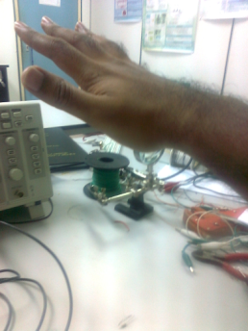

Figure 9: Position of right hand also affects noise. When right is lifted from the table, there is allot of noise

After this observation, I decided to record EMG signals from my left forearm by lifting my left forearm from the table, but keeping my right arm on the table to reduce noise. I have also twisted the two recording electrode wires together as an effort to reduce electromagnetic interference pickups. There is some slight improvement, however still sometimes the results are good and at other times the results are poor despite using the exact same circuit, in the same laboratory and on the same individual.

**Protection Using Parallel Diodes (at each instrumentation amplifier inputs)**

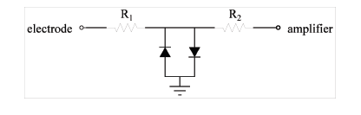

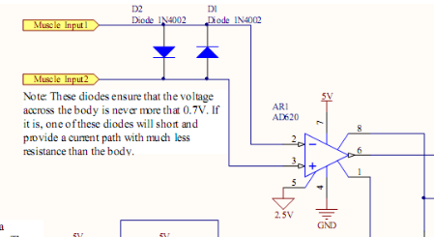

From: http://biomed.engsoc.org/system/files/images/EMG_Arduino.png