Watch Window is CCS V5:
Option 1:
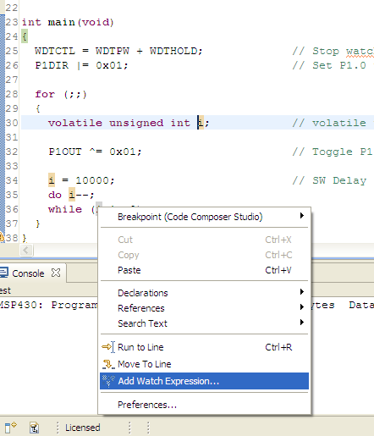
Option 2:
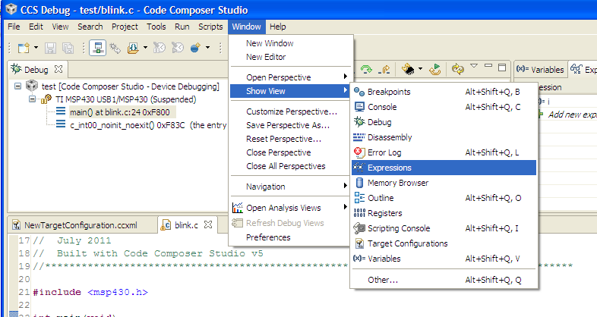
Adding expressions:
