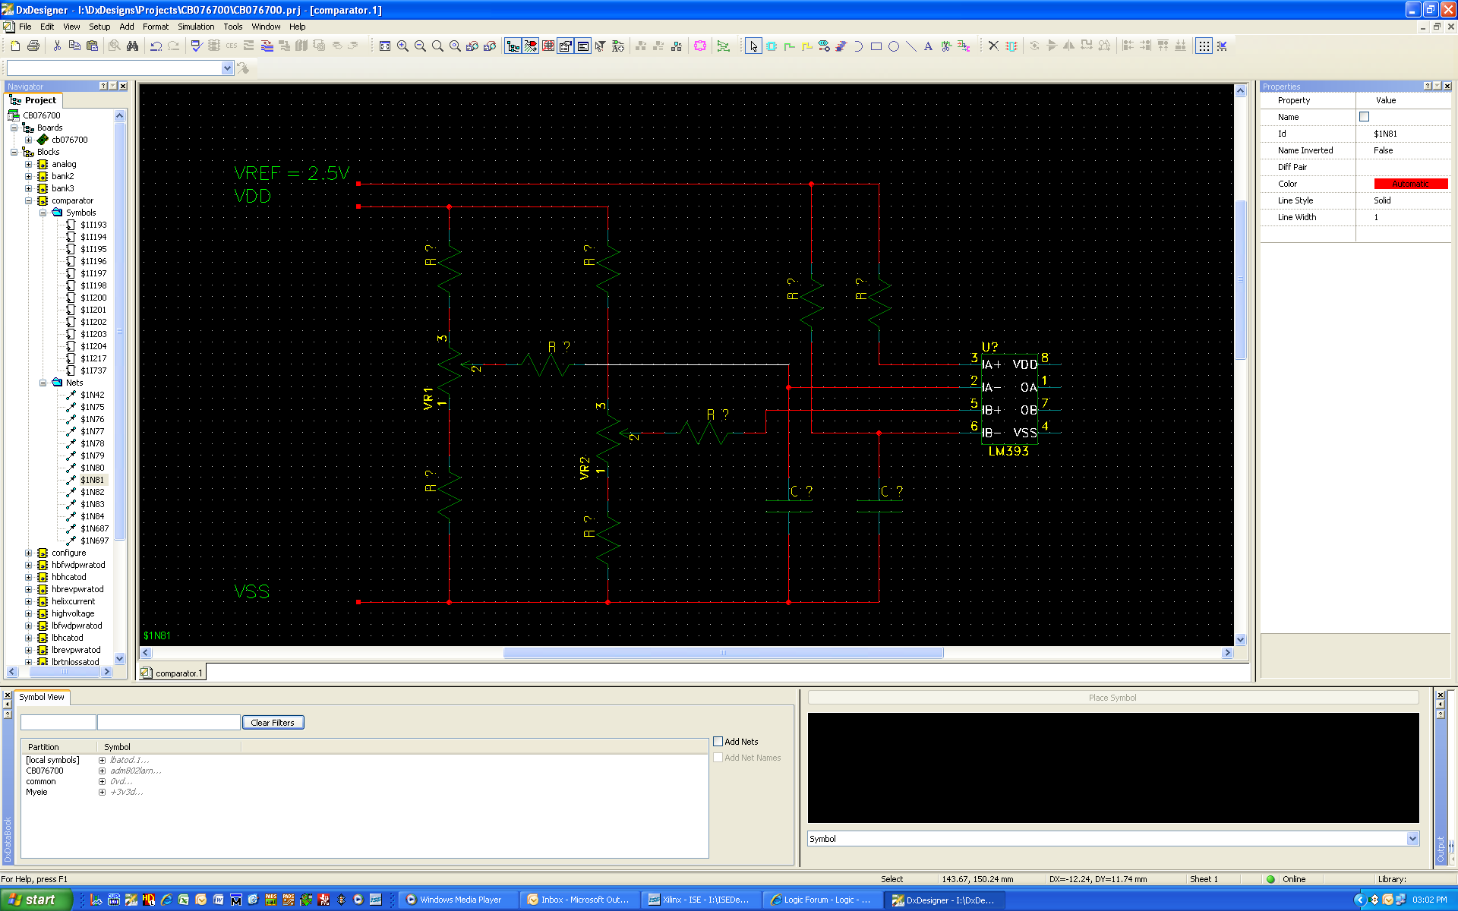

VR1 must be able to tune from VREF to VREF -20%.

VR2 must be able to tune from VREF to VREF +20%.

What is the formula to calculate the different resistor values?