ADI Diagram
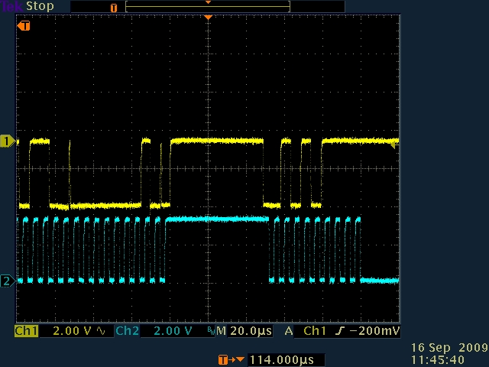
Output from DM648 I2C as master.

