|  |  |  |
| --- | --- | --- |
| Title of your project  **Electrocardiogram with Bluetooth for Android** | Name of School  **INSTITUTO POLITECNICO NACIONAL** | C:\Users\x0184343\Documents\TI Design Guidelines + Graphics\universityprogram_lockup_stacked_rgb.jpg |

**TI Innovation Challenge 2014 Project Report**

|  |  |  |  |
| --- | --- | --- | --- |
| **Team Leader:** | | Name: Manuel Said Torres Gonzalez Email: [mtorresg1002@alumno.ipn.mx](mailto:mtorresg1002@alumno.ipn.mx) | |
| **Team Members:** | | Member 1: Manuel Said Torres Gonzalez Email: [mtorresg1002@alumno.ipn.mx](mailto:mtorresg1002@alumno.ipn.mx)  Member 2: Juan Jesus Hernandez Carlon Email: [jhernandezc1031@alumno.ipn.mx](mailto:jhernandezc1031@alumno.ipn.mx)  Team Member 3: Fernando Vargas Ortiz Email: [f.er.cho65@hotmail.com](mailto:f.er.cho65@hotmail.com)  Team Member 4: Aldo Garcia Alcantara  Email: [agarciaa1007@alumno.ipn.mx](mailto:agarciaa1007@alumno.ipn.mx)  Member 5: Ramon Hernandez Lopez Email: [rhenrnandezl1004@alumno.ipn.mx](mailto:rhenrnandezl1004@alumno.ipn.mx) | |
| **Advising Professor:** | | Name: Edagar Roman Calderon Diaz  Email: [e.calderon.d@live.com.mx](mailto:e.calderon.d@live.com.mx) | |
| **Texas Instruments Mentor (if applicable):** | |  | |
| **Date:** | |  | |
| **Qty.** | **List all TI analog IC or TI processor part number and URL** | | 1. **Explain where it was used in the project?** 2. **What specific features or performance made this component well-suited to the design?** |
| Ex: 1 | LM137  URL: <http://www.ti.com/lit/>  ds/symlink/lm117.pdf | | The LM137 device was used as a voltage regulator to  approximately 3.3V to feed the Operational Amplifier  Instrumentation (INA118) and MSP430 LaunchPad  Value Line Development Tool.  The 3.3V voltage that is applied to the INA118, aims  at limiting the output voltage, as it is connected to  MSP430 LaunchPad Value Line Development Tool  and this entry can not withstand the higher voltages  of Vcc (3.3 V). |
| Ex : 1 | LM337  URL: <http://www.ti.com.cn/>  cn/lit/ds/symlink/lm137.pdf | | The LM337 device was used as a voltage  regulator to approximately-3.3V to feed the  Operational Amplifier Instrumentation (INA118) |
| Ex:1 | UA78M05  URL: <http://www.ti.com/lit/ds/>  symlink/ua78m05.pdf | | The device UA78M05 job as a 5V voltage  regulator to power the LM324N |
| Ex:1 | UA79M05  URL: <http://www.ti.com/lit/>  ds/symlink/ua79m05.pdf | | The device UA79M05 job as a -5V voltage  regulator to power the LM324N |
| Ex:1 | INA118  URL: <http://www.ti.com/lit/>  ds/symlink/ina118.pdf | | The INA118, is used to amplify the cardiac  signal, which is in the order of mV, the  gain that was used is 500, and the  Rg = 100 |
| Ex:1 | LF353N  URL: <http://www.ti.com/>  lit/ds/symlink/lf353-n.pdf | | The LF353N was employed to make  the protection circuit to the patient and  is the reference to the electrocardiogram |
| Ex:2 | LM324N  URL: <http://www.ti.com/>  lit/ds/symlink/lm324-n.pdf | | The LM324N, which is used for  the Low Pass Filters (Fc = 120Hz)  Second Order, High Pass Filter (0.1Hz)  Second Order, Filter to NOTCH (60Hz), a  buffer for DC level de1.25V, an adder for the  ECG signal and the DC level of 1.25V  and also an inverter to the output.  All these settings are to make positive  ECG signal and the MSP430 Value Line  LaunchPad Development Tool will scan  the signal using the Digital Analog Converter. |
| Ex:1 | MPS430 Value Line LauunchPad Development Tool  (MPS430G2553)  URL: <http://www.ti.com/tool/msp-exp430g2?keyMatch=MPS430>  %20value%20line%20launchpad%  20development%20tool&ti  search=Search-EN | | The development tool MSP430 Value Line  LaunchPad analyzes the signal using the  Analog to Digital Converter, and the  information is sent to the bluetooth module  and this links to an mobile device with  android to see the signal in the mobile device |
| Ex:1 | CC256x Bluetooth / Dual-Mode Evaluation Module URL: <http://www.ti.com/tool/cc256xqfnem> | | The Bluetooth module will arrive on 06/05/2014 |

INDEX

Introduction-----------------------------------------------------------------------4

* The normal ECG
* The electrical axis
* P wave
* QRS Complex
* Onda T

Material----------------------------------------------------------------------------5

Description of the Project Design ------------------------------------------6

Development---------------------------------------------------------------------6

Hardware Design

Códe in Energia ----------------------------------------------------------------19

Conclusions ---------------------------------------------------------------------21

Future Work / Recommendations

**INTRODUCTION**

The electrocardiogram (ECG) is a graphical representation of the electrical activity of the heart, obtained with an electrocardiograph in a continuous ribbon. It is the main instrument of cardiac electrophysiology and has a significant role in the screening and diagnosis of cardiovascular disease, metabolic disorders and predisposition to sudden cardiac death. It is also useful to know the duration of the cardiac cycle.

**The normal ECG**

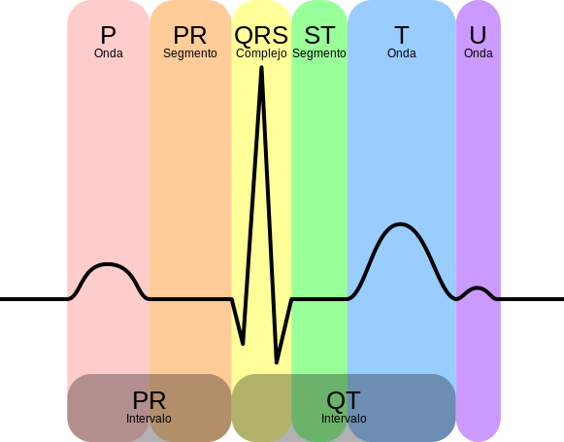The typical layout of an electrocardiogram recording a normal heartbeat consists of a P wave, a QRS complex and a T wave Small wave U is normally invisible. These are electrical events that should not be confused with the corresponding mechanical events , ie , the contraction and relaxation of the heart chambers . Thus, the mechanical systole or ventricular contraction begins just after the start of the QRS complex and ends just before the T-wave end diastole is relaxation and ventricular filling begins after culminating systole corresponding to the contraction of the atria , just after onset of P wave

**The electrical axis**

The electrical axis is the general direction of the electrical impulse through the heart . Usually in the form of vector directed toward the lower left, but may be diverted to the left top in elderly , pregnant or obese people .

**P wave**

The P wave is the electrical signal which corresponds to the atrial depolarization . Results from the superposition of the right atrial depolarization ( initial part of the P wave) and left (end of P wave) .

**QRS Complex**

Main article: QRS Complex

The QRS complex corresponds to the electric current that causes the contraction of the right and left ventricles ( ventricular depolarization ) , which is much stronger than that of the atria and compete more muscle mass , thus producing a greater deflection in the electrocardiogram .

The Q wave, when present, represents the small horizontal flow (left to right) action potential traveling through the interventricular septum. Q waves which are too wide and have a depth no septal origin , but indicate a myocardial infarction .

The R and S waves indicate contraction of the myocardium. Abnormalities in the QRS complex may indicate branch block ( when it is wide ) , ventricular tachycardia origin , ventricular hypertrophy or other ventricular abnormalities . The complexes are often small in pericarditis.

The normal duration is 60 to 100 milliseconds appears When complete, the QRS complex consists of three vectors, named using the nomenclature described by Willem Einthoven :

Q wave is the first wave of the complex and has negative values ​​(down on the graph of the ECG, but not always visible).

R. Wave is the first positive deflection of the QRS complex and the classic image of the ECG, is the largest.

S. Onda is any negative wave following the R wave

**Onda T**

The T -wave represents the repolarization of the ventricles . During formation of the QRS complex , usually atrial repolarization also occurs which is not recorded in the normal ECG , as it is masked by the QRS complex . Electrically, the cardiac muscle cells are like loaded springs ; a small boost the hit , depolarize and contract. Recharging dock is repolarization (also called action potential ) .

In most of the leads , the T wave is positive . Negative T waves can be symptoms of disease, although inverted T wave is normal in lead aVR and sometimes V1 (V2 -3 in African ethnicity) .

The ST segment connects to the QRS complex and the T wave can be reduced by elevated in ischemia and myocardial infarction .

Its duration is about 0.20 seconds or less and measured 0.5 mV.

**MATERIAL**

* + LM337
  + LM137
  + UA78M05
  + UA79M05
  + INA118
  + LF353N
  + LM324N
  + MSP430 Value Line LaunchPad Development Tool
  + CC256x Bluetooth / Dual-Mode Evaluation Module   
    (The Bluetooth module will arrive on 06/05/2014)
  + 20 capacitores de 0.1uF
  + 5 resisores 180 ohms)
  + 5 resistores de 15 ohms
  + 5 resitores de 1 ohm
  + 8 diodos 1N4001
  + 3 led rojo
  + 5 resistencias de 1K
  + 5 resistencias de 390k
  + 5 resistencias de 18k
  + 5 resistencias de 33K
  + 5 resistencias de 4.7k
  + 5 resistencias de 2.2M
  + 5 Resistencias de 1 M
  + 5 resistencias de 27K
  + 5 Resistencias de 12K
  + 5 Resistencias de 1.5K
  + 5 Resistencias de 10 Ohms
  + 5 Resistencias de 220 Ohms
  + 5 Resistencias de 150 Ohms
  + 10 Resistencias de 10K

**DESCRIPTION OF THE PROJECT**

**Our Objectives:**   
Perform a low cost ECG, and you can connect via Bluetooth to an app on android.

**What do you do?**   
Our project shows the cardiac signal in an application in android

**What problem does it solve?**   
This was developed with the idea that anyone with heart problems or athletes may be viewing your heart rate

**How it works?**   
The Cardica signal is amplified because it is very small, then it is filtered with a band-pass (0.1Hz to 120Hz) and filter a NOTCH filter at 60Hz, the latter filter is to remove noise that absorbs signal the line electric.

Once the filtered signal is added a DC level to become completely positive and connected to MSP430G2553 which employs the Analog Digital Converter, to sample the signal and can be sent over the bluetooth module.

With the application in android, the bluetooth signal is receive and the ECG signal is reconstructed, and will show on the mobile.

**Development**

The power supply was developed with electronic components (SMD) exist to prevent noise voltage alimetación and affect the ECG signal.

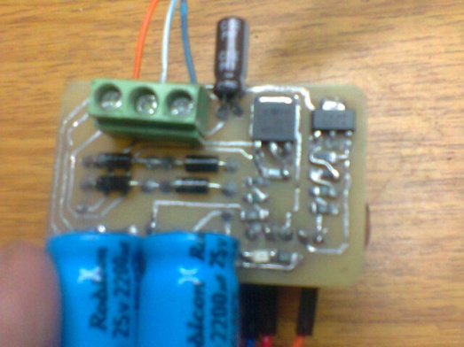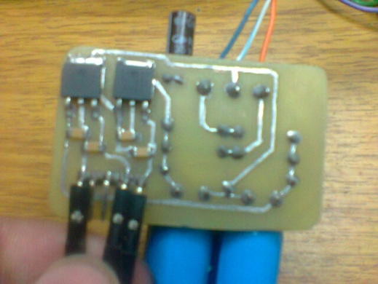

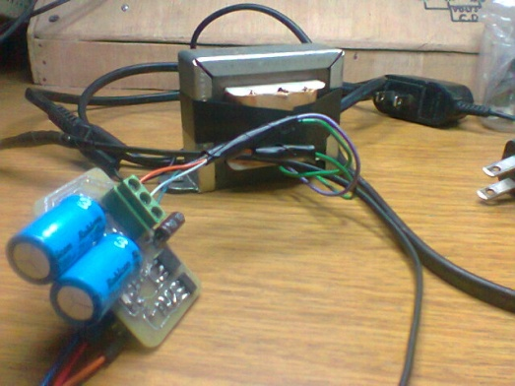

First har filters and tests were done with a signal generator

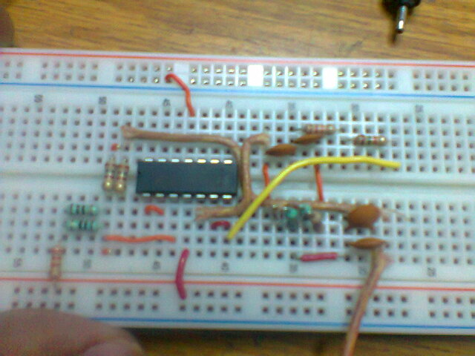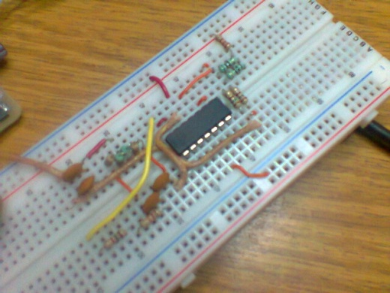

They connect the INA118 and protection circuit, later tests were made

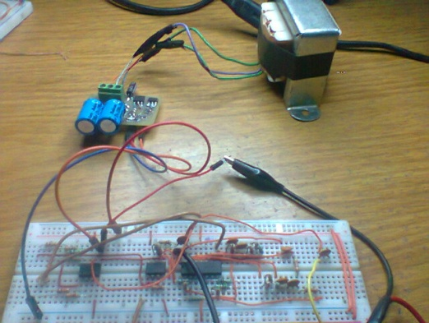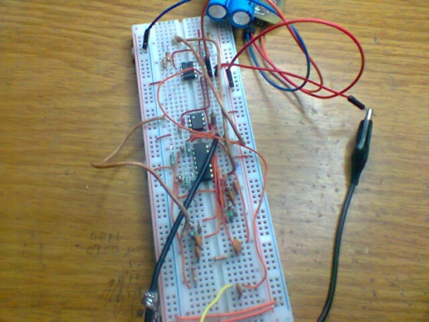

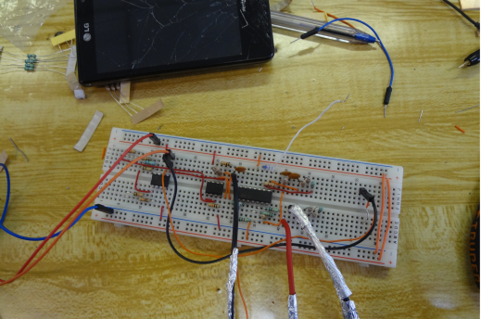

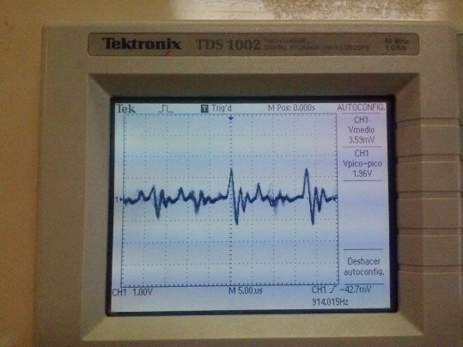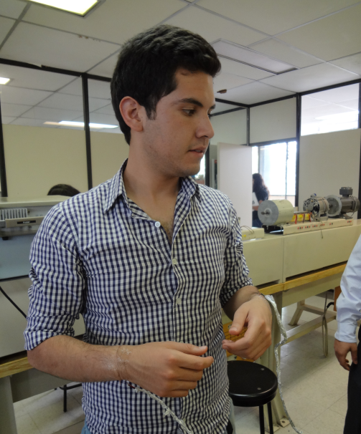 Signal obtained with the circuit

He was subsequently high DC level (1.25v) to the signal obtained, and they connect to MSP430

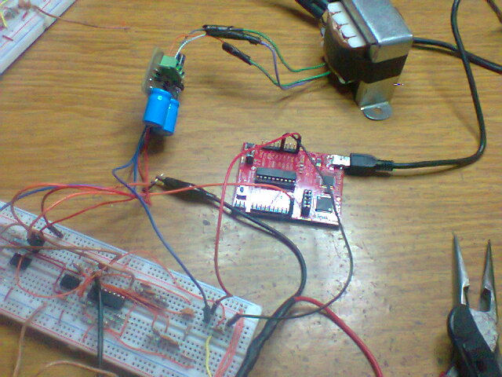

**COMPUTER TEST**

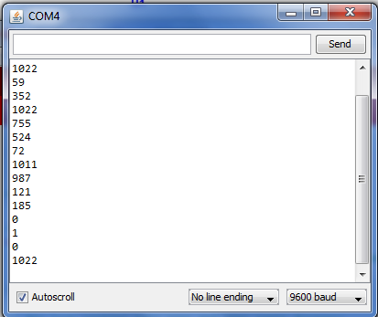

**Electronic Diagrams**

* Power supply (+3.3 v,-3.3v)
* Power supply (+5 v,-6v)

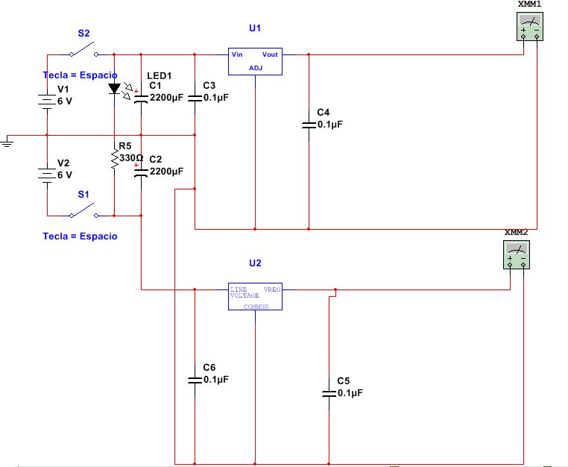

**NOTE: All filters were simulated with a power supply of +6 v and-6v, but in reality was armed with power supplies of +5 v and-5v**

**Fourth order low pass filter witha cutoff frequency of 120Hz.**

To do this, we choose to perform two Low Pass Filters Butterworth Second Order and make a connection of both.

**Design of Low Pass Filter Butterworth Second Order witha cutoff frequency of 120Hz.**

$$f_{c}=\frac{1}{2π\sqrt{2}RC_{2}}…FORMULA$$

Solving for R and proposing to

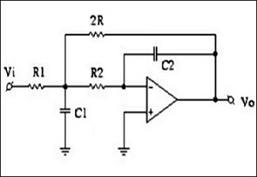

Interconnection Both filters.

GRAPHIC BODE

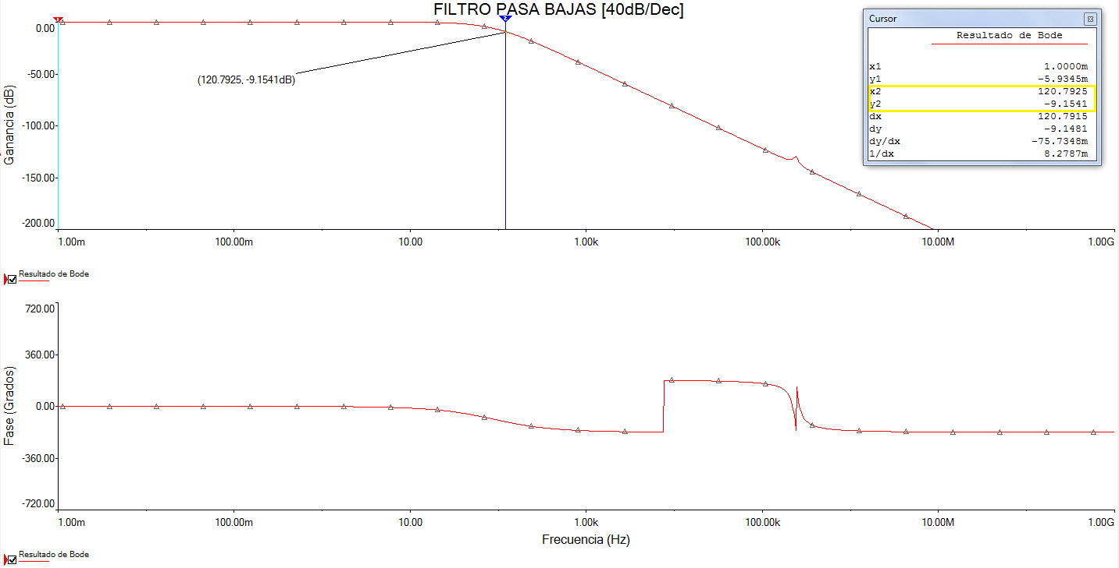

**NotchFilterwitha cutoff frequency of 120Hz.**

**NotchFilterDesign**

$$f_{c}=\frac{1}{2πRC}…FORMULA$$

Solving for R and proposing to $C=100pF$

$$R=\frac{1}{2πf_{c}C}=\frac{1}{2π\left(60Hz\right)(100{x10}^{-9}F)}=26.5258KΩ≈27KΩ….MARKET VALUE$$

$$R=27KΩ \\ R_{f}=\frac{R}{2}=13.5KΩ \\ C_{f}=2C=200pF \\ C=100pF$$

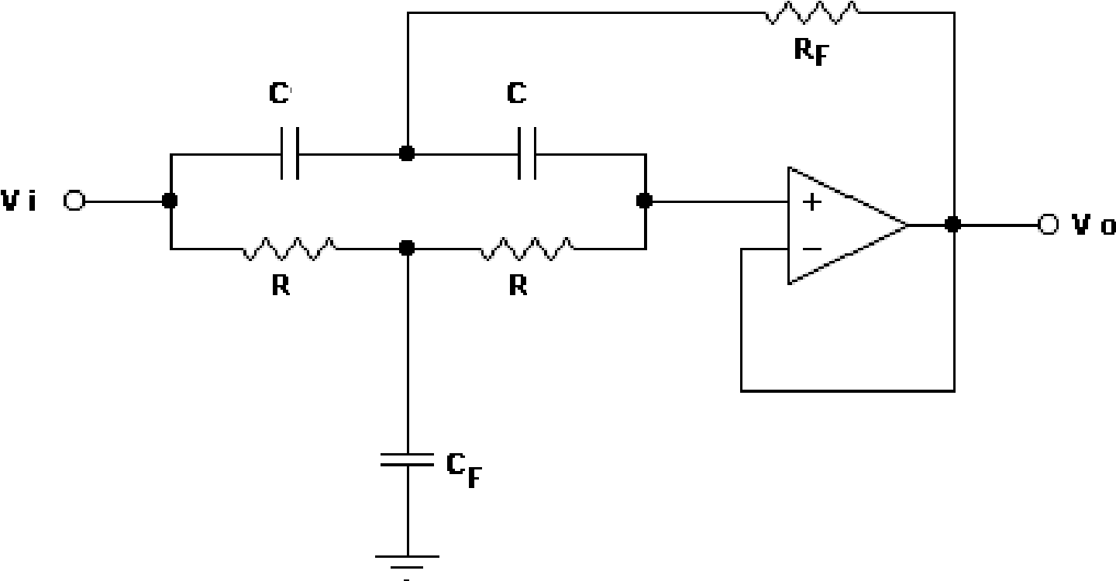

NotchFilterCircuit



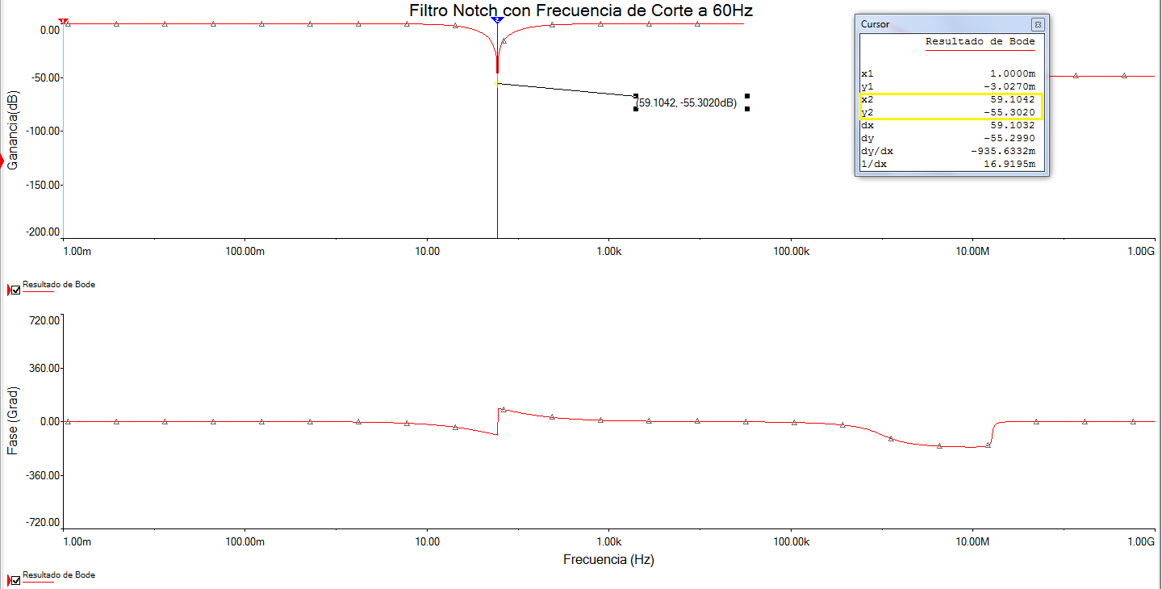GRAPHIC BODE

ADDER CIRCUIT

Because the Converter Analog to Digital (ADC) does not recognize signals with negative amplitudes, it was decided to add to the signal, one level of CD through a Adder Circuit, which will add to the output signal and will add one level of CD of 1.5v

First to obtain a of DC level of 1.5V, we chose a voltage divider, however because the tension of Array may be affected by the load, we add an op amp with settings Buffer, for the purpose of to a coupling of impedances

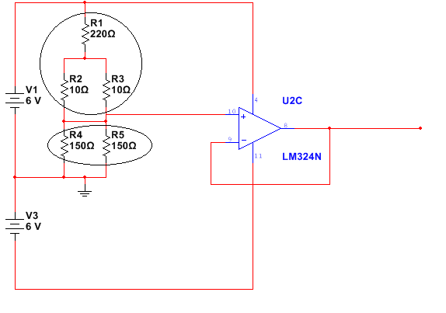

RB

RA

Voltage divider calculations.

DATA: $$I=20mA \\ V_{RB}=1.5V \\ V_{cc}= +6V$$

$$RB=\frac{V_{RB}}{I}=\frac{1.5 V}{20{x10}^{-3}A}=75Ω=150Ω||150Ω$$

$$RA=\frac{{V_{cc}-V}_{R}}{I}=\frac{6V-1.5 V}{20{x10}^{-3}A}=225Ω=[(10Ω|\left|10Ω\right)+220Ω]$$

Adder design.

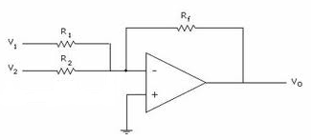 $Expression of Voltage at the Output of Adder$ $$V_{OUT 1}=-R_{f}\left(\frac{V_{1}}{R_{1}}+\frac{V_{2}}{R_{2}}\right)$$

***However due to the expression, the voltage output will be negative.***

To solve this problem it was decided to add an inverter to the output.

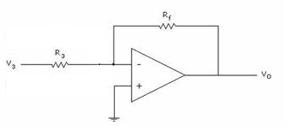 $Expression of voltage to the inverter output.$ $$V_{OUT 2}=-\left(\frac{R_{f}}{R_{3}}\right)V_{IN}$$

Interconnecting the adder and the Investor.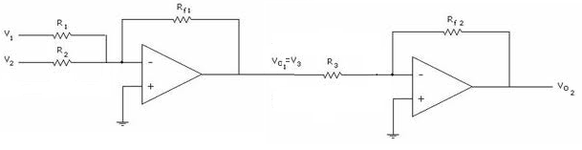

$$V_{OUT 2}=-\left(\frac{R_{f2}}{R_{3}}\right)\left[-R_{f1}\left(\frac{V_{1}}{R_{1}}+\frac{V_{2}}{R_{2}}\right)\right]$$

$$To not amplify the signal take the following conditions:$$

$$R_{f2}=R_{3}=R_{1}=R_{2}=R_{f1}=10kΩ$$

$$V_{OUT 2}=-\left(\frac{10kΩ}{10kΩ}\right)\left[-10kΩ\left(\frac{V_{1}}{10kΩ}+\frac{V_{2}}{10kΩ}\right)\right]=-1\left[-1(V_{1}+V_{2})\right]=(V_{1}+V_{2})$$

So that the circuit remained follows:



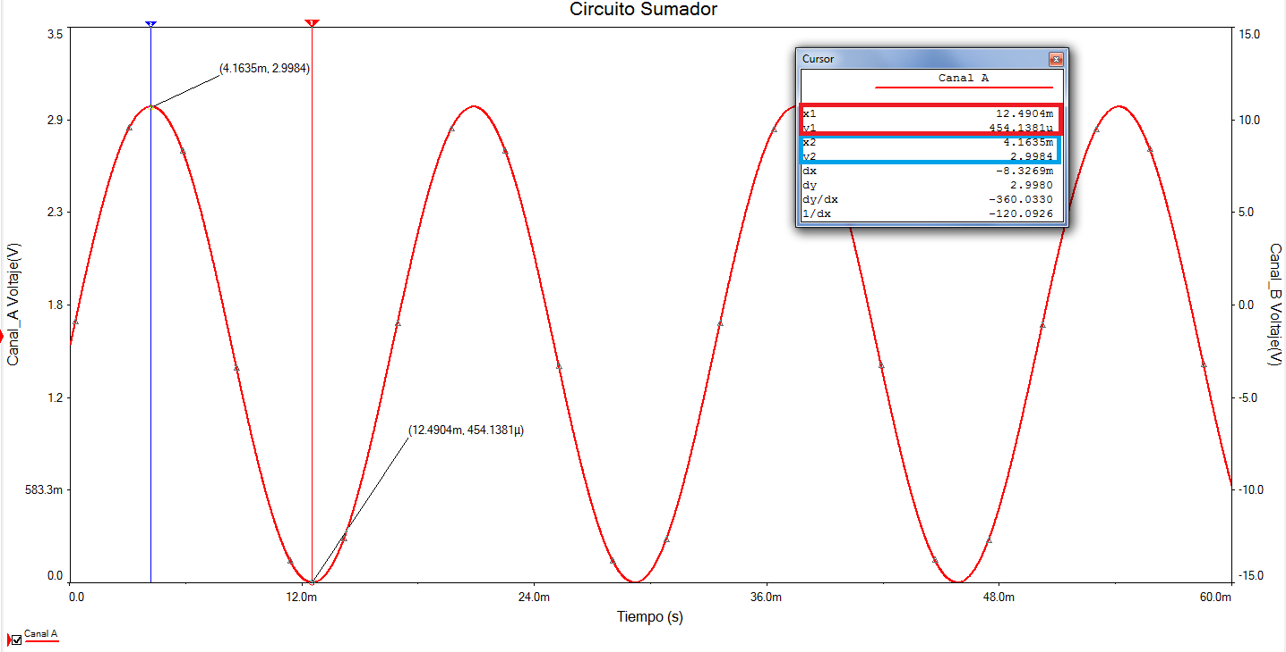Oscilloscope Graph "Sum of Both Signals"

Hardware Designs

* Power supply (+3.3 v,-3.3v, +5 v and-5v)

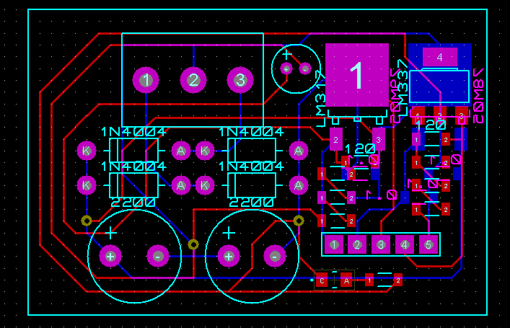

3D Visualization

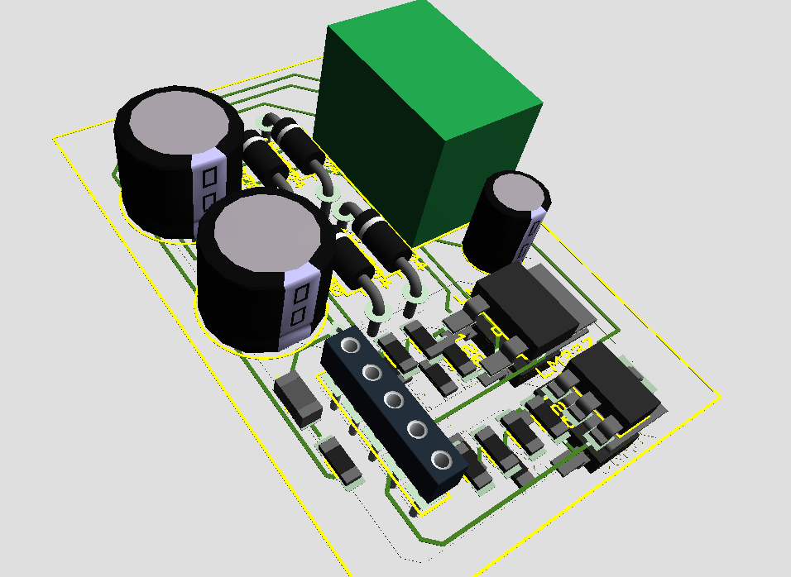

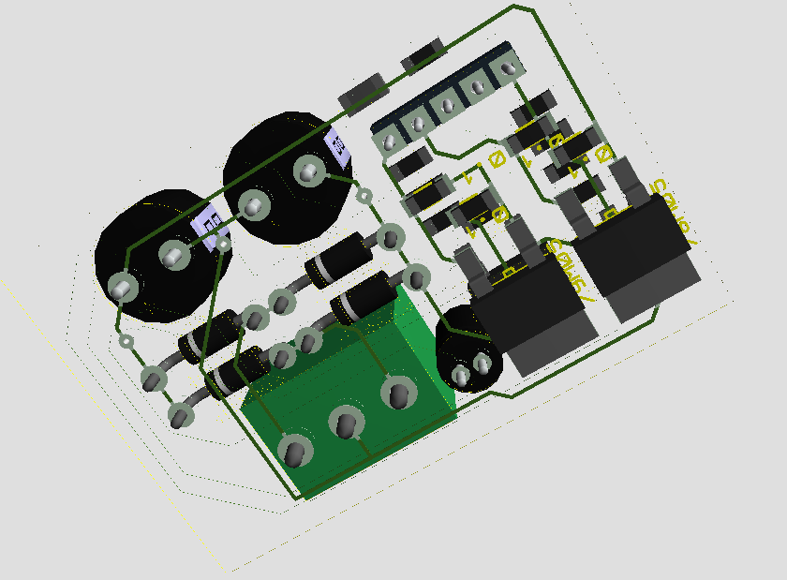

INA118 and LF353N

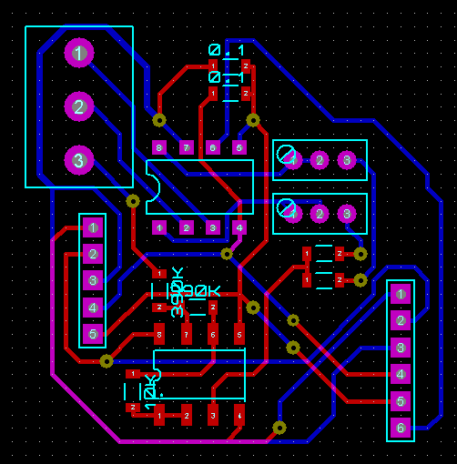

3D Visualization

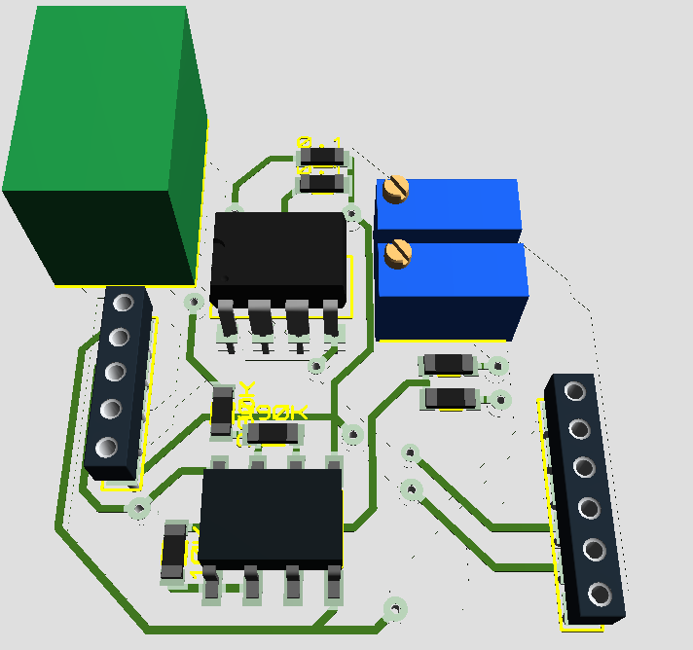

**CODE IN ENERGIA**

* **CODE ADC**

void setup()

{

Serial.begin(9600);

}

void loop()

{

int sensorValue = analogRead(A3);

Serial.println(sensorValue);

delay(1);

}

* **CODE BLUETOOTH**

**NOTE: the code was developed, however not counted with any bluetooth module to be tested**

#include <IRremote.h>

#include <IRremoteInt.h>

#define sensorPin A0

void setup() {

Serial.begin(9600);

}

void loop() {

if(Serial.available()>0){

char re = Serial.read();

switch(re){

case 'E':

start();

break;

}

}

}

void start(){

while(1){

Serial.print('s');

Serial.print(floatMap(analogRead(sensorPin),0,1023,0,5),4);

delay(10);

if(Serial.available()>0){

if (Serial.read()=='Q') return;

}

}

}

floatfloatMap(float x, float inMin, float inMax, float outMin, float outMax){

return (x-inMin)\*(outMax-outMin)/(inMax-inMin)+outMin;

}

* **APPS (ANDROID)**



**LOGO**

**CONCLUSIONS**

The conclusion of this study can say that part of the design and construction

 and part of the experiment was successful

The ECG worked fine the program performs the analog to digital conversion also

The application on the Android platform was developed correctly however it was not possible to connect to Bluetooth

This part has not come to our country to the present and it is the responsibility of texas instruments

Either way we are thankful for the opportunity and thank the support provided Texas Instruments

Future Work / Recommendations

**This work has great application in everyday life and can develop more.**