Hello I am working with the DSP C6713, using Code Composer Studio V5.2.1. I am trying to implement a digital signature by using a cryptographic library known as Miracl. I did not use TI libraries. The C6000 Compiler tools version is 7.3.4.
For debugging the project I include the files mirdef.h, miracl.h, miracl.lib and ecsign.c. See the next figure:
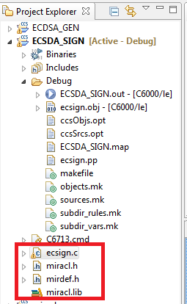
Here is the code of the file ecsign.c:
/*
* Elliptic Curve Digital Signature Algorithm (ECDSA)
*
*
* This program asks for the name of a <file>, computes its message digest,
* signs it, and outputs the signature to a file <file>.ecs. It is assumed
* that curve parameters are available from a file common.ecs, as well as
* the private key of the signer previously generated by the ecsgen program
*
* The curve is y^2=x^3+Ax+B mod p
*
* The file common.ecs is presumed to exist, and to contain the domain
* information {p,A,B,q,x,y}, where A and B are curve parameters, (x,y) are
* a point of order q, p is the prime modulus, and q is the order of the
* point (x,y). In fact normally q is the prime number of points counted
* on the curve.
*
*/

#include <stdio.h>
#include "miracl.h"
#include <stdlib.h>
#include <string.h>

#ifdef MR_COUNT_OPS
int fpm2,fpi2,fpc,fpa,fpx;
#endif

void strip(char *name)
{ /* strip off filename extension */
int i;
for (i=0;name[i]!='\0';i++)
{
if (name[i]!='.') continue;
name[i]='\0';
break;
}
}

static void hashing(FILE *fp,big hash)
{ /* compute hash function */
char h[20];
int ch;
sha sh;
shs_init(&sh);
while ((ch=fgetc(fp))!=EOF) shs_process(&sh,ch);
shs_hash(&sh,h);
bytes_to_big(20,h,hash);
}

int main()
{
FILE *fp;
char ifname[50],ofname[50];
big a,b,p,q,x,y,d,r,s,k,hash;
epoint *g;
long seed;
int bits;
miracl *mip;
/* get public data */
#ifndef MR_EDWARDS
fp=fopen("c:\\common.ecs","rt");/*Modified Line here*/ /*ORIGINAL: fp=fopen("common.ecs","rt");*/
if (fp==NULL)
{
printf("file common.ecs does not exist\n");
return 0;
}
fscanf(fp,"%d\n",&bits);
#else
fp=fopen("edwards.ecs","rt");
if (fp==NULL)
{
printf("file edwards.ecs does not exist\n");
return 0;
}
fscanf(fp,"%d\n",&bits);
#endif
mip=mirsys(bits/4,16); /* Use Hex internally */
a=mirvar(0);
b=mirvar(0);
p=mirvar(0);
q=mirvar(0);
x=mirvar(0);
y=mirvar(0);
d=mirvar(0);
r=mirvar(0);
s=mirvar(0);
k=mirvar(0);
hash=mirvar(0);

innum(p,fp); /* modulus */
innum(a,fp); /* curve parameters */
innum(b,fp);
innum(q,fp); /* order of (x,y) */
innum(x,fp); /* (x,y) point on curve of order q */
innum(y,fp);
fclose(fp);

/* randomise */
printf("Enter 9 digit random number seed = ");
scanf("%ld",&seed);
getchar();
irand(seed);

ecurve_init(a,b,p,MR_PROJECTIVE); /* initialise curve */
g=epoint_init();

if (!epoint_set(x,y,0,g)) /* initialise point of order q */
{
printf("1. Problem - point (x,y) is not on the curve\n");
exit(0);
}

/* calculate r - this can be done offline,
and hence amortized to almost nothing */
bigrand(q,k);
#ifdef MR_COUNT_OPS
fpm2=fpi2=fpc=fpa=fpx=0;
#endif
ecurve_mult(k,g,g); /* see ebrick.c for method to speed this up */
#ifdef MR_COUNT_OPS
printf("Number of modmuls= %d, inverses= %d\n",fpc,fpx);
#endif
epoint_get(g,r,r);
divide(r,q,q);

/* get private key of signer */
fp=fopen("c:\\private.ecs","rt");/*Modified Line*/ /*ORIGINAL: fp=fopen("private.ecs","rt");*/
if (fp==NULL)
{
printf("file private.ecs does not exist\n");
return 0;
}
innum(d,fp);
fclose(fp);

/* calculate message digest */
printf("file to be signed = ");
gets(ifname);
strcpy(ofname,ifname);
strip(ofname);
strcat(ofname,".ecs");
if ((fp=fopen(ifname,"rb"))==NULL)
{
printf("Unable to open file %s\n",ifname);
return 0;
}
hashing(fp,hash);
fclose(fp);

/* calculate s */
xgcd(k,q,k,k,k);

mad(d,r,hash,q,q,s);
mad(s,k,k,q,q,s);
fp=fopen(ofname,"wt");
otnum(r,fp);
otnum(s,fp);
fclose(fp);
return 0;
}

After debugging I get the next results in the CDT Build Console:
**** Build of configuration Debug for project ECSDA_SIGN ****

C:\ti\ccsv5\utils\bin\gmake -k all
'Building file: ../ecsign.c'
'Invoking: C6000 Compiler'
"C:/ti/ccsv5/tools/compiler/c6000_7.3.4/bin/cl6x" -mv6700 -g -O2 --define=c6713 --include_path="C:/ti/ccsv5/tools/compiler/c6000_7.3.4/include" --display_error_number --diag_warning=225 --abi=coffabi --preproc_with_compile --preproc_dependency="ecsign.pp" "../ecsign.c"
"../ecsign.c", line 59: warning #552-D: variable "mip" was set but never used
'Finished building: ../ecsign.c'
' '
'Building target: ECSDA_SIGN.out'
'Invoking: C6000 Linker'
"C:/ti/ccsv5/tools/compiler/c6000_7.3.4/bin/cl6x" -mv6700 -g -O2 --define=c6713 --display_error_number --diag_warning=225 --abi=coffabi -z -m"ECSDA_SIGN.map" --stack_size=0x1000 --heap_size=0x800 --warn_sections --display_error_number -i"C:/ti/ccsv5/tools/compiler/c6000_7.3.4/lib" -i"C:/ti/ccsv5/tools/compiler/c6000_7.3.4/include" --reread_libs --rom_model -o "ECSDA_SIGN.out" "./ecsign.obj" -l"libc.a" "../C6713.cmd" "../miracl.lib"
<Linking>
'Finished building target: ECSDA_SIGN.out'
' '

**** Build Finished ****
After that I enabled the clock, and click the resume button, as the reader can see in the next figure
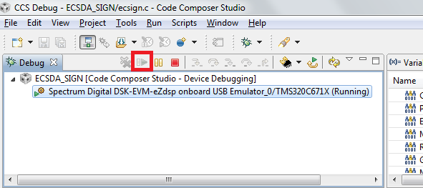

Nevertheless, the ECDSA_SIGN:CIO Console did not appear, the program stopped and also the clock did not count anything.
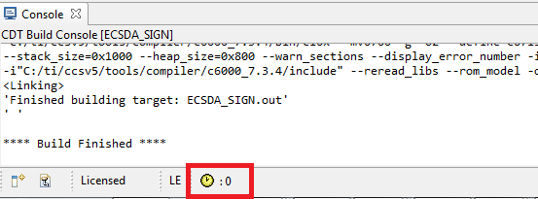
I waited for almost 30 minutes and the program did not produce any answer. What can I do?.

