We have problems in debugging arm USB communication at present, when the device is powered up or reset, the link is not find the lna9513.

We use the following:

DM3730.usb0 connect to TPS65920 apply in OTG; open this link
DM3730.usb1 connect to TUSB1210 apply in Host link to LNA9513 USB hub.

We use the Tusb1210 ULPI input-clock mode
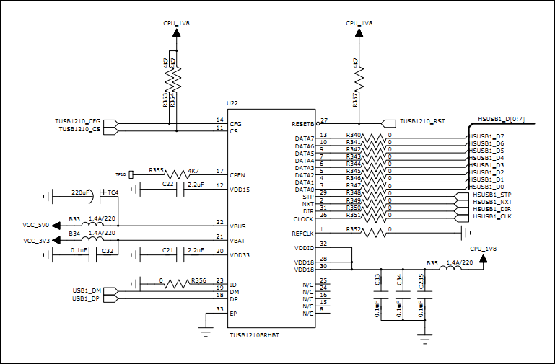
But
We canot find the device on the USB1; the ULPI CLK as bellow:
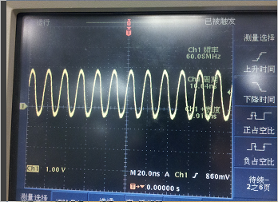

And we should see the signal on the dp/dm as bellow:
