1.-Right click on the yellow banged “PCI standard PCI to PCI bridge” instance and select “Uninstall” option.  
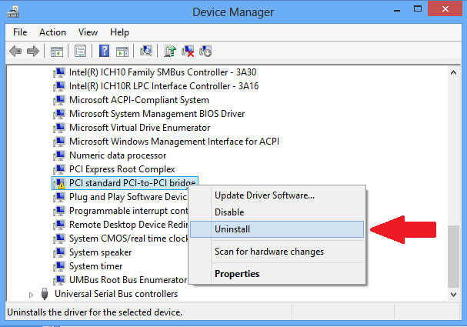

2. - Select “OK” on the Uninstall window.

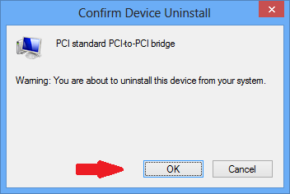

3.- Open the Win 8 task bar and click on the “Settings” icon,

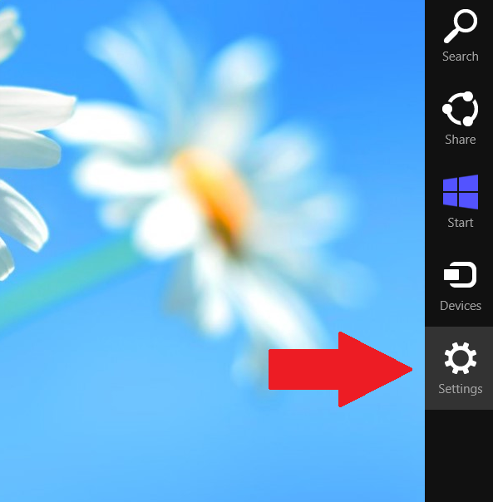

4. - Select “Change PC Settings”.

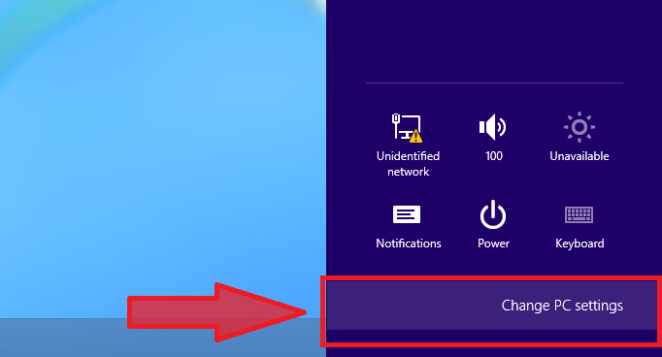

5.- In the “PC settings” windows select the “General” option.

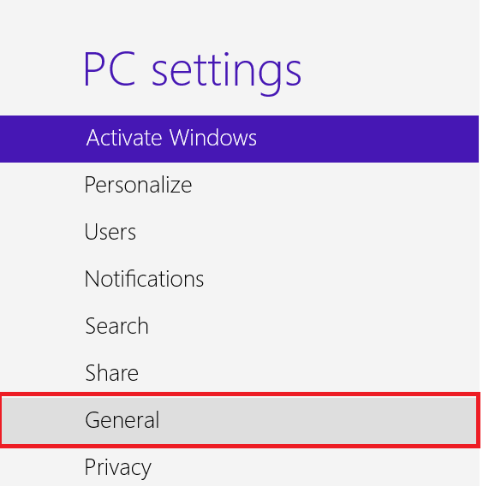

6. - Scroll down and select “Restart Now” on the “Advance startup” section.

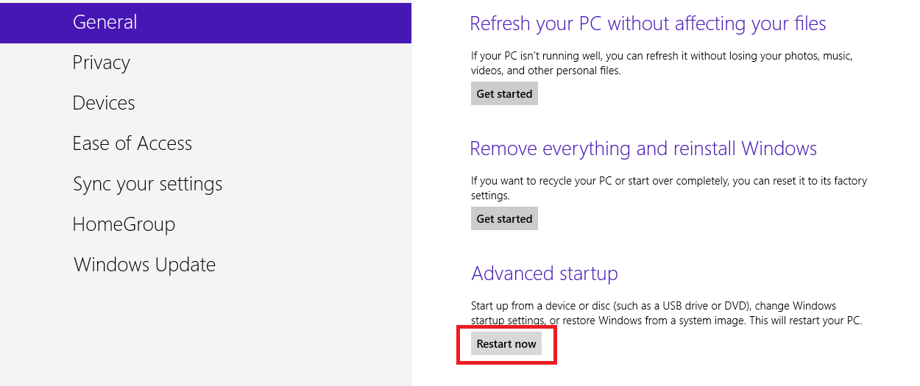

7. - Select “Turn off your PC” option.

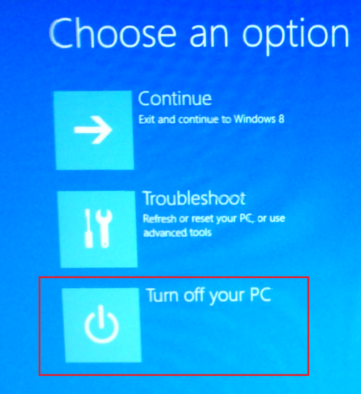

8. - After system reset, both instance will be correctly enumerated.

