Problem Description:
We are using the USB port of DM3730 encountered the following problems:
ARM itself only recognizes the three USB HOST port, failed to identify the peripheral USB HUB, the application used the TI DM3730 + TPS65920 + TUSB1210.
ARM's USB port usage is as follows:

OTG mode: DM3730.USB0 connection tps65920, which is reserved for the usb port;
HOST mode: DM3730.USB1 connection TUSB1210 USB phy, connecting peripherals USB HUB LAN9513;

By USB1 port TUSB1210 phy LAN9513 not recognize peripherals connected to, but the peripherals LAN9513 jumper to tps65920 reserved interfaces, able to identify to the peripheral HUB.
Therefore, whether to apply TUSB1210 where there is a problem?
TUSB1210 use the ULPI interface (input clock mode) ，SCH as bellow：
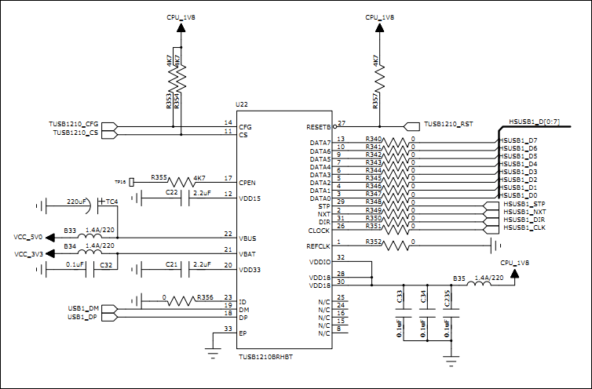

REFCLK tied low to GND，ID tied low to GND，CS，RESET tied high to vcc1V8，VBUS supply external
5V，VDD3V3 Connect to external filtering capacitor.

measuring the ULPI inferface clk ,as bellow:60Mhz
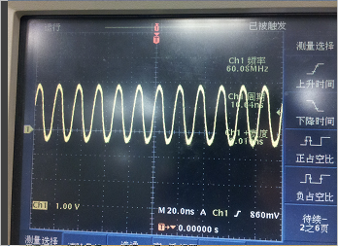
We can measure the ware on the DP/DM of TUSB1210,as bellow：
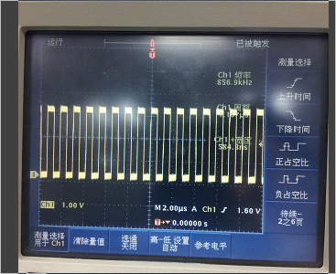

Have three question :
1.What is cause of the square ware about 800Khz；
2.what way to decide the TUSB1210 is really work with average；
3.what problem with this applition？

