DS25CP104A IBIS-AMI Model User Guide

Version: 1.1
Date: 21-01-2013

DS25cp104A AMI Model Parameters
- RX Parameters
- There is only one parameter named EQ which is used to specify the level of equalization.
- The parameter takes the values 0, 1, 2 and 3 in the increasing order of Equalization.

- Tx Parameters
There are two parameters:
- PE
- It specifies the Pre-emphasis level setting.
- It takes the values 0, 1, 2 and 3 in the increasing order of Pre-emphasis.

- Gain_adjust
- This parameter is used for Debug purposes and is fixed to the value of 2.4138.
- It should not be changed by the user.

Note on how to choose Samples per UI simulation parameter:
Samples per UI should be chosen such that, the sample time (UI / Samples per UI) should be less than 10e-12 for accurate results. Typical recommended values for different Bit Rates :
- 1 Gbps – 128 Samples per UI or higher
- 2.5 Gbps- 64 Samples per UI or higher
- 3.125 Gbps- 64 Samples per UI or higher
- 4 Gbps – 64 Samples per UI or higher
- 8 Gbps – 32 Samples per UI or higher

ADS Simulation results
- EQ Performance setup

- Channels : Rx channel = 60’’ 5mil stripline, Tx channel = 0’’ stripline
Parameters: EQ=0, PE=0
Input Source: BitRate=3.125 Gbps PRBS-23, Vp-p = 1V, DE = 0dB

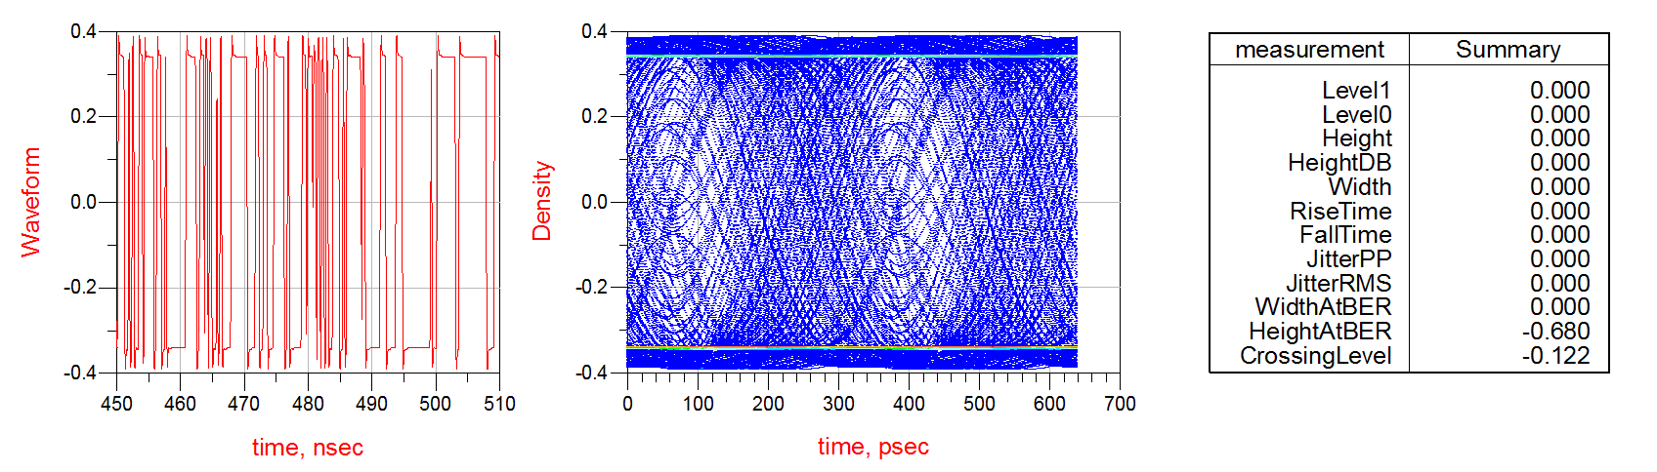
- Channels : Rx channel = 60’’ 5mil stripline, Tx channel = 0’’ stripline
Parameters: EQ=1, PE=0
Input Source: BitRate=3.125 Gbps PRBS-23, Vp-p = 1V, DE = 0dB

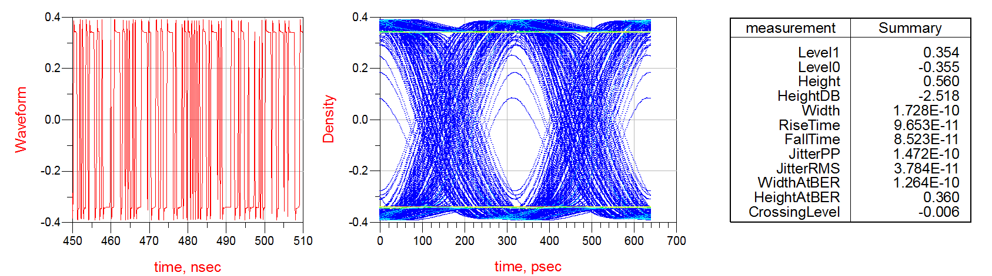

- Channels : Rx channel = 60’’ 5mil stripline, Tx channel = 0’’ stripline
Parameters: EQ=2, PE=0
Input Source: BitRate=3.125 Gbps PRBS-23, Vp-p = 1V, DE = 0dB

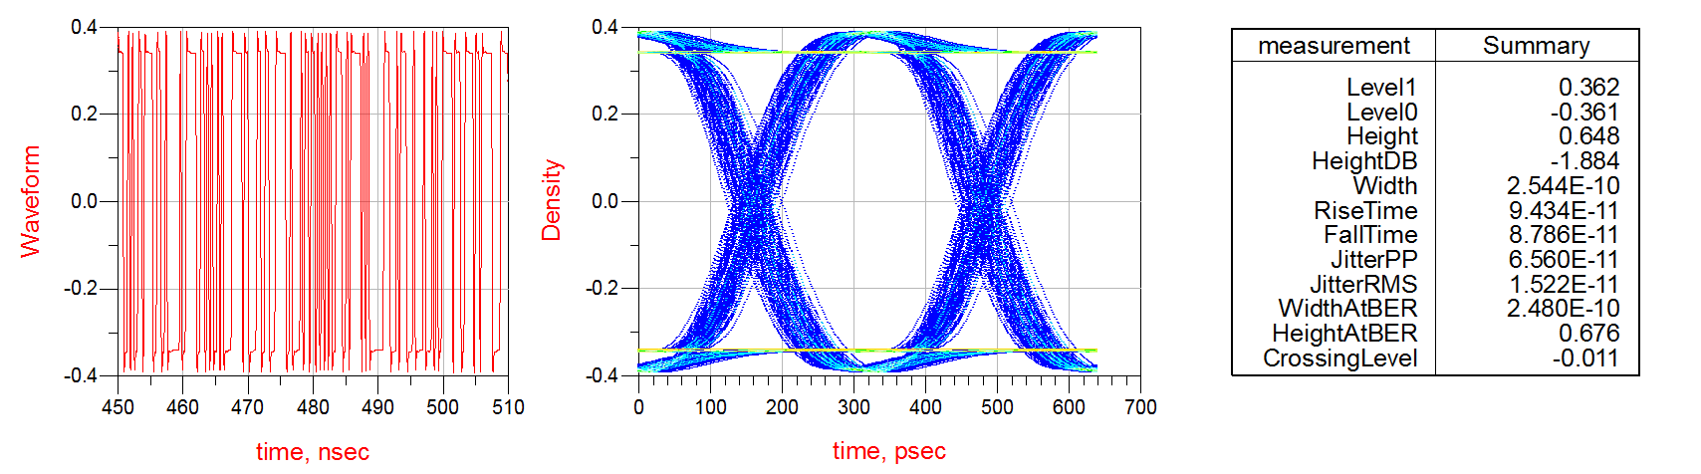

- Channels : Rx channel = 60’’ 5mil stripline, Tx channel = 0’’ stripline
Parameters: EQ=3, PE=0
Input Source: BitRate=3.125 Gbps PRBS-23, Vp-p = 1V, DE = 0dB

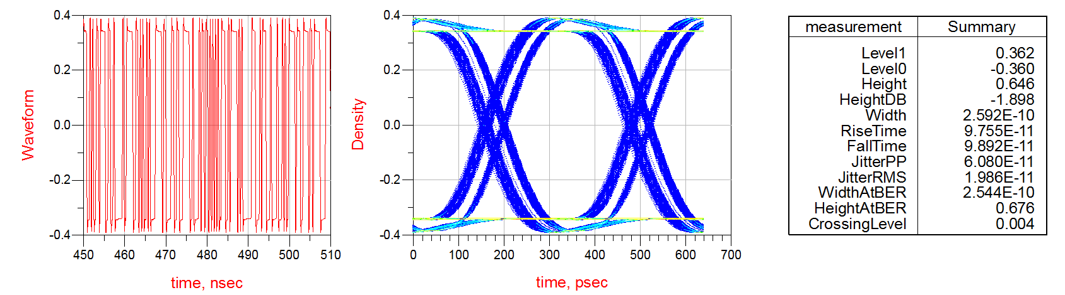

- Channels : Rx channel = 40’’ 5mil stripline, Tx channel = 0’’ stripline
Parameters: EQ=0, PE=0
Input Source: BitRate=3.125 Gbps PRBS-23, Vp-p = 1V, DE = 0dB

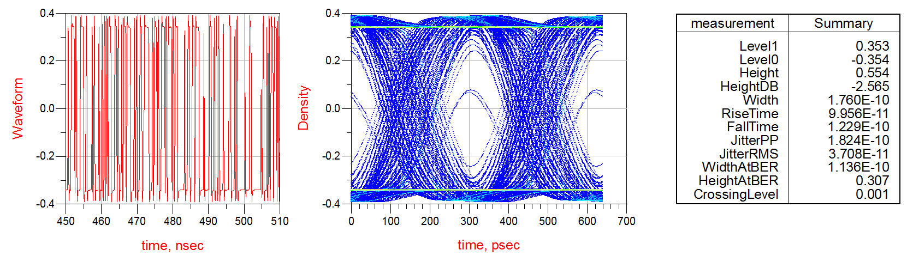

- Channels : Rx channel = 40’’ 5mil stripline, Tx channel = 0’’ stripline
Parameters: EQ=1, PE=0
Input Source: BitRate=3.125 Gbps PRBS-23, Vp-p = 1V, DE = 0dB

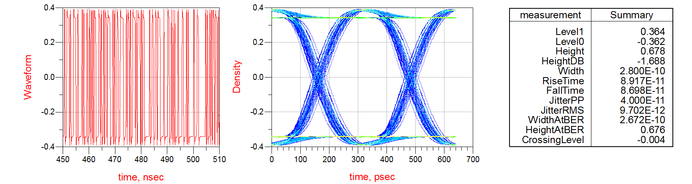

- PE Performance setup

- Channels : Rx channel = 0’’ stripline, Tx channel = 30’’ 5mil stripline
Parameters: EQ=0, PE=0
Input Source: BitRate=3.125 Gbps PRBS-23, Vp-p = 1V, DE = 0dB

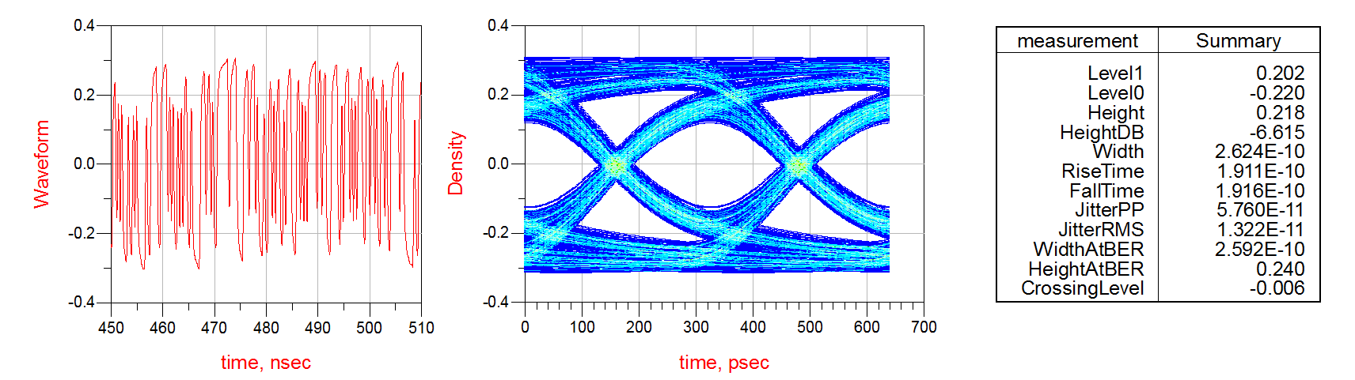

- Channels : Rx channel = 0’’ stripline, Tx channel = 30’’ 5mil stripline
Parameters: EQ=0, PE=1
Input Source: BitRate=3.125 Gbps PRBS-23, Vp-p = 1V, DE = 0dB

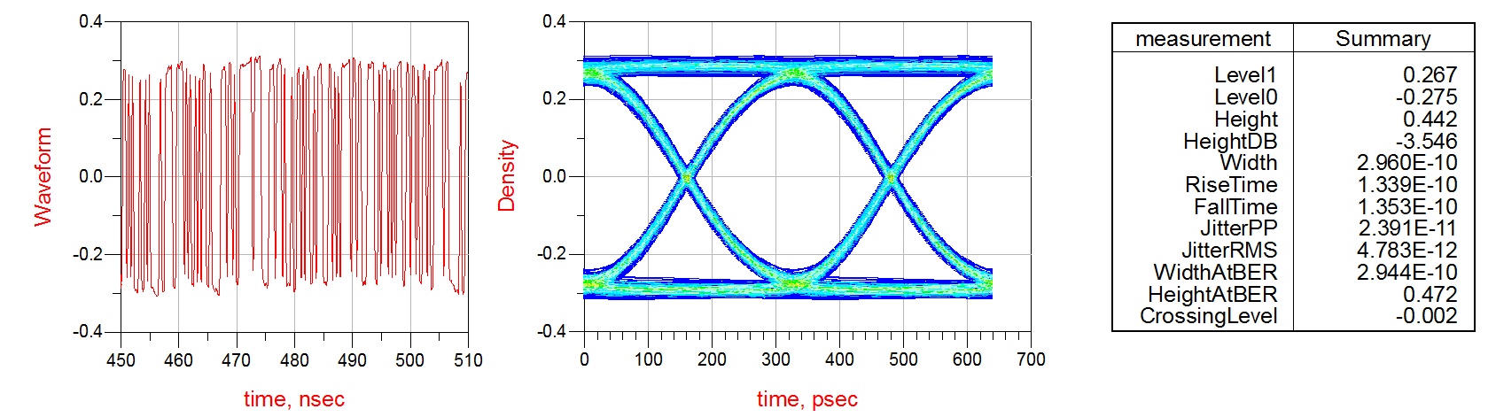

- Channels : Rx channel = 0’’ stripline, Tx channel = 30’’ 5mil stripline
Parameters: EQ=0, PE=2
Input Source: BitRate=3.125 Gbps PRBS-23, Vp-p = 1V, DE = 0dB

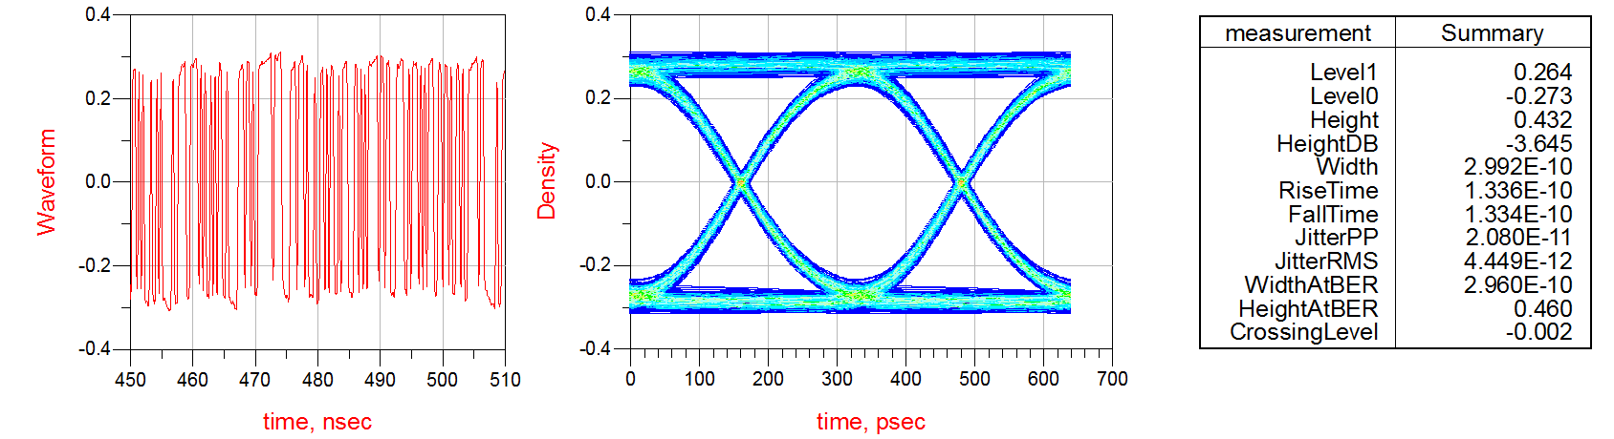

- Channels : Rx channel = 0’’ stripline, Tx channel = 30’’ 5mil stripline
Parameters: EQ=0, PE=3
Input Source: BitRate=3.125 Gbps PRBS-23, Vp-p = 1V, DE = 0dB

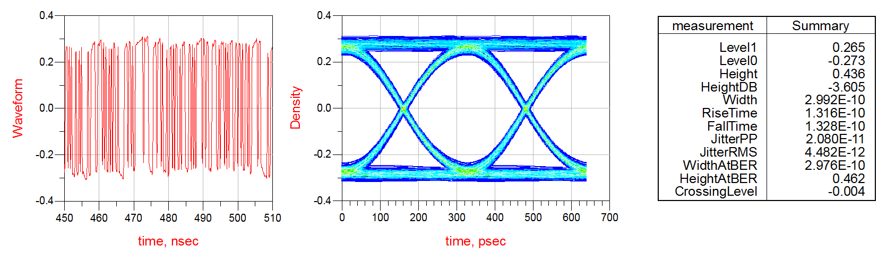

- Channels : Rx channel = 0’’ stripline, Tx channel = 3’’ 5mil stripline
Parameters: EQ=0, PE=0
Input Source: BitRate=3.125 Gbps PRBS-23, Vp-p = 1V, DE = 0dB
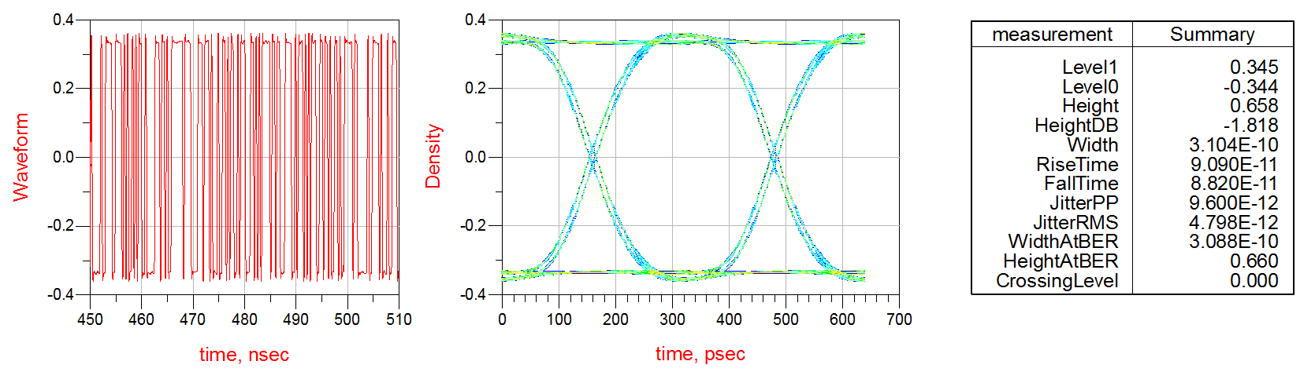

- Channels : Rx channel = 0’’ stripline, Tx channel = 3’’ 5mil stripline
Parameters: EQ=0, PE=1
Input Source: BitRate=3.125 Gbps PRBS-23, Vp-p = 1V, DE = 0dB

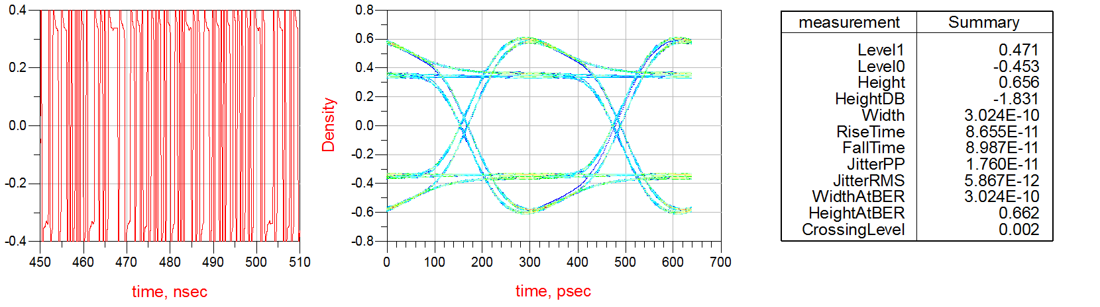

- Setup with lossy channels on Both sides
- Channels : Rx channel = 60’’ 5mil stripline, Tx channel = 30’’ 5mil stripline
Parameters: EQ=2, PE=2
Input Source: BitRate=3.125 Gbps PRBS-23, Vp-p = 1V, DE = 0dB
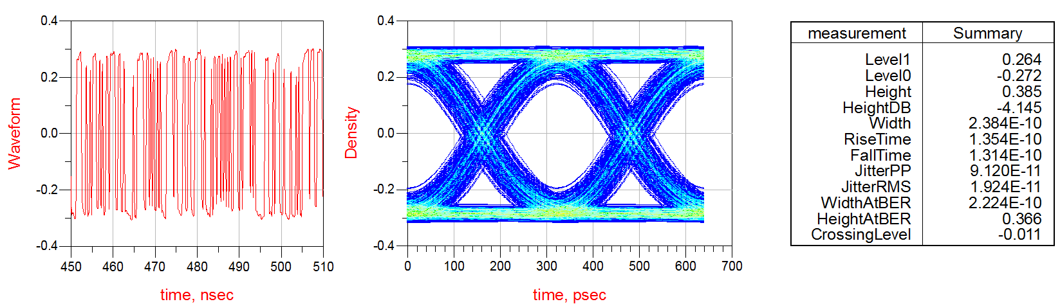
Comparisons with actual Measurements
1)
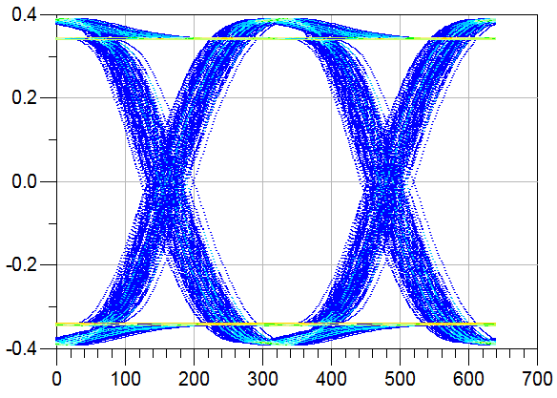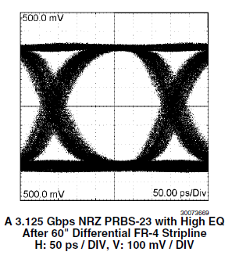
A 3.125 Gbps PRBS-23 source with EQ=2
After 60”” Differential Strip line
2)
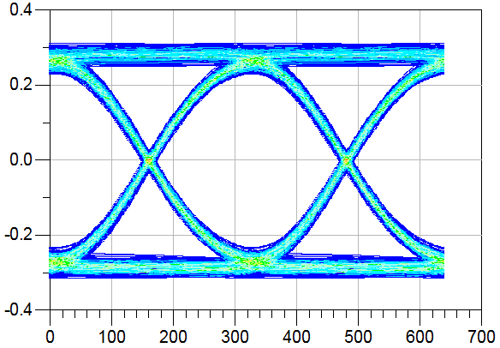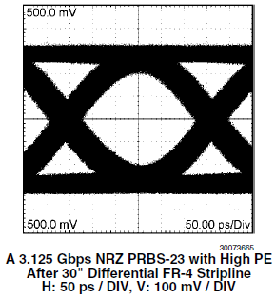
A 3.125 Gbps PRBS-23 source with PE=2
After 30”” Differential Strip line

