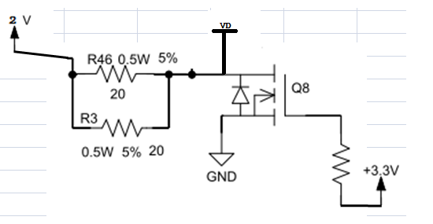

The MOSFET is N-MOSFET and the working condition shows as picture.The Vgs> the threshold and also >VD

The questions are below:

1. Does it working well at saturation state?
2. Is there no risk for the MOSFET ?