Problems with CD74HC4060M
SLP:
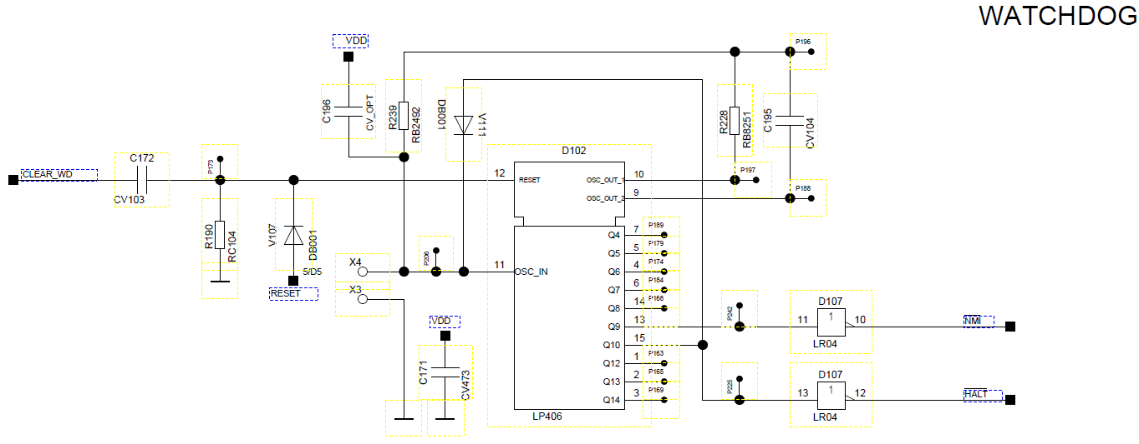
Measurement:
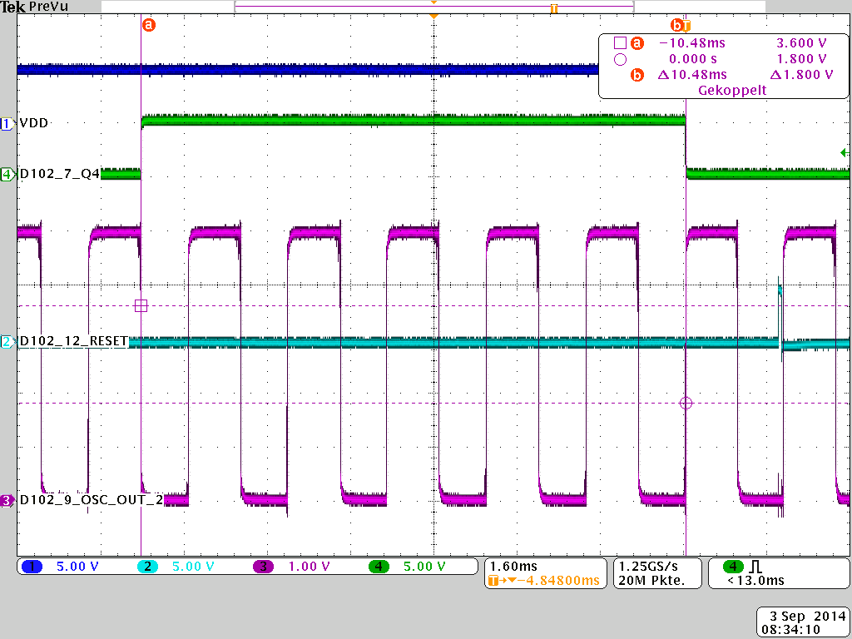  Figure 1 Fault verification | Description | Q4 switches normally after 8 clocks.  Rx = 8.25k Ohm  Cx = 100nF  - F=~550Hz
 | Result | NOK
 | Comment /  Action | There only 5 clocks
 | Reference | GND Pin8
 | CH1 | VDD Pin16
 | CH2 | RESET Pin12
 | CH3 | OSC_OUT_2 Pin9
 | CH4 | Q4 Pin7

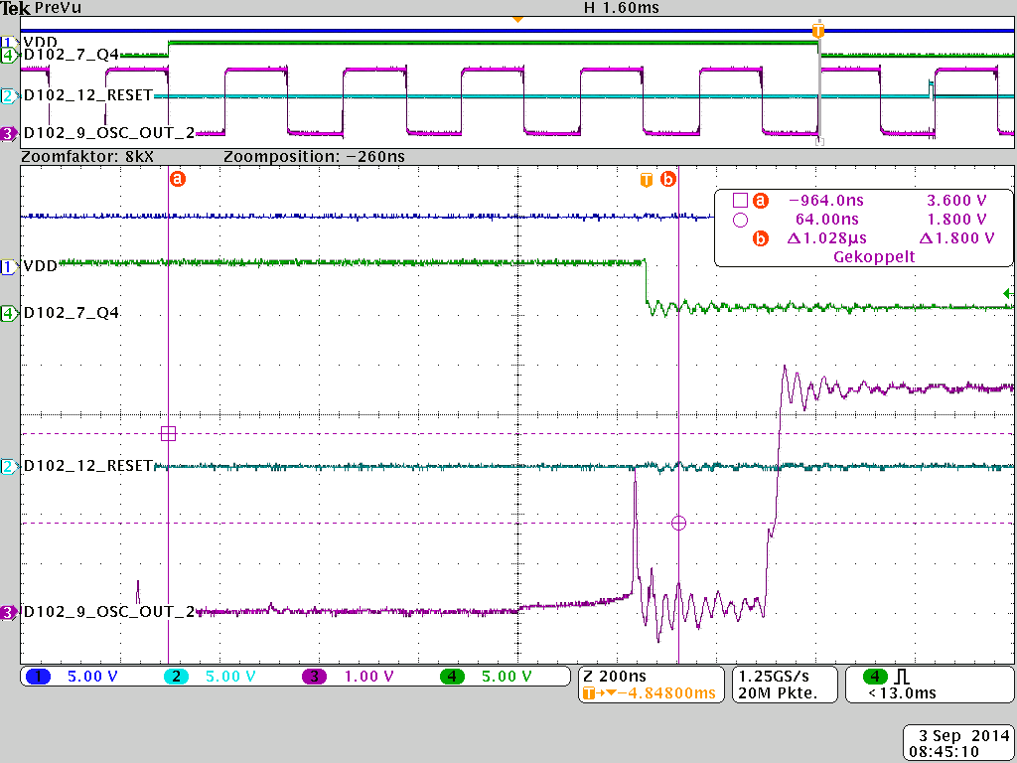  Figure 2 Fault verification | Description | Noise on OSC_OUT_2
 | Result | NOK
 | Comment /  Action | Noise on OSC_OUT causes that Q4 switch to fast.
 | Reference | GND
 | CH1 | VDD Pin16
 | CH2 | RESET Pin12
 | CH3 | OSC_OUT_2 Pin9
 | CH4 | Q4 Pin7

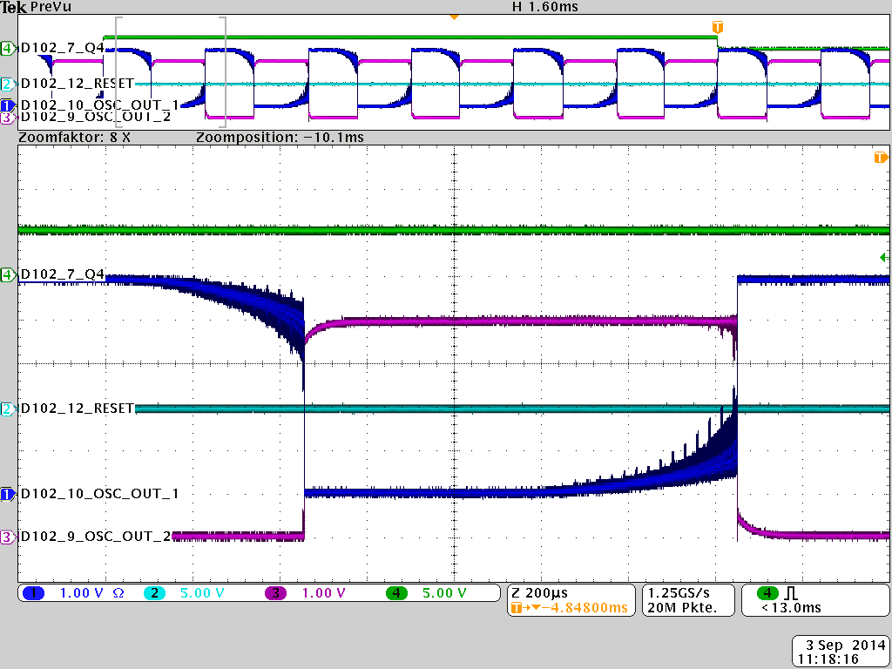  Figure 3 Fault verification | Description | Measurement with active probe on OSC_OUT_1 Pin10
 | Result | NOK
 | Comment /  Action | Noise on both OSC_OUT
 | Reference | GND
 | CH1 | VDD Pin16
 | CH2 | OSC_OUT_1 Pin10
 | CH3 | OSC_OUT_2 Pin9
 | CH4 | Q4 Pin7

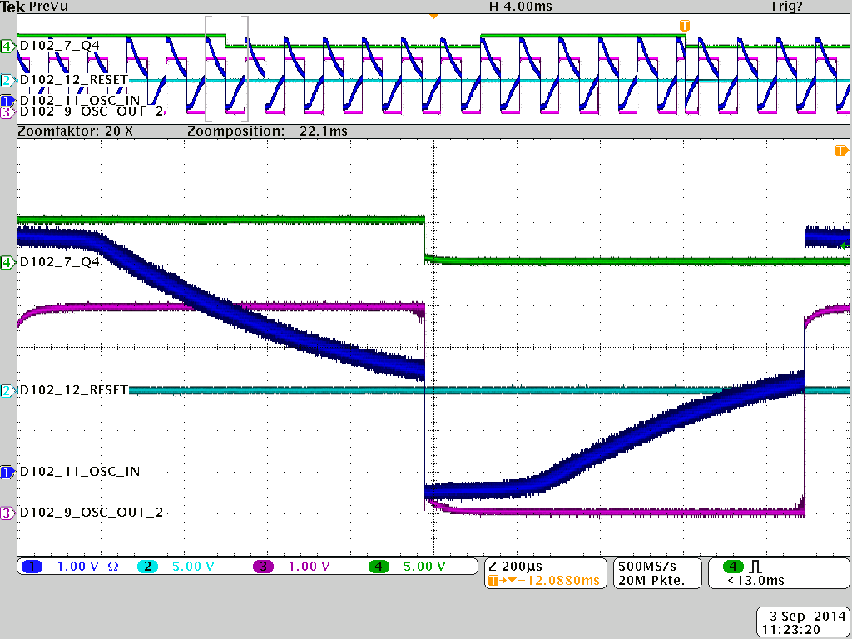Figure 4 Fault verification | Description | Measurement with active probe on OSC_IN Pin11
 | Result | NOK
 | Comment /  Action | Input Rise and Fall Time very long
 | Reference | GND
 | CH1 | VDD Pin16
 | CH2 | OSC_IN Pin11
 | CH3 | OSC_OUT_2 Pin9
 | CH4 | Q4 Pin7

