- Choose workspace
- Create new project:
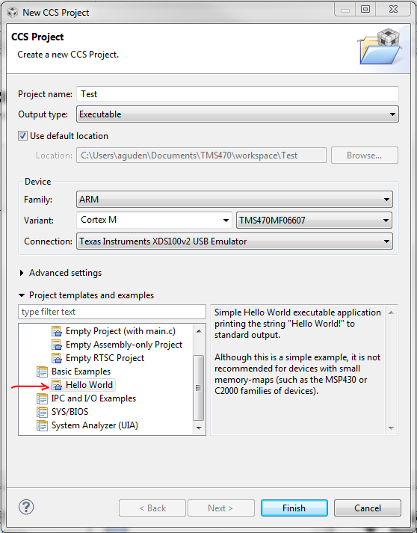
- This is what files are provided, and main code:
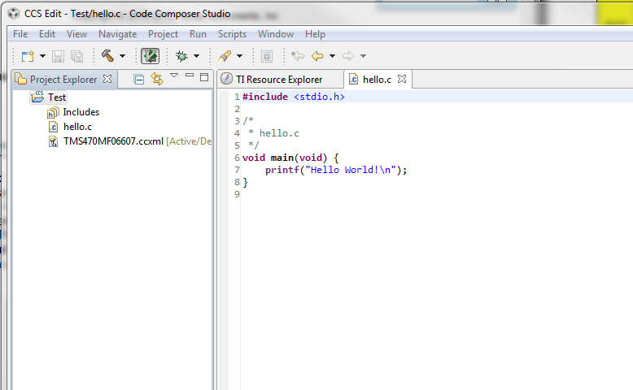
- Build project. Compilation exits with errors:
Here is a dump of the console, so you can see if any flags may have been set wrong or libraries incorrectly referenced, as well as the full error message.
**** Build of configuration Debug for project Test ****

C:\ti\ccsv5\utils\bin\gmake -k all
'Building file: ../hello.c'
'Invoking: ARM Compiler'
"C:/ti/ccsv5/tools/compiler/tms470_4.9.5/bin/cl470" -mv7M3 --code_state=16 --abi=eabi -g --include_path="C:/ti/ccsv5/tools/compiler/tms470_4.9.5/include" --diag_warning=225 --display_error_number --enum_type=packed --preproc_with_compile --preproc_dependency="hello.pp" "../hello.c"
'Finished building: ../hello.c'
' '
'Building target: Test.out'
'Invoking: ARM Linker'
"C:/ti/ccsv5/tools/compiler/tms470_4.9.5/bin/cl470" -mv7M3 --code_state=16 --abi=eabi -g --diag_warning=225 --display_error_number --enum_type=packed -z -m"Test.map" -i"C:/ti/ccsv5/tools/compiler/tms470_4.9.5/lib" -i"C:/ti/ccsv5/tools/compiler/tms470_4.9.5/include" --reread_libs --warn_sections --display_error_number --rom_model --be32 -o "Test.out" "./hello.obj"
<Linking>
warning #10366-D: automatic library build: using library
"C:\ti\ccsv5\tools\compiler\tms470_4.9.5\lib\rtsv7M3_T_be_eabi.lib" for the
first time, so it must be built. This may take a few minutes.
cygwin warning:
MS-DOS style path detected: c:/ti/ccsv5/tools/compiler/tms470~1.5/lib/rtssrc.zip
Preferred POSIX equivalent is: /cygdrive/c/ti/ccsv5/tools/compiler/tms470~1.5/lib/rtssrc.zip
CYGWIN environment variable option "nodosfilewarning" turns off this warning.
Consult the user's guide for more details about POSIX paths:
http://cygwin.com/cygwin-ug-net/using.html#using-pathnames
cygwin warning:
MS-DOS style path detected: C:\Users\aguden\Documents\TMS470\workspace\Test\Debug
Preferred POSIX equivalent is: /cygdrive/c/Users/aguden/Documents/TMS470/workspace/Test/Debug
CYGWIN environment variable option "nodosfilewarning" turns off this warning.
Consult the user's guide for more details about POSIX paths:
http://cygwin.com/cygwin-ug-net/using.html#using-pathnames
cygwin warning:
MS-DOS style path detected: C:\Users\aguden\Documents\TMS470\workspace\Test\Debug
Preferred POSIX equivalent is: /cygdrive/c/Users/aguden/Documents/TMS470/workspace/Test/Debug
CYGWIN environment variable option "nodosfilewarning" turns off this warning.
Consult the user's guide for more details about POSIX paths:
http://cygwin.com/cygwin-ug-net/using.html#using-pathnames
cygwin warning:
MS-DOS style path detected: C:\Users\aguden\Documents\TMS470\workspace\Test\Debug
Preferred POSIX equivalent is: /cygdrive/c/Users/aguden/Documents/TMS470/workspace/Test/Debug
CYGWIN environment variable option "nodosfilewarning" turns off this warning.
Consult the user's guide for more details about POSIX paths:
http://cygwin.com/cygwin-ug-net/using.html#using-pathnames
--> error: '*.obj
' not found
gmake.exe[1]: *** [library] Error 1
>> ERROR: mklib: gmake error during rtsv7M3_T_be_eabi.lib build
warning #10207-D: automatic RTS selection: resolving index library "libc.a" to
"C:\ti\ccsv5\tools\compiler\tms470_4.9.5\lib\rtsv7M3_T_be_eabi.lib", but
"C:\ti\ccsv5\tools\compiler\tms470_4.9.5\lib\rtsv7M3_T_be_eabi.lib" was not
found
error #10198-D: no input section is linked in
warning #10062-D: entry-point symbol "_c_int00" undefined
warning #10202-D: no suitable entry-point found; setting to 0
error #10010: errors encountered during linking; "Test.out" not built

>> Compilation failure
gmake: *** [Test.out] Error 1
gmake: Target `all' not remade because of errors.

**** Build Finished ****

