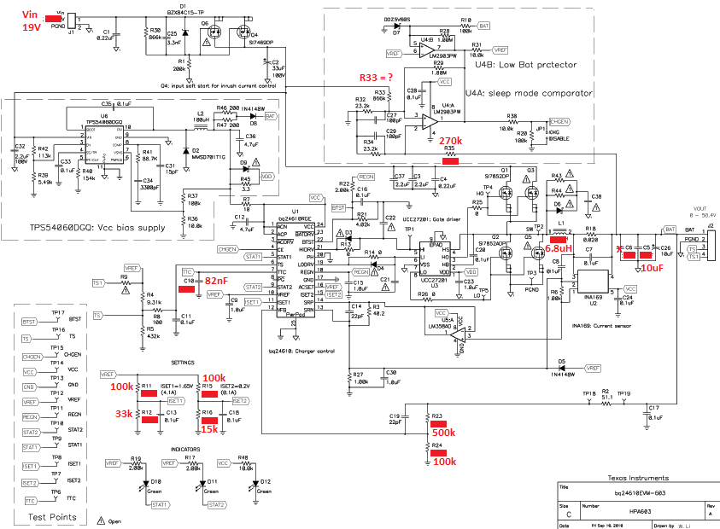This modification is done for 3-Cell lion battery charging application. In this modification, the charge current is set to 2A. The Battery Voltage is set to 12.6V. The precharge and termination currents are set to 0.2A. The safety time is set to 7.6h by 82nF capacitance.

In sleep mode comparator part, the possitive input voltage of U4A is needed to set by the resistor **R33**. The “-“ input of U4A is set to 1V by the resistor R35 (270k).

At the 19V input voltage, it is not certain the TPS54060 works correctly. TPS54060 needs modification to be certain about if it is going to work correctly at the 19V input voltage.

**Vin = 19V**

3 Cell, VBAT = 12.6V, ICHARGE = 2A, IPRECHARGE/TERM = 0.2A, 7.6h safety timer.

R11 =100k

R12 =33k

R15 =100k

R16 = 15k

R23 =500k

R24 =100k

C6 =0

C5 = 10uF

L1 = 6.8uH

R35 = 270k

C10 =82nF