Sample test circuit using LM7171AIN

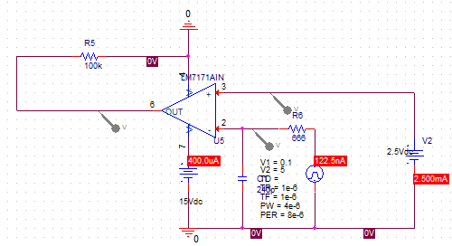

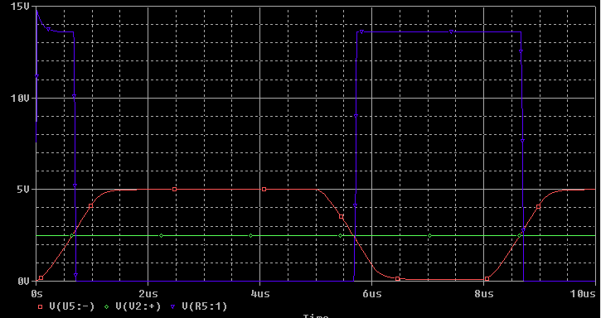

This where indicates it shows that it rises when the negative input is smaller than the positive input using LM7171AIN

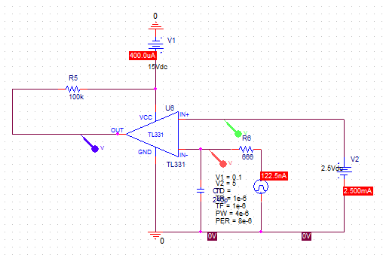

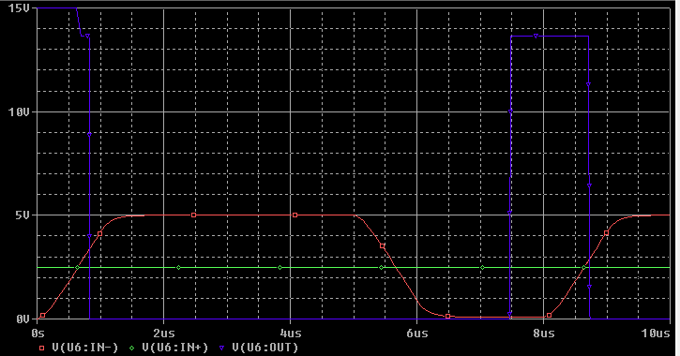

This where indicates it shows that it doesn’t use when the negative input is smaller than the positive input using TL331 for the same circuit