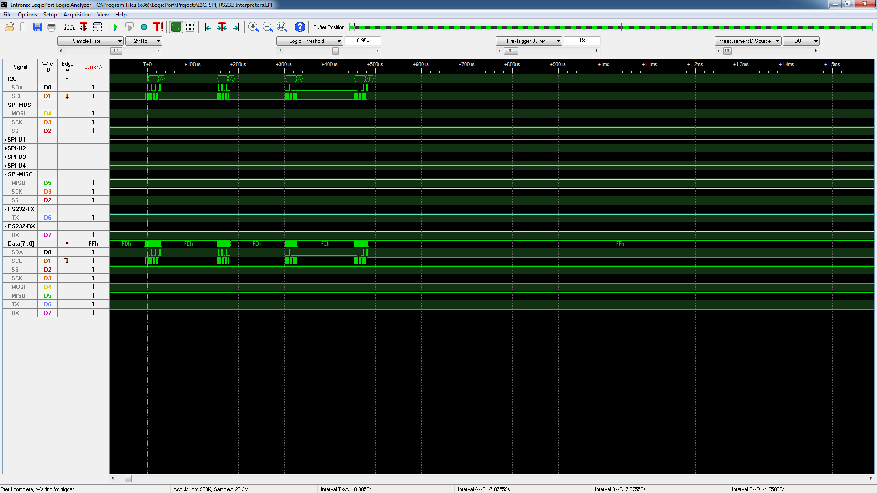

Voltage Read (ninth bit clock stretch)