UCC28600 Questions

The following is my flyback converter. The input is from a battery (21V to 36V), not from AC line. The status output is left open. I combine Vbias and Cstart in one cap and removed D2, D3 and Rbias. Will this cause any problems? Please see my circuit.

My Rsu (R2) = 100K and the Cap on Vdd is C6=10uF. How long is the startup time at Vbatt = 21V due to the 1s time constant?

UCC28600 calculator does not have back control section. Please check my TL431 compensation parameters to see if they are correct.

The design requirement is listed. If you find any other problems, please let me know.

I appreciate your help.

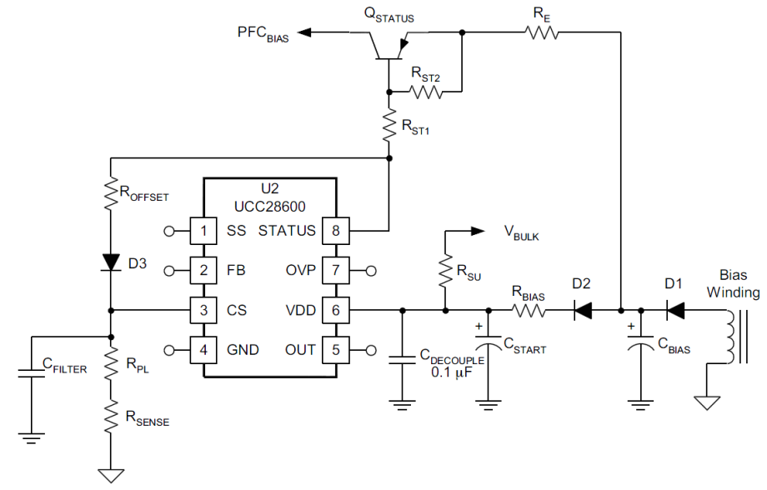

|  |  |  |
| --- | --- | --- |
| Flyback Circuit 80KHz |  |  |
| Max Input Voltage Vin | 36 | V |
| Mim Input Voltage Vin | 21 | V |
| Output Voltage V1 | 13 | V |
| Output Voltage V2 | 5.5 | V |
| Output Voltage V3 | 13 | V |
| Output Power P1 | 6.8 | W |
| Output Power P2 | 1 | W |
| Output Power P3 | 0.2 | W |
| Total Output Power = | 8 | W |
| Efficiency-η | 0.8 |  |
|  |  |  |
| **Minimum Switching fre fs at Vin(min)** | **80** | **KHz** |
| Maximum Duty at Vin(min) = | 0.40 |  |
| Turns Ratio, Nprim:Nsecond1 = | 1.00 |  |
|  |  |  |
| **Primary Inductance Lm =** | **44.1** | **uH** |
| **Lm Charging Time at Vin(min), Tcharge =** | **5.00** | **us** |
| **Max Primary Ipk at Vin(min) =** | **2.38** | **A** |

