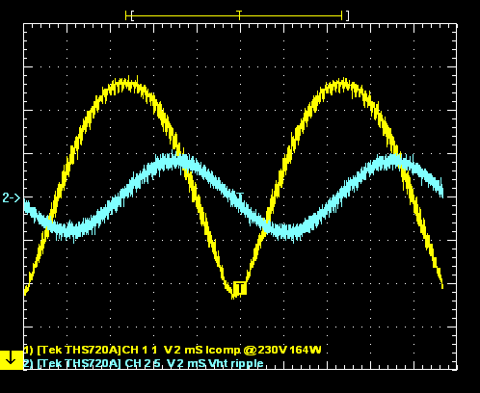
Yellow = Icomp @ 230V 164W. reference = bottom line. Blue = Vht ripple @ 5V/div

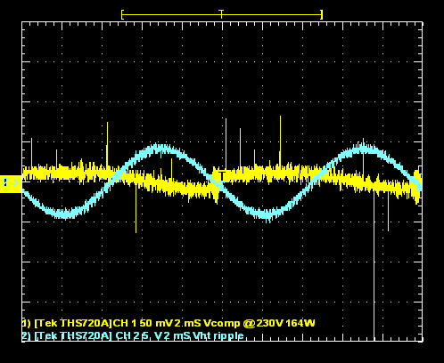
Second picture is Vcomp ripple at the same load point
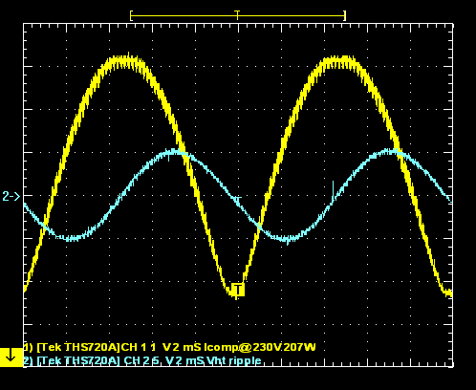
I comp vs Vht ripple at 230V 207W input reference for I comp is -4 div (bottom line)

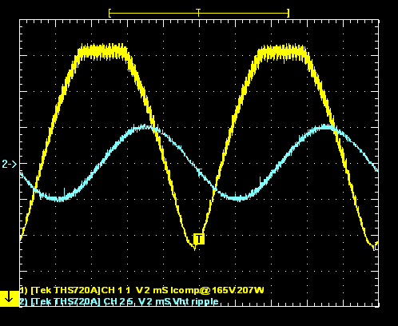
Icomp vs Vht ripple @ 165V 207W input

