Tamb = 25C | UCC28070 in low temperature
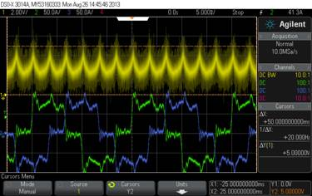 | 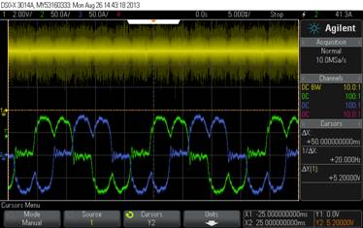
Ch.1 – V_IMO (U10 pin 6)
Ch.2 – L1 phase current
Ch.3 – L2 phase current
Ch.4 – channel off

Pout=16kW
Mains=3x175V
PFC boosts voltage to 600V.
Pic. 1 Input current waveforms @Tamb=25C (left), @Tamb (+10C and lower)

Pic. 2 Vinac voltage divider (VIANC net)
Pic. 3 UCC28070 PFC controller

