.
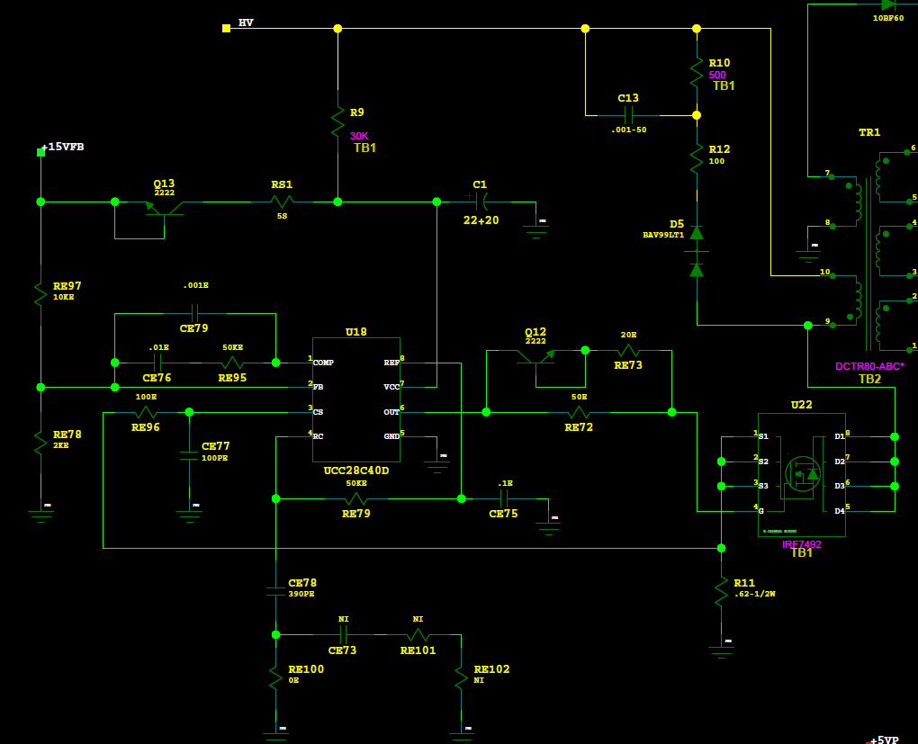

Current through R11= 0.62Ω Imax= 225mA at 7VHV in

10/20/2014
Replace R11, U18, U22, RE72, RE73 RE96, Q12
The Drive produce current as sample board

Use a power board to make 5VLS and connect that power board with same HV=24V will supply to the amplifier

Connect series 1Ω resistor with motor out with 1mH load inductance and try to kill the FET in DC_DC circuit but nothing happen

The SC only working with HV= 30VHV or higher
If try to do SC at 20VHV for a long time (do not see SC error in Drive Status) then it will burn the SC shunt resistor

