1. XLAT pulse is about 3.5uS

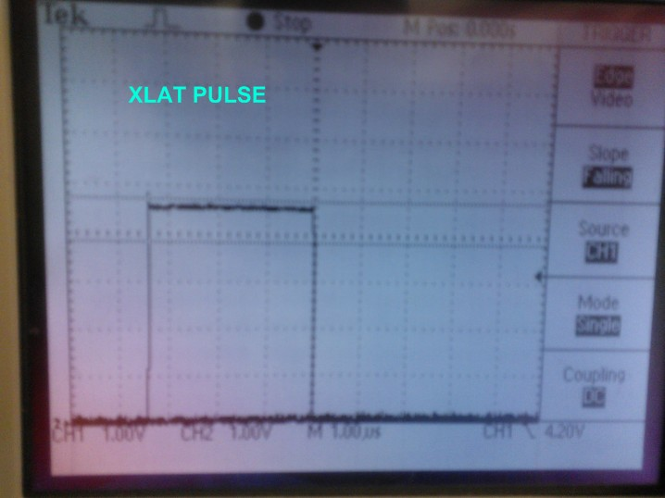

1. Blank pulse and XLAT pulse together

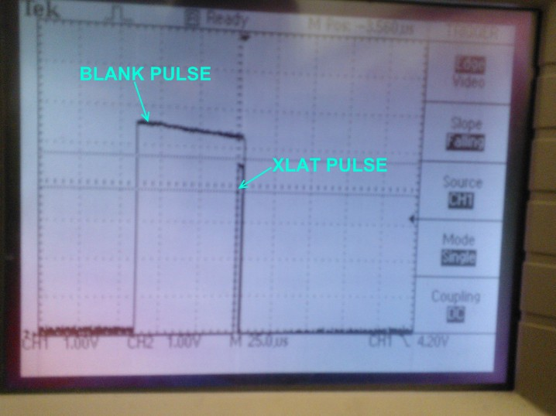

1. Zoomed in on the Blank and XLAT pulse

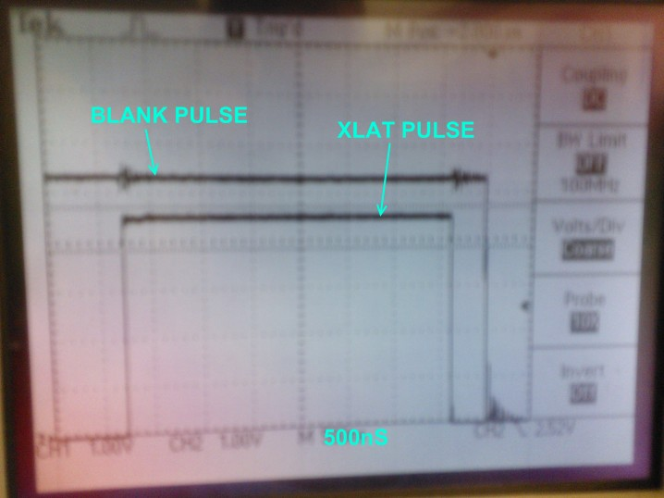

1. The following shows the Blank/XLAT pulse together and then a spurious pulse on the XLAT line. This spurious pulse is about 200uS and appears randomly at various times. Just happened to capture it at about 4mS after the original XLAT pulse.

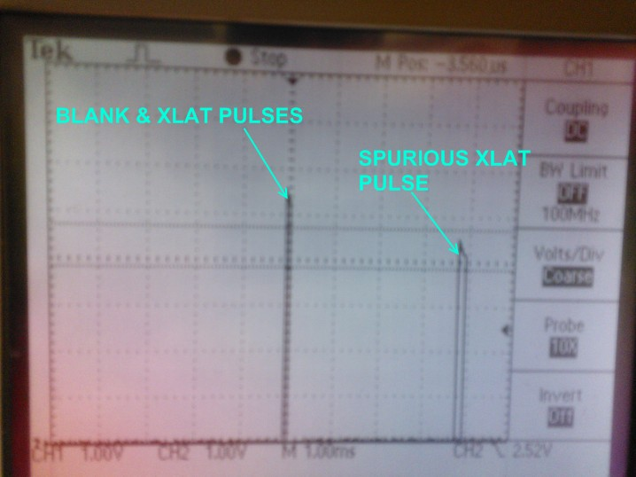

1. GSCLK

