<Inquiry regarding TPS54360 behavior on light load>

１．We have captured the signal on BOOT pin of TPS54360 (TPS54360EVM-182)
CH2 is the actual waveform on BOOT pin, which is measured on same load condition.
1.1 Input: DC27V, Output: DC5Ｖ@0.017A
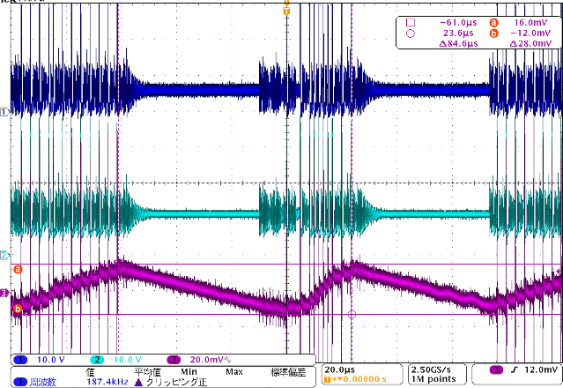
CH1: TP5 voltage (10V/div), CH2: BOOT pin (10V/div), CH3: Output ripple voltage (20mV/div)
H: 20us/div

1.2 Input: DC27V, Output: DC5V@0.33A
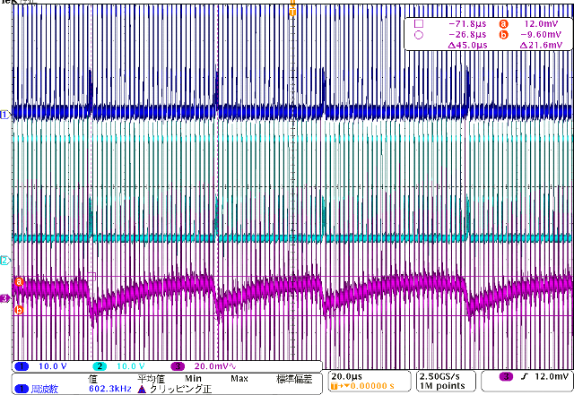
CH1: TP5 voltage (10V/div), CH2: BOOT pin (10V/div), CH3: Output ripple voltage (20mV/div)
H: 20us/div

1.3 Enlarged view on item 1.2
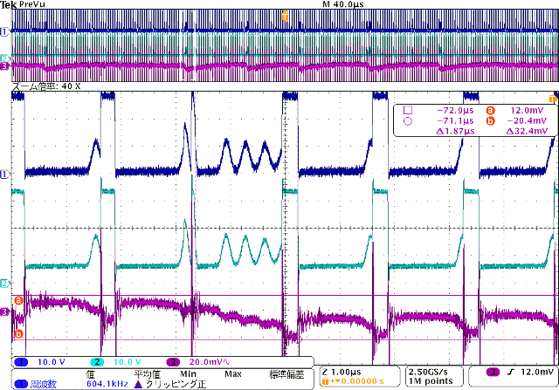
CH1: TP5 voltage (10V/div), CH2: BOOT pin (10V/div), CH3: Output ripple voltage(20mV/div),
H: 40us/div, 1us/div (40 times zoom)

1.4 Input: DC40V, Output: DC5V@0.35A
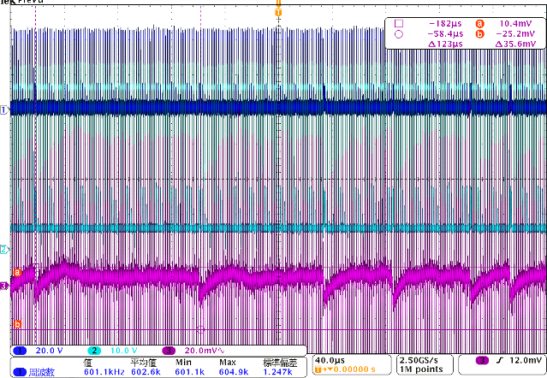
CH1：TP5電圧(20V/div)，CH2：BOOTﾋﾟﾝ(10V/div),CH3：出力ﾘｯﾌﾟﾙ電圧(20mV/div)，H：40μs/div,

1.5 Enlarged view on item 1.4
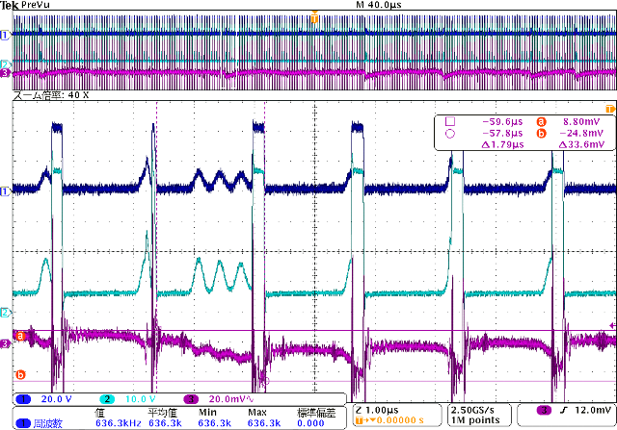
CH1: TP5 voltage (20V/div), CH2: BOOT pin (10V/div), CH3: Output ripple voltage (20mV/div)，
H：40us/div, 1us/div (40 times zoom)

