Very strange

maybe we got bad party or something like that

I connecting FSW to GND or VOUT at my new design

the problem of current design (that using) 62143 is that FSW was connected to VIN

this is the reason why I left it floating this time otherwise the circuit is damaged

see layout for TPS62142

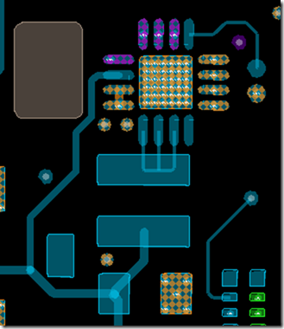

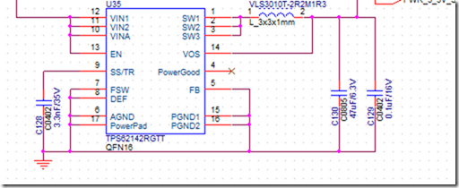

see layout of TPS62143

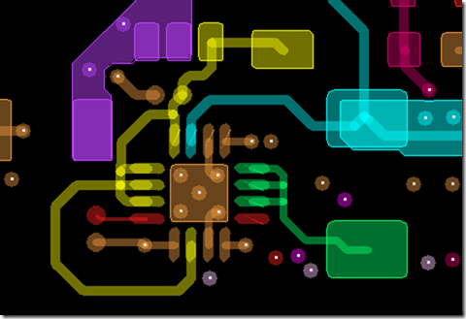

I have cut PIN number 7 at PCB to avoid PWR supply reach FSW as result FSW is not connected to board

our power supply provides up to 3A @ 12V