<Inquiry regarding TPS54360 behavior on light load>
-Background-
We found some unstable behavior when seeing waveform on switching frequency and output ripple on TPS54360EVM-182, when adopting light load (Iout = 0~0.5A).
Please refer to the items below and feedback us with your comment, in order to clarify this root cause.
<The result of evaluation on TPS54360EVM-182>
- Input: DC27V, Output: DC5Ｖ@0.017A
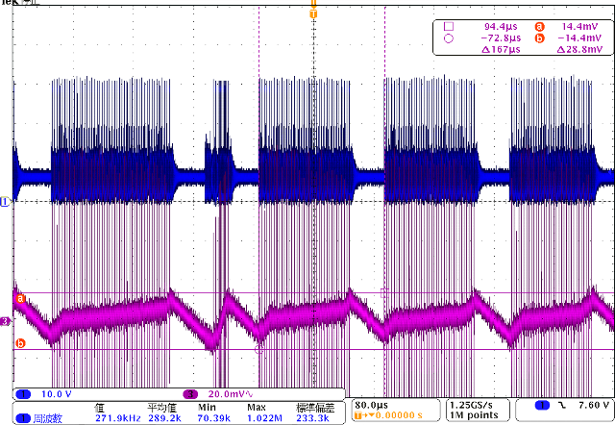
CH1:TP5 voltage(10V/div), CH3:Output ripple voltage(20mV/div)，H:80us/div
- Input: DC:7V, Output: DC5V@ 0.33A
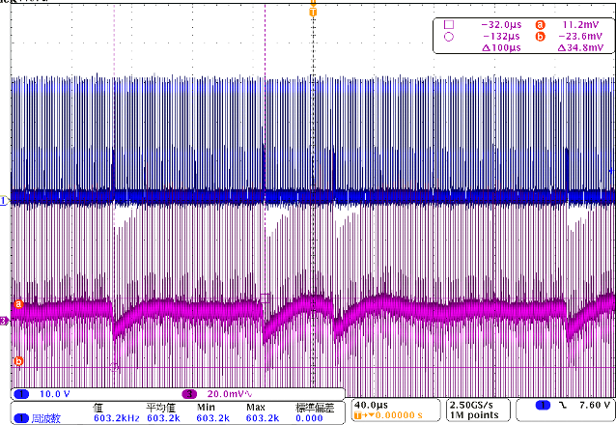
CH1:TP5 voltage (10V/div), CH3: Output ripple voltage(20mV/div), H: 40us/div
- Enlarged view on item 1.2
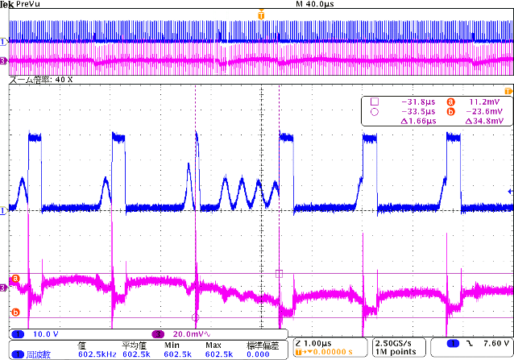
CH1:TP5 voltage (10V/div), CH3: Output ripple voltage (20mV/div), H: 40us/div, 1us/div (40 times zoom)
- Input: DC40V, Output: DC5V@0.35A
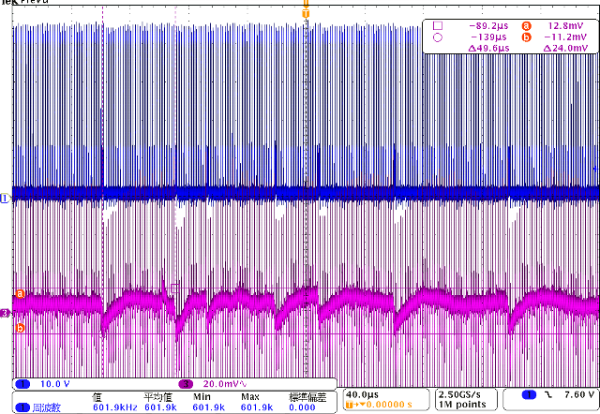
CH1: TP5 voltage(10V/div)，CH3: Output ripple voltage (20mV/div), H:40us/div,

- Enlarged view on item 1.4
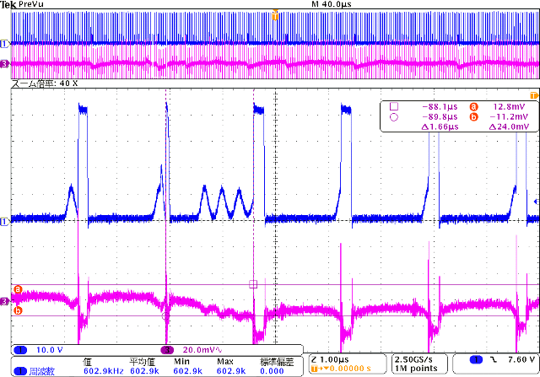
CH1: TP5 voltage(10V/div), CH3: Output ripple voltage (20mV/div), H:40us/div,1us/div(40 times zoom)

