Oscilloscope captures of 1kHz large oscillation in Vout and noise on Vout and PN nodes

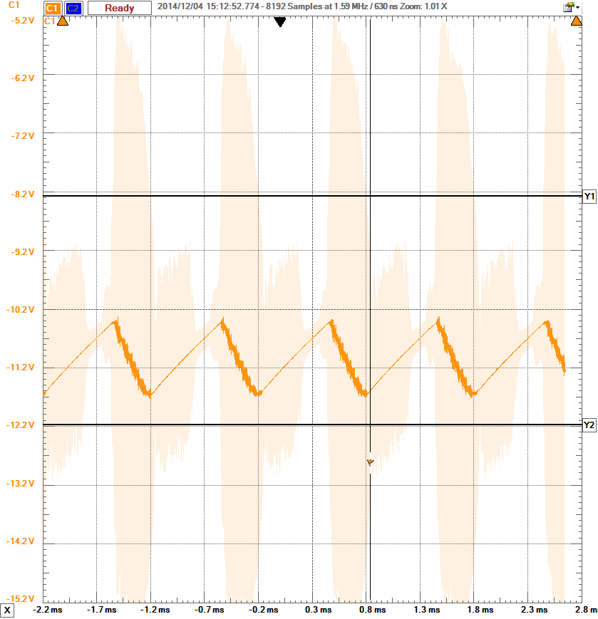

Vout node 1kHz 1 Vpp slow ripple.

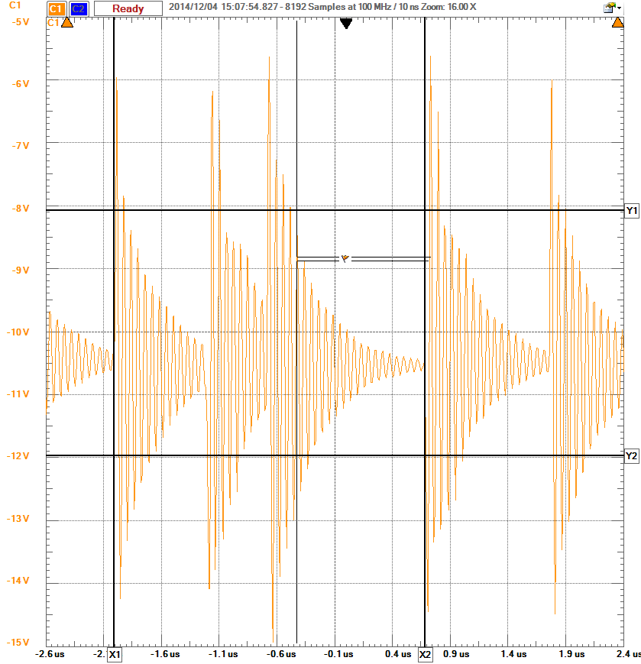

Vout node high frequency capture

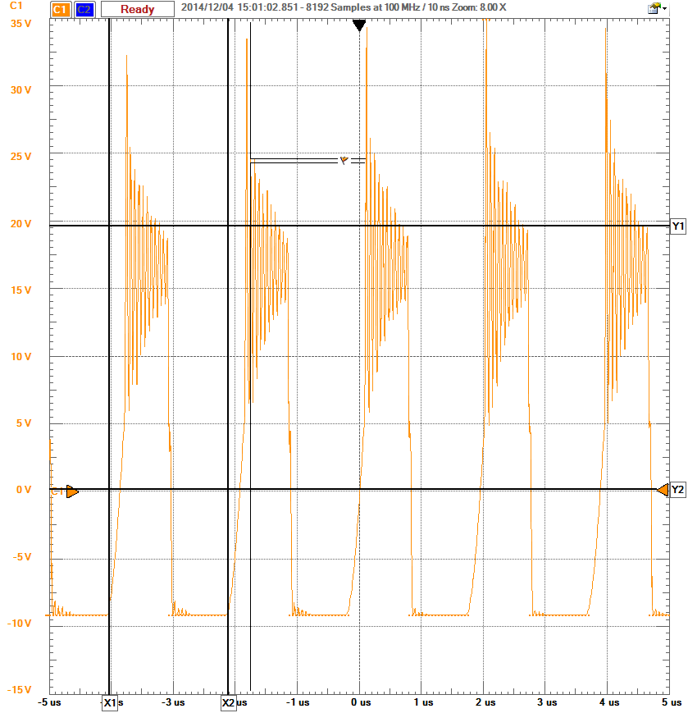

Phase node - it is indeed switching at 500kHz

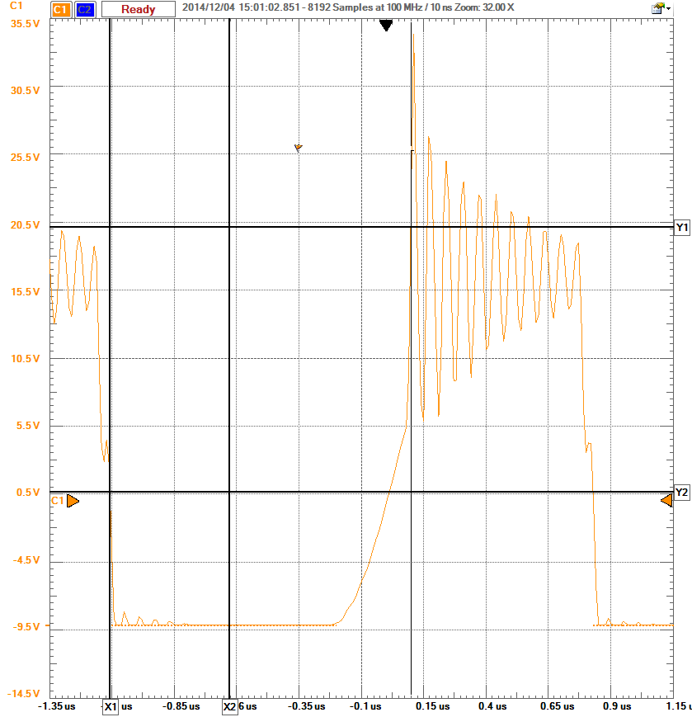

Close up of single cycle on Phase node