**TPS63060DSC**

**Circuit Diagram:**

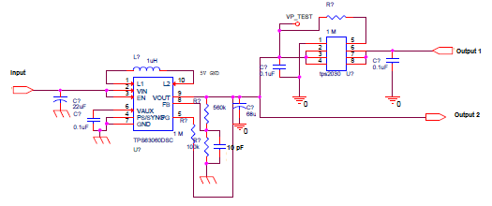

|  |  |  |  |  |  |  |
| --- | --- | --- | --- | --- | --- | --- |
| **Sl No.** | **IC**  **Parameter** | TPS63060DSC | | | | |
|  |  |
|  |  | **With Current Limiter ( TPS 2030)** | | | | |
|  |  | **OutputVoltage in Volts** | **Drawn Input Current in mA** | **Spike Voltage in mV** | **Ripple Voltage in mV** | **Ripple frequency in KHZ** |
| 1 | Cut in Voltage | At 2.2 V | 230 |  |  |  |
| 2 | Inrush Current |  |  |  |  |  |
| 3 | Hysteresis | 2.2V - 1.9V  (300mV) |  |  |  |  |
| 6 | Input Voltage for 3V | 3.34 | 160 | 324 | 220 | 385 |
| 7 | Input Voltage for 3.5V | 3.34 | 130 | 356 | 300 | 344.8 |
| 8 | Input Voltage for 4V | 3.34 | 110 | 512 | 370 | 277.7 |
| 9 | Input Voltage for 4.5V | 3.34 | 100 | 540 | 440 | 384 |
| 10 | Input Voltage for 5V | 3.33 | 90 | 576 | 510 | 416.6 |
| 11 | Input Voltage for 5.5V | 3.33 | 80 | 588 | 540 | 416.6 |
| 12 | Input Voltage for 6V | 3.33 | 80 | 624 | 590 | 416.6 |
| 13 | Input Voltage for6.5V | 3.32 | 70 | 660 | 600 | 416.6 |
| 14 | Input Voltage for 7V | 3.32 | 70 | 708 | 660 | 416.6 |
| 15 | Input Voltage for 7.5V | 3.32 | 60 | 740 | 710 | 384.6 |
| 16 | Input Voltage for 8V | 3.33 | 60 | 764 | 720 | 384.6 |
| 17 | Input Voltage for8.5V | 3.33 | 60 | 768 | 740 | 344.8 |
| 16 | Input Voltage for 9V | 3.35 | 50 | 760 | 750 | 312.5 |
| 17 | Input Voltage for 9.2V | 3.35 | 50 | 760 | 740 | 312.5 |

The Waveforms are as follows:

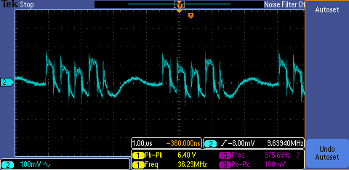

Input Voltage is 2.2V

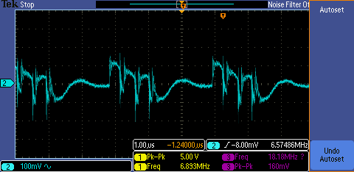

Input Voltage is 3.0V

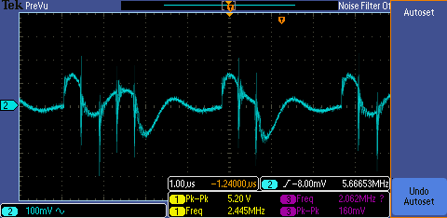

Input Voltage is 3.5V

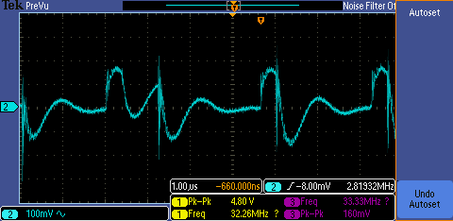

Input Voltage is 4.0V

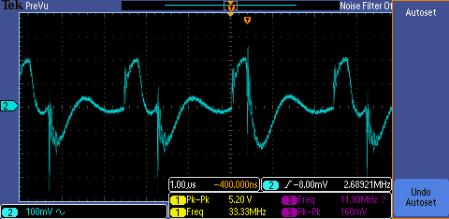

Input Voltage is 4.5V

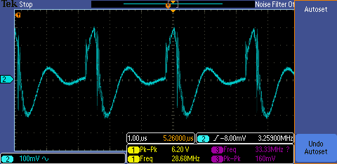

Input Voltage is 5.0V

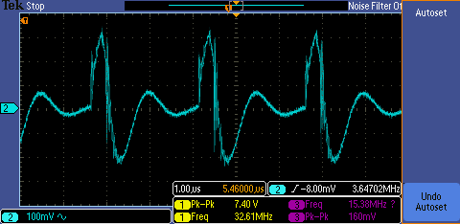

Input Voltage is 5.5V

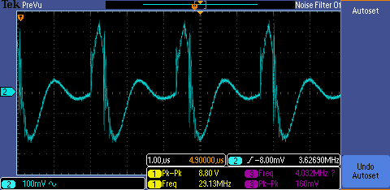

Input Voltage is 6.0V

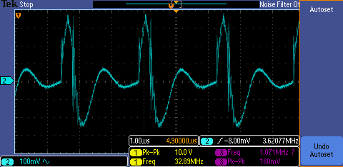

Input Voltage is 6.5V

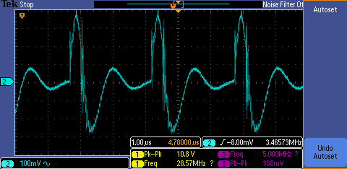

Input Voltage is 7.0V

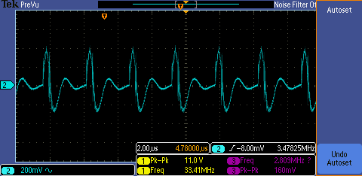

Input Voltage is 7.5V

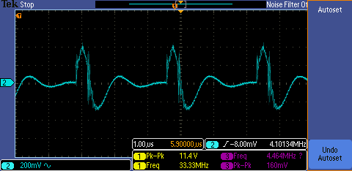

Input Voltage is 8.0V

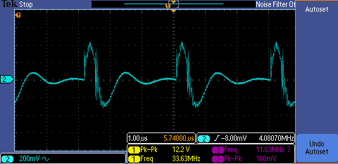

Input Voltage is 8.5V

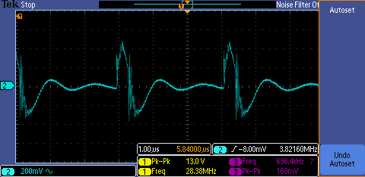

Input Voltage is 9.0V

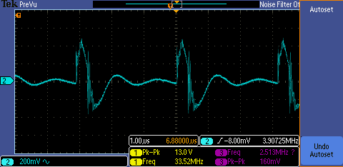

Input Voltage is 9.2V