the layout picture is real

you don't see everything because we using laser vias

you can see the missing part,

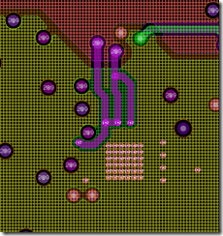

I know about FSW it is noted in datasheet, but my current board with TPS62143 was designed using FSW connected to VIn, this is reason why I remove the pad and left it not connected this time

will be fixed in feature design

anyway I would like to test your EVB, because I need to take decision witch parts to use in my new designs

My current status

1) I have replaced the TPS62143 with TPS62110 (by adding some patch board from outside)

2) I am bringing up board that uses TPS62142 and it makes me a lot of troubles because I need to replace it each time when the power overloaded or shorted

the shortcuts caused in most cases by oscilloscope probe during firmware development, all board hardware works fine