WEBENCH to TINA-TI Export

You can now export your customized schematic and simulation models from WEBENCH to popular simulators including TINA-TI and Altium. This feature called ‘Simulation Export” has been enabled for this device within WEBENCH. The advantage of using this approach to get the TINA-TI simulation files is that you start from a working customized schematic for your application, not just a reference design which saves you time and effort and avoids mistakes.

In order to export your customized design and simulation files to TINA-TI, please follow the following steps:

1. Enter your design specifications into the WEBENCH Panel for this device. This can be found in the product folder for the device that you are looking at. For this example, we are using TPS54620. Once you have entered you specifications, click on “Open Design”

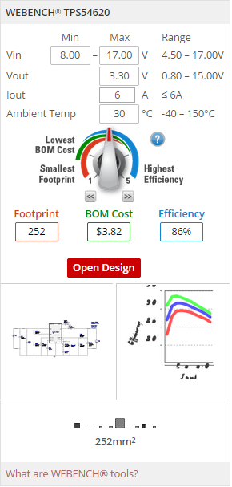

1. At this point, you can either explore the design within WEBENCH to do some more analysis like pre-defined electrical simulations, thermal simulations, evaluation of the BOM and the effect of selecting alternate components on the design, etc. This step is optional for “Simulation Export” but highly recommended if you want a better understanding of the design.
2. In order to export the design and simulation files into TINA-TI, click on the “Export” button on the top navigation bar



1. Next, click on TINA-TI under “Simulation Export” and click on Export

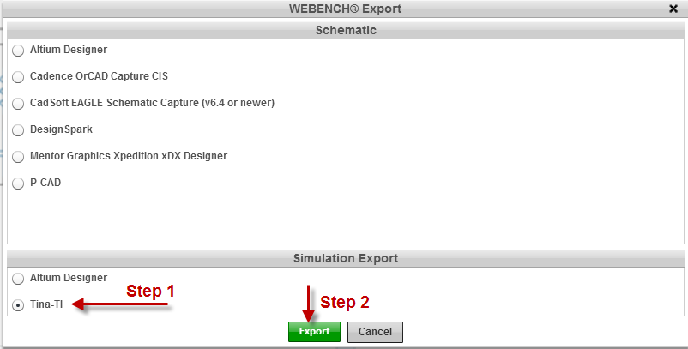

1. The files should be ready for you to download in less than 60 seconds.

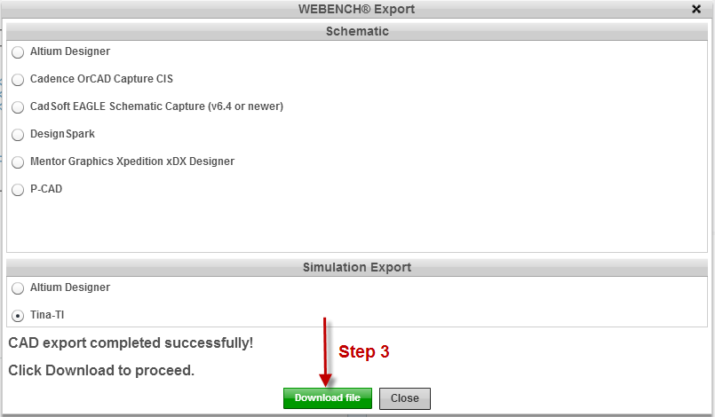

1. Once the files are ready, you can download them on your computer to simulate offline in TINA-TI or the other simulation formats available.
2. Once you are satisfied with the simulation results and want to move on to prototyping, WEBENCH offers a very convenient feature to export your schematics and layout into 6 popular CAD formats. This can be accessed from under the “Export” button as well. This feature saves time in drawing the schematics and laying out the board in your CAD tool. It also eliminates human error during this step. This is another advantage of using WEBENCH to export your simulation schematics to TINA-TI for evaluation rather than starting from a reference design.
3. If you have any issues while using this feature or any other feature in WEBENCH, please submit your questions by clicking on the “Assistant” button from within WEBENCH.



Alternately, we have several help resources available [here](http://www.ti.com/lsds/ti/analog/webench/help-overview.page) including [videos](http://www.ti.com/lsds/ti/analog/webench/webench-videos.page) showing step by step instruction to use many of the features.