Hello Jody,
I was speaking with Steven today and he clarified to me the "issue" they have faced with the Bluetooth signal.

The performance of the BT signal is not the expected, due to different cycles of the signal. The expected performance would be a signal with cycles of "power-on" and "power-off" with a constant period/behavior.

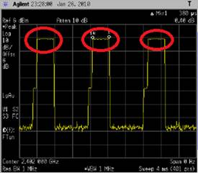

But they are receiving from your device a BT signal that is not consistent, the "power-on" cycles are not the expected:

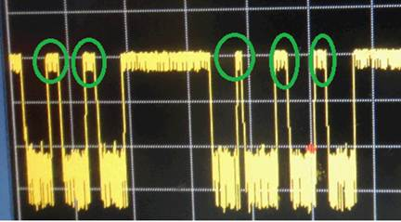

We need a confirmation from your side that the Bluetooth signal behavior shown here is the expected and is correct. In other case, we would need next steps to stabilize the signal.

Thanks and regards,
Ignacio

Hi Nacho
For BT part
we want to perform Dwell time as below describe
I also attach the normal picture as below as red part
The red circle is mean power on and it is really regular
but the wave figure is not regular as green circle of your product
so this the reason I should confirm for you
Please let me know if you have any concern
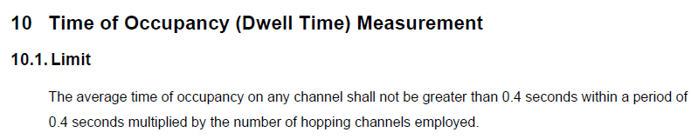
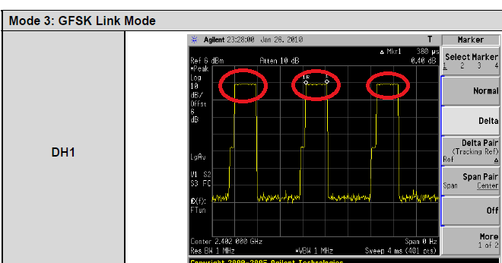
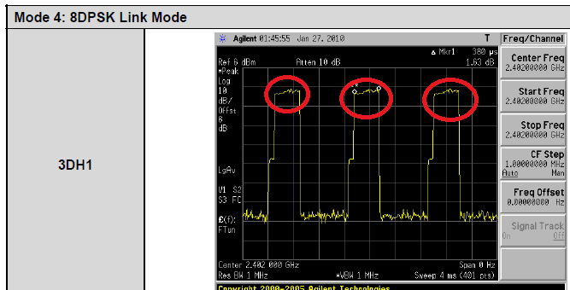
Normal figure
