**Topology & waveform for signal FP_TFP2_ODCK with 28(ST0_OB2) as Driver and U1(lvcmos_rrin) as Receiver. Freq – 162MHz.**

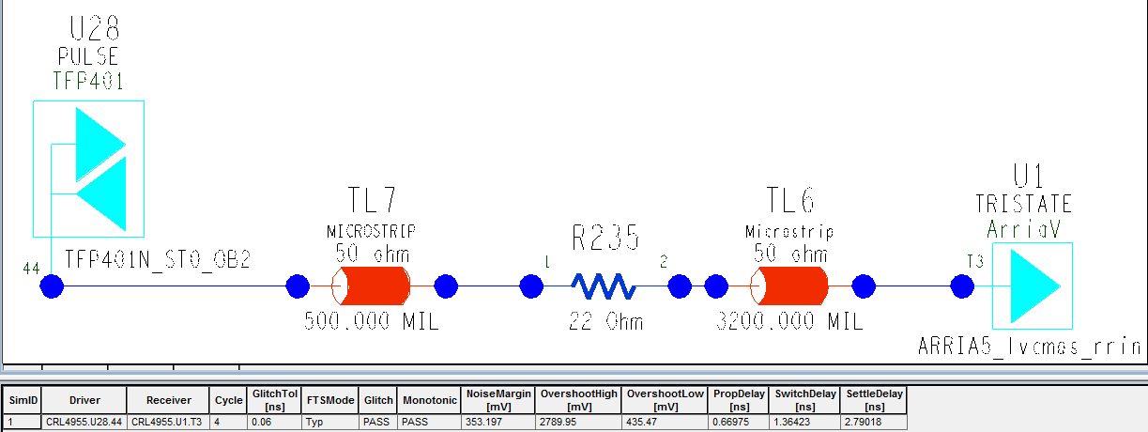

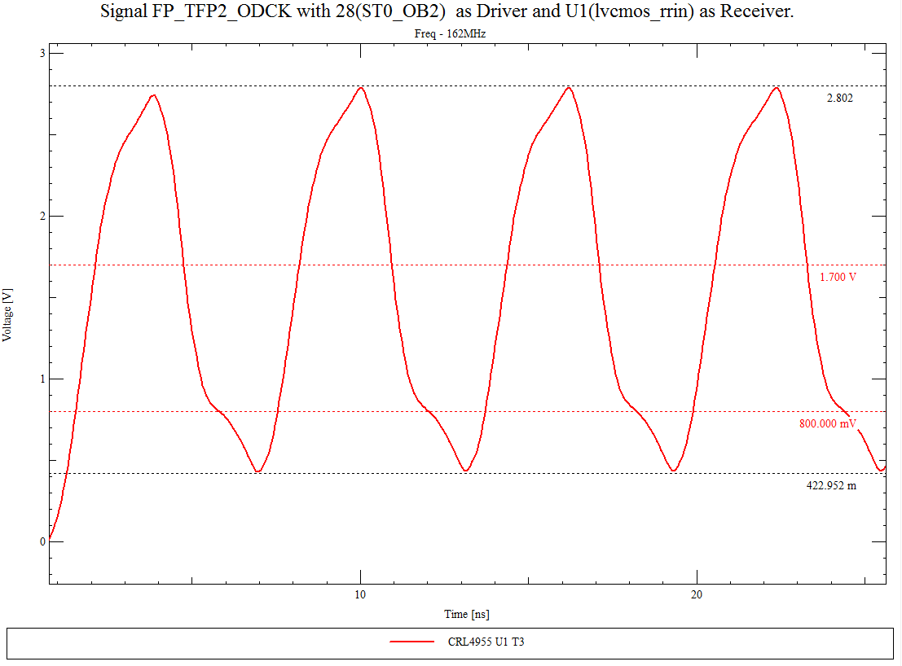

**Topology & waveform for signal FP_TFP2_ODCK with 28(ST0_OB2) as Driver and U1(lvcmos_rrin) as Receiver. Freq – 162MHz.**

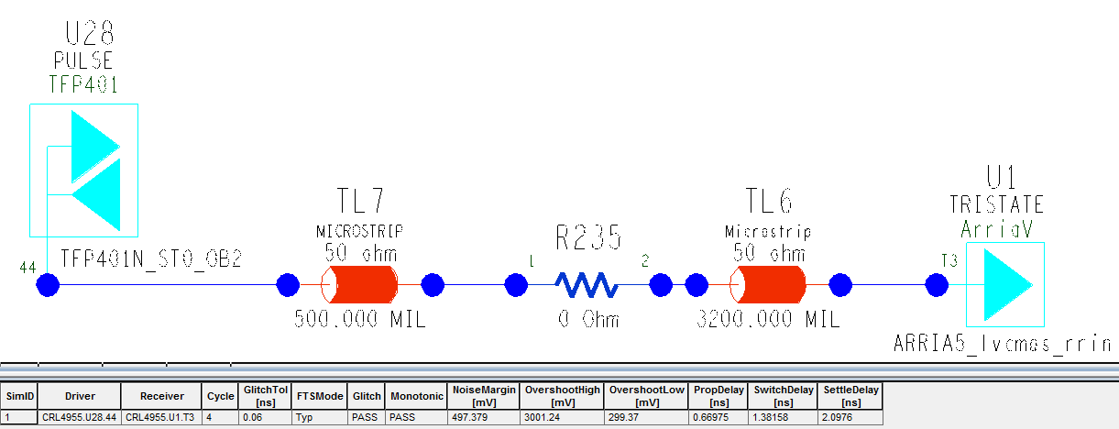

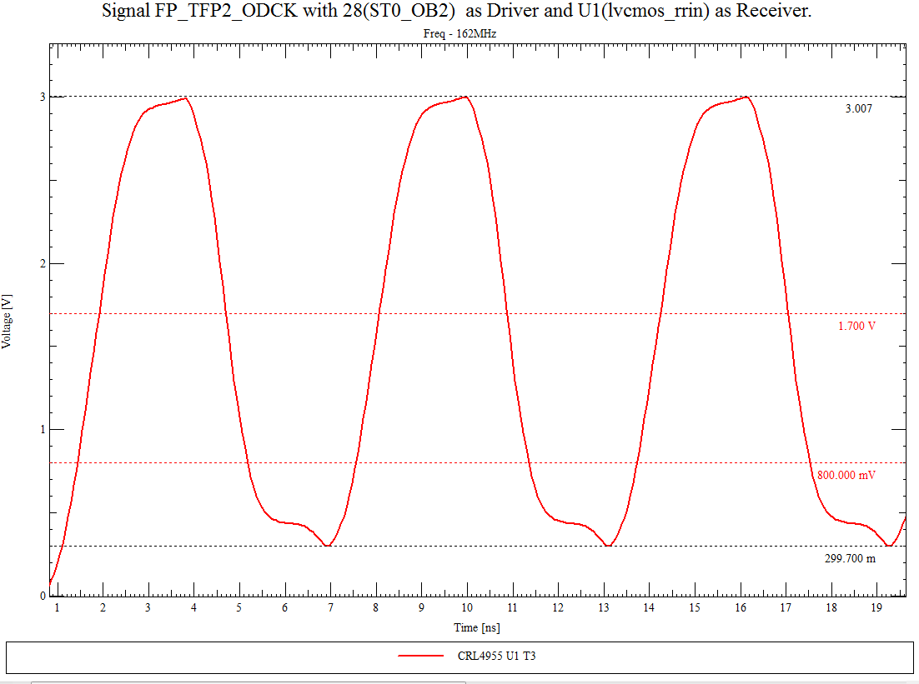

**Note: Without 22E Series termination**

**Topology & waveform for signal FP_TFP1_DI0 with 27(ST0_OB) as Driver and U1(lvcmos_crin) as Receiver. Freq – 162MHz.**

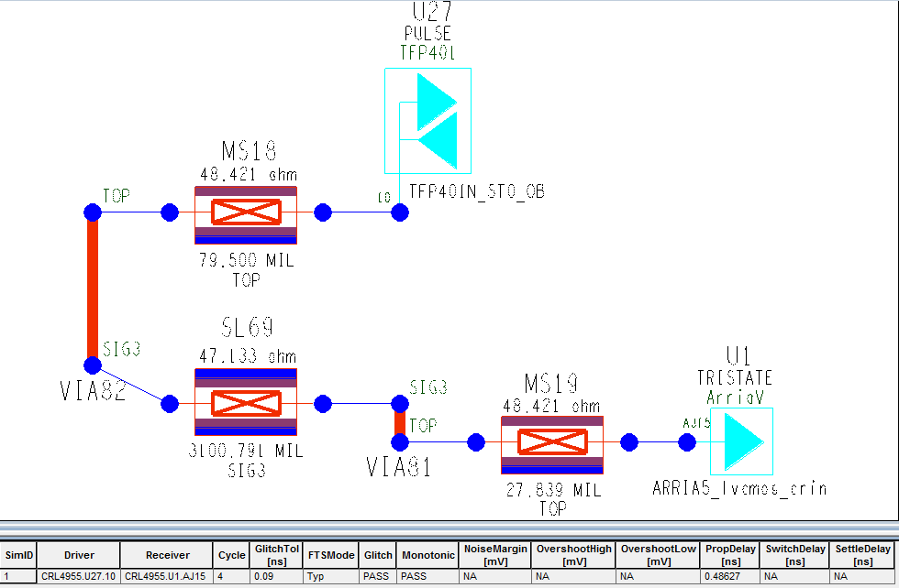

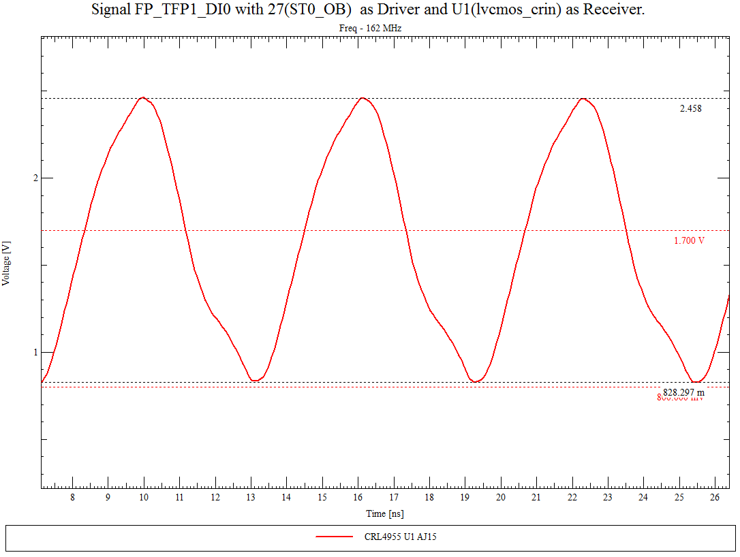

**Topology & waveform for signal FP_TFP1_DI0 with 27(ST0_OB) as Driver and U1(lvcmos_crin) as Receiver. Freq – 50MHz.**

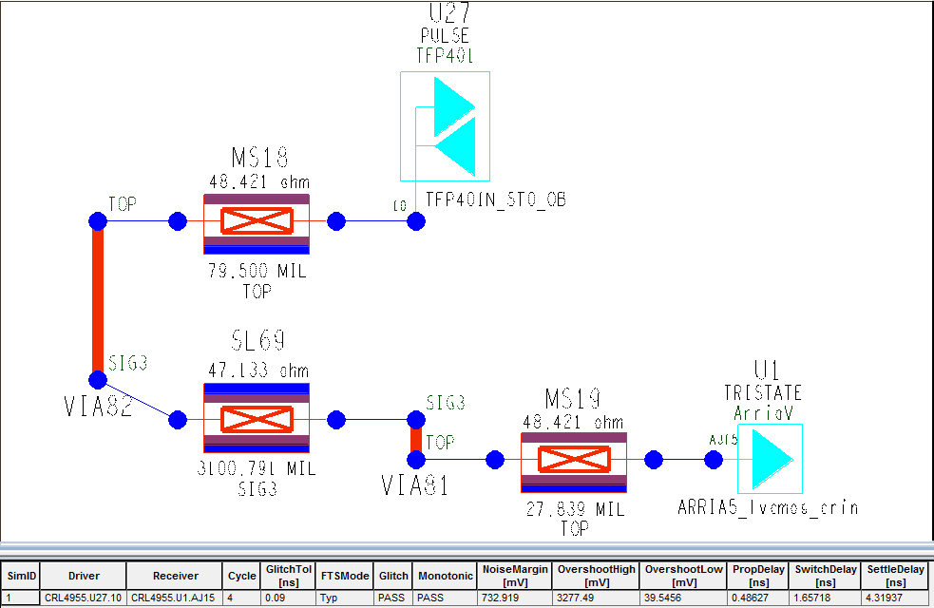

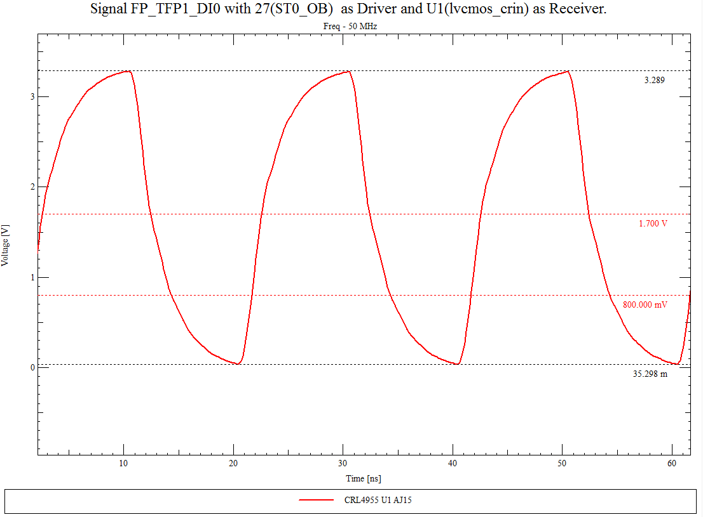

**Note : Able to See 3.3 V for Lesser frequency.**