# It takes long time to enter debug mode.(XDS560V2)

<Phenomenon>

Normal case : it can be enter debug mode under 30seconds. Please see CASE1.(it seems that it goes 3993 packet smoothly.)

NG case : it takes around 120seconds because there’s no response ACK from Emulator around 1min. after 3403 packet. It makes to wait for a while on PC(CCS). Please see CASE2

# Packet Fragment phenomenon when LAN is connected.

* 1. CASE1 : it can be sent under 1,514byte fragment.
  2. CASE2(NG) : it send xxKbyte fragment at one time.

CASE1. Normal case, it takes under 30sec to enter debug mode

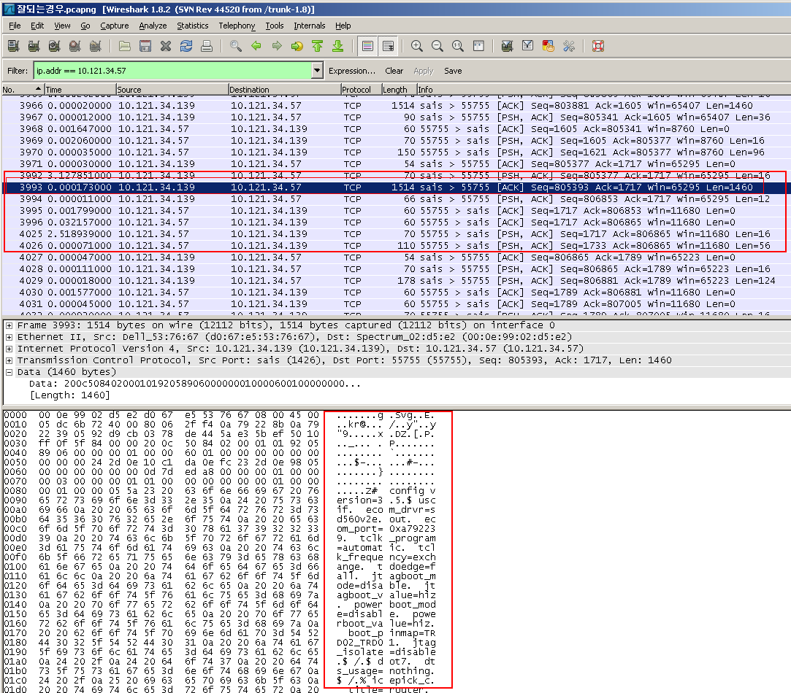

Case2 : NG case. It takes around 120second to enter debug mode.

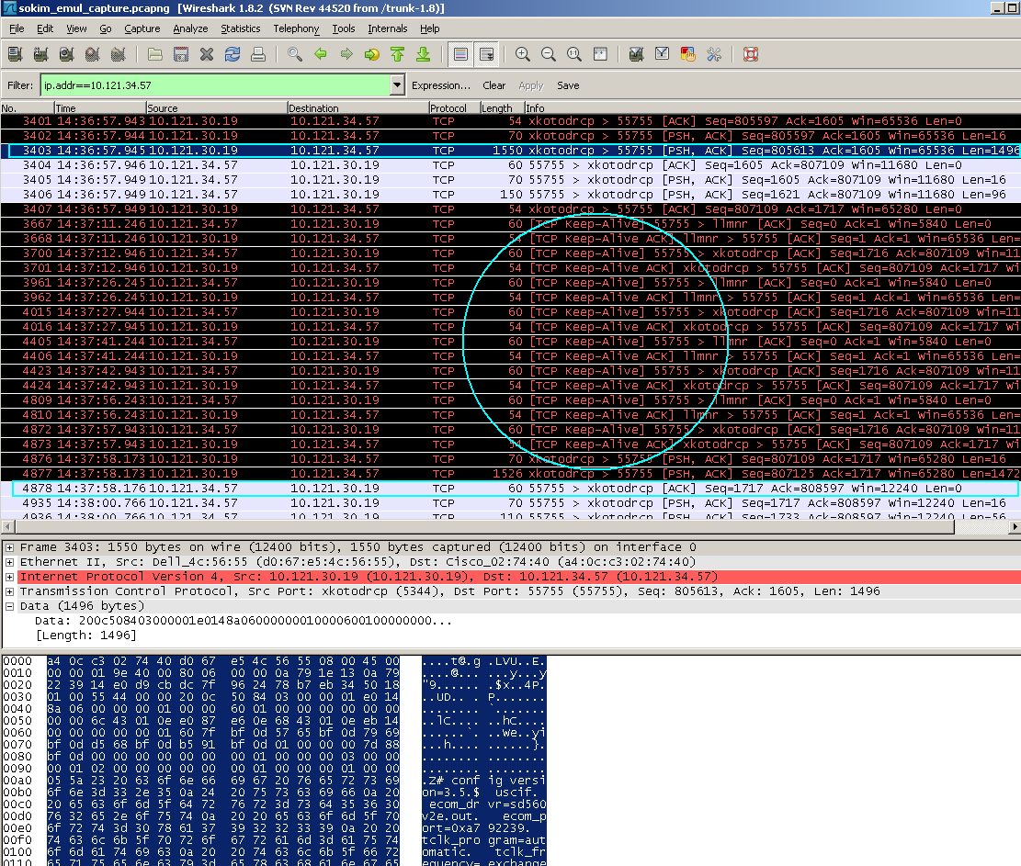

Ethernet packet size.

