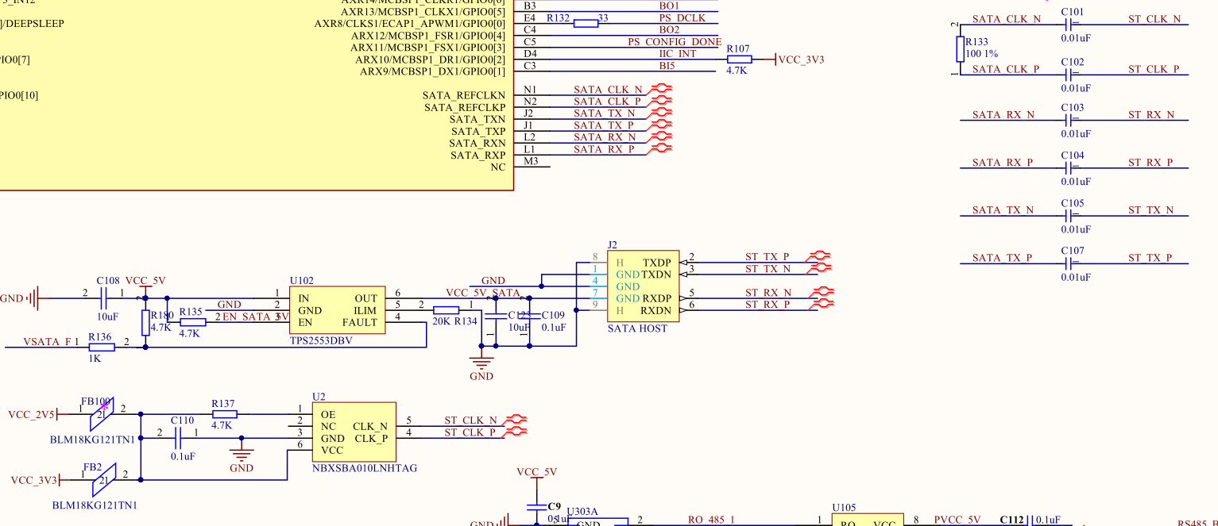

U2 is LVDS differential oscillator，value of AC capacitors is 0.01uF，100Ω resistor is unsolder。

(DPO5204B scope with active differential probe) The signal measured at CPU side as bellow.

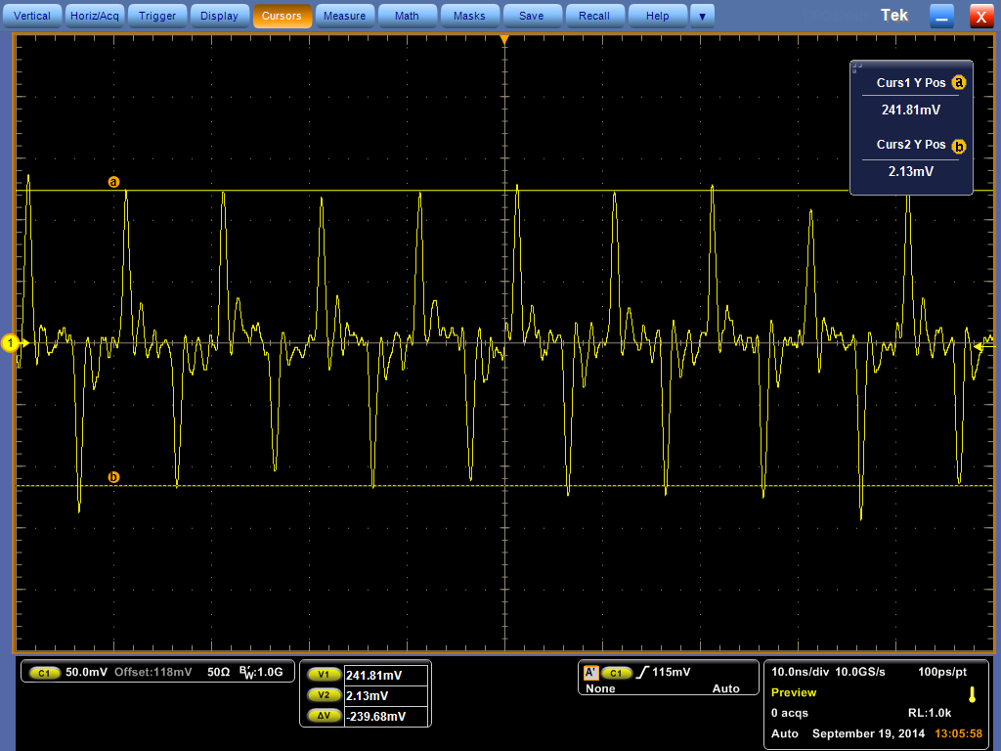

The following picture is PCB board. Here U2 drives the 100MHz LVDS clock output to AC coupling capacitors, then connects to CPU input PINs(SATA_REFCLKn/p). PCB route rules:

PCB route Line width is 8mil; and space between differential lines is 16mil. Total length(from U2 to CPU) of route line is 1550mil.

[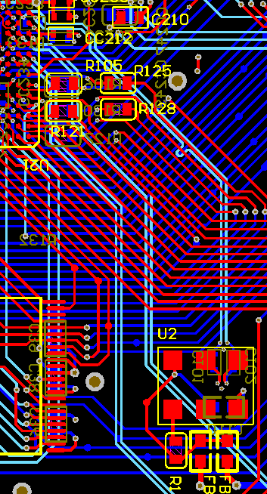](http://e2e.ti.com/cfs-file.ashx/__key/communityserver-discussions-components-files/42/4061.Capture.PNG)

The power supply of oscillator uses bead and capacitor to filter. Please check. Thank you!

And the log printed by cpu:

    6.624727] ata1: SATA link down (SStatus 1 SControl 300)

[    6.630296] ata1: link online but 1 devices misclassified, retrying

[    6.636723] ata1: reset failed (errno=-11), retrying in 5 secs

[   21.244621] ata1: softreset failed (1st FIS failed)

[   21.424627] ata1: softreset failed (device not ready)

[   56.434630] ata1: softreset failed (1st FIS failed)

[   56.614621] ata1: softreset failed (device not ready)

[   56.619725] ata1: limiting SATA link speed to 1.5 Gbps

[   61.814639] ata1: softreset failed (device not ready)

[   61.994621] ata1: softreset failed (device not ready)

[   61.999802] ata1: reset failed, giving up

[   62.003933] ata1: exception Emask 0x10 SAct 0x0 SErr 0x4050202 action 0xe frozen t4

[   62.011731] ata1: irq_stat 0x00400040, connection status changed

[   62.017883] ata1: SError: { RecovComm Persist PHYRdyChg CommWake DevExch }

[   62.024985] ata1: hard resetting link

[   63.654724] ata1: SATA link up 3.0 Gbps (SStatus 123 SControl 300)

[   63.661071] ata1: link online but 1 devices misclassified, retrying

[   63.667500] ata1: reset failed (errno=-11), retrying in 9 secs

[   72.024619] ata1: hard resetting link

[   82.034628] ata1: softreset failed (1st FIS failed)

[   82.214616] ata1: softreset failed (device not ready)

[   82.219719] ata1: hard resetting link

[  117.224624] ata1: softreset failed (1st FIS failed)

[  117.404620] ata1: softreset failed (device not ready)

[  117.409725] ata1: limiting SATA link speed to 1.5 Gbps

[  117.415019] ata1: hard resetting link

[  119.684608] ata1: COMRESET failed (errno=-32)

[  119.689097] ata1: reset failed, giving up

[  119.693209] ata1: exception Emask 0x10 SAct 0x0 SErr 0x4050002 action 0xe frozen t3

[  119.701028] ata1: irq_stat 0x00400040, connection status changed

[  119.707178] ata1: SError: { RecovComm PHYRdyChg CommWake DevExch }

[  119.713486] ata1: hard resetting link

[  126.304722] ata1: SATA link down (SStatus 1 SControl 300)

[  126.310328] ata1: exception Emask 0x10 SAct 0x0 SErr 0x4050002 action 0xe frozen t2

[  126.318158] ata1: irq_stat 0x00400040, connection status changed

[  126.324216] ata1: SError: { RecovComm PHYRdyChg CommWake DevExch }

[  126.330606] ata1: hard resetting link

[  128.714723] ata1: SATA link down (SStatus 1 SControl 300)

[  128.720331] ata1: exception Emask 0x10 SAct 0x0 SErr 0x4050002 action 0xe frozen t1

[  128.728161] ata1: irq_stat 0x00400040, connection status changed

[  128.734219] ata1: SError: { RecovComm PHYRdyChg CommWake DevExch }

[  128.740599] ata1: limiting SATA link speed to 1.5 Gbps

[  128.745896] ata1: hard resetting link

[  130.974700] ata1: SATA link down (SStatus 1 SControl 310)

[  130.980263] ata1: EH pending after 5 tries, giving up

[  130.985471] ata1: EH complete