

LMX2541 Family

Ultra Low Noise Frequency Synthesizer with Integrated VCO
Evaluation Board Operating Instructions
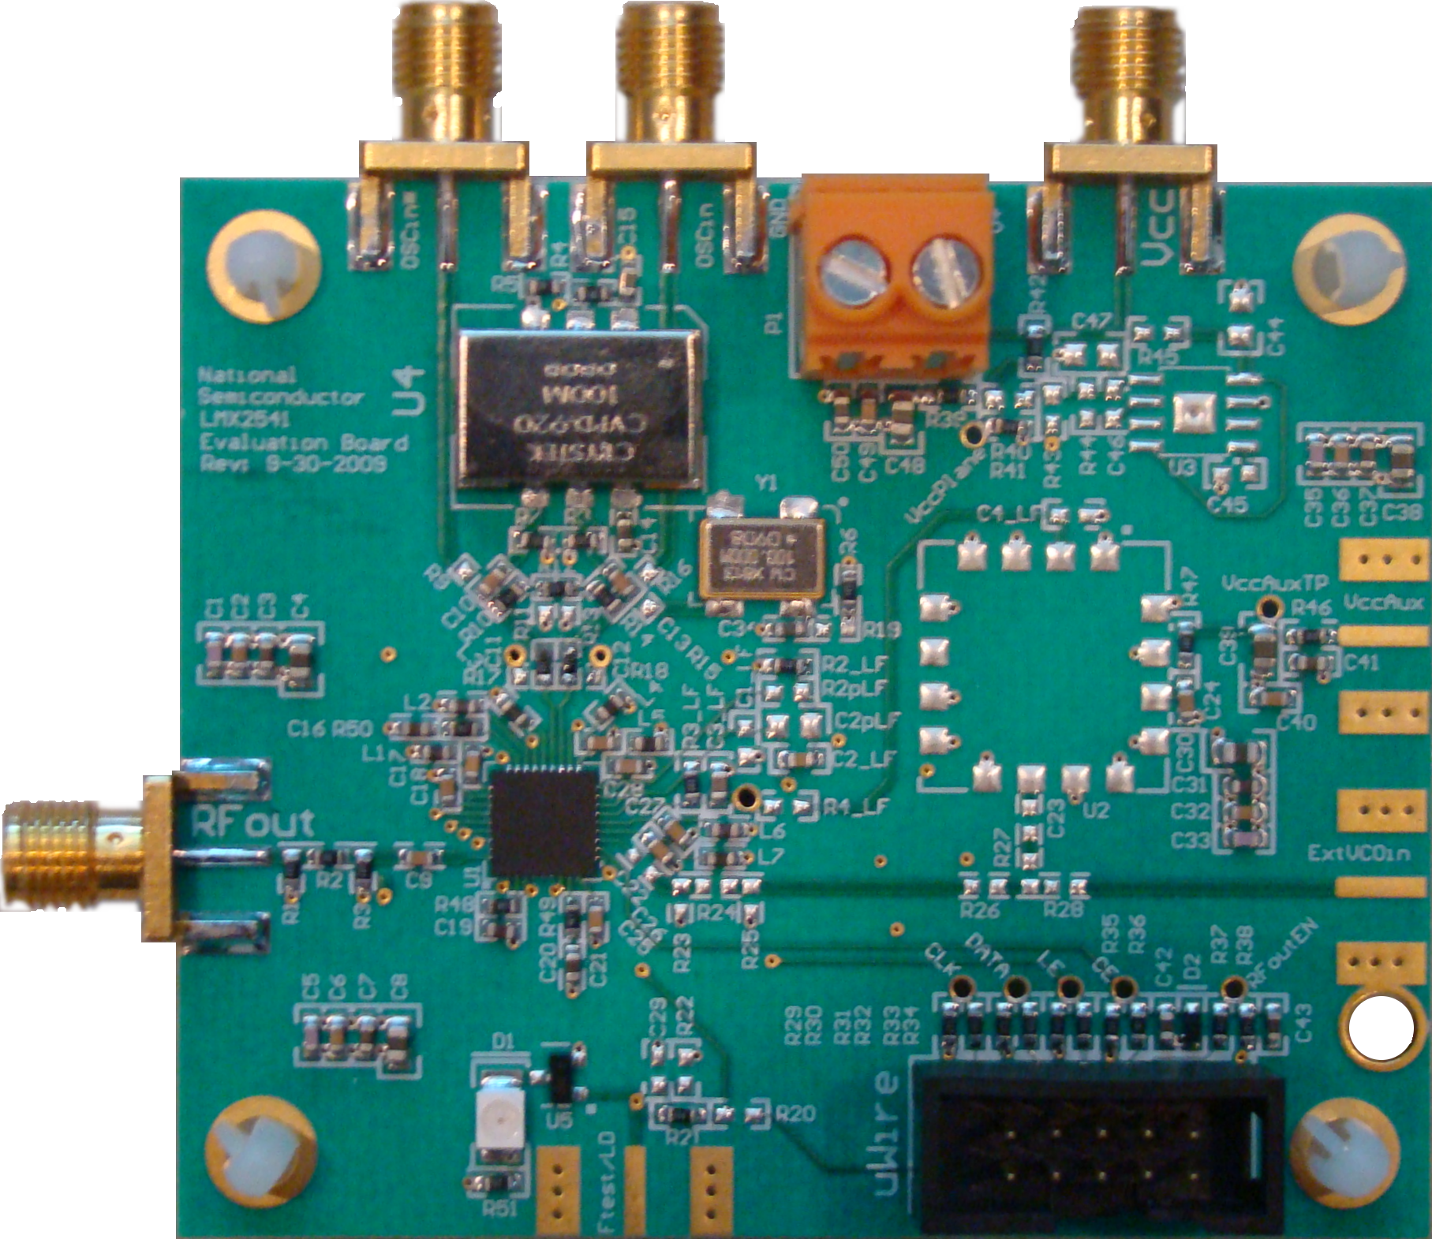

National Semiconductor Corporation
High Speed Signal Path Division
Precision Timing Devices
12-4-2009

Table of Contents

Loop Filter Values 6
CodeLoader Setup 7
Spurs for All Device Options 10
LMX2541SQ2060E Default Setup and Measured Performance 13
LMX2541SQ2380E Default Setup and Measured Performance 16
LMX2541SQ2690E Default Setup and Measured Performance 19
LMX2541SQ3030E Default Setup and Measured Performance 22
LMX2541SQ3320E Default Setup and Measured Performance 25
LMX2541SQ3740E Default Setup and Measured Performance 28
Bill of Materials 31
Schematic 34
Board Layer Stackup 35

Quick Setup
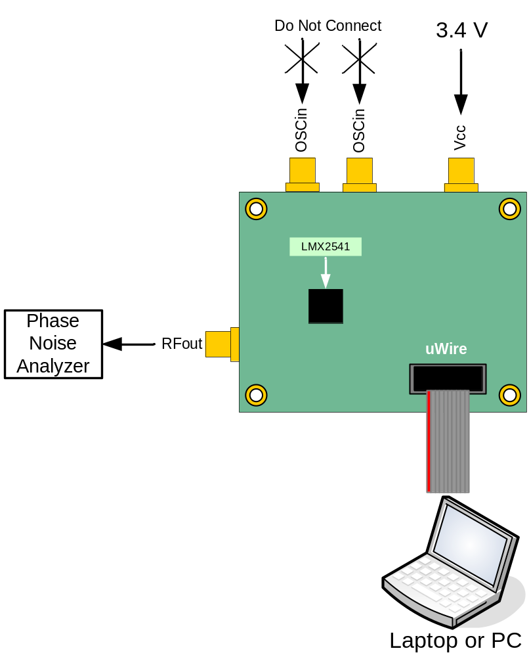
RFout
Connect to a spectrum analyzer or phase noise analyzer. The Agilent E5052A was used for these instructions.

Vcc
Connect to a 3.4 volt low noise power supply

uWire
Connect to a computer with CodeLoader software

ExtVCOin
This is not used in the default setup, but is included to support the use of an external VCO.
In Full Chip Mode, this device has an on-chip VCO.

Ftest/LD
The LED is to ensure that the part is locked. This output can be very useful for diagnostic purposes

OSCin/OSCin*
This is not used in the default setup, but is included to support the use of an external OSCin signal. The board includes a 100 MHz TCXO, which has two varieties. The OSCin signal is absolutely critical for the phase noise and spur performance of the LMX2541.

Manufacturer | Model | Frequency | Comments
Connor Winfield | CWX-813 | 100 MHz | - Good phase noise  - Low Cost  - Drifts a lot.
Crystek | CVPD920 | 100 MHz | - Good Phase Noise  - Drifts much less  - High Cost
National Semiconductor | LMK01000  LMK02000  LMK03000  LMK04000 | Any | - Eliminate drift issues  - Potentially the best phase noise  - Best for fractional spurs

Be very aware of the TCXO drift and the contribution that it can have to phase noise. Termination of the TCXO has a large impact on fractional spurs as well. The best results can be achieved by driving this board with an LMK01000 LVPECL output. Doing so results in about a 4 dB spur improvement.

Loop Filter Values

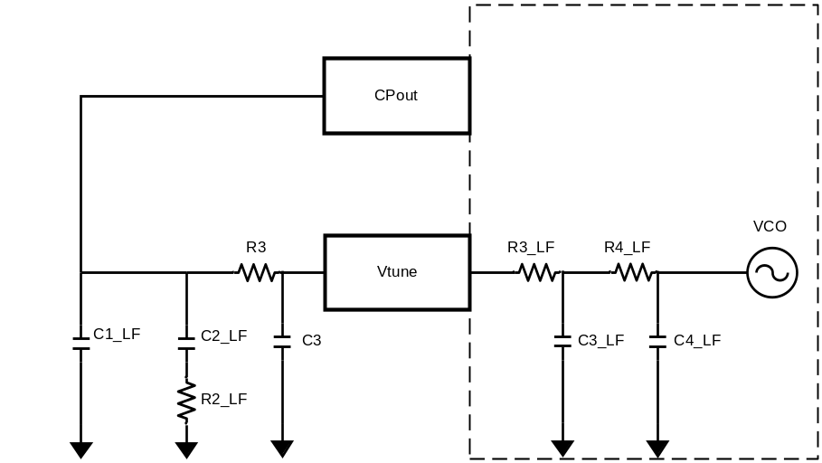
Parameter | LMX2541  SQ2060E | LMX2541  SQ2380E | LMX2541  SQ2690E | LMX2541  SQ3030E | LMX2541  SQ3320E | LMX2541  SQ3470E
VCO Frequency  (MHz) | 1990 –  2240 | 2200 - 2530 | 2490 – 2865 | 2810 - 3230 | 3130 - 3600 | 3480 - 4000
VCO Gain  (MHz/V) | 13-23 | 16-30 | 17-32 | 20-37 | 21-37 | 27 - 42
Charge Pump Gain (mA) | 3.2 | 3.2 | 3.2 | 3.2 | 3.2 | 3.2
Phase Detector Frequency (MHz) | 25 | 25 | 25 | 25 | 25 | 25
OSCin Frequency (MHz) | 100 | 100 | 100 | 100 | 100 | 100
Loop Bandwidth (kHz) | 37.3 –  54.6 | 40.8 –  61.7 | 38.7 –  58.6 | 40.0 –  59.9 | 38.1 –  54.7 | 43.1 –  55.7
Phase Margin (deg) | 52.7 –  52.8 | 53.1-  52 | 52.9 –  52.4 | 53.0 –  52.2 | 52.8 –  52.8 | 53.2 –  52.7
C1_LF (nF) | 2.2 | 2.2 | 2.2 | 2.2 | 2.2 | 2.2
C2_LF (nF) | 22 | 22 | 22 | 22 | 22 | 22
R2_LF (Kohm) | 0.47 | 0.47 | 0.47 | 0.47 | 0.47 | 0.47
C3_LF (Internal) (nF) | 0.02 | 0.02 | 0.02 | 0.02 | 0.02 | 0.02
C4_LF (Internal) (nF) | 0.1 | 0.1 | 0.1 | 0.1 | 0.1 | 0.1
R3_LF (Internal) (Kohm) | 1 | 1 | 1 | 1 | 1 | 1
R4_LF (Internal) (Kohm) | 0.2 | 0.2 | 0.2 | 0.2 | 0.2 | 0.2

* Note that the VCO gain does change a fair amount. Although not demonstrated in these instructions, the charge pump gain could be adjusted to account for this variation.

CodeLoader Setup
Select the part. In this case, it is the LMX2541SQ3320E.
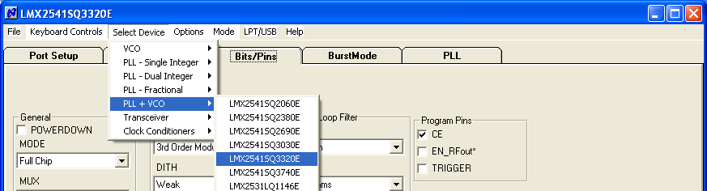

Choose the correct startup mode. This is determined by the part option.

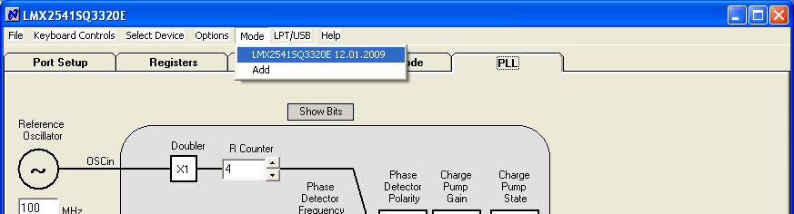

Load the part. You can load it from the menu or also press Cntrl + L.

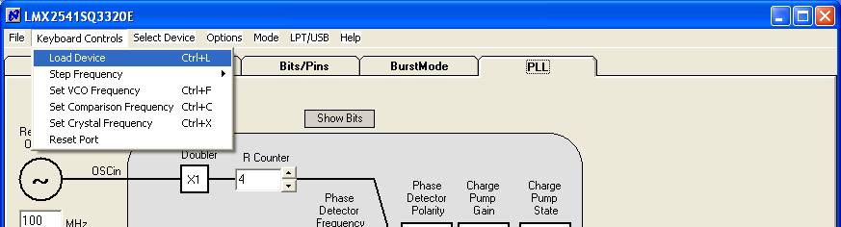
On the Port Setup tab, the user may select the type of communication port (USB or Parallel) that will be used to program the device on the evaluation board. If parallel port is selected, the user should ensure that the correct port address is entered.

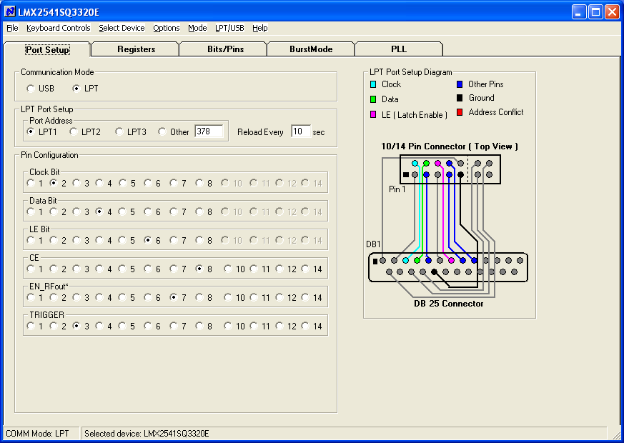

The Pin Configuration field is hardware dependent and normally SHOULD NOT be changed by the user.

The evaluation board is typically shipped with a parallel port cable that is used to interconnect the board to a PC LPT port, enabling the board to be programmed.

Separately available is a USB2UWIRE-IFACE board which simplifies evaluation by enabling the user to establish a USB connection from the Codeloader 4 software to the evaluation board.
http://www.national.com/store/view_item/index.html?nsid=USB2UWIRE-IFACE

To view the function of any bit on the CodeLoader configuration tabs, place the cursor over the desired bit register label and click the right mouse button on it for a description. This Bits/Pins configuration is common to all options of the LMX2541 evaluation board.

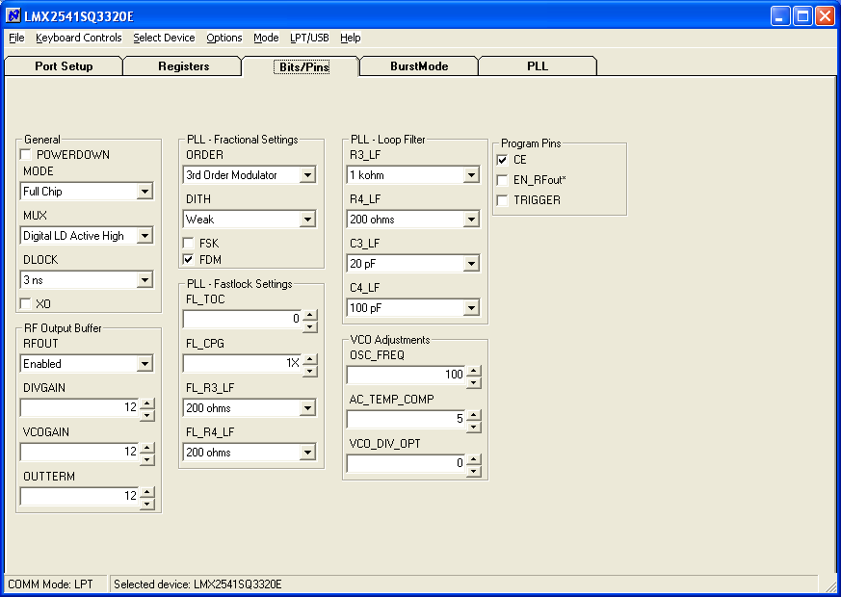

Spurs for All Device Options

Oscillator Spurs
Oscillator spurs occur at the oscillator frequency (100 MHz) offset from the carrier. They can be largely impacted by the board layout. These were taken in 25 MHz increments.
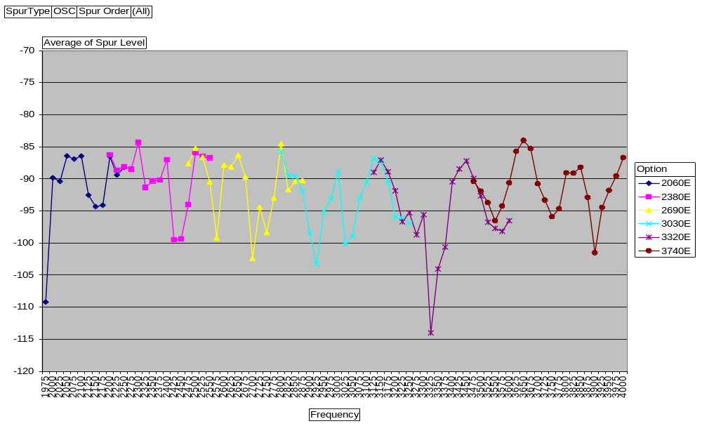
Reference (Phase Detector) Spurs
Reference spurs occur at a multiple of the phase detector frequency (25 MHz) from the carrier

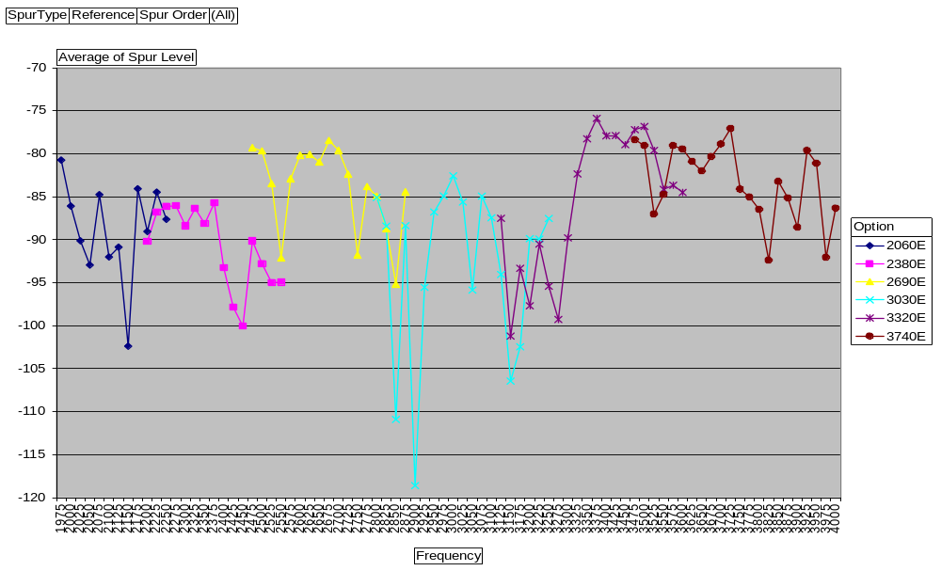
Fractional Spurs
In-band spurs occur inside the loop bandwidth. These spurs were measured with a WORST CASE fraction of 1/5000. The primary fractional spurs are at 5 kHz and the sub-fractional spurs are at 2.5 kHz. The actual frequency is the frequency in the chart plus 5 kHz.
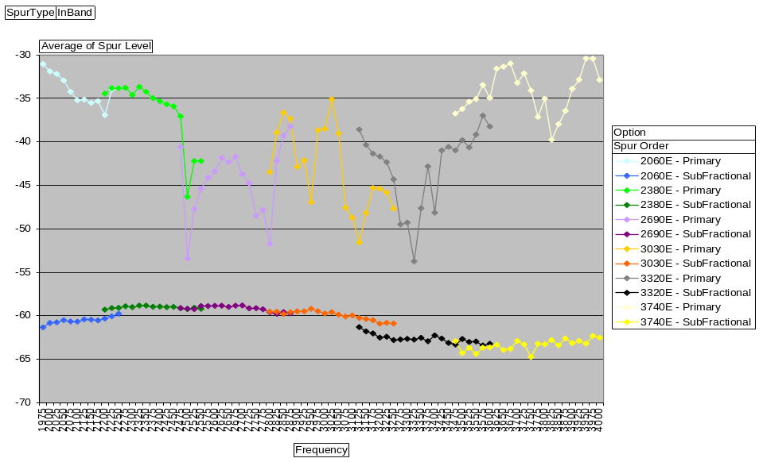
Out-band spurs occur inside the loop bandwidth. These spurs were measured with a WORST CASE fraction of 1/100. The primary fractional spurs are at 250 kHz and the sub-fractional spurs are at 125 kHz. The actual frequency is the frequency in the chart plus 250 kHz.
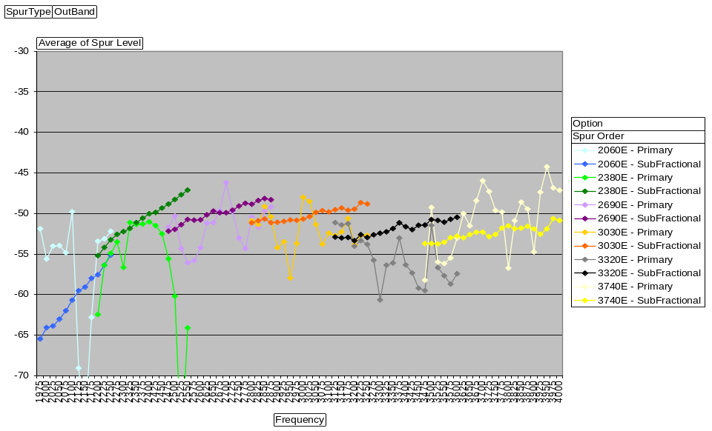
Minimizing Fractional Spurs
- Both fractional and sub-fractional spurs are highly sensitive to the OSCin signal. Higher slew rates are desired. Also, the termination makes a big difference. For this evaluation board, a series 120 ohm resistor had a large impact.
- The best results have been achieved when driving the part differentially with an LVPECL output of the LMK01000/2000/3000/400 series of clock conditioner devices from National Semiconductor.
- The spurs on this evaluation board are relatively high because the loop bandwidth is very wide. This wide loop bandwidth takes advantage of the close-in phase noise, but it does expose the fractional spurs more. The fractional spurs can be reduced by orders of magnitude by reducing the loop bandwidth. This requires a re-design of the loop filter.
- To eliminate the SubFractional spurs entirely, choose a fractional denominator with no factors of 2 or 3. For this 100 MHz TCXO and 250 kHz channel spacing, a phase detector frequency of 6.25 MHz and a fractional denominator of 25 would work. However, the higher N value does degrade the phase noise. An ideal scenario would be to use a TCXO frequency of something like 125 MHz. Then the sub-fractional spurs are eliminated if the phase detector is chosen to be 30.25 MHz and the fractional denominator is chosen to be 125.

In the plot below, one was taken with the default 100 MHz TCXO and another was taken with a 125 MHz signal. The phase detector frequency was changed to 31.25 MHz, but the charge pump gain was reduced to 26X to compensate for this. This is the same part, board, and frequency (3030.25 MHz). Although the fraction is different, notice that the fractional denominator of 125 has no sub fractional spurs at 125 kHz, 375 kHz, and so on. An LMK01000 evaluation board driven by a 1250 MHz signal was used to produce this 125 MHz signal.

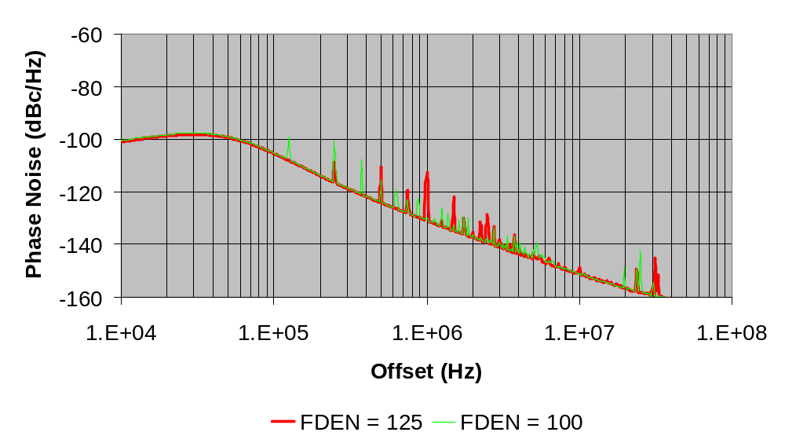

LMX2541SQ2060E Default Setup and Measured Performance
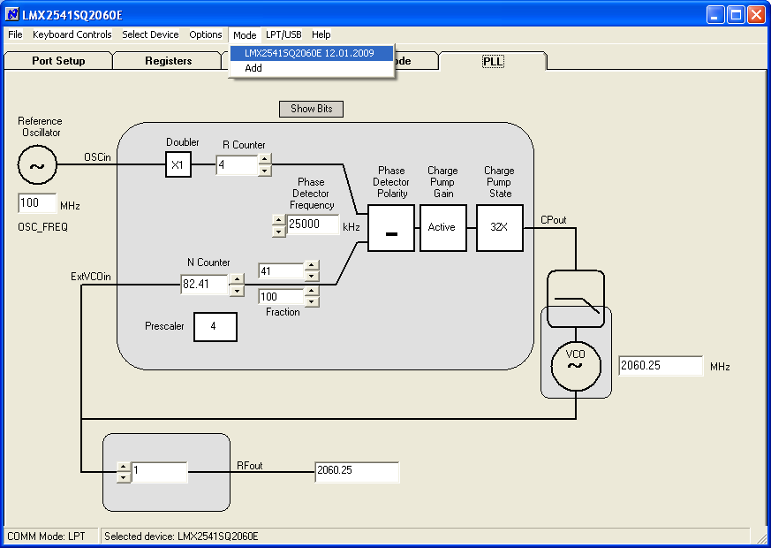
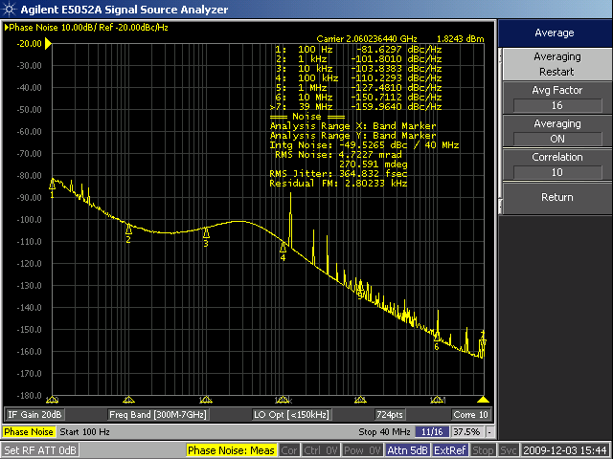

LMX2541SQ2060E Spurs for WORST CASE Channels
(Fraction = 1/100)
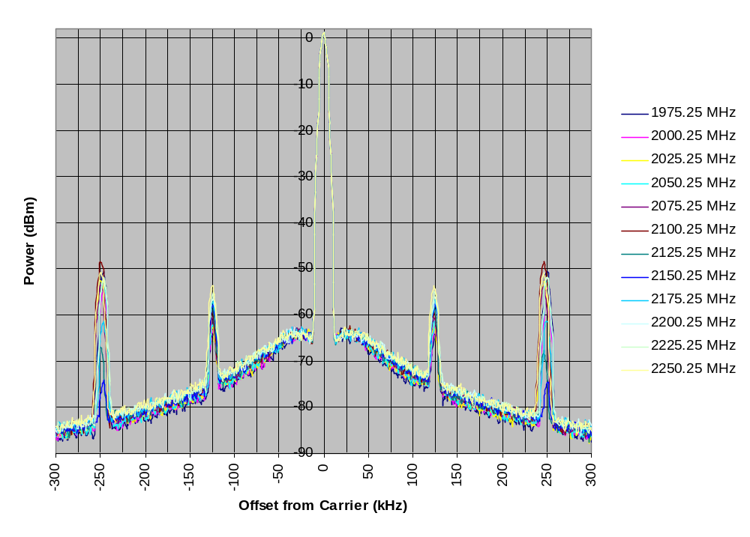

This graph has been normalized to the average carrier power.

LMX2541SQ2060E VCO Phase Noise
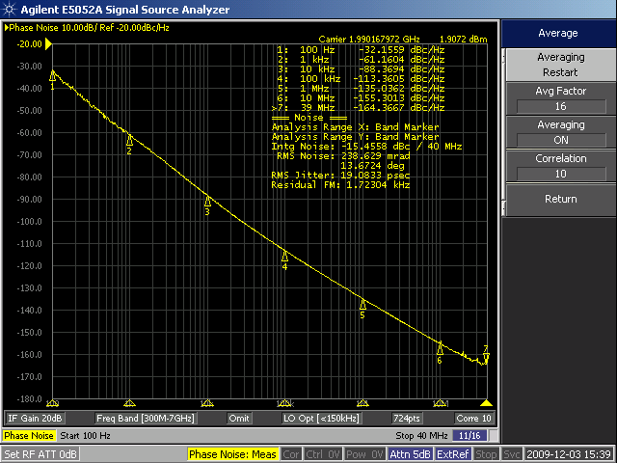 | The plots show the VCO phase noise at low, middle, and high frequency.  To measure the VCO phase noise, a simple technique is to lock the PLL to the desired frequency and set the charge pump state to “Tri-State”, by clicking this on the PLL tab on Codeloader. If the phase noise analyzer can track the signal, a reasonable measurement can be made. To ensure that this measurement is of the VCO noise, omit the the spurs and disconnect the microwire programming cable.
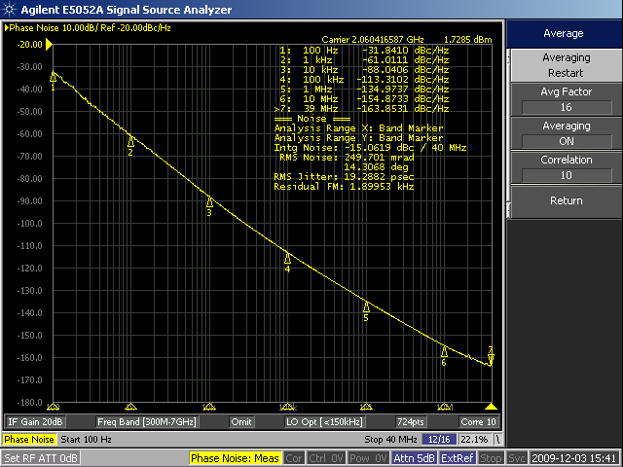
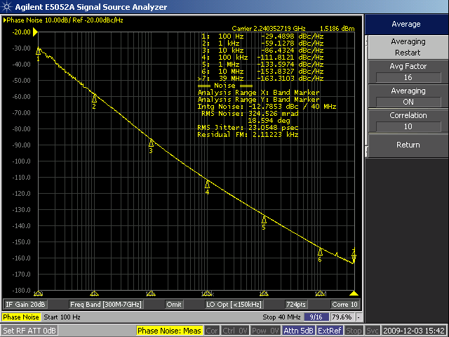

LMX2541SQ2380E Default Setup and Measured Performance
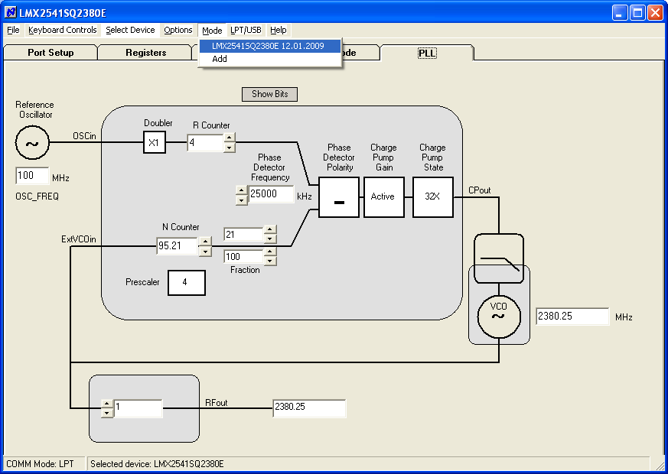
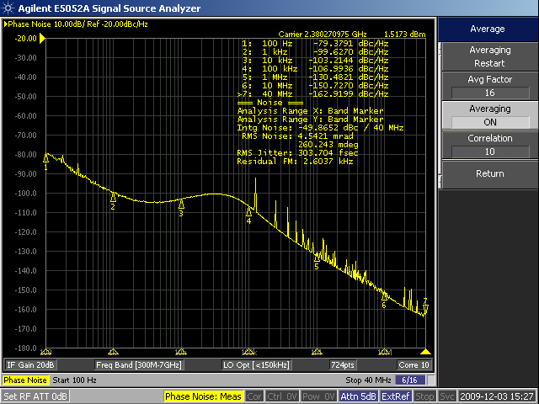

LMX2541SQ2380E Spurs for WORST CASE Channels
(Fraction = 1/100)
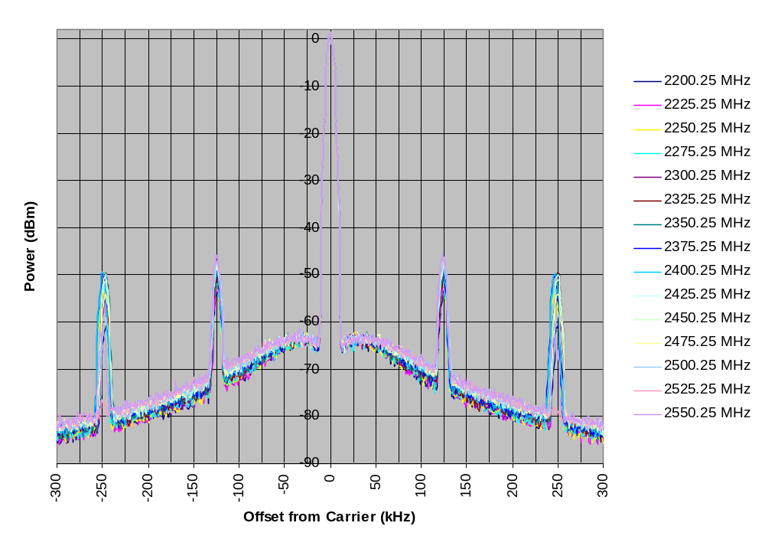

This graph has been normalized to the average carrier power.

LMX2541SQ2380E VCO Phase Noise
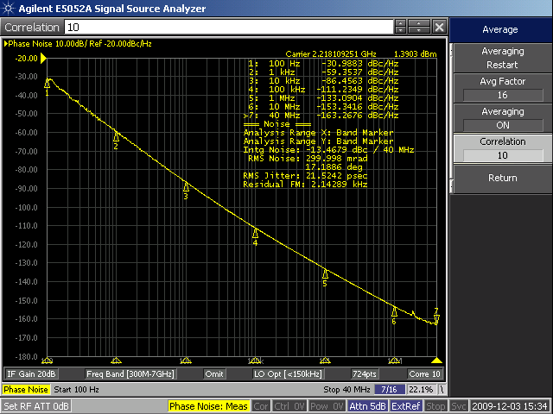 | The plots show the VCO phase noise at low, middle, and high frequency.  To measure the VCO phase noise, a simple technique is to lock the PLL to the desired frequency and set the charge pump state to “Tri-State”, by clicking this on the PLL tab on Codeloader. If the phase noise analyzer can track the signal, a reasonable measurement can be made. To ensure that this measurement is of the VCO noise, omit the the spurs and disconnect the microwire programming cable.
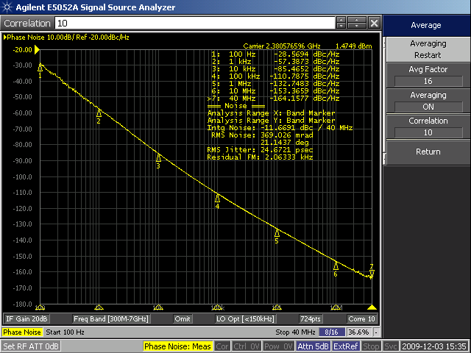
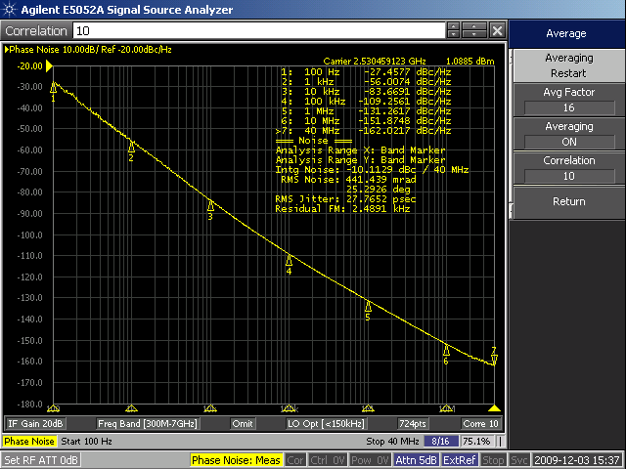

LMX2541SQ2690E Default Setup and Measured Performance
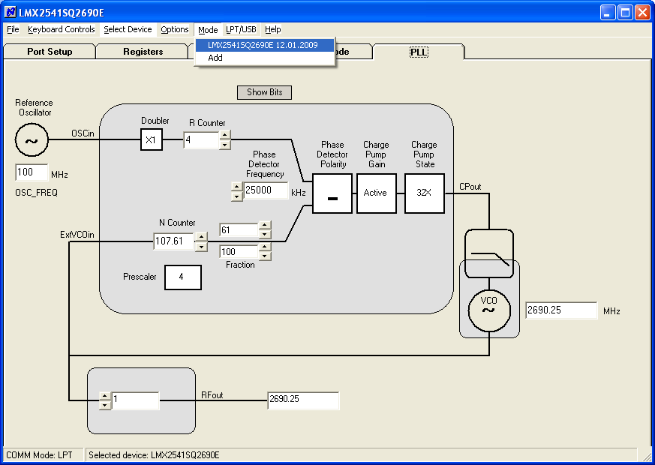
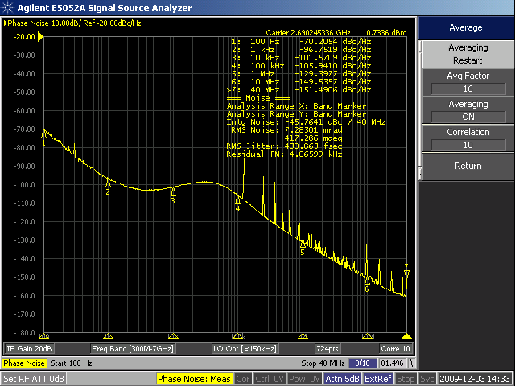

LMX2541SQ2690E Spurs for WORST CASE Channels
(Fraction = 1/100)
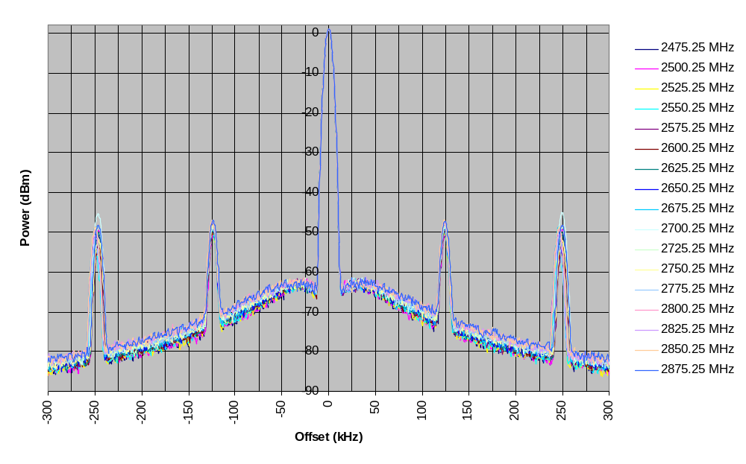

This graph has been normalized to the average carrier power.

LMX2541SQ2690E VCO Phase Noise
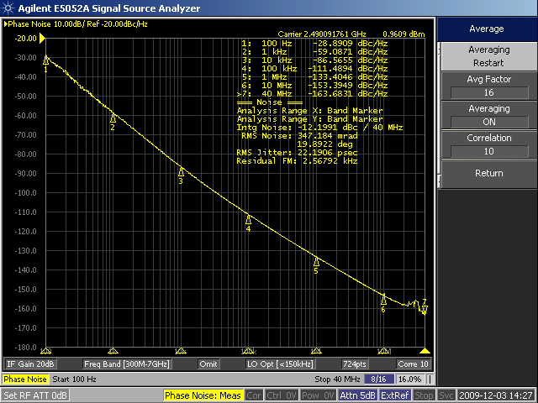  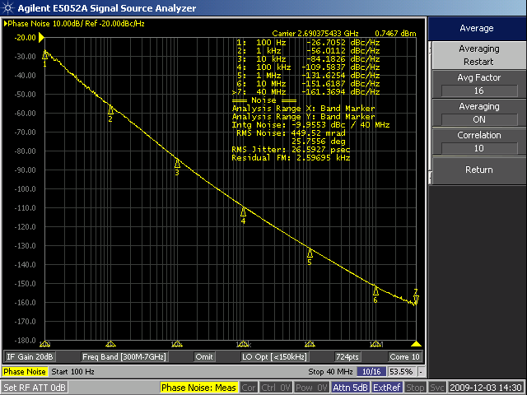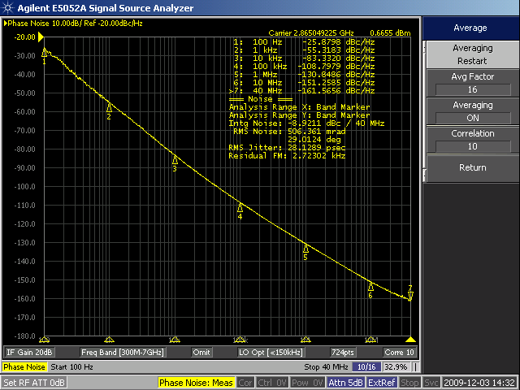 | The plots show the VCO phase noise at low, middle, and high frequency.  To measure the VCO phase noise, a simple technique is to lock the PLL to the desired frequency and set the charge pump state to “Tri-State”, by clicking this on the PLL tab on Codeloader. If the phase noise analyzer can track the signal, a reasonable measurement can be made. To ensure that this measurement is of the VCO noise, omit the the spurs and disconnect the microwire programming cable.

LMX2541SQ3030E Default Setup and Measured Performance
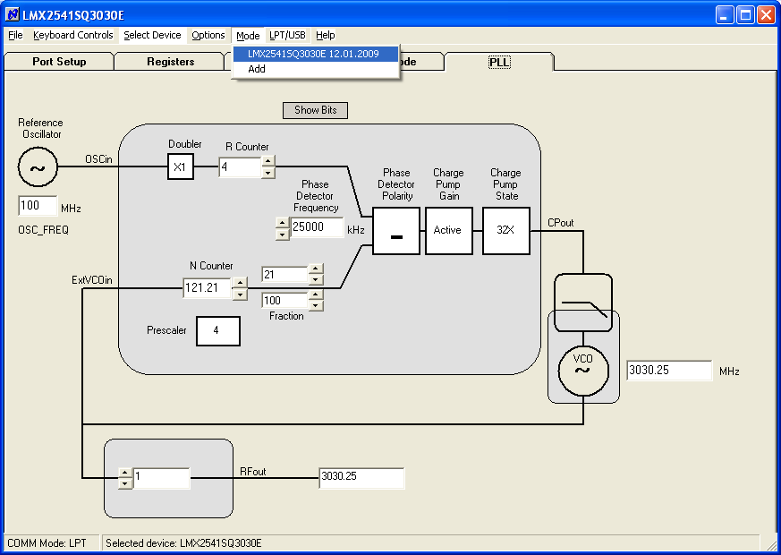
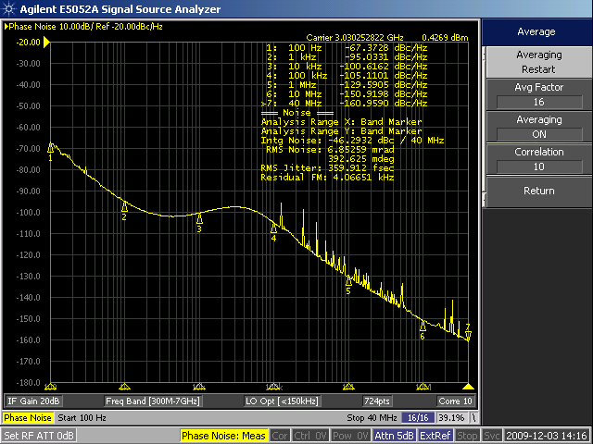

LMX2541S3030E Spurs for WORST CASE Channels
(Fraction = 1/100)
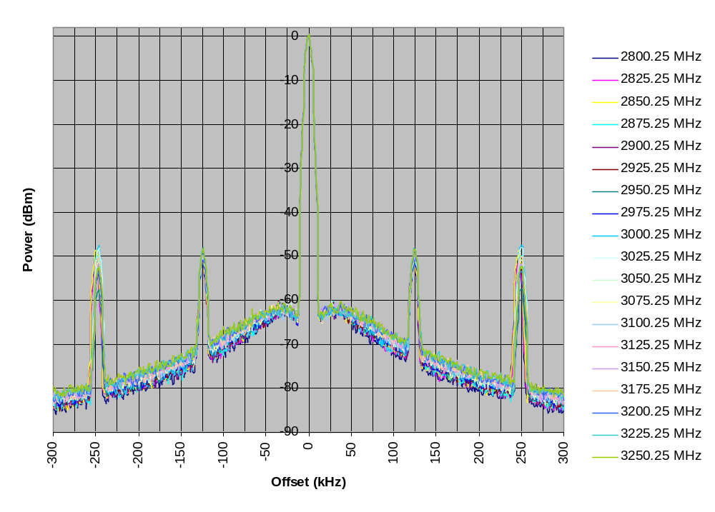

This graph has been normalized the average carrier power.

LMX2541SQ3030E VCO Phase Noise
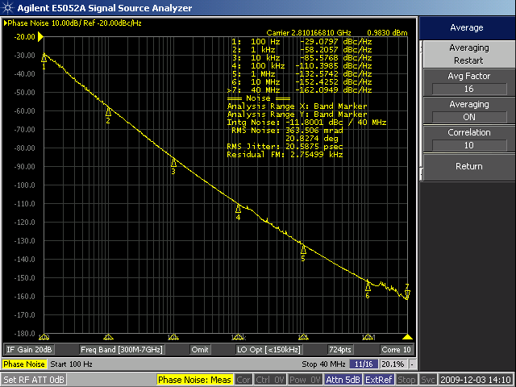  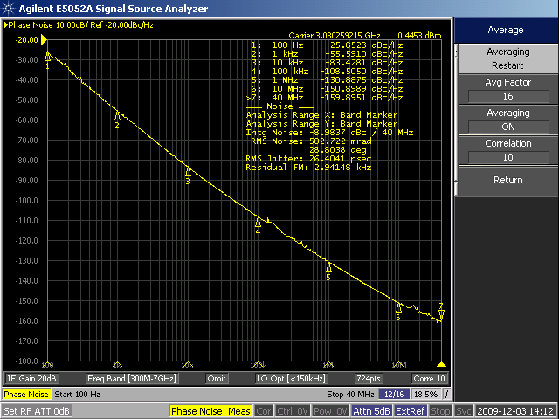  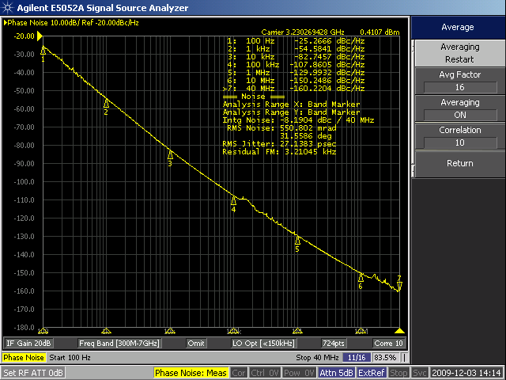 | The plots show the VCO phase noise at low, middle, and high frequency.  To measure the VCO phase noise, a simple technique is to lock the PLL to the desired frequency and set the charge pump state to “Tri-State”, by clicking this on the PLL tab on Codeloader. If the phase noise analyzer can track the signal, a reasonable measurement can be made. To ensure that this measurement is of the VCO noise, omit the the spurs and disconnect the microwire programming cable.

LMX2541SQ3320E Default Setup and Measured Performance
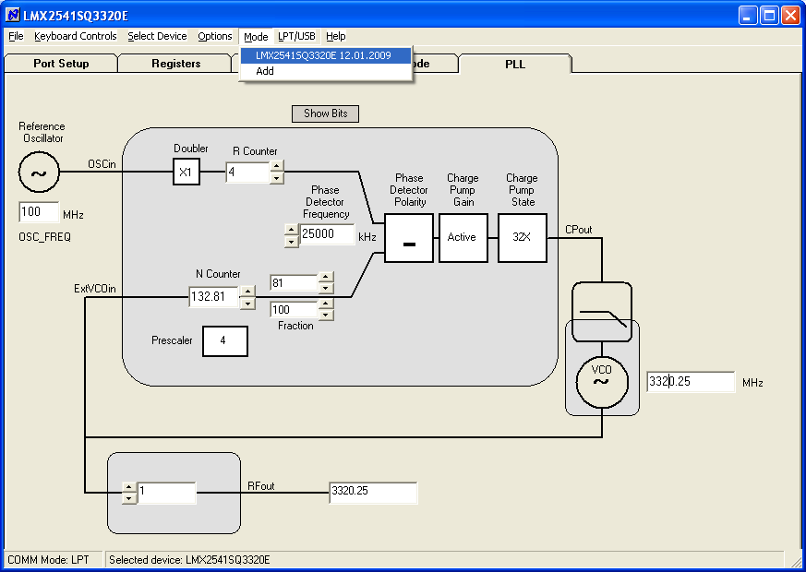
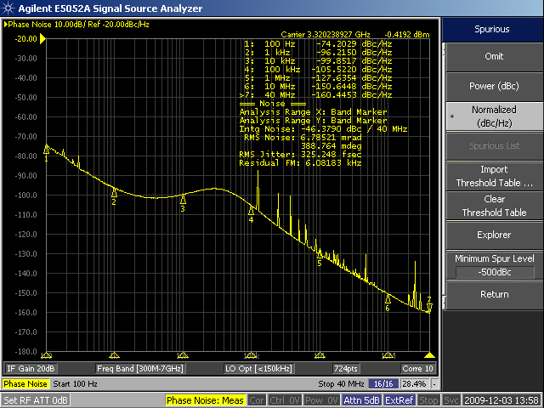

LMX2541S3320E Spurs for WORST CASE Channels
(Fraction = 1/100)
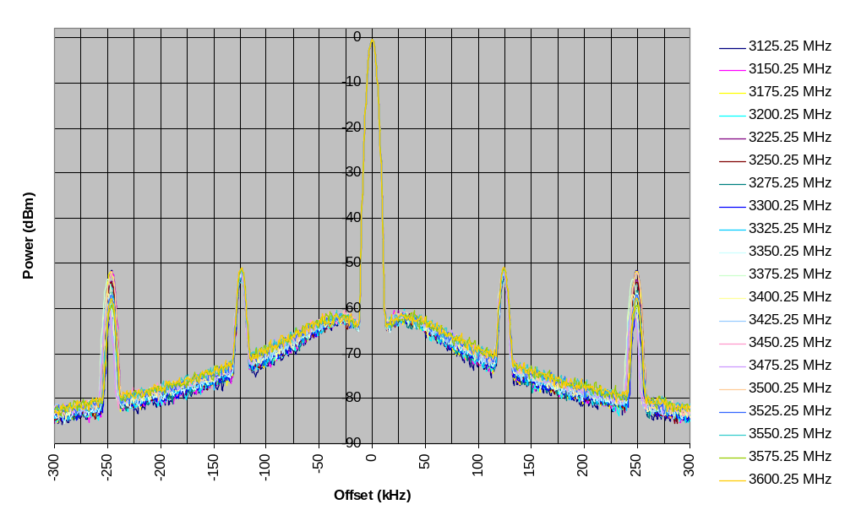

Note that the graphs have all been normalized the average carrier power.

LMX2541SQ3320E VCO Phase Noise
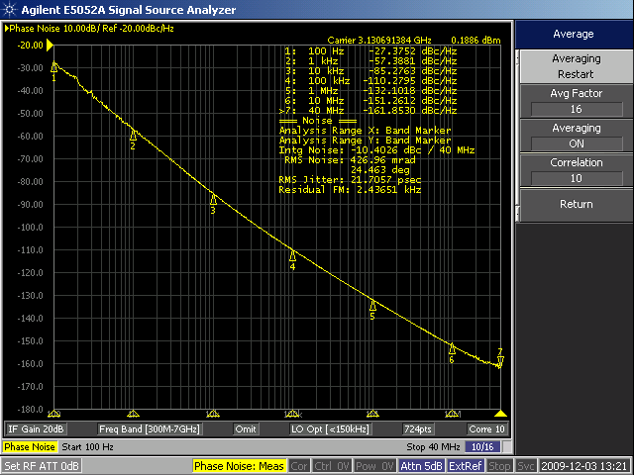  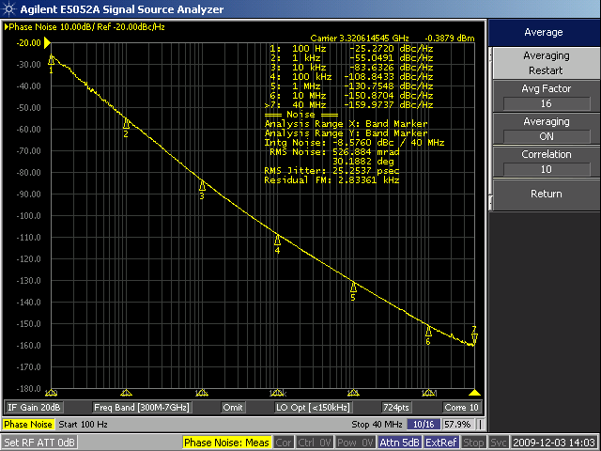  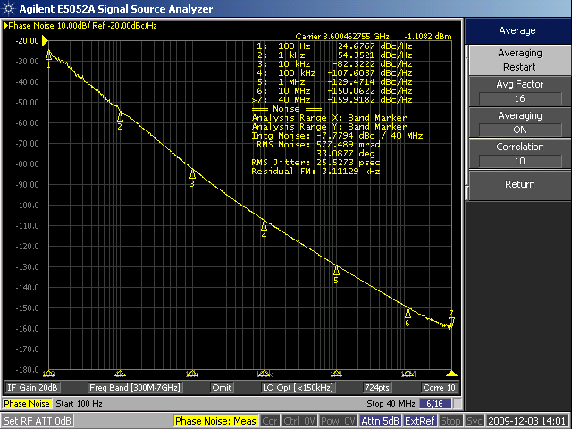 | The plots show the VCO phase noise at low, middle, and high frequency.  To measure the VCO phase noise, a simple technique is to lock the PLL to the desired frequency and set the charge pump state to “Tri-State”, by clicking this on the PLL tab on Codeloader. If the phase noise analyzer can track the signal, a reasonable measurement can be made. To ensure that this measurement is of the VCO noise, omit the the spurs and disconnect the microwire programming cable.

LMX2541SQ3740E Default Setup and Measured Performance
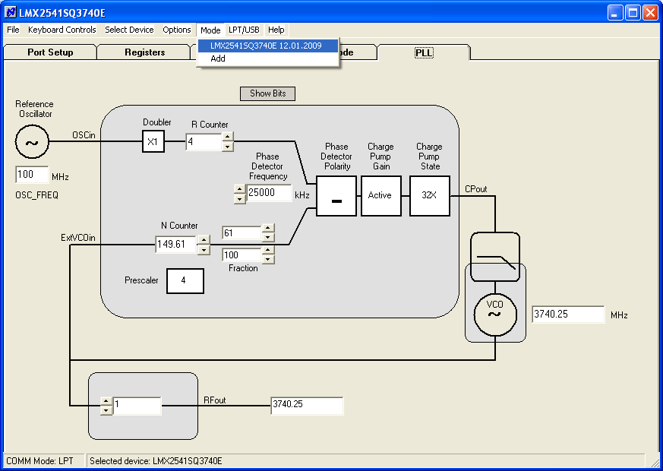
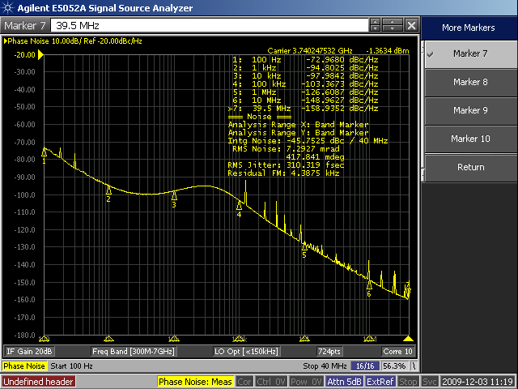

LMX2541S3740E Spurs for WORST CASE Channels
(Fraction = 1/100)
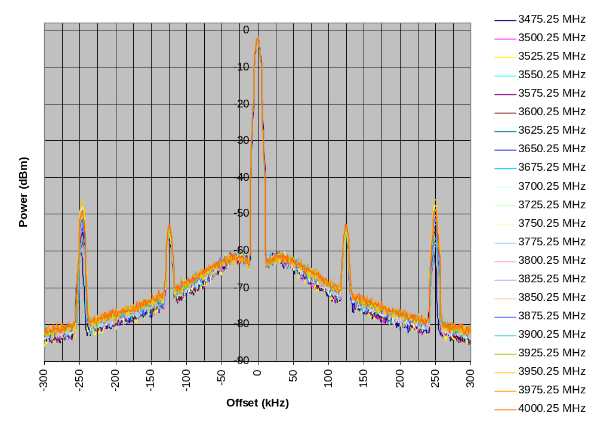

Note that the graphs have all been normalized the average carrier power.

LMX2541SQ3740E VCO Phase Noise
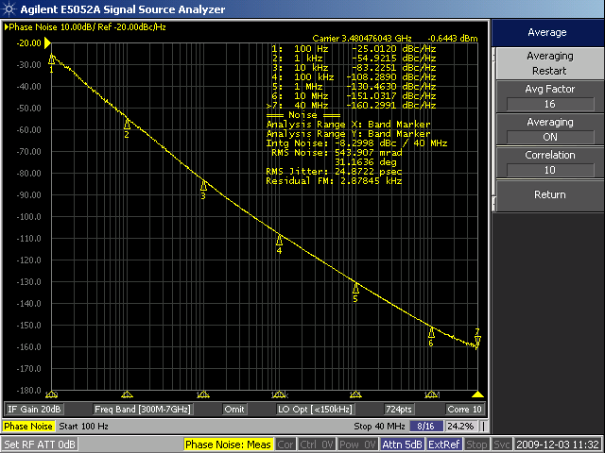  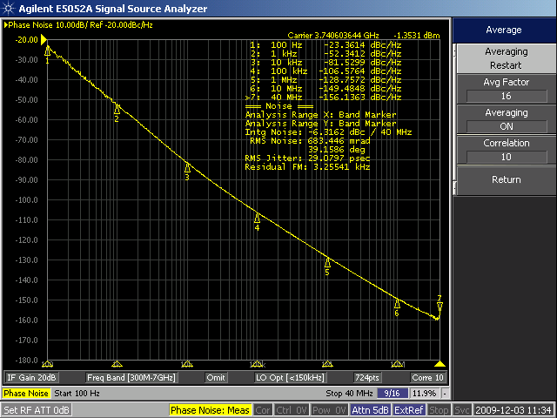  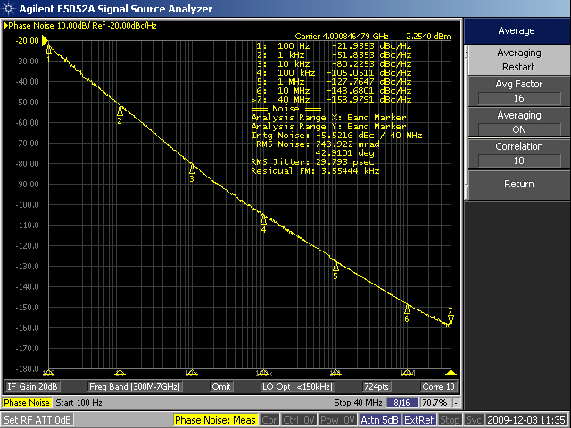 | The plots show the VCO phase noise at low, middle, and high frequency.  To measure the VCO phase noise, a simple technique is to lock the PLL to the desired frequency and set the charge pump state to “Tri-State”, by clicking this on the PLL tab on Codeloader. If the phase noise analyzer can track the signal, a reasonable measurement can be made. To ensure that this measurement is of the VCO noise, omit the the spurs and disconnect the microwire programming cable.

Bill of Materials
Revision | 9/30/2009
Part | Manufacturer | Part Number | Qty | Identifier
Capacitors
100 pF | Kemet | C0603C101J5GAC | 4 | C1, C5, C33, C35
2.2 nF | Kemet | C0603C222J5GAC | 1 | C3_LF
22 nF | Kemet | C0603C223K5RAC | 1 | C2_LF
0.1 uF | Kemet | C0603C104K5RAC | 19 | C2, C6, C9, C10, C11, C12, C13, C17, C18, C21, C24, C25, C26, C27, C28, C32, C36, C40, C49
1 uF | Kemet | C0603C105K8VAC | 10 | C3, C7, C16, C19, C31, C37, C41, C42, C43, C50
4.7 uF | Kemet | C0603C475K9PAC | 4 | C14, C15, C20, C34
10 uF | Kemet | C0805C106K9PAC | 6 | C4, C8, C30, C38, C39, C48
Resistors
0 ohm | Vishay/Dale | CRCW06030000Z0EA | 7 | R3_LF, R12, R21, R39, R41, R42, R46
4.7 ohm | Vishay/Dale | CRCW06034R7JNEA | 2 | R49, R50
10 ohm | Vishay/Dale | CRCW060310R0JNEA | 3 | R6, R47, R48
18 ohm | Vishay/Dale | CRCW060318R0JNEA | 1 | R2
51 ohm | Vishay/Dale | CRCW060351R0JNEA | 2 | R10, R14
120 ohm | Vishay/Dale | CRCW0603120RJNEA | 3 | R7, R8, R51
180 ohm | Vishay/Dale | CRCW0603180RJNEA | 1 | R36
330 ohm | Vishay/Dale | CRCW0603330RJNEA | 2 | R1, R3
470 ohm | Vishay/Dale | CRCW0603470RJNEA | 1 | R2_LF
2.2 k | Vishay/Dale | CRCW06032K20JNEA | 1 | R35
15 k | Vishay/Dale | CRCW060315K0JNEA | 3 | R30, R32, R34
27 k | Vishay/Dale | CRCW060327K0JNEA | 5 | R29, R31, R33, R37, R38
100 k | Vishay/Dale | CRCW0603100KJNEA | 2 | R4, R5
Other
Ferrite | Digikey | 490-1015-1-ND | 7 | L1, L2, L3, L4, L5, L6, L7
3.3 V zener | Comchip | CZRU52C3V3 | 1 | D2
HEADER_2X5  (POLARIZED) | FCI Electronics | 52601-S10-8 | 1 | uWire
Green LED | Lumex | SML-LX2832GC-TR | 1 | D1
POWER_SMALL | Weidmuller | 1594540000.0 | 1 | P1
SMA | Johnson Components | 142-0701-851 | 4 | OSCin, OSCin*, RFout, Vcc
TCXO - 100 MHz | Connor-Winfield | CWX813 - 100 MHz | 1 | Y1
NFET | Fairchild | BSS138 | 1 | U5
VCXO - 100 MHz | CRYSTEK | CVPD-920 – 100 MHz | 1 | U4
LMX2541 | National Semiconductor | LMX2541SQxxxx | 1 | U1
Standoffs | SPC Technology | SPCS-6 | 4 | Place in Holes at the corners of the board.
Open
Open | - | Open Capacitor | 14 | C1_LF, C2pLF, C4_LF, C22, C23, C29, C44, C45, C46, C47
Open |  | Open Capacitor | 6 | C100, C101, C102, C103, C104, C105
Open | - | Open Resistor | 22 | R2pLF,R4_LF, R9, R11, R13, R15, R16, R17, R18, R19, R20, R22, R23, R24, R25, R26, R27, R28, R40, R43, R44, R45
Open | - | Open Resistor | 9 | R100, R101, R102, R103, R104, R105, R106, R107, R108, R109
Open | - | Open Crystal | 1 | Y100
Open | - | Open IC | 3 | U2, U3, U100
Open | - | Open SMA | 3 | ExtVCOin, Ftest/LD, VccAux

Top Assembly Diagram
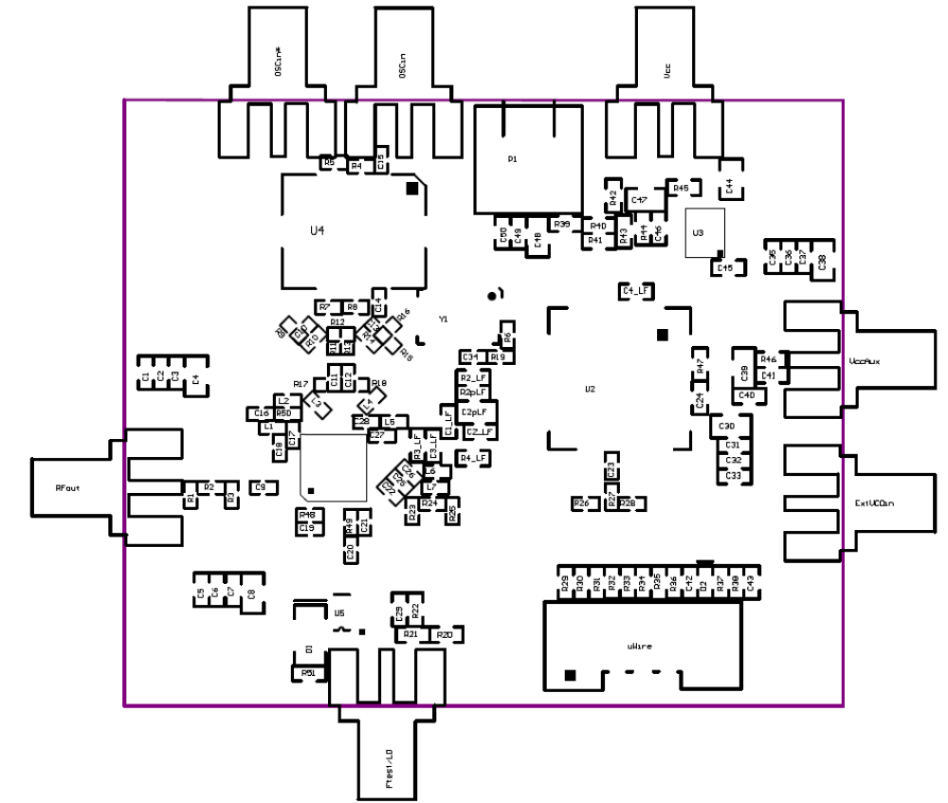
234
Bottom Assembly Diagram
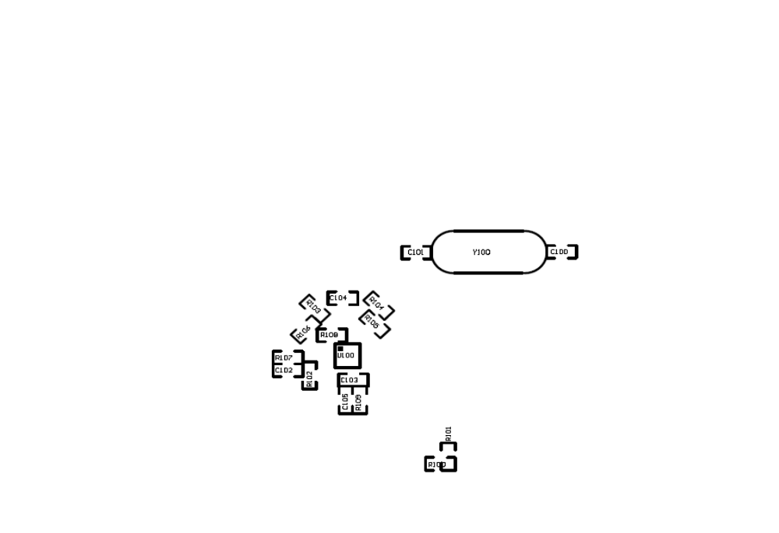
No parts are on the bottom layer for the default assembly. These components are for the crystal and active filter options.

Schematic
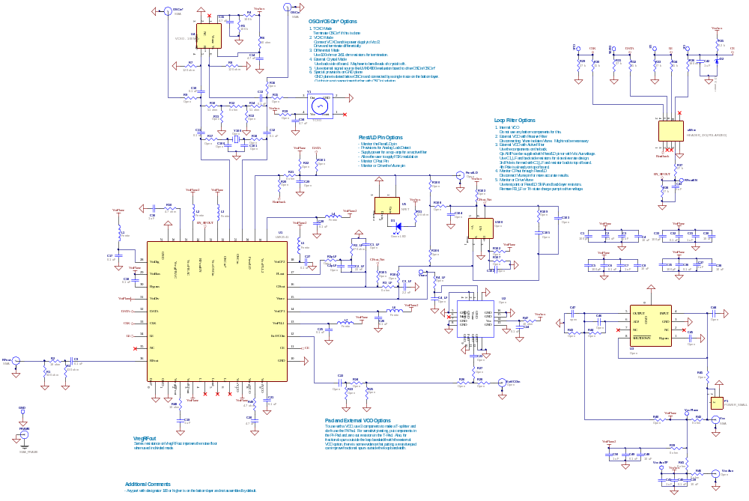

Board Layer Stackup
RO4003 (ε_{r} = 3.38, Tand = 0.0022)
CONTROLLED THICKNESS of
16 mils thick
Top Layer 1oz thick
GND1 Layer
FR4 (ε_{r} = ~4.6)
?? mils thick, but thinner is preferable
VccPlane Layer
FR4
?? mils thick
62 mils thick total
Mid Layer 1
FR4 (ε_{r} = ~4.6)
?? mils thick, but thinner is preferable
GND2 Layer
FR4 (ε_{r} = ~4.6) = ~4.6)
?? mils thick
Bottom Layer
Board Material | Rogers RO4003
Number of Layers | 6
Board Thickness | 0.062”
Copper Weight | 1 oz Finished
Finish | Immersion Gold
Solder Mask Color | Green/Gloss
Testing | 100% Electrical Testing
Top Layer and Silkscreen
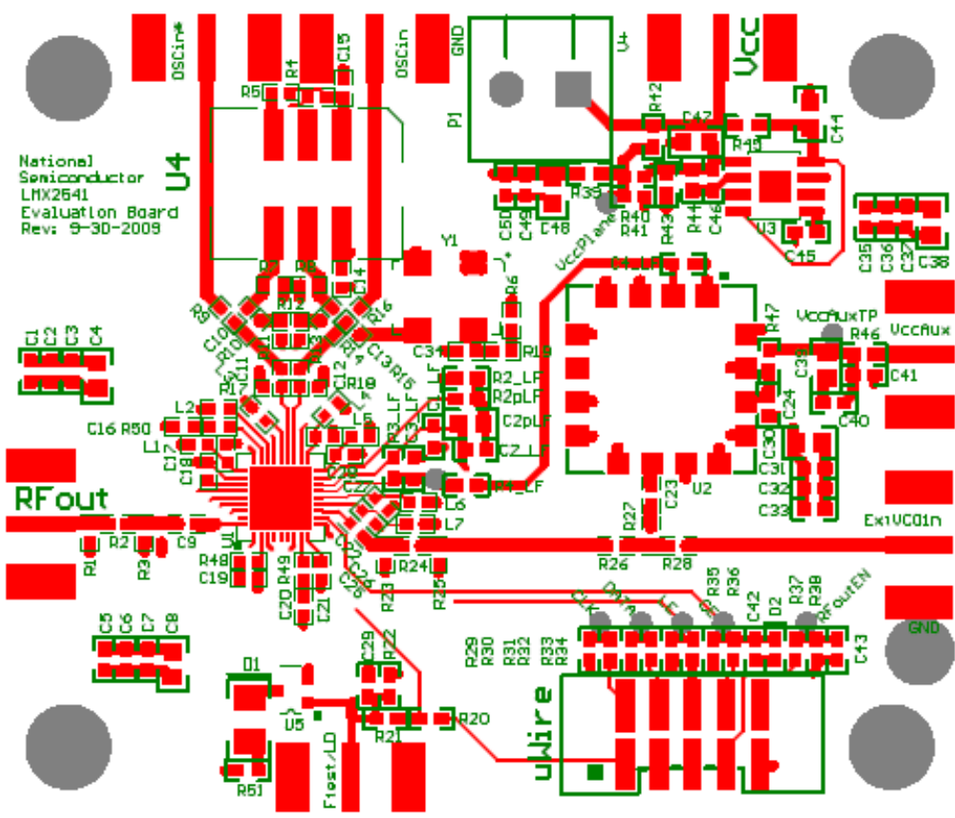
GND1 Layer
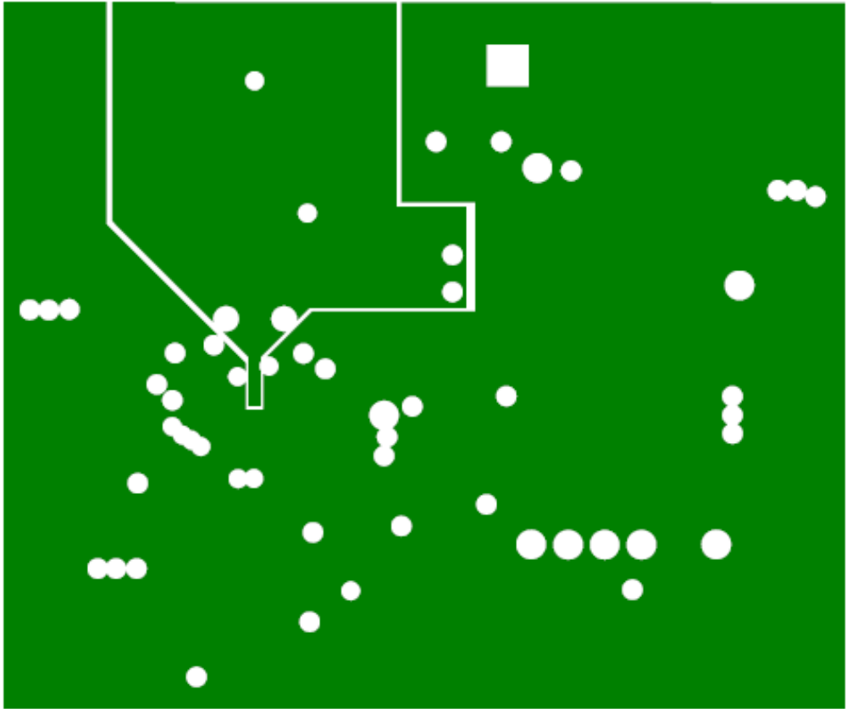

Beneath the TCXO, the ground plane is separated. It is believed that this may improve spurs, especially at offset frequencies equal to the TCXO frequency. These planes are connected on the bottom layer by a small trace.
VccPlane Layer
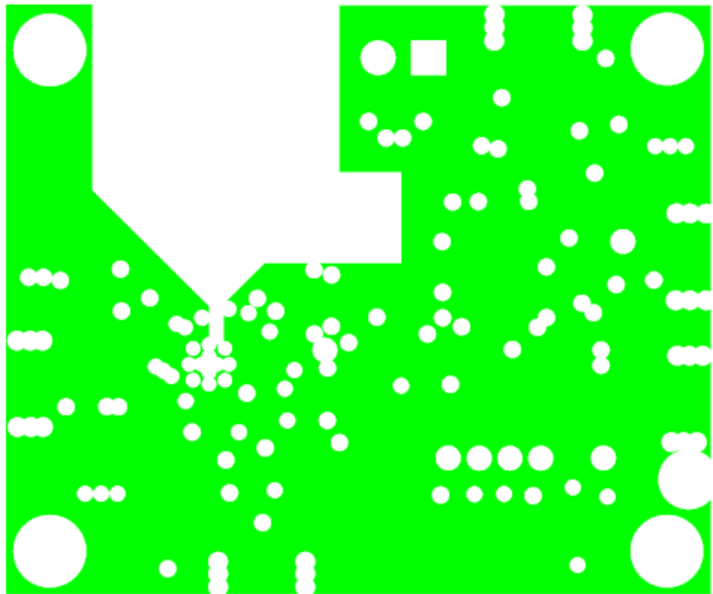

Beneath the TCXO, the power plane is removed to minimize the chance of any noise getting onto this plane.
MidLayer 1

Certain pins like VccFRAC and the TCXO supply pins could potentially be sources of noise. These traces were put on this separate layer to try to isolate them more from the
GND2 Layer
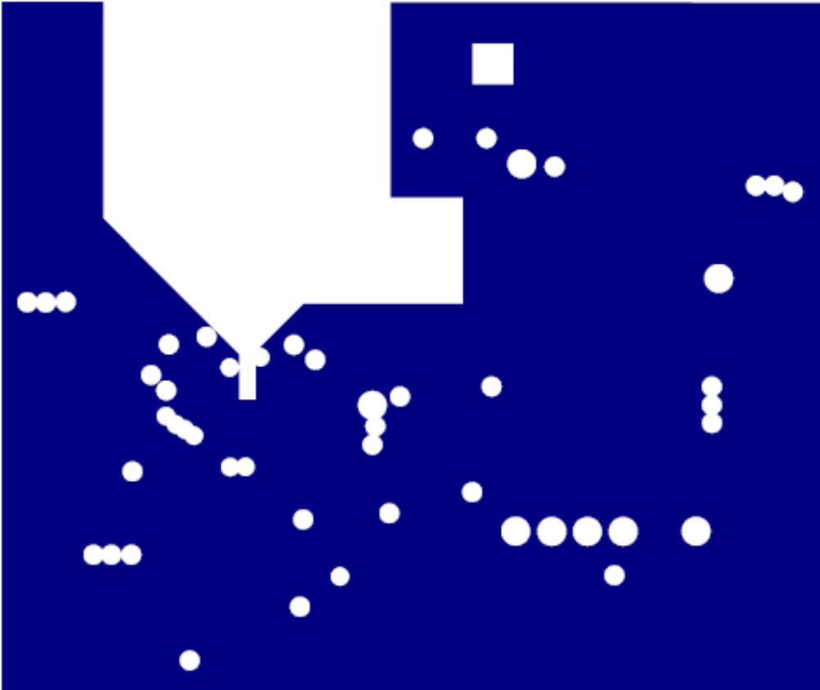
Beneath the TCXO, the ground plane is separated. It is believed that this may improve spurs, especially at offset frequencies equal to the TCXO frequency. These planes are connected on the bottom layer by a small trace.
Bottom Layer and Silkscreen
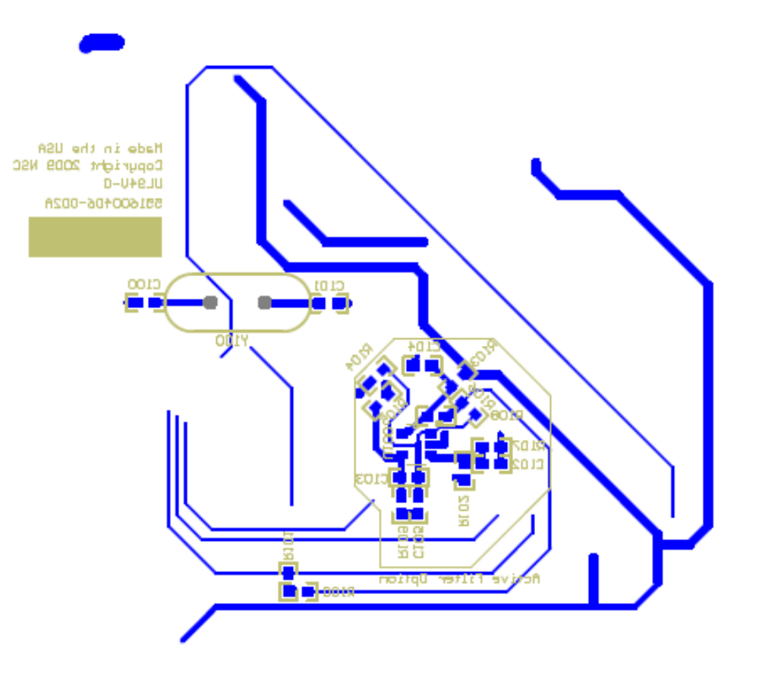
This layer has the small trace that connects the grounded pieces in the GND1 layer. It has options for an active filter and crystal as well.

